

RISK ASSESSMENT FINDINGS

Department/Service
Date
Assessor
Approved By
Review Date

Relevant Legislation:

The Management of Health and Safety at Work Regulations 1999

RISK ASSESSMENT RECORD

ACTIVITY and/or ENVIRONMENT TO BE ASSESSED: Dining Hall
DATE:

KEY (People at risk) | Likelihood (L) | Severity (S) | Risk Calculation | Risk Rating
E = Employee YP = Young Persons  P = Public  C = Contractors  V = Visitors  EM = Expectant Mothers | 1. Very Low (rare/very unlikely)  2. Low (unlikely)  3. Medium (could occur/possible)  4. High (likely to occur/probable)  5. Very High (near certain to occur) | 1. Insignificant (nuisance/discomfort)  2. Minor (no lost time)  3. Moderate (time loss)  4. Significant (serious/incapacity to work)  5. Major (Death) | Likelihood x Severity  =  Rating | 1- 6 LOW RISK Monitor  - MEDIUM RISK Monitor, review & reduce risk where possible  14-25 HIGH RISK Further Action Required

1.Hazards Identified and potential harm it could cause | 2. People  At Risk | 3.Controls in Place | 4.Risk Rating |  |  |  | 5. Further Action Required/ Recommendations | 6.Target Date for Completion
1.Hazards Identified and potential harm it could cause | 2. People  At Risk | 3.Controls in Place | L | S | Score | Risk | 5. Further Action Required/ Recommendations | 6.Target Date for Completion

Defective flooring – slips, trips, falls |  | - Inspection of flooring  - Prompt maintenance of defects
Spillage of food/liquids – slips /falls |  | - Regular cleaning of floors  - Prompt cleaning of spillages
Obstacles - causing trips & falls |  | - Walkways to be kept clear of bags etc.  - Adequate space allowed between tables for access  - Adequate levels of supervision
Defective furniture – causing injury |  | - Regular inspection routine with prompt remedial action  - Reporting procedure for defects
Hot food / drinks – causing burns / scalds |  | - Appropriately trained staff  - Trays provided  - Adequate levels of supervision
Electrical equipment and sockets – electrocution |  | - Portable appliance testing and regular visual inspection  - Fixed installation testing
Broken glass - cuts |  | - Reusable plastic items preferred  - Breakages cleared up promptly  - Damaged items discarded safely

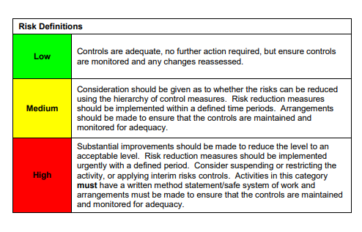

ACKNOWLEDGEMENT OF RISK ASSESSMENT Version:

PLEASE READ THE NOTICE BELOW BEFORE SIGNING THIS FORM
I acknowledge that I have read and understood the Risk Assessment/s associated with this task/event/equipment etc

Forename | Surname | Employee Signature | Date | Manager’s Signature

