

RISK ASSESSMENT FINDINGS

Department/Service
Date
Assessor
Approved By
Review Date

Relevant Legislation:

The Management of Health and Safety at Work Regulations 1999

RISK ASSESSMENT RECORD

ACTIVITY and/or ENVIRONMENT TO BE ASSESSED: DSE WORKSTATION (to be completed alongside the DSE Checklist)
DATE:

KEY (People at risk) | Likelihood (L) | Severity (S) | Risk Calculation | Risk Rating
E = Employee YP = Young Persons  P = Public  C = Contractors  V = Visitors  EM = Expectant Mothers | 1. Very Low (rare/very unlikely)  2. Low (unlikely)  3. Medium (could occur/possible)  4. High (likely to occur/probable)  5. Very High (near certain to occur) | 1. Insignificant (nuisance/discomfort)  2. Minor (no lost time)  3. Moderate (time loss)  4. Significant (serious/incapacity to work)  5. Major (Death) | Likelihood x Severity  =  Rating | 1- 6 LOW RISK Monitor  - MEDIUM RISK Monitor, review & reduce risk where possible  14-25 HIGH RISK Further Action Required

1.Hazards Identified and potential harm it could cause | 2. People  At Risk | 3.Controls in Place | 4.Risk Rating |  |  |  | 5. Further Action Required/ Recommendations | 6.Target Date for Completion
1.Hazards Identified and potential harm it could cause | 2. People  At Risk | 3.Controls in Place | L | S | Score | Risk | 5. Further Action Required/ Recommendations | 6.Target Date for Completion

Upper limb disorders (including pains in the neck, arms, elbows, wrists, hands and fingers), often referred to as Repetitive Strain Injury (RSI) |  | - Every hour of continuous DSE work take a 5 to 10-minute break or change work activities to alternate tasks away from the DSE.  - External keyboard and mouse used.
Backache |  | - Every hour of continuous DSE work take a 5 to 10-minute break or change work activities to alternate tasks away from the DSE.  - Adjustable chair used with foot rest. |  |  |  |  | - Alternative device that is lighter to carry  - Choose a lightweight carry case with handle and shoulder straps  - Consider using a trolley bag
Fatigue and Stress |  | - Every hour of continuous DSE work take a 5 to 10-minute break or change work activities to alternate tasks away from the DSE.
Temporary eye strain (not damage) |  | - Every hour of continuous DSE work take a 5 to 10-minute break or change work activities to alternate tasks away from the DSE.  - Screens are 14inch or larger, bright and clear.  - Secondary monitor used  - Eye testing
Headaches |  | - Every hour of continuous DSE work take a 5 to 10-minute break or change work activities to alternate tasks away from the DSE.  - Appropriate lighting  - Eye testing
Staff with existing health conditions and pregnancy |  | - Monitoring as necessary  - Every hour of continuous DSE work take a 5 to 10-minute break or change work activities to alternate tasks away from the DSE.
Software |  | - Appropriate software used and updated as patches released.

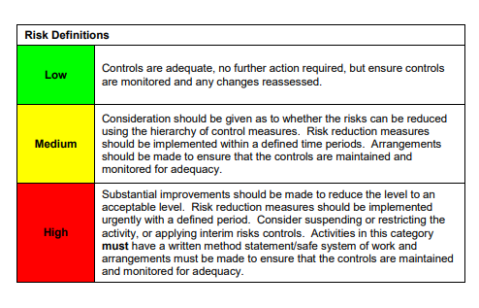

ACKNOWLEDGEMENT OF RISK ASSESSMENT Version:

PLEASE READ THE NOTICE BELOW BEFORE SIGNING THIS FORM
I acknowledge that I have read and understood the Risk Assessment/s associated with this task/event/equipment etc

Forename | Surname | Employee Signature | Date | Manager’s Signature

