

RISK ASSESSMENT FINDINGS

Department/Service
Date
Assessor
Approved By
Review Date

Relevant Legislation:

RISK ASSESSMENT RECORD

ACTIVITY and/or ENVIRONMENT TO BE ASSESSED: Epilepsy Management
DATE:

KEY (People at risk) | Likelihood (L) | Severity (S) | Risk Calculation | Risk Rating
E = Employee YP = Young Persons  P = Public  C = Contractors  V = Visitors  EM = Expectant Mothers | 1. Very Low (rare/very unlikely)  2. Low (unlikely)  3. Medium (could occur/possible)  4. High (likely to occur/probable)  5. Very High (near certain to occur) | 1. Insignificant (nuisance/discomfort)  2. Minor (no lost time)  3. Moderate (time loss)  4. Significant (serious/incapacity to work)  5. Major (Death) | Likelihood x Severity  =  Rating | 1- 6 LOW RISK Monitor  - MEDIUM RISK Monitor, review & reduce risk where possible  14-25 HIGH RISK Further Action Required

1.Hazards Identified and potential harm it could cause | 2. People  At Risk | 3.Controls in Place | 4.Risk Rating |  |  |  | 5. Further Action Required/ Recommendations | 6.Target Date for Completion
1.Hazards Identified and potential harm it could cause | 2. People  At Risk | 3.Controls in Place | L | S | Score | Risk | 5. Further Action Required/ Recommendations | 6.Target Date for Completion

Display Screen Equipment (DSE) |  | Annual DSE assessment to ensure screen is in good working order and not flickering |  |  |  |  | Are there any reasonable adjustments that need to be made to the persons workplace/job/curriculum etc. to ensure compliance with the Equality Act 2010
Falls, slips and trips

Tonic seizures may cause individual to fall during a seizure
Stress and fatigue  Individual may have more seizures if tired or stressed. |  |  |  |  |  |  | Pupil may start school later or finish earlier if tired.
Evacuation during fire and other emergencies |  | Individual may have a seizure or be recovering from one during an emergency and may need assistance to evacuate |  |  |  |  | Conduct a Personal Emergency Evacuation Plan (PEEP)
First Aid |  | Could injure themselves whilst having a seizure.  Appropriate number of trained First Aiders  First Aiders aware of who is epileptic.  Ensure all staff know who all first aiders are and where they can be contacted. |  |  |  |  | Arrange epilepsy awareness training
Personal Care |  | Consider toileting requirements, e.g. uses toilet independently – seek whereabouts if not returned after approx. 5 minutes
Lessons

What risks are posed in certain lessons, science, DT, PE, Science for example

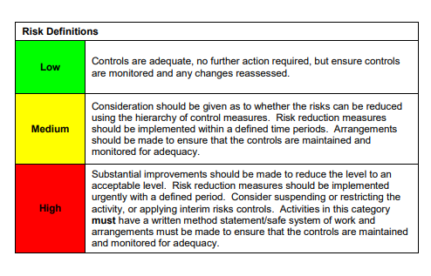

ACKNOWLEDGEMENT OF RISK ASSESSMENT Version:

PLEASE READ THE NOTICE BELOW BEFORE SIGNING THIS FORM
I acknowledge that I have read and understood the Risk Assessment/s associated with this task/event/equipment etc

Forename | Surname | Employee Signature | Date | Manager’s Signature

