

RISK ASSESSMENT FINDINGS

Department/Service
Date
Assessor
Approved By
Review Date

Relevant Legislation:

The Management of Health and Safety at Work Regulations 1999

RISK ASSESSMENT RECORD

ACTIVITY and/or ENVIRONMENT TO BE ASSESSED: Evacuation Chair
DATE:

KEY (People at risk) | Likelihood (L) | Severity (S) | Risk Calculation | Risk Rating
E = Employee YP = Young Persons  P = Public  C = Contractors  V = Visitors  EM = Expectant Mothers | 1. Very Low (rare/very unlikely)  2. Low (unlikely)  3. Medium (could occur/possible)  4. High (likely to occur/probable)  5. Very High (near certain to occur) | 1. Insignificant (nuisance/discomfort)  2. Minor (no lost time)  3. Moderate (time loss)  4. Significant (serious/incapacity to work)  5. Major (Death) | Likelihood x Severity  =  Rating | 1- 6 LOW RISK Monitor  - MEDIUM RISK Monitor, review & reduce risk where possible  14-25 HIGH RISK Further Action Required

1.Hazards Identified and potential harm it could cause | 2. People  At Risk | 3.Controls in Place | 4.Risk Rating |  |  |  | 5. Further Action Required/ Recommendations | 6.Target Date for Completion
1.Hazards Identified and potential harm it could cause | 2. People  At Risk | 3.Controls in Place | L | S | Score | Risk | 5. Further Action Required/ Recommendations | 6.Target Date for Completion

Risk of injury from undertaking planned evacuation of person(s) |  | - All evac chair operators to be trained at least annually. In addition to practical exercises.  - All Evac chair operators to be fit and healthy |  |  |  |  | Ensure the individual to be evacuated has a Personal Emergency Evacuation Plan (PEEP) which is regularly reviewed.  Training logs kept.
Manual Handling Injuries including strains, sprains from incorrect handling |  | - Refer to Manual Handling assessments  - All Evac chair operators must be trained in order to operate the chairs. Training is available by contacting the Health & Safety Adviser / Building Manager.  - Self-refresher practice sessions are advised whenever possible.  - Any operator with a physical injury, or a new or expectant mother, must not operate the Evac chair.  - In the event of emergency alarm activation, operators should make their way to the nearest Evac chair point / refuge area / designated area on their way out of the building.  - Under no circumstances should an operator put themselves at risk by trying to reach a refuge area where the fire is. The location of the fire should be noted and reported to the Security Officer leading the evacuation.  If the refuge has two-way communication points, contact should be made with the Lead Security Officer of the Fire Response Team who will advise the next course of action – i.e. if it is a drill or false alarm then evacuation should not take place. If it is a fire or unknown situation begin to evacuate vertically out of the building.
Evac Chair in disrepair  Lack of maintenance to an evacuation chair may result in its failure to operate during an emergency evacuation, leading to potentially serious consequences, including injury or harm to the occupant being evacuated. Delays or difficulties during the evacuation process may also be encountered. |  | Regular inspection and maintenance |  |  |  |  | An annual service undertaken by a competent person

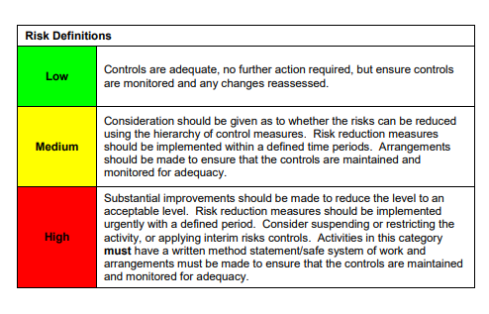

ACKNOWLEDGEMENT OF RISK ASSESSMENT Version:

PLEASE READ THE NOTICE BELOW BEFORE SIGNING THIS FORM
I acknowledge that I have read and understood the Risk Assessment/s associated with this task/event/equipment etc

Forename | Surname | Employee Signature | Date | Manager’s Signature

