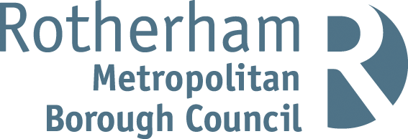

RISK ASSESSMENT FINDINGS

Department/Service
Date
Assessor
Approved By
Review Date

Relevant Legislation:

The Management of Health and Safety at Work Regulations 1999

RISK ASSESSMENT RECORD

ACTIVITY and/or ENVIRONMENT TO BE ASSESSED: Face Painting
DATE:

KEY (People at risk) | Likelihood (L) | Severity (S) | Risk Calculation | Risk Rating
E = Employee YP = Young Persons  P = Public  C = Contractors  V = Visitors  EM = Expectant Mothers | 1. Very Low (rare/very unlikely)  2. Low (unlikely)  3. Medium (could occur/possible)  4. High (likely to occur/probable)  5. Very High (near certain to occur) | 1. Insignificant (nuisance/discomfort)  2. Minor (no lost time)  3. Moderate (time loss)  4. Significant (serious/incapacity to work)  5. Major (Death) | Likelihood x Severity  =  Rating | 1- 6 LOW RISK Monitor  - MEDIUM RISK Monitor, review & reduce risk where possible  14-25 HIGH RISK Further Action Required

1.Hazards Identified and potential harm it could cause | 2. People  At Risk | 3.Controls in Place | 4.Risk Rating |  |  |  | 5. Further Action Required/ Recommendations | 6.Target Date for Completion
1.Hazards Identified and potential harm it could cause | 2. People  At Risk | 3.Controls in Place | L | S | Score | Risk | 5. Further Action Required/ Recommendations | 6.Target Date for Completion

Adverse reactions caused by the application of face painting materials to the skin |  | - Only use approved paints and materials  - Don't paint children under three (as their skin is delicate and more likely to be vulnerable, offer to paint hand or arm instead of face).  - Advise people who appear to have skin conditions. |  |  |  |  | - Only use proprietary materials recognised within the industry as very good quality. Products used are more expensive and higher quality than brands in general use.  - Paint manufacturers advise against painting children under three years of age.  - Insurance may be invalid if painting children under three.
Paint brush in the eye |  | - Don't paint children under three.  - Don't paint children who are unable to follow instructions  - Keep spectators away from face painters.  - Be firm but polite to maintain space round the working area/cordon area off. |  |  |  |  | - Offer to paint hand or arm instead  - Organisers need to locate face painters in an un-crowded area
Spreading infections such as cold sores and conjunctivitis |  | - Do not paint the infected area.  - Use clean sponges for each person.  - Regularly wash brushes in use.  - Frequently change water.  - Thoroughly clean brushes, sponges and water bowls after the event. |  |  |  |  | - Always work as hygienically as possible and follow guidelines for the cleanliness of face painting kit.
Aggravating existing skin conditions |  | - Do not paint children or adults with sensitive skin, eczema, open cuts or sores. |  |  |  |  | - Offer to paint hands or arms instead.
Falling off the chair |  | - Give assistance when child gets on and off. |  |  |  |  | - Consider higher chairs as painters may prefer to stand whilst painting.
Falling or tripping over equipment |  | - Keep work area tidy.  - Containers boxes, stored safely. Maintain a clear space round the work area.  - Keep spectators away from the work area |  |  |  |  | - Organisers must allocate an un-crowded area for face painting.

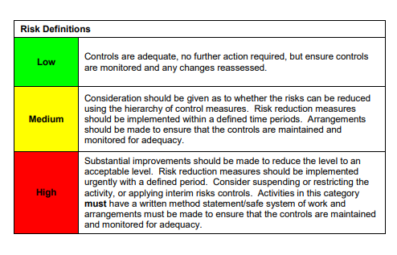

ACKNOWLEDGEMENT OF RISK ASSESSMENT Version:

PLEASE READ THE NOTICE BELOW BEFORE SIGNING THIS FORM
I acknowledge that I have read and understood the Risk Assessment/s associated with this task/event/equipment etc

Forename | Surname | Employee Signature | Date | Manager’s Signature

