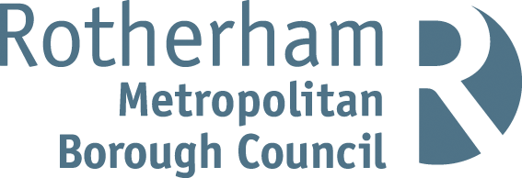

RISK ASSESSMENT FINDINGS

Department/Service
Date
Assessor
Approved By
Review Date

Relevant Legislation:

The Management of Health and Safety at Work Regulations 1999

RISK ASSESSMENT RECORD

ACTIVITY and/or ENVIRONMENT TO BE ASSESSED: Fire (General)
DATE:

KEY (People at risk) | Likelihood (L) | Severity (S) | Risk Calculation | Risk Rating
E = Employee YP = Young Persons  P = Public  C = Contractors  V = Visitors  EM = Expectant Mothers | 1. Very Low (rare/very unlikely)  2. Low (unlikely)  3. Medium (could occur/possible)  4. High (likely to occur/probable)  5. Very High (near certain to occur) | 1. Insignificant (nuisance/discomfort)  2. Minor (no lost time)  3. Moderate (time loss)  4. Significant (serious/incapacity to work)  5. Major (Death) | Likelihood x Severity  =  Rating | 1- 6 LOW RISK Monitor  - MEDIUM RISK Monitor, review & reduce risk where possible  14-25 HIGH RISK Further Action Required

1.Hazards Identified and potential harm it could cause | 2. People  At Risk | 3.Controls in Place | 4.Risk Rating |  |  |  | 5. Further Action Required/ Recommendations | 6.Target Date for Completion
1.Hazards Identified and potential harm it could cause | 2. People  At Risk | 3.Controls in Place | L | S | Score | Risk | 5. Further Action Required/ Recommendations | 6.Target Date for Completion

Source of ignition
For example: electricals, smoking, arson, heating installations, fixed/portable heating, cooking, grinding equipment, and lightning
Source of fuel and storage of combustible materials
For example: general waste materials, furniture and furnishings, storage of stock/packaging, decorations, storage/use of dangerous substances e.g. flammable liquids
Work processes that create an increased risk of fire impact on general fire precautions
For example: laundry rooms, cutting or welding equipment, dust/cooking extraction systems, oily rags, processes which use hazardous substances
Structural features that could promote the spread of fire
For example: open staircases, insulated core panels, open roof voids, laundry chutes, service risers, false ceilings
Hazards introduced by outside contractors and building works
For example: hot works such as soldering, wielding, flame cutting; introduction of temporary electrical equipment or heaters
Means of escape blocked/restricted |  | - Are the escape routes and exits adequate for the number of people who may need to use them? (e.g. consider the number, width and distribution)  - How far do people have to travel? Are there any areas where people may have to walk past a fire to get out? (e.g. dead-end corridors, inner rooms)  - Can escape routes (including external routes) be used quickly and safely by anyone who may need to use them? (e.g. clear from obstructions, doors can be opened without the use of a key or a code)  - Are there sufficient stairways for the number of people who may need to use them? How long will it take for people to reach a final exit?  - Has the stairway (including external) been adequately protected from fire?  - Is the escape route suitable for everyone who may need to use it?  - Are all stairways (including external) clear of obstruction, free from trips, slips and falls, and in good repair?
Fire alarm temporarily out of commission e.g. requires part, repair, attention etc.  No audible means of raising the alarm. |  | - Building Manager and health and safety section must be notified immediately.  - Consult Building Manager as to availability of audible portable devices e.g. bells, claxons etc. and the best places to site them and to review fire risk assessment for building.  - Portable devices should be placed strategically around the building to raise the alarm.  - Staff/pupil /visitors must be informed via staff meeting/ assembly etc. of the temporary fire alarm arrangements.  - A full fire drill must be undertaken to test the arrangements are adequate as soon as possible.  - Details of the temporary arrangements and fire drill must be documented in the fire log book.  - Reactive Cleaning, removal of combustible material  Nonessential portable electricals switched off/unplugged |  |  |  |  | Temporary Fire Alarm System
Loss of lighting |  | Emergency lighting system
Lack of Firefighting equipment
Is there a sufficient amount and is it appropriate for the risks? Is it easily accessible and suitably located?

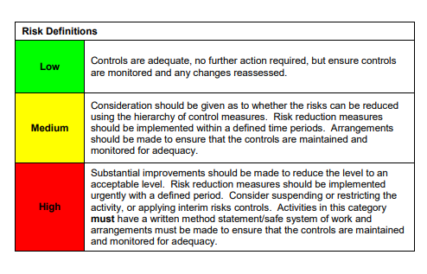

ACKNOWLEDGEMENT OF RISK ASSESSMENT Version:

PLEASE READ THE NOTICE BELOW BEFORE SIGNING THIS FORM
I acknowledge that I have read and understood the Risk Assessment/s associated with this task/event/equipment etc

Forename | Surname | Employee Signature | Date | Manager’s Signature

