

RISK ASSESSMENT FINDINGS

Department/Service
Date
Assessor
Approved By
Review Date

Relevant Legislation:

The Management of Health and Safety at Work Regulations 1999

RISK ASSESSMENT RECORD

ACTIVITY and/or ENVIRONMENT TO BE ASSESSED: Provision of First Aid cover/spillages of blood or other fluids/procedure re human or animal bites
DATE:

KEY (People at risk) | Likelihood (L) | Severity (S) | Risk Calculation | Risk Rating
E = Employee YP = Young Persons  P = Public  C = Contractors  V = Visitors  EM = Expectant Mothers | 1. Very Low (rare/very unlikely)  2. Low (unlikely)  3. Medium (could occur/possible)  4. High (likely to occur/probable)  5. Very High (near certain to occur) | 1. Insignificant (nuisance/discomfort)  2. Minor (no lost time)  3. Moderate (time loss)  4. Significant (serious/incapacity to work)  5. Major (Death) | Likelihood x Severity  =  Rating | 1- 6 LOW RISK Monitor  - MEDIUM RISK Monitor, review & reduce risk where possible  14-25 HIGH RISK Further Action Required

1.Hazards Identified and potential harm it could cause | 2. People  At Risk | 3.Controls in Place | 4.Risk Rating |  |  |  | 5. Further Action Required/ Recommendations | 6.Target Date for Completion
1.Hazards Identified and potential harm it could cause | 2. People  At Risk | 3.Controls in Place | L | S | Score | Risk | 5. Further Action Required/ Recommendations | 6.Target Date for Completion

Size of the premises and layout – e.g. split sites, different levels, separate buildings etc. |  | Number and location of first aid boxes and other first aid equipment e.g. first aid room where appropriate with appropriate signage (at least 1) in a prominent position informing people who first aid trained personnel are and their location |  |  |  |  | Person nominated to check stock and replace used stock.
Number of staff, pupils, service users etc. |  | Number of qualified (First Aid at Work) certificate holders and appointed persons/Emergency First Aid trained certificate holders with training kept up to date as per legal requirements
Location of building – e.g. rural, close to town etc.
Specific risks e.g. pupil with specific health needs, use of machinery, PE etc. |  | Health Care Plan in place |  |  |  |  | Refer to School Nurse Team and/or GP/Specialist
Previous history of accidents.

Lunch/break time cover |  | Staff Rota in place
Offsite activities e.g. educational visits |  | First Aid kit taken on visits along with any medication |  |  |  |  | Refer to EVOLVE
Protocol for blood / other bodily fluid spillages: |  | - Plastic container / bucket with lid containing leak proof bags, paper towels, cleaning solution e.g. Milton, disinfectant etc.  - Personal protective clothing (PPE) disposable gloves and aprons, eye protection. (single use items must be replaced).  - Person cleaning the spillage must wear: Disposable gloves and apron and eye protection. Using paper towels soak up spillage and place paper towels in to leak proof bag.  - Clean affected area using cleaning solution and paper towels and place used towels in to leak proof bag. Ensure area is left clean and dry.  - Dispose of all bagged items including gloves, aprons etc. securely e.g. medical waste bin if available. |  |  |  |  | Replace used stock.
Human or Animal Bites that have penetrated the skin: |  | Basic first aid should be applied to minimise the risk of infection and control bleeding. The injured person must be referred to either Hospital A & E department or Occupational Health Department – (OHD referral can be arranged by contacting RMBC HR department for employees) or GP referral in the case of pupils immediately (dependant on extent of injury).
Vaccinations and Personal Protective Clothing / Equipment: |  | Individual schools are responsible for the provision of any personal protective equipment and treatment identified via a risk assessment/ advised by a medical practitioner to enable staff to work safely Anaphylaxis management – Allergic reaction Risk Assessment
Allergic reactions |  | Refer to Anaphylaxis management – Allergic reaction Risk Assessment

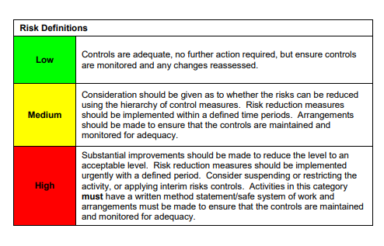

ACKNOWLEDGEMENT OF RISK ASSESSMENT Version:

PLEASE READ THE NOTICE BELOW BEFORE SIGNING THIS FORM
I acknowledge that I have read and understood the Risk Assessment/s associated with this task/event/equipment etc

Forename | Surname | Employee Signature | Date | Manager’s Signature

