

RISK ASSESSMENT FINDINGS

Department/Service
Date
Assessor
Approved By
Review Date

Relevant Legislation:

The Management of Health and Safety at Work Regulations 1999

RISK ASSESSMENT RECORD

ACTIVITY and/or ENVIRONMENT TO BE ASSESSED: Gymnasium

KEY (People at risk) | Likelihood (L) | Severity (S) | Risk Calculation | Risk Rating
E = Employee YP = Young Persons  P = Public  C = Contractors  V = Visitors  EM = Expectant Mothers | 1. Very Low (rare/very unlikely)  2. Low (unlikely)  3. Medium (could occur/possible)  4. High (likely to occur/probable)  5. Very High (near certain to occur) | 1. Insignificant (nuisance/discomfort)  2. Minor (no lost time)  3. Moderate (time loss)  4. Significant (serious/incapacity to work)  5. Major (Death) | Likelihood x Severity  =  Rating | 1- 6 LOW RISK Monitor  - MEDIUM RISK Monitor, review & reduce risk where possible  14-25 HIGH RISK Further Action Required

1.Hazards Identified and potential harm it could cause | 2. People  At Risk | 3.Controls in Place | 4.Risk Rating |  |  |  | 5. Further Action Required/ Recommendations | 6.Target Date for Completion
1.Hazards Identified and potential harm it could cause | 2. People  At Risk | 3.Controls in Place | L | S | Score | Risk | 5. Further Action Required/ Recommendations | 6.Target Date for Completion

Defective flooring – slips, trips, falls |  | Inspection of flooring & prompt maintenance of defects
Broken glazing – cuts |  | Impact resistant toughened glass or glazing protection provided where a risk assessment indicates that it is required
Sports equipment storage areas – injury, accumulation of dust/litter |  | - Equipment safely stacked  - Regular inspection of equipment and storage areas  - Good housekeeping regime
Misuse of sports equipment – injury |  | - Adequate supervision of pupils by appropriate staff  - Induction for users in correct use of equipment  - No unauthorised access to equipment  - Adequate level of first aider cover and equipment
Defective sports equipment - injury |  | - Planned inspection and maintenance routine with  official testing where required for certain items  - Defective items removed from area/locked away and marked clearly marked ‘do not use’  - Repair/replace schedule
 |  |  |  |  |  |  | Refer to AfPE guidance

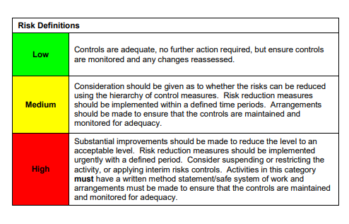

ACKNOWLEDGEMENT OF RISK ASSESSMENT Version:

PLEASE READ THE NOTICE BELOW BEFORE SIGNING THIS FORM
I acknowledge that I have read and understood the Risk Assessment/s associated with this task/event/equipment etc

Forename | Surname | Employee Signature | Date | Manager’s Signature

