

RISK ASSESSMENT FINDINGS

Department/Service
Date
Assessor
Approved By
Review Date

Relevant Legislation:

The Management of Health and Safety at Work Regulations 1999

RISK ASSESSMENT RECORD

ACTIVITY and/or ENVIRONMENT TO BE ASSESSED: Hairdressing Salon (Vocational Education)

KEY (People at risk) | Likelihood (L) | Severity (S) | Risk Calculation | Risk Rating
E = Employee YP = Young Persons  P = Public  C = Contractors  V = Visitors  EM = Expectant Mothers | 1. Very Low (rare/very unlikely)  2. Low (unlikely)  3. Medium (could occur/possible)  4. High (likely to occur/probable)  5. Very High (near certain to occur) | 1. Insignificant (nuisance/discomfort)  2. Minor (no lost time)  3. Moderate (time loss)  4. Significant (serious/incapacity to work)  5. Major (Death) | Likelihood x Severity  =  Rating | 1- 6 LOW RISK Monitor  - MEDIUM RISK Monitor, review & reduce risk where possible  14-25 HIGH RISK Further Action Required

1.Hazards Identified and potential harm it could cause | 2. People  At Risk | 3.Controls in Place | 4.Risk Rating |  |  |  | 5. Further Action Required/ Recommendations | 6.Target Date for Completion
1.Hazards Identified and potential harm it could cause | 2. People  At Risk | 3.Controls in Place | L | S | Score | Risk | 5. Further Action Required/ Recommendations | 6.Target Date for Completion

Wet hand work, e.g. washing hair, working with wet hair. Staff / pupils may suffer from dermatitis, increased sensitivity, severely dry skin. |  | - Staff will instruct pupils to wear gloves for all wet work.  - Protective gloves/non-latex gloves are provided for staff/ pupils.  - Staff to brief pupils to dry their hands thoroughly/ moisturise between wet jobs.  - Non-perfumed hand cream is provided for Staff / pupils.  - Staff will instruct pupils to remove hand jewellery at beginning of session.
Hairdressing products and chemicals. All products, e.g. bleaches, colouring, perm solutions, sterilising liquid, cleaning chemicals |  | - Staff / pupils to check and follow instructions on supplier information sheets.  - Staff/pupils to use gloves when mixing and using product and when washing up bowls etc.  - Salon and stockroom well ventilated.  - Clients must be well-protected with single-use towels.  - Eye wash provision in case of spillages.  - Frequent checks for skin allergy/reactions.
Slips and trips |  | - Ensure a good housekeeping regime.  - Ensure sensible footwear is worn at all times.  - Ensure trailing cables are secured.  - Matting provided at salon entrance
Faulty electrical items |  | - Daily visual checks of equipment and removal of faulty items.  - PAT testing of equipment.  - Fixed installation testing.  - Safe storage of equipment when not in use e.g. hairdryers etc.  - Staff know how to isolate utility services in the event of an emergency.
Fatigue due to long standing periods |  | - Ergonomically designed furniture e.g. adjustable height client chairs etc.  - Sinks designed and located to minimise twisting.  - Frequent breaks built in to programme
Fire |  | - Fire risk assessment for the salon completed and articles and substances stored correctly e.g. flammable aerosols etc.  - Appropriate fire extinguishers, located in salon.  - Training of staff and regular fire drills.
Blades and sharp instruments |  | - Correct storage when not in use.  - Adequate supervision of pupils when in use.  - Adequate training / briefing prior to use.  - Correct cleaning procedures for sharps
Inappropriate behaviour of pupils |  | Salon rules in force and implemented/enforced by staff
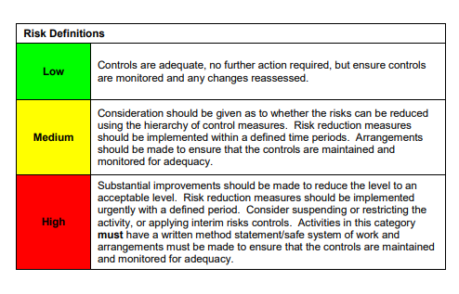

ACKNOWLEDGEMENT OF RISK ASSESSMENT Version:

PLEASE READ THE NOTICE BELOW BEFORE SIGNING THIS FORM
I acknowledge that I have read and understood the Risk Assessment/s associated with this task/event/equipment etc

Forename | Surname | Employee Signature | Date | Manager’s Signature

