

RISK ASSESSMENT FINDINGS

Department/Service
Date
Assessor
Approved By
Review Date

Relevant Legislation:

The Management of Health and Safety at Work Regulations 1999

RISK ASSESSMENT RECORD

ACTIVITY and/or ENVIRONMENT TO BE ASSESSED: Landing of MoD/Emergency Services Helicopter/Visit on School Playing field

KEY (People at risk) | Likelihood (L) | Severity (S) | Risk Calculation | Risk Rating
E = Employee YP = Young Persons  P = Public  C = Contractors  V = Visitors  EM = Expectant Mothers | 1. Very Low (rare/very unlikely)  2. Low (unlikely)  3. Medium (could occur/possible)  4. High (likely to occur/probable)  5. Very High (near certain to occur) | 1. Insignificant (nuisance/discomfort)  2. Minor (no lost time)  3. Moderate (time loss)  4. Significant (serious/incapacity to work)  5. Major (Death) | Likelihood x Severity  =  Rating | 1- 6 LOW RISK Monitor  - MEDIUM RISK Monitor, review & reduce risk where possible  14-25 HIGH RISK Further Action Required

1.Hazards Identified and potential harm it could cause | 2. People  At Risk | 3.Controls in Place | 4.Risk Rating |  |  |  | 5. Further Action Required/ Recommendations | 6.Target Date for Completion
1.Hazards Identified and potential harm it could cause | 2. People  At Risk | 3.Controls in Place | L | S | Score | Risk | 5. Further Action Required/ Recommendations | 6.Target Date for Completion

Management of aircraft in flight transit route and when stationary on ground |  | Responsibility for aircraft subject to pilot & MoD/police control & CAA. |  |  |  |  | School have notified police, Fire & Ambulance Services making them aware of time and purpose of visit. Services will be represented during day.
Management of crowd control for young persons, visitors and members of the public. Persons coming into contact with working/hot parts of machinery. Lack of crowd control resulting in violent/aggressive/  inappropriate behaviour.  Unauthorised person on site potential risks to vulnerable young people. |  | - School will maintain order of numbers/type of persons permitted to enter gate, invitation only, and locked gates prior to helicopter landing.  - Pupils will not be permitted out of the school building until the rotors have ceased turning and pilot/operatives signal to Head teacher all clear.  - Only pupils attended by staff will be permitted on the school field in small manageable parties at the discretion of the Head teacher.  - Unauthorised visitors will be ejected/refused entry on the site during visit time.  - Notification to local community has not been given to restrict the attention it may receive locally. |  |  |  |  | First aid assistance will be offered locally by nominated staff member.  Police or other emergency service intervention where required.
Debris being blown about by helicopter. |  | - Litter pick the landing site prior to helicopter’s arrival.  - Consider use of marshall to await helicopter’s arrival in sheltered site away from direction of approach of helicopter.  - Landing pad/area sufficient distance from parked cars. |  |  |  |  | Litter pickers, gloves and suitable bags to be used.  Warnings in case sharps encountered.  Staff to check all clear.
Helicopter crash. |  | - Competent pilot using properly maintained aircraft.  - E-mail from pilot/Company detailing his safe procedure for landing.  - Evacuate building as per incident procedure. Staff to call (9)999. |  |  |  |  | Windsock deployed

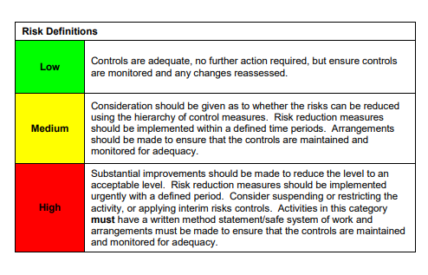

ACKNOWLEDGEMENT OF RISK ASSESSMENT Version:

PLEASE READ THE NOTICE BELOW BEFORE SIGNING THIS FORM
I acknowledge that I have read and understood the Risk Assessment/s associated with this task/event/equipment etc

Forename | Surname | Employee Signature | Date | Manager’s Signature

