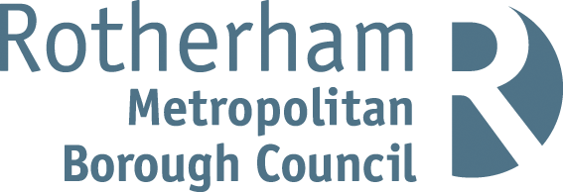

RISK ASSESSMENT FINDINGS

Department/Service
Date
Assessor
Approved By
Review Date

Relevant Legislation:

The Management of Health and Safety at Work Regulations 1999

RISK ASSESSMENT RECORD

ACTIVITY and/or ENVIRONMENT TO BE ASSESSED: Henna tattooing

KEY (People at risk) | Likelihood (L) | Severity (S) | Risk Calculation | Risk Rating
E = Employee YP = Young Persons  P = Public  C = Contractors  V = Visitors  EM = Expectant Mothers | 1. Very Low (rare/very unlikely)  2. Low (unlikely)  3. Medium (could occur/possible)  4. High (likely to occur/probable)  5. Very High (near certain to occur) | 1. Insignificant (nuisance/discomfort)  2. Minor (no lost time)  3. Moderate (time loss)  4. Significant (serious/incapacity to work)  5. Major (Death) | Likelihood x Severity  =  Rating | 1- 6 LOW RISK Monitor  - MEDIUM RISK Monitor, review & reduce risk where possible  14-25 HIGH RISK Further Action Required

1.Hazards Identified and potential harm it could cause | 2. People  At Risk | 3.Controls in Place | 4.Risk Rating |  |  |  | 5. Further Action Required/ Recommendations | 6.Target Date for Completion
1.Hazards Identified and potential harm it could cause | 2. People  At Risk | 3.Controls in Place | L | S | Score | Risk | 5. Further Action Required/ Recommendations | 6.Target Date for Completion

Reaction to products causing adverse effects. |  | - 100% henna tattooing is safe except in extreme cases eg allergic reactions. Pure 100% henna comes in orange, red, burgundy, brown and coffee colours. This can cause a condition known as ‘glucose 6 – phosphate dehydrogenase deficiency’ (G6PD) which is rare and occurs most commonly in infants.  - Black henna is rarely 100% henna and often contains a substance called para-phenylenediamine (synthetic coal tar dye). This can cause a severe skin reaction in some people with symptoms resembling burns eg redness, swelling, itching and blistering and even permanent scarring in extreme cases.  - School need to ensure a competent professional third party with their own public liability insurance is doing the henna treatments. Confirmation would be needed that products are ‘100% henna’ and the risks would need to be displayed on the stand / station where henna tattooing is being done along with restrictions eg children can only have a tattoo if parents accompany their child and consent is given etc. |  |  |  |  | Refer to Anaphylaxis management – Allergic reaction Risk Assessment  It may be necessary for henna tattooists to be registered/ licenced etc. - this question would be worth asking to the provider.
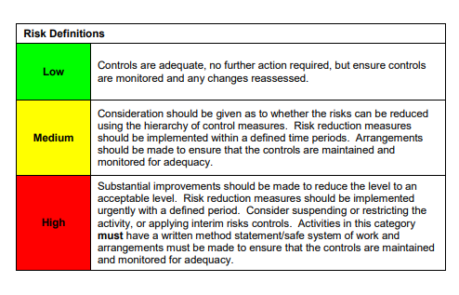

ACKNOWLEDGEMENT OF RISK ASSESSMENT Version:

PLEASE READ THE NOTICE BELOW BEFORE SIGNING THIS FORM
I acknowledge that I have read and understood the Risk Assessment/s associated with this task/event/equipment etc

Forename | Surname | Employee Signature | Date | Manager’s Signature

