

RISK ASSESSMENT FINDINGS

Department/Service
Date
Assessor
Approved By
Review Date

Relevant Legislation:

The Management of Health and Safety at Work Regulations 1999

RISK ASSESSMENT RECORD

ACTIVITY and/or ENVIRONMENT TO BE ASSESSED: Home Tuition

KEY (People at risk) | Likelihood (L) | Severity (S) | Risk Calculation | Risk Rating
E = Employee YP = Young Persons  P = Public  C = Contractors  V = Visitors  EM = Expectant Mothers | 1. Very Low (rare/very unlikely)  2. Low (unlikely)  3. Medium (could occur/possible)  4. High (likely to occur/probable)  5. Very High (near certain to occur) | 1. Insignificant (nuisance/discomfort)  2. Minor (no lost time)  3. Moderate (time loss)  4. Significant (serious/incapacity to work)  5. Major (Death) | Likelihood x Severity  =  Rating | 1- 6 LOW RISK Monitor  - MEDIUM RISK Monitor, review & reduce risk where possible  14-25 HIGH RISK Further Action Required

1.Hazards Identified and potential harm it could cause | 2. People  At Risk | 3.Controls in Place | 4.Risk Rating |  |  |  | 5. Further Action Required/ Recommendations | 6.Target Date for Completion
1.Hazards Identified and potential harm it could cause | 2. People  At Risk | 3.Controls in Place | L | S | Score | Risk | 5. Further Action Required/ Recommendations | 6.Target Date for Completion

No adult present |  | Staff not to stay if appropriate adult not present |  |  |  |  | Record visit in log  Report to SLT /manager  Letter to parent
Aggressive Pet |  | - Tetanus injection  - Hepatitis injections  - Ask for animal to be in alternate room or outside during tuition |  |  |  |  | Report to police  Letter to parent  Use of alternative premises
Aggressive Pupil |  | - Avoid confrontation  - Leave session if pupil does not calm.  - Inform SLT & complete relevant reporting forms |  |  |  |  | Report to police
Staff threatened by parent in home |  | - Staff to leave  - Report to SLT/line manager  - Seek medical advice if needed |  |  |  |  | Report to police  Use of alternative premises or adult
Staff ‘tricked’ into entering house and detained |  | - Contact school if possible  - School routine to contact staff at set times each session with agreed message to confirm safety. |  |  |  |  | Report to police
Unacceptable behaviour to/by members of family witnessed |  | - Leave premises  - Contact school/safeguarding |  |  |  |  | Report to appropriate service, e.g. police, social services
Illegal substances visible |  | - Explain situation to parent  - Leave premises  - Inform SLT/line manager |  |  |  |  | Letter to parent before next session
Theft of items from tutor |  | - Do not take valuable items or large amounts of money to tuition.  - Explain situation to parent  - Inform SLT/line manager |  |  |  |  | Report to police
Tutor involved in accident on route to/from venue |  | - Tutor to phone school on arrival and departure at each venue  - Emergency contact details for home tutor to be held in school
 |  |  |  |  |  |  | Refer to Lone Working Risk Assessment

Personal Safety Guidelines for Home Tutors

- Always have a mobile phone charged and available

- Do not give your address or home/mobile phone numbers to pupils and/or parents and do not contact them on your home or mobile phone as they can then access your personal numbers.

- Do not give your mobile phone to the young person to use for any reason

- Keep your personal items, purse/wallet, car keys, etc safe and secure

- Ensure the venue is suitable for tuition and that there is table and chairs available – visit first

- Arrange for an appropriate adult to be present if tuition is in the home or use a public building, e.g. library

- Ensure your school/service has a copy of your tuition commitments and venues

- Arrange regular contact with school/service i.e. a minimum of on arrival and departure from each session

- Give an emergency contact name and number to your school/service

- Keep a diary of each session – including brief notes of work covered, people present and any other appropriate information, e.g. issues with pupil and/or parent

- Ask for a copy of any individual pupil risk assessments for your information. Compile your own risk assessment of each venue you use.

- Report any concerns to school/service as soon as possible.

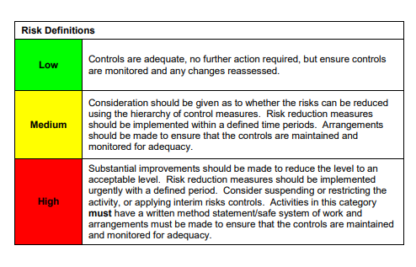

ACKNOWLEDGEMENT OF RISK ASSESSMENT Version:

PLEASE READ THE NOTICE BELOW BEFORE SIGNING THIS FORM
I acknowledge that I have read and understood the Risk Assessment/s associated with this task/event/equipment etc

Forename | Surname | Employee Signature | Date | Manager’s Signature

