

RISK ASSESSMENT FINDINGS

Department/Service
Date
Assessor
Approved By
Review Date

Relevant Legislation:

The Management of Health and Safety at Work Regulations 1999

RISK ASSESSMENT RECORD

ACTIVITY and/or ENVIRONMENT TO BE ASSESSED: Industrial Action

KEY (People at risk) | Likelihood (L) | Severity (S) | Risk Calculation | Risk Rating
E = Employee YP = Young Persons  P = Public  C = Contractors  V = Visitors  EM = Expectant Mothers | 1. Very Low (rare/very unlikely)  2. Low (unlikely)  3. Medium (could occur/possible)  4. High (likely to occur/probable)  5. Very High (near certain to occur) | 1. Insignificant (nuisance/discomfort)  2. Minor (no lost time)  3. Moderate (time loss)  4. Significant (serious/incapacity to work)  5. Major (Death) | Likelihood x Severity  =  Rating | 1- 6 LOW RISK Monitor  - MEDIUM RISK Monitor, review & reduce risk where possible  14-25 HIGH RISK Further Action Required

1.Hazards Identified and potential harm it could cause | 2. People  At Risk | 3.Controls in Place | 4.Risk Rating |  |  |  | 5. Further Action Required/ Recommendations | 6.Target Date for Completion
1.Hazards Identified and potential harm it could cause | 2. People  At Risk | 3.Controls in Place | L | S | Score | Risk | 5. Further Action Required/ Recommendations | 6.Target Date for Completion

Number of staff reduced significantly during period of industrial action affecting supervision of pupils and site/pupil security. |  | - Consider the number of staff who may be participating in industrial action and whether pupil safety and security can be maintained  - Consider closure of certain buildings/departments/areas of the school site to ensure pupils are adequately supervised and the site is safe.  - Consider the utilisation of other staff e.g. Agency cover/other staffing options.  - Consider the partial closure of school if necessary e.g. school closed to specific year groups with homework set in advance.  - Consider a shortened school day on the days of industrial action (e.g. if support staff are participating in action).  - Maintain communication with the Local Authority regarding the impact of industrial action on the School and pupils.  - Maintain communication with parents/carers regarding school opening times / closure details etc.  - Consider contingencies for catering, break time supervision, transport etc. in the event of ancillary staff action.  - If a school has to close for some or all pupils on a strike day, the Y code should be used for pupils who are not required to attend. Pupils who are required to attend should be marked down in the usual way. |  |  |  |  | Refer to Business Continuity Plan  Contact School Organisation in advance of industrial action to inform if the school will be staying open and complete the electronic notification of closure /partial closure form on the day of closure (contact Communications Manager) in advance of industrial action  Contact the HR Service Centre (hrpgenenq@rotherham.gov.uk) in advance of industrial action to inform if the school will be staying open or not

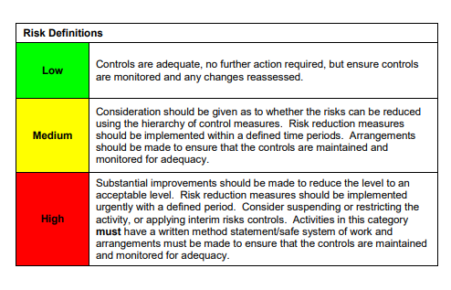

ACKNOWLEDGEMENT OF RISK ASSESSMENT Version:

PLEASE READ THE NOTICE BELOW BEFORE SIGNING THIS FORM
I acknowledge that I have read and understood the Risk Assessment/s associated with this task/event/equipment etc

Forename | Surname | Employee Signature | Date | Manager’s Signature

