

RISK ASSESSMENT FINDINGS

Department/Service
Date
Assessor
Approved By
Review Date

Relevant Legislation:

The Control of Artificial Optical Radiation at Work Regulations 2010 (AOR10);
The Management of Health and Safety at Work Regulations 1999 (MHSWR99)
The Laser Misuse (Vehicles) Act 2018

RISK ASSESSMENT RECORD

ACTIVITY and/or ENVIRONMENT TO BE ASSESSED: Laser Equipment
DATE:

KEY (People at risk) | Likelihood (L) | Severity (S) | Risk Calculation | Risk Rating
E = Employee YP = Young Persons  P = Public  C = Contractors  V = Visitors  EM = Expectant Mothers | 1. Very Low (rare/very unlikely)  2. Low (unlikely)  3. Medium (could occur/possible)  4. High (likely to occur/probable)  5. Very High (near certain to occur) | 1. Insignificant (nuisance/discomfort)  2. Minor (no lost time)  3. Moderate (time loss)  4. Significant (serious/incapacity to work)  5. Major (Death) | Likelihood x Severity  =  Rating | 1- 6 LOW RISK Monitor  - MEDIUM RISK Monitor, review & reduce risk where possible  14-25 HIGH RISK Further Action Required

1.Hazards Identified and potential harm it could cause | 2. People  At Risk | 3.Controls in Place | 4.Risk Rating |  |  |  | 5. Further Action Required/ Recommendations | 6.Target Date for Completion
1.Hazards Identified and potential harm it could cause | 2. People  At Risk | 3.Controls in Place | L | S | Score | Risk | 5. Further Action Required/ Recommendations | 6.Target Date for Completion

High Voltage |  | Any high voltage is inside power supplies, which are properly grounded and contained. Users should never open these boxes, which requires several tools to do so. Only trained engineers working under their own procedures will ever access the high voltage
Noise |  | The laser control boxes, and power supplies make some noise – it is well within safe working conditions, but it is constant and noticeable.
Trailing Cables |  | Cables trail from cooling system which is kept in the annex to laser system. Trip mats are placed over all trailing cables/pipes, cables are also located from regular pathways around the laboratory.
Open beams |  | There will be times when the beams after the laser box are open for alignment – this will be often as the wavelengths used change. PPE is supplied and all users are thoroughly trained. A laser Standard Operating Practice is in place (SOP), which details the procedures to follow when open beams are present.
Objects in beam |  | The only objects that should ever be in the beam are the sample, which is open during alignment but contained during measurement, and beam blocks which are designed to absorb the beam and thus present minimal hazard. All controls that applied to open beams apply here too.
Beam alignment/ variable beam path |  | The beam path is designed so that variation is kept to a minimum – this usually means minor adjustments on mirrors when wavelengths change. There are occasions when a beam will be direct from one beam path to another by way of swapping mirrors on magnetic bases. In these cases, SOPs exist to minimise risk, and after the initial change, again, beam alignment is minimal.
Scatter from target |  | Laser alignment is, wherever possible, achieved using a low scattering proxy target (for instance, a fluorescent dye which transmits or absorbs >90% of the beam, but fluoresces at safe power levels for visual alignment. Alternatively, alignment is achieved by redirecting the beam through an anodized pin hole or other target proxy, with only final fine adjustments taking place on the target itself. Highly scattering targets themselves are very rarely used as this would usually negate the efficacy of the experiment, which requires well transmitted light to observe.
Manual handling of target |  | SOPs outline that lasers should not be open when inserting and removing samples from the target area. Once alignment has been achieved, the target is kept enclosed along with the rest of the beam line
Damage to safety equipment |  | Regular checks of the relevant safety equipment
Fire |  | No incendiary materials will be placed in the beam paths. In the event of a fire, usual building evacuation will be followed.
Eye injury |  | In the event of an eye injury call 999 and inform emergency contact.

Further advice can be sought from CLEAPPS
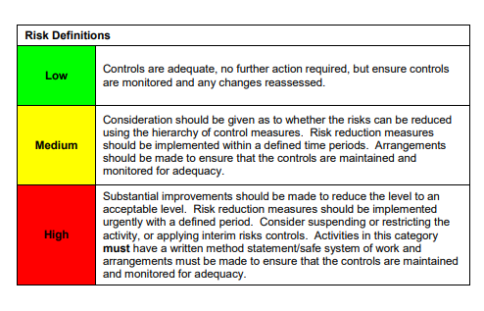

ACKNOWLEDGEMENT OF RISK ASSESSMENT Version:

PLEASE READ THE NOTICE BELOW BEFORE SIGNING THIS FORM
I acknowledge that I have read and understood the Risk Assessment/s associated with this task/event/equipment etc

Forename | Surname | Employee Signature | Date | Manager’s Signature

