

RISK ASSESSMENT FINDINGS

Department/Service
Date
Assessor
Approved By
Review Date

Relevant Legislation:

The Management of Health and Safety at Work Regulations 1999

RISK ASSESSMENT RECORD

ACTIVITY and/or ENVIRONMENT TO BE ASSESSED: Lone Working
DATE:

KEY (People at risk) | Likelihood (L) | Severity (S) | Risk Calculation | Risk Rating
E = Employee YP = Young Persons  P = Public  C = Contractors  V = Visitors  EM = Expectant Mothers | 1. Very Low (rare/very unlikely)  2. Low (unlikely)  3. Medium (could occur/possible)  4. High (likely to occur/probable)  5. Very High (near certain to occur) | 1. Insignificant (nuisance/discomfort)  2. Minor (no lost time)  3. Moderate (time loss)  4. Significant (serious/incapacity to work)  5. Major (Death) | Likelihood x Severity  =  Rating | 1- 6 LOW RISK Monitor  - MEDIUM RISK Monitor, review & reduce risk where possible  14-25 HIGH RISK Further Action Required

1.Hazards Identified and potential harm it could cause | 2. People  At Risk | 3.Controls in Place | 4.Risk Rating |  |  |  | 5. Further Action Required/ Recommendations | 6.Target Date for Completion
1.Hazards Identified and potential harm it could cause | 2. People  At Risk | 3.Controls in Place | L | S | Score | Risk | 5. Further Action Required/ Recommendations | 6.Target Date for Completion

Injury through accident / illness. |  | - Lone working should be avoided where possible.  - High-risk activities will not be undertaken while lone working (working at height, working with electricity, meeting with members of the public.)  - Reception, or a “buddy”, will be made aware if lone working does have to take place in any part of the school.  - A written lone working procedure is in place, which details the check in system and communication system for lone working.  - Staff who are pregnant, or who have certain underlying health conditions identified in individual risk assessments, are to avoid lone working.  - Notify head teacher / manager of intention to work outside regular hours.  - Do not allow access to unknown callers.  - External lighting adequate  - Reduce time spent working alone so far as is reasonably practicable.  - Mobile phone to be carried at all times/office lines available at all times |  |  |  |  | Look at the feasibility of using a lone working app
Lone working with pupils. |  | - Lone working (1 on 1) with pupils should be avoided where possible. Where not possible, school procedure for lone working will be followed.  - Searches must be carried out by a member of staff of the same sex as the student and must be witnessed by another member of staff.  - Administering of medicines must be witnessed by another member of staff.
Injury through violence. |  | - Where meetings with upset or angry parents must take place, another member of staff will be present.  - Staff will avoid undertaking home visits to deal with upset of angry parents.  - The school’s policy on home visits includes the process for monitoring staff safety. This includes:  • Managers/buddies being aware of schedule.  • Regular check-ins  • Use of a lone working app  - Staff will avoid leaving the premises on their own if they are concerned about their welfare.  - Sufficient lighting is provided in car parking areas.  - Staff will avoid lingering in the carpark/pickup area on their own, especially during winter months where there is limited daylight.
Driving |  | - Drive at appropriate speed for the road conditions.  - Drive in accordance with the Highways law  - Driver to undertake Certificate of Professional Competence (CPC training)
Lone worker subject to medical condition that may increase risk when working alone. |  | - HR and health and safety to respond to specific concerns.  - Individual is not to work alone if it places them at an increased risk.  - Any person who requires assistance out of a building in an emergency must not work alone.  - Ensure risks are discussed with Line managers/HR/H&S and if necessary, Occupational health and GP.
Manual Handling |  | - Not to lift anything that is outside of their capability.  - Do not lift any load that is too heavy  - Manual handling training given to staff

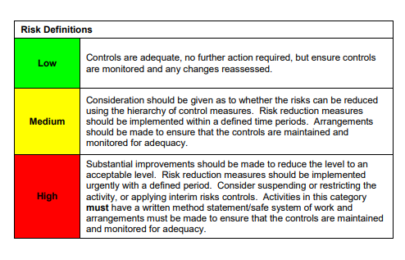

ACKNOWLEDGEMENT OF RISK ASSESSMENT Version:

PLEASE READ THE NOTICE BELOW BEFORE SIGNING THIS FORM
I acknowledge that I have read and understood the Risk Assessment/s associated with this task/event/equipment etc

Forename | Surname | Employee Signature | Date | Manager’s Signature

