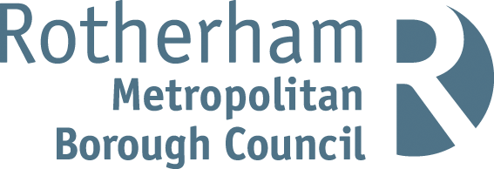

RISK ASSESSMENT FINDINGS

Department/Service
Date
Assessor
Approved By
Review Date

Relevant Legislation:

The Management of Health and Safety at Work Regulations 1999

RISK ASSESSMENT RECORD

ACTIVITY and/or ENVIRONMENT TO BE ASSESSED: Manual Handling of Loads
DATE:

KEY (People at risk) | Likelihood (L) | Severity (S) | Risk Calculation | Risk Rating
E = Employee YP = Young Persons  P = Public  C = Contractors  V = Visitors  EM = Expectant Mothers | 1. Very Low (rare/very unlikely)  2. Low (unlikely)  3. Medium (could occur/possible)  4. High (likely to occur/probable)  5. Very High (near certain to occur) | 1. Insignificant (nuisance/discomfort)  2. Minor (no lost time)  3. Moderate (time loss)  4. Significant (serious/incapacity to work)  5. Major (Death) | Likelihood x Severity  =  Rating | 1- 6 LOW RISK Monitor  - MEDIUM RISK Monitor, review & reduce risk where possible  14-25 HIGH RISK Further Action Required

1.Hazards Identified and potential harm it could cause | 2. People  At Risk | 3.Controls in Place | 4.Risk Rating |  |  |  | 5. Further Action Required/ Recommendations | 6.Target Date for Completion
1.Hazards Identified and potential harm it could cause | 2. People  At Risk | 3.Controls in Place | L | S | Score | Risk | 5. Further Action Required/ Recommendations | 6.Target Date for Completion

Injury caused by the task – holding loads away from the body, twisting, stooping, overstretching,  Long carrying distance, strenuous pushing / pulling, fatigue, slips, trips falls. |  | - Lifting aids, trolleys / other equipment used  - Maintenance of handling equipment  - Adequate housekeeping arrangements to minimise slip, trip, fall hazards.  - Are staff appropriately trained to move and handle large, heavy, awkward loads (e.g. a caretaker maybe but a teacher isn’t).  - Safe stacking/storage of articles  - Rest periods during heavy/ prolonged manual handling tasks  - Is it possible to lighten some loads  - Team handling to reduce the strain on individuals  - Provision of personal protective equipment e.g. gloves when required  - Route clear of obstacles |  |  |  |  | Training requirements –  Equipment needed –
Injury caused by the load-  Heavy, bulky, unstable, difficult to hold or grasp, harmful e.g. sharp, hot, awkwardly stacked, too large to handle. |  | - Is it possible to make the load more stable  - Lifting aids, trolleys / other equipment used  - Is it possible to lighten some loads  - Team handling to reduce the strain on individuals  - Safe stacking/storage of articles |  |  |  |  | Training requirements –  Equipment needed –
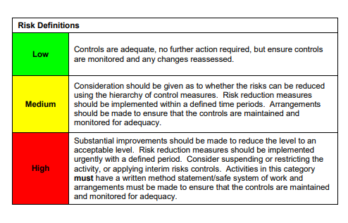

ACKNOWLEDGEMENT OF RISK ASSESSMENT Version:

PLEASE READ THE NOTICE BELOW BEFORE SIGNING THIS FORM
I acknowledge that I have read and understood the Risk Assessment/s associated with this task/event/equipment etc

Forename | Surname | Employee Signature | Date | Manager’s Signature

