

RISK ASSESSMENT FINDINGS

Department/Service
Date
Assessor
Approved By
Review Date

Relevant Legislation:

The Management of Health and Safety at Work Regulations 1999

RISK ASSESSMENT RECORD

ACTIVITY and/or ENVIRONMENT TO BE ASSESSED: Oxygen therapy and suction equipment in school
DATE:

KEY (People at risk) | Likelihood (L) | Severity (S) | Risk Calculation | Risk Rating
E = Employee YP = Young Persons  P = Public  C = Contractors  V = Visitors  EM = Expectant Mothers | 1. Very Low (rare/very unlikely)  2. Low (unlikely)  3. Medium (could occur/possible)  4. High (likely to occur/probable)  5. Very High (near certain to occur) | 1. Insignificant (nuisance/discomfort)  2. Minor (no lost time)  3. Moderate (time loss)  4. Significant (serious/incapacity to work)  5. Major (Death) | Likelihood x Severity  =  Rating | 1- 6 LOW RISK Monitor  - MEDIUM RISK Monitor, review & reduce risk where possible  14-25 HIGH RISK Further Action Required

1.Hazards Identified and potential harm it could cause | 2. People  At Risk | 3.Controls in Place | 4.Risk Rating |  |  |  | 5. Further Action Required/ Recommendations | 6.Target Date for Completion
1.Hazards Identified and potential harm it could cause | 2. People  At Risk | 3.Controls in Place | L | S | Score | Risk | 5. Further Action Required/ Recommendations | 6.Target Date for Completion

Manual handling injury lifting / carrying equipment. |  | - Ensure staff are adequately trained in manual handling.  - Ensure appropriate equipment is provided and used.
Incorrect use of equipment causing harm or injury |  | - Ensure responsible appointed staff are appropriately trained, supervised, instructed and provided with adequate information to enable them to conduct oxygen supervision procedures competently.  - Ensure care plan is drafted and regularly reviewed |  |  |  |  | Training provided by:  Date of training:  Date of review / re training etc.:
Safe storage, use, handling and transport on site. |  | - Ensure spare cylinders etc. are stored appropriately and secure e.g. locked container / adequate ventilation etc.  - Ensure staff are adequately trained in first aid etc.  - Ensure Building manager is informed (fire safety).  - Ensure the positioning of equipment does not cause a trip hazard e.g. in classroom etc.
Staff anxiety using equipment. |  | Ensure training and competence is kept up to date.
Transport of pupil from home – school – home. |  | Transport plan should be completed to ensure safe transport of pupil and equipment.
Evacuation of pupil in an emergency |  | Ensure that a Personal Emergency Evacuation Plan (PEEP) is completed and kept up to date for the pupil.
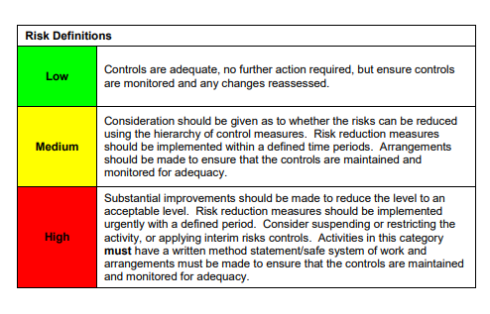

ACKNOWLEDGEMENT OF RISK ASSESSMENT Version:

PLEASE READ THE NOTICE BELOW BEFORE SIGNING THIS FORM
I acknowledge that I have read and understood the Risk Assessment/s associated with this task/event/equipment etc

Forename | Surname | Employee Signature | Date | Manager’s Signature

