

RISK ASSESSMENT FINDINGS

Department/Service
Date
Assessor
Approved By
Review Date

Relevant Legislation:

RISK ASSESSMENT RECORD

ACTIVITY and/or ENVIRONMENT TO BE ASSESSED: P.E. Lessons
DATE:

KEY (People at risk) | Likelihood (L) | Severity (S) | Risk Calculation | Risk Rating
E = Employee YP = Young Persons  P = Public  C = Contractors  V = Visitors  EM = Expectant Mothers | 1. Very Low (rare/very unlikely)  2. Low (unlikely)  3. Medium (could occur/possible)  4. High (likely to occur/probable)  5. Very High (near certain to occur) | 1. Insignificant (nuisance/discomfort)  2. Minor (no lost time)  3. Moderate (time loss)  4. Significant (serious/incapacity to work)  5. Major (Death) | Likelihood x Severity  =  Rating | 1- 6 LOW RISK Monitor  - MEDIUM RISK Monitor, review & reduce risk where possible  14-25 HIGH RISK Further Action Required

1.Hazards Identified and potential harm it could cause | 2. People  At Risk | 3.Controls in Place | 4.Risk Rating |  |  |  | 5. Further Action Required/ Recommendations | 6.Target Date for Completion
1.Hazards Identified and potential harm it could cause | 2. People  At Risk | 3.Controls in Place | L | S | Score | Risk | 5. Further Action Required/ Recommendations | 6.Target Date for Completion

Accident / injury occurring during lesson |  | - Competent staff to teach subject.  - Adequate briefing of pupils.  - Use of official and approved practices and equipment e.g. sport’s governing body rules applied.  - Refer to AFPE guidance where appropriate.  - Rules and guidelines for pupil safety and behaviour set by sports leading authority are adhered to.  - Regular reviews of practice.  - Hazard free playing surfaces. (See playing fields risk assessment).  - Sufficient space allocated for activity.  - Inspection and maintenance regime for equipment.  - Equipment used appropriately.  - Attendance and assessment records.  - Reporting of accidents / incidents / near misses and follow up investigation where necessary.  - Communication with parent / guardian where appropriate.  - Safe storage of equipment.  - Visual equipment checks prior to use.  - Apparatus used and assembled in line with manufactures guidelines.  - Where appropriate P.E. equipment to be subject to annual formal inspection e.g. gym equipment where recommended by manufacturers / recommended under PUWER or other legislation or guidance.  - Tasks matched to pupil capability.  - Appropriate levels of supervision.  - Appropriate dress code for PE.  - Earrings / necklaces etc. not to be worn for PE / Sport due to the risk of entanglement / pulling etc. in many activities / sports. NB should parents insist on pupils leaving earrings / nose piercings in then this will impact on what activities the pupil can safely participate in.  - The wearing of piercings etc. should also be addressed in the schools uniform and appearance policy to establish what is acceptable.  - Emergency first aid procedures.  - Are pupils instructed not to chew sweets or gum?
Medical Conditions |  | - Refer to Asthma/Diabetes Risk Assessment  - Awareness of condition and appropriate/hazardous activities  (tasks matched to pupil capability).
Area to be used for P.E. |  | - Are procedures in place for regular inspections of the area?  - Are adequate reporting procedures in place when defects have been identified?  - Is there adequate ventilation?  - Are lighting levels adequate?  - Are the lighting units adequately guarded for the activities undertaken?  - Is the area free from clutter and obstructions?  - Is the floor surface in good condition (no trip hazards)?  - Are the floors of a non-slip type, treated properly, cleaned regularly and free from dust?  - Is safety glazing provided in all areas used for ball games?
Welfare Facilities |  | - Are there adequate changing, washing and shower facilities?
Legionella |  | - Does the local Works Authority undertake routine maintenance to avoid the risk of exposure to Legionella from the showers? (i.e. temperature checks, flushing of the system and cleaning of the shower heads)?  - Are records retained by the Works Authority relating to these arrangements?
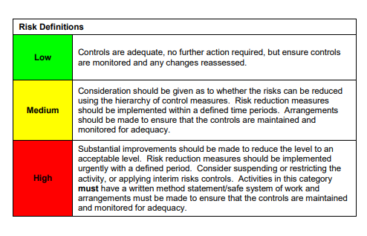

ACKNOWLEDGEMENT OF RISK ASSESSMENT Version:

PLEASE READ THE NOTICE BELOW BEFORE SIGNING THIS FORM
I acknowledge that I have read and understood the Risk Assessment/s associated with this task/event/equipment etc

Forename | Surname | Employee Signature | Date | Manager’s Signature

