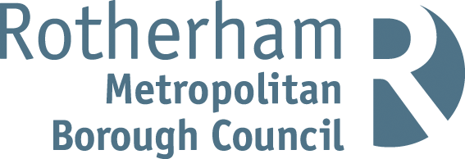

RISK ASSESSMENT FINDINGS

Department/Service
Date
Assessor
Approved By
Review Date

Relevant Legislation:

The Management of Health and Safety at Work Regulations 1999

RISK ASSESSMENT RECORD

ACTIVITY and/or ENVIRONMENT TO BE ASSESSED: Painting and Decorating – Vocational education
DATE:

KEY (People at risk) | Likelihood (L) | Severity (S) | Risk Calculation | Risk Rating
E = Employee YP = Young Persons  P = Public  C = Contractors  V = Visitors  EM = Expectant Mothers | 1. Very Low (rare/very unlikely)  2. Low (unlikely)  3. Medium (could occur/possible)  4. High (likely to occur/probable)  5. Very High (near certain to occur) | 1. Insignificant (nuisance/discomfort)  2. Minor (no lost time)  3. Moderate (time loss)  4. Significant (serious/incapacity to work)  5. Major (Death) | Likelihood x Severity  =  Rating | 1- 6 LOW RISK Monitor  - MEDIUM RISK Monitor, review & reduce risk where possible  14-25 HIGH RISK Further Action Required

1.Hazards Identified and potential harm it could cause | 2. People  At Risk | 3.Controls in Place | 4.Risk Rating |  |  |  | 5. Further Action Required/ Recommendations | 6.Target Date for Completion
1.Hazards Identified and potential harm it could cause | 2. People  At Risk | 3.Controls in Place | L | S | Score | Risk | 5. Further Action Required/ Recommendations | 6.Target Date for Completion

Working at Height |  | See generic working at height risk assessment
Manual Handling |  | See generic manual handling risk assessment
Sanding down woodwork etc. before painting |  | - All staff to wear respiratory protection when sanding down old painted surfaces, woodwork, metal work etc.  - All dusts to be dampened down before sweeping up.
Moving about in general |  | - Floor surfaces to be kept in a good clean condition.  - Spilled paint and liquids will be cleaned up immediately.  - Work areas to be cordoned off to prevent access by other people.
Use of flammable materials such as paint thinners etc. |  | - Flammable liquids to be kept to a minimum on site and kept locked in a flameproof cabinet when not in use.  - Naked flames (e.g. from blow lamps etc.) to be kept away from the area where flammable liquids are being used/stored.  - Staff to be made aware of fire prevention methods associated with their work.  - All rags and cleaning cloths used with flammable liquids to be placed in a flameproof, lidded container after use.  - Containers to be kept away from naked flames.  - All such rags and cleaning cloths etc. to be disposed of properly.
Using paints and varnishes etc. |  | - Where possible, paints and varnishes etc. of a non-hazardous type to be used.  - Staff to be instructed to read the safety label on all paint and varnish etc. containers before use.  - Where a substance is identified as hazardous, COSHH assessment to be carried out and specific control measures introduced.  - Staff / pupils to wear the relevant personal protective equipment when carrying out painting tasks, including coveralls, gloves, eyeshields etc.  - All splashes on the skin to be treated immediately.
Use of cutting tools during wallpapering |  | - Staff to use decorator’s scissors for cutting wallpaper.  - The use of knives by pupils to be prohibited/closely supervised.
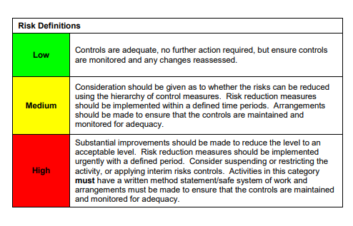

ACKNOWLEDGEMENT OF RISK ASSESSMENT Version:

PLEASE READ THE NOTICE BELOW BEFORE SIGNING THIS FORM
I acknowledge that I have read and understood the Risk Assessment/s associated with this task/event/equipment etc

Forename | Surname | Employee Signature | Date | Manager’s Signature

