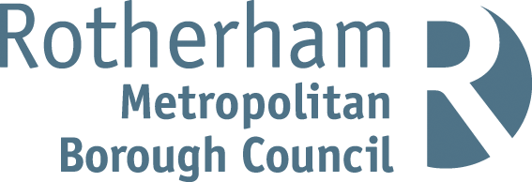

RISK ASSESSMENT FINDINGS

Department/Service
Date
Assessor
Approved By
Review Date

Relevant Legislation:

The Management of Health and Safety at Work Regulations 1999

RISK ASSESSMENT RECORD

ACTIVITY and/or ENVIRONMENT TO BE ASSESSED: Plastering - Vocational training
DATE:

KEY (People at risk) | Likelihood (L) | Severity (S) | Risk Calculation | Risk Rating
E = Employee YP = Young Persons  P = Public  C = Contractors  V = Visitors  EM = Expectant Mothers | 1. Very Low (rare/very unlikely)  2. Low (unlikely)  3. Medium (could occur/possible)  4. High (likely to occur/probable)  5. Very High (near certain to occur) | 1. Insignificant (nuisance/discomfort)  2. Minor (no lost time)  3. Moderate (time loss)  4. Significant (serious/incapacity to work)  5. Major (Death) | Likelihood x Severity  =  Rating | 1- 6 LOW RISK Monitor  - MEDIUM RISK Monitor, review & reduce risk where possible  14-25 HIGH RISK Further Action Required

1.Hazards Identified and potential harm it could cause | 2. People  At Risk | 3.Controls in Place | 4.Risk Rating |  |  |  | 5. Further Action Required/ Recommendations | 6.Target Date for Completion
1.Hazards Identified and potential harm it could cause | 2. People  At Risk | 3.Controls in Place | L | S | Score | Risk | 5. Further Action Required/ Recommendations | 6.Target Date for Completion

Working at height |  | Refer to working at height risk assessment
Manual handling |  | Refer to manual handling risk assessment
Hazardous substances |  | Refer to COSHH risk assessments for individual hazardous substances
Slips and trips |  | Refer to preventing slips and trips risk assessment
Accident / incident |  | Ensure adequate first aid arrangements are in place including qualified first aid at work staff.
Fire |  | Refer to fire safety risk assessment
Dry plaster mix |  | - Pupils briefed on the risks of dry plaster powder and know to avoid skin contact, excessive dust build-up and contact with eyes.  - Work area suitable to prevent excessive dust build-up.  - Water supply nearby to wash dust off skin.  - Pupils to wear eye protection when plastering.  - Gloves and barrier creams available. |  |  |  |  | Adequate supervision of pupils
Electricity |  | - Supervisor to turn of power while plastering work ongoing if required.  - Use of 110 v supply and RCDs where necessary.  - Regular documented checks of equipment and PAT testing.  - Procedure in place for defective equipment. |  |  |  |  | Adequate supervision of pupils
Hygiene |  | Adequate washing facilities on site.
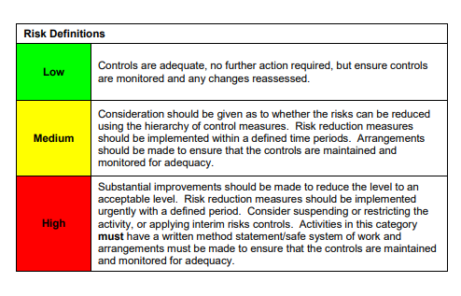

ACKNOWLEDGEMENT OF RISK ASSESSMENT Version:

PLEASE READ THE NOTICE BELOW BEFORE SIGNING THIS FORM
I acknowledge that I have read and understood the Risk Assessment/s associated with this task/event/equipment etc

Forename | Surname | Employee Signature | Date | Manager’s Signature

