

RISK ASSESSMENT FINDINGS

Department/Service
Date
Assessor
Approved By
Review Date

Relevant Legislation:

The Management of Health and Safety at Work Regulations 1999

RISK ASSESSMENT RECORD

ACTIVITY and/or ENVIRONMENT TO BE ASSESSED: Playing fields and playground
DATE:

KEY (People at risk) | Likelihood (L) | Severity (S) | Risk Calculation | Risk Rating
E = Employee YP = Young Persons  P = Public  C = Contractors  V = Visitors  EM = Expectant Mothers | 1. Very Low (rare/very unlikely)  2. Low (unlikely)  3. Medium (could occur/possible)  4. High (likely to occur/probable)  5. Very High (near certain to occur) | 1. Insignificant (nuisance/discomfort)  2. Minor (no lost time)  3. Moderate (time loss)  4. Significant (serious/incapacity to work)  5. Major (Death) | Likelihood x Severity  =  Rating | 1- 6 LOW RISK Monitor  - MEDIUM RISK Monitor, review & reduce risk where possible  14-25 HIGH RISK Further Action Required

1.Hazards Identified and potential harm it could cause | 2. People  At Risk | 3.Controls in Place | 4.Risk Rating |  |  |  | 5. Further Action Required/ Recommendations | 6.Target Date for Completion
1.Hazards Identified and potential harm it could cause | 2. People  At Risk | 3.Controls in Place | L | S | Score | Risk | 5. Further Action Required/ Recommendations | 6.Target Date for Completion

Litter/glass etc. causing injury |  | - Regular inspection of area  - Litter picking carried out as required
Discarded syringes etc. |  | - Regular inspection of area  - Safe litter picking procedures involving use of personal protective equipment and clothing  - Safe disposal of collected materials
Dog faeces causing infection / toxocariasis |  | - Prohibit dog walking on site so far as is reasonably practicable  - Signage prohibiting dog walking on site  - Safe clearing procedures involving use of personal protective clothing and equipment  - Safe disposal of collected waste
Poisonous / thorny plants  Skin irritation, scratches etc. |  | - Consideration of pupil safety when selecting plants with reference to position of planting and age of pupils on site etc.  - Regular inspection of areas for unsuitable plants and weeds  - Grounds maintenance procedures including safe  disposal where necessary
Hard surfaces – injury through falling |  | - Consideration of surface type with respect to age of pupils and usage  - Suitable play surfaces installed around play equipment in accordance with British Standards  - Adequate supervision of pupils
Defective ground surfaces e.g. potholes causing trips and injury |  | - Regular inspection of area  - Reporting procedure for defects  - Screening off of defective areas  - Prompt remedial action
Trespassers causing vandalism, assault, harassment etc. |  | - Signage regarding trespass  - Well maintained fencing  - Gates kept closed locked with appropriate signage  - Adequate supervision when pupils are at play
Defective playground equipment and fixed apparatus causing injury |  | - Regular inspection of playground equipment  - Maintenance of equipment  - Appropriate levels of security to prevent vandalism of equipment  - Appropriate supervision of pupils and ensure equipment is appropriate for the age of pupils |  |  |  |  | Caretakers monthly report to Head Teacher to include playground and fixed apparatus  To set up an annual inspection and maintenance regime with an approved  company of fixed apparatus
Inclement weather conditions |  | - Restricted / prohibited access to apparatus during periods of inclement weather e.g. snow / ice / Strong winds etc.
Out of Bounds Areas |  | - The Head will decide on the day whether play is suitable.  - Adequate supervision provided.  - Pupils informed of area that is out of bounds.  - Staff appropriately positioned to deter pupils.
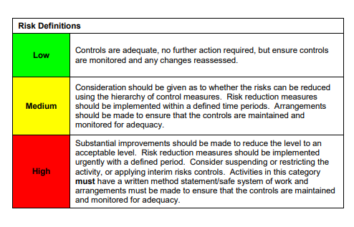

ACKNOWLEDGEMENT OF RISK ASSESSMENT Version:

PLEASE READ THE NOTICE BELOW BEFORE SIGNING THIS FORM
I acknowledge that I have read and understood the Risk Assessment/s associated with this task/event/equipment etc

Forename | Surname | Employee Signature | Date | Manager’s Signature

