

RISK ASSESSMENT FINDINGS

Department/Service
Date
Assessor
Approved By
Review Date

Relevant Legislation:

The Management of Health and Safety at Work Regulations 1999

RISK ASSESSMENT RECORD

ACTIVITY and/or ENVIRONMENT TO BE ASSESSED: Pond on Site
DATE:

KEY (People at risk) | Likelihood (L) | Severity (S) | Risk Calculation | Risk Rating
E = Employee YP = Young Persons  P = Public  C = Contractors  V = Visitors  EM = Expectant Mothers | 1. Very Low (rare/very unlikely)  2. Low (unlikely)  3. Medium (could occur/possible)  4. High (likely to occur/probable)  5. Very High (near certain to occur) | 1. Insignificant (nuisance/discomfort)  2. Minor (no lost time)  3. Moderate (time loss)  4. Significant (serious/incapacity to work)  5. Major (Death) | Likelihood x Severity  =  Rating | 1- 6 LOW RISK Monitor  - MEDIUM RISK Monitor, review & reduce risk where possible  14-25 HIGH RISK Further Action Required

1.Hazards Identified and potential harm it could cause | 2. People  At Risk | 3.Controls in Place | 4.Risk Rating |  |  |  | 5. Further Action Required/ Recommendations | 6.Target Date for Completion
1.Hazards Identified and potential harm it could cause | 2. People  At Risk | 3.Controls in Place | L | S | Score | Risk | 5. Further Action Required/ Recommendations | 6.Target Date for Completion

Poorly designed or slippery edges, falling in, unauthorised access, drowning. |  | - Edges of the pond should be shallow  - Pond should be visible from the school building  - Trees and shrubs in the immediate area and in the line of sight from school building should not obscure observation of the pond area.  - Pond should be located away from regular paths and pitches  - Depth should be limited to 1m at its deepest point  - The area surrounding the pond should be flat or gently sloping, all potholes and potential trip hazards should be eliminated  - Bank side should be protected from erosion  - Edges of the pond should be clearly visible e.g. paved/ edged to ensure pupils/ children are safe at the water’s edge  - Where the pond has a ‘soft edge’ for the development of wildlife it should not be accessible to pupils  - Schools must have fencing and gates to restrict unauthorised access (minimum 1.10m height with a lockable gate).  - If the school is used in the evenings – illumination of the pond area is required e.g. solar lighting.  - Adequate information, instruction, training and supervision for pupils prior to use.  - Pond regularly maintained to ensure that the perimeter does not become obscured and that the area around the pond does not deteriorate. |  |  |  |  | Install appropriate signage e.g.:  ‘DANGER DEEP WATER’  ‘RULES’ such as:  Keep gate locked when not in use  Key returned to –  Behaviour rules  Maximum number of pupils to staff ratio  Emergency procedure and first aid
Pond dipping – injury caused by nets, falls, cuts and abrasions etc. |  | - Equipment I regularly inspected and well maintained. Damaged equipment is repaired or disposed of.  - Instruction to children regarding use and expected behaviour.  - Areas maintained with minimal overgrowth to ensure good visibility for leaders to supervise and monitor whole area.  - Avoid use of glass containers or equipment, to minimise the risk of breakages and lacerations.  - Young people dipping are spaced well apart  - Appropriate clothing for conditions (including hats and sun cream where necessary)
Risk of disease e.g. Weils disease |  | - Thorough hygiene (e.g. no hand-mouth contact) during use and thorough hand washing after using the pond  - Adequate provision for hand washing readily available.  - Provide paper towels rather than communal hand towels.  - Do not allow children to touch any part of their face or handle any foodstuff with their hands before hands are washed.  - For younger pupils, handwashing should be supervised.  - Cuts / abrasions covered with waterproof plaster prior to any activity around water sources.  - No eating in the pond area.  - Prevent access to the area by cats/dogs, check always made of the area to remove (hygienically) any faeces before children enter the area.  - Algal scum should be removed regularly, avoiding skin contact.  - Pupils should be supervised carefully so that they have no opportunity to eat any parts of the plants growing in or around the pond.  - Pupils are instructed of the hazards associated with any toxic/poisonous plant life.  - Areas are regularly checked for any particularly hazardous plants such as giant hogweed.
Electric shock from water pumping / filtering systems |  | Where an electric pump is required this must be installed and regularly inspected by a competent electrician (consider if it is feasible to fit a solar unit).

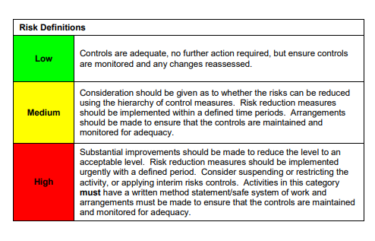

ACKNOWLEDGEMENT OF RISK ASSESSMENT Version:

PLEASE READ THE NOTICE BELOW BEFORE SIGNING THIS FORM
I acknowledge that I have read and understood the Risk Assessment/s associated with this task/event/equipment etc

Forename | Surname | Employee Signature | Date | Manager’s Signature

