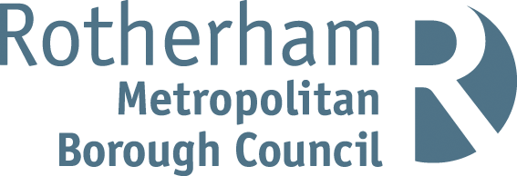

RISK ASSESSMENT FINDINGS

Department/Service
Date
Assessor
Approved By
Review Date

Relevant Legislation:

RISK ASSESSMENT RECORD

ACTIVITY and/or ENVIRONMENT TO BE ASSESSED: Pony Rides
DATE:

KEY (People at risk) | Likelihood (L) | Severity (S) | Risk Calculation | Risk Rating
E = Employee YP = Young Persons  P = Public  C = Contractors  V = Visitors  EM = Expectant Mothers | 1. Very Low (rare/very unlikely)  2. Low (unlikely)  3. Medium (could occur/possible)  4. High (likely to occur/probable)  5. Very High (near certain to occur) | 1. Insignificant (nuisance/discomfort)  2. Minor (no lost time)  3. Moderate (time loss)  4. Significant (serious/incapacity to work)  5. Major (Death) | Likelihood x Severity  =  Rating | 1- 6 LOW RISK Monitor  - MEDIUM RISK Monitor, review & reduce risk where possible  14-25 HIGH RISK Further Action Required

1.Hazards Identified and potential harm it could cause | 2. People  At Risk | 3.Controls in Place | 4.Risk Rating |  |  |  | 5. Further Action Required/ Recommendations | 6.Target Date for Completion
1.Hazards Identified and potential harm it could cause | 2. People  At Risk | 3.Controls in Place | L | S | Score | Risk | 5. Further Action Required/ Recommendations | 6.Target Date for Completion

Appropriate provider |  | - Check appropriate insurance in place  - Check if helmets provided  - Pre arrange route  - Check if appropriate clothing recommended |  |  |  |  | Insurance seen and copied  Helmets provided  Route planned  Appropriate footwear suggested
Fall / slip off pony |  | - Ride closely supervised by owner at all times  - Appropriate footwear worn  - Ensure appropriate helmets worn by all participants  - Select route carefully with facility provider  - Brief participants with safety instructions  - Ensure adequate first aid arrangements are in place |  |  |  |  | Route selected prior to activity
Pony gets out of control |  | - Pony supervised by owner at all times  - Queues supervised in appropriate area well away from ride area, hence keeping distractions at a minimum – people kept away at all times if not riding  - First aid on site
Pony kicks / bites |  | - Pony supervised by owner at all times  - Queues supervised in appropriate area well away from ride area, hence keeping distractions at a minimum – people kept away at all times if not riding  - First aid on site
Spread of infectious disease |  | - Pony supervised by owner at all times  - Brief participants with safety instructions  - Any manure cleared immediately – AR  - Hand washing advice given - anti-bacterial gel provided for all children after ride |  |  |  |  | Anti-bacterial gel purchased

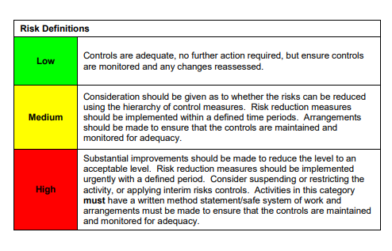

ACKNOWLEDGEMENT OF RISK ASSESSMENT Version:

PLEASE READ THE NOTICE BELOW BEFORE SIGNING THIS FORM
I acknowledge that I have read and understood the Risk Assessment/s associated with this task/event/equipment etc

Forename | Surname | Employee Signature | Date | Manager’s Signature

