

RISK ASSESSMENT FINDINGS

Department/Service
Date
Assessor
Approved By
Review Date

Relevant Legislation:

The Management of Health and Safety at Work Regulations 1999

RISK ASSESSMENT RECORD

ACTIVITY and/or ENVIRONMENT TO BE ASSESSED: Portable Heaters
DATE:

KEY (People at risk) | Likelihood (L) | Severity (S) | Risk Calculation | Risk Rating
E = Employee YP = Young Persons  P = Public  C = Contractors  V = Visitors  EM = Expectant Mothers | 1. Very Low (rare/very unlikely)  2. Low (unlikely)  3. Medium (could occur/possible)  4. High (likely to occur/probable)  5. Very High (near certain to occur) | 1. Insignificant (nuisance/discomfort)  2. Minor (no lost time)  3. Moderate (time loss)  4. Significant (serious/incapacity to work)  5. Major (Death) | Likelihood x Severity  =  Rating | 1- 6 LOW RISK Monitor  - MEDIUM RISK Monitor, review & reduce risk where possible  14-25 HIGH RISK Further Action Required

1.Hazards Identified and potential harm it could cause | 2. People  At Risk | 3.Controls in Place | 4.Risk Rating |  |  |  | 5. Further Action Required/ Recommendations | 6.Target Date for Completion
1.Hazards Identified and potential harm it could cause | 2. People  At Risk | 3.Controls in Place | L | S | Score | Risk | 5. Further Action Required/ Recommendations | 6.Target Date for Completion

Risk of Injury |  | - Adequate supervision of pupils  - Immediate safe storage after use  Portable appliance testing (PAT)  - Regular visual inspection  - Portable heaters should be maintained regularly in accordance with the manufacturer’s instructions.  Maintenance, testing and cleaning undertaken by the user should be recorded together with details of  periodic servicing undertaken by a competent service agent.  - Damaged heaters should be taken out of service immediately |  |  |  |  | Always use a portable fire in accordance with the manufacturer’s instructions.  Whatever the type of heater:
Siting and  separation |  | - Portable heaters should be sited according to the manufacturer’s instructions. They should be stood  - on a level, dry, non-combustible surface where they are not liable to be subjected to mechanical  - Damage or be overturned.  - They should not be sited on escape routes or in confined spaces, cupboards, ducts or passageways.  - Portable heaters should be sited in areas clear of combustible goods or other readily ignitable materials. A guard should be provided or the floor area around the hater hatched prominently to maintain a clear space of at least 1m on all sides between a heater and combustible goods or combustible elements of the construction  - In certain circumstances (such as marquees and workshops) the heater may be sited externally, and  warm air piped or ducted into the premises by means of flame retardant hosing. It should be ensured however, that exhaust fumes cannot enter the structure and are safely dispersed
Using incorrect Portable Heater for the environment |  | Portable heaters may be fueled in a number of ways, LPG, electricity and liquid fuels for example. It is essential that where their use cannot be avoided, the type of heater is compatible with the  Environment. For example, LPG fueled heaters should not be used in basements or in other low lying locations where leaking vapor may accumulate Liquid fueled heaters, such as paraffin heaters should not be used other than in agricultural and horticultural premises and electric heaters with exposed heating elements should not be provided. Convection heaters or oil filled radiators should be used in preference to appliances with radiant elements
Slips and Trips |  | - Avoid use of extension leads  - Use of cable covers where cables are a trip hazard

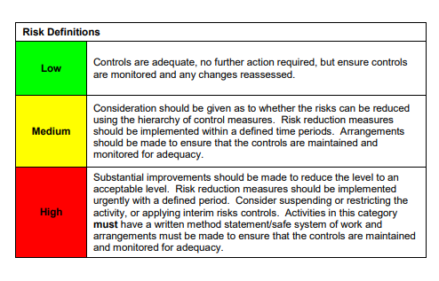

ACKNOWLEDGEMENT OF RISK ASSESSMENT Version:

PLEASE READ THE NOTICE BELOW BEFORE SIGNING THIS FORM
I acknowledge that I have read and understood the Risk Assessment/s associated with this task/event/equipment etc

Forename | Surname | Employee Signature | Date | Manager’s Signature

