

RISK ASSESSMENT FINDINGS

Department/Service
Date
Assessor
Approved By
Review Date

Relevant Legislation:

The Management of Health and Safety at Work Regulations 1999

RISK ASSESSMENT RECORD

ACTIVITY and/or ENVIRONMENT TO BE ASSESSED: Pupil Absconding/Missing (Child leaving School Grounds)

DATE:

KEY (People at risk) | Likelihood (L) | Severity (S) | Risk Calculation | Risk Rating
E = Employee YP = Young Persons  P = Public  C = Contractors  V = Visitors  EM = Expectant Mothers | 1. Very Low (rare/very unlikely)  2. Low (unlikely)  3. Medium (could occur/possible)  4. High (likely to occur/probable)  5. Very High (near certain to occur) | 1. Insignificant (nuisance/discomfort)  2. Minor (no lost time)  3. Moderate (time loss)  4. Significant (serious/incapacity to work)  5. Major (Death) | Likelihood x Severity  =  Rating | 1- 6 LOW RISK Monitor  - MEDIUM RISK Monitor, review & reduce risk where possible  14-25 HIGH RISK Further Action Required

1.Hazards Identified and potential harm it could cause | 2. People  At Risk | 3.Controls in Place | 4.Risk Rating |  |  |  | 5. Further Action Required/ Recommendations | 6.Target Date for Completion
1.Hazards Identified and potential harm it could cause | 2. People  At Risk | 3.Controls in Place | L | S | Score | Risk | 5. Further Action Required/ Recommendations | 6.Target Date for Completion

Child leaving School  Grounds  Injury when climbing fence  Road Traffic Collision  Abduction |  | - Door access systems on required doors  - Monitoring doors  - Staff Vigilance  - One to one Classroom Assistant  - Children with history of running from school grounds are supervised closely when playing in outdoor play area  - High levels of supervisors in high-risk areas – especially with older children with history of running.  - Emergency procedures that can be activated quickly when a child has left the play area  - Staff aware of any potential triggers for pupils |  |  |  |  | Emergency procedures that can be activated quickly when a child has left the site  • Improving door access control in school building  • School site security Risk  Assessment carried out taking into consideration issues of child leaving site – Improvements to  site security
Missing Child Site check  Child hiding |  | - Daily attendance procedures in place  - Regular site checks including perimeter walks to check boundary fencing  - Site security measures in place  - Immediate check carried out of the school including toilets, meeting rooms and classrooms etc.  - Playground and other external areas of the school checked for missing pupil.  - Checks made with office to ensure pupil has not been signed out for an appointment or has a visiting appointment at the school.  - If a child goes missing after being dismissed to parents, staff to support parent with search of the site.  - Headteacher (in their absence the deputy headteacher) must always authorise a search widening to outside of the school gates.

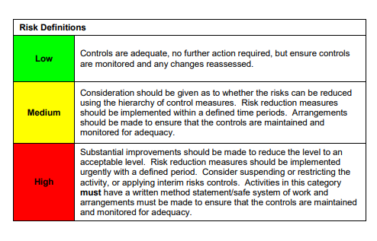

ACKNOWLEDGEMENT OF RISK ASSESSMENT Version:

PLEASE READ THE NOTICE BELOW BEFORE SIGNING THIS FORM
I acknowledge that I have read and understood the Risk Assessment/s associated with this task/event/equipment etc

Forename | Surname | Employee Signature | Date | Manager’s Signature

