

RISK ASSESSMENT

Department/Service
Date
Assessor
Approved By
Review Date

Relevant Legislation:

Department for Education Behaviour in Schools Advice for headteachers and school staff February 2024

Department for Education Suspension and permanent exclusion from maintained schools, academies and pupil referral units in England, including pupil movement Guidance for maintained schools, academies, and pupil referral units in England August 2024

Parent’s guide to behaviour A guide for parents on school behaviour and exclusion - GOV.UK

Department for Education Special educational needs and disability code of practice: 0 to 25 years Statutory guidance for organisations which work with and support children and young people who have special educational needs or disabilities January 2015
Relevant Rotherham Guidance

Part-time timetable
Managed move
Reintegration
Off-site direction

RISK ASSESSMENT RECORD

ACTIVITY and/or ENVIRONMENT TO BE ASSESSED: Pupil’s reintegration into school following a suspensions, off-site direction or period of time absent due to medical reasons, Elective Home Education.
DATE:

KEY (People at risk) | Likelihood (L) | Severity (S) | Risk Calculation | Risk Rating
E = Employee YP = Young Persons  P = Public  C = Contractors  V = Visitors  EM = Expectant Mothers | 1. Very Low (rare/very unlikely)  2. Low (unlikely)  3. Medium (could occur/possible)  4. High (likely to occur/probable)  5. Very High (near certain to occur) | 1. Insignificant (nuisance/discomfort)  2. Minor (no lost time)  3. Moderate (time loss)  4. Significant (serious/incapacity to work)  5. Major (Death) | Likelihood x Severity  =  Rating | 1- 6 LOW RISK Monitor  - MEDIUM RISK Monitor, review & reduce risk where possible  14-25 HIGH RISK Further Action Required

1.Hazards Identified and potential harm it could cause | 2. People  At Risk | 3.Controls in Place | 4.Risk Rating |  |  |  | 5. Further Action Required/ Recommendations | 6.Target Date for Completion
1.Hazards Identified and potential harm it could cause | 2. People  At Risk | 3.Controls in Place | L | S | Score | Risk | 5. Further Action Required/ Recommendations | 6.Target Date for Completion

Persistent Challenges |  | - Analyse the reasons for this and identify whether aspects of the environment are stressful or overwhelming. Make use of structured provision during break times where necessary. identify any patterns of behavior that could suggest underlying needs and difficulties across all 4 categories of the SEN Code of Practice 2015.  - Regular mentoring to support the student to reflect on their strengths, targets (this could take various approaches) Targets should be SMART  - Liaise regularly with parents and carers and ensure the student is aware of this open and regular communication. Plans, rewards and consequences should be jointly agreed by staff, parents/carers and students and applied consistently.  - Discuss any other factors that might be influencing the student’s behaviour and how these could be addressed or supported such as communication and interaction needs or social, emotional and mental health needs.
Signs of stress/anxiety |  | - Development of a clear and thorough transition plan that is developed well in advance where possible and collects the views of settings, parents and the student. The plan will need to be bespoke and personalised to reflect the student’s interests and current needs.  - The transition should be phased and designed to minimise anxiety.  - Any part-time timetable completed to support successful reintegration should be submitted to the LA as per guidance.  - Pupil/Student should be able to access their proposed timetable and be able to visit key physical locations at the school (safe space).  - Pupil/Student has somewhere they can go to ask about worries or concerns (key/safe person). |  |  |  |  | Refer to Pupil Portrait (are all staff aware of this Portrait)
Pupils/Students with SEND  (Autism) |  | - Pupils/students being listened to and having their point of view understood, especially how autism impacts on them as an individual.  - Consider SEMH assessment  - Aiming to reduce the pupil’s anxiety/stress so that they increase their resilience and willingness to engage in learning.  - Staff working together as a team, supporting one another; looking for solutions  together and agreeing consistent approaches (use solution circles).  - Using strategies to help the pupil to communicate in a way that meets their needs.
SEN Pupils/Students with SEMH needs |  | - Understanding the child & parent/carer situation  - Having an individualised approach  - Ensuring provision matches pupil need.  - Reasonable adjustments based on barriers & protective factors.  - Empowering the child/young people to lead the reintegration plan.  - Promoting a sense of belonging  - Building positive relationships
Pupils with a specific medical/physical need |  | - Bespoke for each individual  - Training requirements for staff  - Control measures in place for dosage etc.

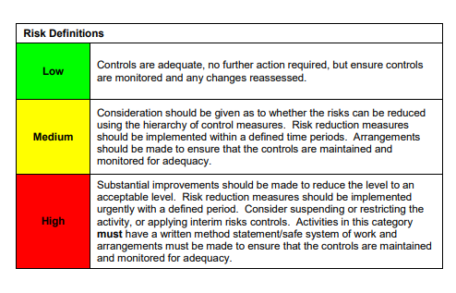

ACKNOWLEDGEMENT OF RISK ASSESSMENT Version:

PLEASE READ THE NOTICE BELOW BEFORE SIGNING THIS FORM
I acknowledge that I have read and understood the Risk Assessment/s associated with this task/event/equipment etc

Forename | Surname | Employee Signature | Date | Manager’s Signature

