

RISK ASSESSMENT FINDINGS

Department/Service
Date
Assessor
Approved By
Review Date

Relevant Legislation:

RISK ASSESSMENT RECORD

ACTIVITY and/or ENVIRONMENT TO BE ASSESSED: Pupil Safety on Y6 transition placement to Secondary school
DATE:

KEY (People at risk) | Likelihood (L) | Severity (S) | Risk Calculation | Risk Rating
E = Employee YP = Young Persons  P = Public  C = Contractors  V = Visitors  EM = Expectant Mothers | 1. Very Low (rare/very unlikely)  2. Low (unlikely)  3. Medium (could occur/possible)  4. High (likely to occur/probable)  5. Very High (near certain to occur) | 1. Insignificant (nuisance/discomfort)  2. Minor (no lost time)  3. Moderate (time loss)  4. Significant (serious/incapacity to work)  5. Major (Death) | Likelihood x Severity  =  Rating | 1- 6 LOW RISK Monitor  - MEDIUM RISK Monitor, review & reduce risk where possible  14-25 HIGH RISK Further Action Required

1.Hazards Identified and potential harm it could cause | 2. People  At Risk | 3.Controls in Place | 4.Risk Rating |  |  |  | 5. Further Action Required/ Recommendations | 6.Target Date for Completion
1.Hazards Identified and potential harm it could cause | 2. People  At Risk | 3.Controls in Place | L | S | Score | Risk | 5. Further Action Required/ Recommendations | 6.Target Date for Completion

Pupils leaving site for appointments/Home Dinners |  | Written permission from parent / carer required to leave site e.g. at lunchtimes/GP appointments etc. |  |  |  |  | Collection by Parent or Guardian
Missing pupil |  | - Primary School to ensure emergency contact details of parents/carers updated.  - Conflicting end of terms – INSET day etc. Pupils to remain on roll at their primary school until the end of term:
Travel to and from school |  | - Travel to and from Secondary school arrangements should be pre-arranged and consented prior to commencement of transition placement e.g. pupils making own way, school bus, etc.  - Travel arrangements for SEN/LAC pupils etc.
Specific arrangements for SEN/LAC pupils |  | Refer to Care/Behaviour/EHC Plans

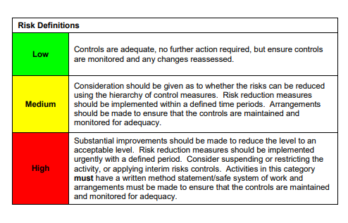

ACKNOWLEDGEMENT OF RISK ASSESSMENT Version:

PLEASE READ THE NOTICE BELOW BEFORE SIGNING THIS FORM
I acknowledge that I have read and understood the Risk Assessment/s associated with this task/event/equipment etc

Forename | Surname | Employee Signature | Date | Manager’s Signature

