

RISK ASSESSMENT FINDINGS

Department/Service
Date
Assessor
Approved By
Review Date

Relevant Legislation:

The Management of Health and Safety at Work Regulations 1999

RISK ASSESSMENT RECORD

ACTIVITY and/or ENVIRONMENT TO BE ASSESSED: Reasonable adjustments
DATE:

KEY (People at risk) | Likelihood (L) | Severity (S) | Risk Calculation | Risk Rating
E = Employee YP = Young Persons  P = Public  C = Contractors  V = Visitors  EM = Expectant Mothers | 1. Very Low (rare/very unlikely)  2. Low (unlikely)  3. Medium (could occur/possible)  4. High (likely to occur/probable)  5. Very High (near certain to occur) | 1. Insignificant (nuisance/discomfort)  2. Minor (no lost time)  3. Moderate (time loss)  4. Significant (serious/incapacity to work)  5. Major (Death) | Likelihood x Severity  =  Rating | 1- 6 LOW RISK Monitor  - MEDIUM RISK Monitor, review & reduce risk where possible  14-25 HIGH RISK Further Action Required

1.Hazards Identified and potential harm it could cause | 2. People  At Risk | 3.Controls in Place | 4.Risk Rating |  |  |  | 5. Further Action Required/ Recommendations | 6.Target Date for Completion
1.Hazards Identified and potential harm it could cause | 2. People  At Risk | 3.Controls in Place | L | S | Score | Risk | 5. Further Action Required/ Recommendations | 6.Target Date for Completion

Medical condition requiring medication |  | - Training requirements for staff  - Control measures in place for dosage etc. |  |  |  |  | Nominated person to give medication and log when given.
Injury causing temporary disability e.g. the wearing of a plaster cast etc. |  | - You will need to look at the individuals work role/timetable and consider any access problems they may have/ encounter.  - Restrictions on work activity e.g. avoid manual handling tasks due to current pain and discomfort from back condition etc.  - Reallocating certain elements of the work activity to other colleagues  - Rescheduling duties to more suitable times  - Providing suitable alternative equipment (for example automated equipment to reduce manual handling) |  |  |  |  | Temporary/Permanent adjustments  Have ‘reasonable adjustments’ been agreed with the individual
Permanent disability e.g. visual impairment, hearing impairment, wheelchair user etc. |  | - You will need to look at the individuals work role/timetable and consider any access problems they may have/ encounter.  - Restrictions on work activity e.g. avoid manual handling tasks due to current pain and discomfort from back condition etc.  - Are the ‘reasonable adjustments’ on a temporary basis or permanent e.g. adjustments made for a wheelchair user / person returning to work post operation/after injury etc.: |  |  |  |  | Temporary/Permanent adjustments  Have ‘reasonable adjustments’ been agreed with the individual  Training requirements for staff  Refer to Wheelchair user Risk Assessment
Pregnancy |  | Refer to Pregnant and Expectant Mothers Risk Assessment |  |  |  |  | Restrictions on work activities
Mental Health |  | - Helping them speak openly about how their condition affected them, so they could work together on making adjustments and monitoring the worker’s wellbeing.  - Allowing them to work a three-day week until they were ready to return to full-time work  - Arranging for their colleagues and/or supervisor to attend mental health awareness training so the team has a better understanding

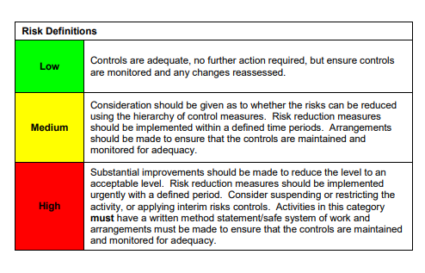

ACKNOWLEDGEMENT OF RISK ASSESSMENT Version:

PLEASE READ THE NOTICE BELOW BEFORE SIGNING THIS FORM
I acknowledge that I have read and understood the Risk Assessment/s associated with this task/event/equipment etc

Forename | Surname | Employee Signature | Date | Manager’s Signature

