

RISK ASSESSMENT FINDINGS

Department/Service
Date
Assessor
Approved By
Review Date

Relevant Legislation:

The Management of Health and Safety at Work Regulations 1999

RISK ASSESSMENT RECORD

ACTIVITY and/or ENVIRONMENT TO BE ASSESSED: Responding to an intruder alarm out of hours
DATE:

KEY (People at risk) | Likelihood (L) | Severity (S) | Risk Calculation | Risk Rating
E = Employee YP = Young Persons  P = Public  C = Contractors  V = Visitors  EM = Expectant Mothers | 1. Very Low (rare/very unlikely)  2. Low (unlikely)  3. Medium (could occur/possible)  4. High (likely to occur/probable)  5. Very High (near certain to occur) | 1. Insignificant (nuisance/discomfort)  2. Minor (no lost time)  3. Moderate (time loss)  4. Significant (serious/incapacity to work)  5. Major (Death) | Likelihood x Severity  =  Rating | 1- 6 LOW RISK Monitor  - MEDIUM RISK Monitor, review & reduce risk where possible  14-25 HIGH RISK Further Action Required

1.Hazards Identified and potential harm it could cause | 2. People  At Risk | 3.Controls in Place | 4.Risk Rating |  |  |  | 5. Further Action Required/ Recommendations | 6.Target Date for Completion
1.Hazards Identified and potential harm it could cause | 2. People  At Risk | 3.Controls in Place | L | S | Score | Risk | 5. Further Action Required/ Recommendations | 6.Target Date for Completion

Lone worker e.g. caretaker or site manager responds to a school intruder alarm activation out of hours  Dark nights, adverse weather poor visibility, intruder on site, risk of threats / physical assault, personal injury e.g. slip / trip, death. | Person responding out of hours (E/C) | - Means of communication:  - Out of hours contact numbers:  - Head Teacher should consider the risks to the key holder out of hours and establish a safe system of work for responding.  - Follow the protocols you have in place  - Buddy systems – e.g. person on call to liaise / meet caretaker at school and respond together.  - More than one staff member receives notification of alarm activation and a co-ordinated response is activated – this is probably more practical in a secondary school where there is more than one caretaker.  - Contract established with a security company who will respond to the alarm e.g. meet the key holder at school site or will hold a key and respond out of hours.  - Carry a mobile phone  - All staff are familiar with the site, alarms and systems;  NB the Head Teacher has a legal duty of care to ensure that a safe system is in place to respond. |  |  |  |  | Dial in remote access to CCTV to assess the site
Intruder on site |  | - DO NOT confront intruders  - Call 999  - Carry Personal attack alarm  - Restraining intruders should be left to the police who are trained in dealing with such situations  - If the lone worker feels a situation is getting out of control, they will try keep moving, listening and talking to the person as they attempt to leave or get away from the situation.
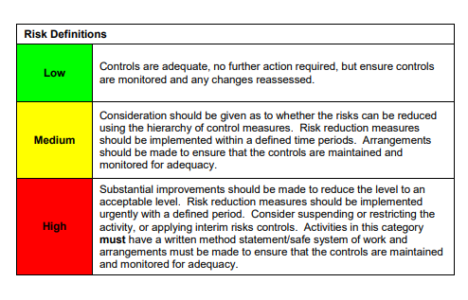

ACKNOWLEDGEMENT OF RISK ASSESSMENT Version:

PLEASE READ THE NOTICE BELOW BEFORE SIGNING THIS FORM
I acknowledge that I have read and understood the Risk Assessment/s associated with this task/event/equipment etc

Forename | Surname | Employee Signature | Date | Manager’s Signature

