

RISK ASSESSMENT FINDINGS

Department/Service
Date
Assessor
Approved By
Review Date

Relevant Legislation:

The Management of Health and Safety at Work Regulations 1999

RISK ASSESSMENT RECORD

ACTIVITY and/or ENVIRONMENT TO BE ASSESSED: Slips and trips
DATE:

KEY (People at risk) | Likelihood (L) | Severity (S) | Risk Calculation | Risk Rating
E = Employee YP = Young Persons  P = Public  C = Contractors  V = Visitors  EM = Expectant Mothers | 1. Very Low (rare/very unlikely)  2. Low (unlikely)  3. Medium (could occur/possible)  4. High (likely to occur/probable)  5. Very High (near certain to occur) | 1. Insignificant (nuisance/discomfort)  2. Minor (no lost time)  3. Moderate (time loss)  4. Significant (serious/incapacity to work)  5. Major (Death) | Likelihood x Severity  =  Rating | 1- 6 LOW RISK Monitor  - MEDIUM RISK Monitor, review & reduce risk where possible  14-25 HIGH RISK Further Action Required

1.Hazards Identified and potential harm it could cause | 2. People  At Risk | 3.Controls in Place | 4.Risk Rating |  |  |  | 5. Further Action Required/ Recommendations | 6.Target Date for Completion
1.Hazards Identified and potential harm it could cause | 2. People  At Risk | 3.Controls in Place | L | S | Score | Risk | 5. Further Action Required/ Recommendations | 6.Target Date for Completion

Slipping on wet/slippery floor surface – causing personal injury. |  | - Is there adequate lighting of the workplace?  - Door entrance canopies to reduce rain water accumulation near doorways.  - Absorbent matting near entrances.  - Use of grit/salt on external walkways during periods of inclement weather.  - Prompt cleaning of spillages and appropriate signage whilst completed.  - Appropriate behaviour of people on site  - Appropriate handrails fitted to steps and ramps where necessary.  - Wearing of appropriate footwear.  - Area made out of bounds (e.g. grassed area).  - Does the floor surface have enough slip resistance to protect against slipping with expected contaminants?  - Is the reception fitted with a carpet/door mat? Is it maintained in good condition and changed when required?
Tripping over uneven floor surface / objects – causing personal injury |  | - Is there adequate lighting of the workplace?  - Procedure in place to remove litter, decaying leaves etc.  - Discourage people from taking short cuts e.g. over grass.  - Appropriate behaviour of people on site  - Adequate inspection regime and prompt repair or maintenance of floor surfaces.  - Wearing of appropriate footwear.  - Appropriate ‘Housekeeping’ arrangements to prevent trip hazards.  - Use of barriers/fencing / hi visibility marking or paint etc. where necessary.  - Are car parks and footpaths safe and free from potholes and tripping hazards? |  |  |  |  | Replace the floor
Are there any other foreseeable hazards associated with Slips, Trips & Falls?

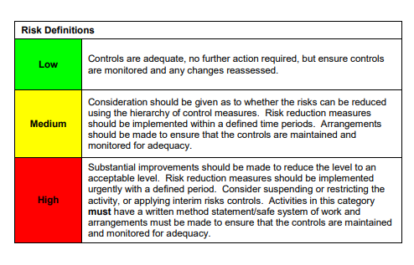

ACKNOWLEDGEMENT OF RISK ASSESSMENT Version:

PLEASE READ THE NOTICE BELOW BEFORE SIGNING THIS FORM
I acknowledge that I have read and understood the Risk Assessment/s associated with this task/event/equipment etc

Forename | Surname | Employee Signature | Date | Manager’s Signature

