

RISK ASSESSMENT FINDINGS

Department/Service
Date
Assessor
Approved By
Review Date

Relevant Legislation:

The Management of Health and Safety at Work Regulations 1999

RISK ASSESSMENT RECORD

ACTIVITY and/or ENVIRONMENT TO BE ASSESSED: Site Security
DATE:

KEY (People at risk) | Likelihood (L) | Severity (S) | Risk Calculation | Risk Rating
E = Employee YP = Young Persons  P = Public  C = Contractors  V = Visitors  EM = Expectant Mothers | 1. Very Low (rare/very unlikely)  2. Low (unlikely)  3. Medium (could occur/possible)  4. High (likely to occur/probable)  5. Very High (near certain to occur) | 1. Insignificant (nuisance/discomfort)  2. Minor (no lost time)  3. Moderate (time loss)  4. Significant (serious/incapacity to work)  5. Major (Death) | Likelihood x Severity  =  Rating | 1- 6 LOW RISK Monitor  - MEDIUM RISK Monitor, review & reduce risk where possible  14-25 HIGH RISK Further Action Required

1.Hazards Identified and potential harm it could cause | 2. People  At Risk | 3.Controls in Place | 4.Risk Rating |  |  |  | 5. Further Action Required/ Recommendations | 6.Target Date for Completion
1.Hazards Identified and potential harm it could cause | 2. People  At Risk | 3.Controls in Place | L | S | Score | Risk | 5. Further Action Required/ Recommendations | 6.Target Date for Completion

Access to site by an unauthorised person. |  | - Gates closed during school day.  - Anti-Climb Fencing  - CCTV  - Trespassers will be prosecuted signage  - Culture in which strangers are challenged  - Clear signage for visitors to main entrance / other services  - Clearly defined route once on site  - Other pedestrian routes controlled and available only at beginning / end of school day  - All visitors report to reception and sign in /out. Visitors wear visible visitors badge and escorted when on site if appropriate.  - Restricted / controlled access to building. E.g. Door intercom / entry phone, staffed reception, keypad / fob access etc. |  |  |  |  | Fencing min 1.8M high. All boundaries well defined and in good condition (no hole/gaps).  Inventory of both permanently and temporarily issued keys maintained.
Theft, Vandalism, Arson, violence/aggression. |  | - Ensure valuable equipment is secured and out of view when not in use.  - Ensure flammable materials are stored away securely when not in use e.g. locked flame-retardant cabinet for substances.  - Ensure rubbish is removed from the building and bins are located and secured a safe distance from buildings.  - Ensure external lighting is operational.  - Ensure fire alarm is operational and tested on a regular basis and subject to formal inspection and testing.  - Ensure security alarms are in working order, activated when the building is empty and subject to informal and formal testing and inspection.  - Ensure internal doors are closed when the building is empty.  - Ensure external doors are fitted with adequate locks / security devices as required and are in good order.  - Ensure all windows are closed / locked and any grilles locked when the building is closed.  - Ensure frequent inspection of perimeter security measures and any damage to perimeter fencing and gates is rectified as soon as possible.  - Ensure key holders are kept to a minimum and details are kept of all key holders.  - Minimise entry points to buildings e.g. signage on site indicating reception / visitors etc.  - Ensure relevant site security devices are on site dependant on risk e.g. CCTV (consult Building Manager for advice).  - Ensure appropriate I.D badge / signing in / out systems are implemented.  - Ensure ‘NO SMOKING’ laws are enforced and appropriate signage is displayed.  - Ensure damaged windows / doors / shutters etc. are repaired/replaced promptly.  - Ensure trees/shrubs etc. on site are kept pruned so they do not create areas of seclusion, where intruders may gain easy cover.  - Ensure adequate ‘call out’ arrangements are in place in the event of burglar alarm activation out of hours (consider the risks to a lone worker – see lone working risk assessment).

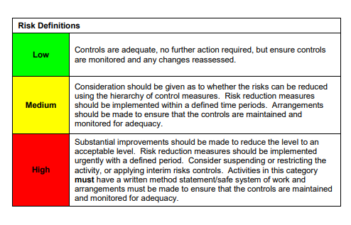

ACKNOWLEDGEMENT OF RISK ASSESSMENT Version:

PLEASE READ THE NOTICE BELOW BEFORE SIGNING THIS FORM
I acknowledge that I have read and understood the Risk Assessment/s associated with this task/event/equipment etc

Forename | Surname | Employee Signature | Date | Manager’s Signature

