

RISK ASSESSMENT FINDINGS

Department/Service
Date
Assessor
Approved By
Review Date

Relevant Legislation:

The Management of Health and Safety at Work Regulations 1999

RISK ASSESSMENT RECORD

ACTIVITY and/or ENVIRONMENT TO BE ASSESSED: Stock delivery
DATE:

KEY (People at risk) | Likelihood (L) | Severity (S) | Risk Calculation | Risk Rating
E = Employee YP = Young Persons  P = Public  C = Contractors  V = Visitors  EM = Expectant Mothers | 1. Very Low (rare/very unlikely)  2. Low (unlikely)  3. Medium (could occur/possible)  4. High (likely to occur/probable)  5. Very High (near certain to occur) | 1. Insignificant (nuisance/discomfort)  2. Minor (no lost time)  3. Moderate (time loss)  4. Significant (serious/incapacity to work)  5. Major (Death) | Likelihood x Severity  =  Rating | 1- 6 LOW RISK Monitor  - MEDIUM RISK Monitor, review & reduce risk where possible  14-25 HIGH RISK Further Action Required

1.Hazards Identified and potential harm it could cause | 2. People  At Risk | 3.Controls in Place | 4.Risk Rating |  |  |  | 5. Further Action Required/ Recommendations | 6.Target Date for Completion
1.Hazards Identified and potential harm it could cause | 2. People  At Risk | 3.Controls in Place | L | S | Score | Risk | 5. Further Action Required/ Recommendations | 6.Target Date for Completion

Overstocking of articles and substances – falling goods causing injury |  | - Pre identified safe storage areas with secure shelving etc.  - Nominated person to check order and sign for
Injury caused by lifting and handling goods |  | - Provision of appropriate equipment to assist staff e.g. trolley etc.  - Suitable number of staff allocated to the task  - Provision of personal protective equipment where  required e.g. gloves  - Suitable number of staff allocated to the task  - Appropriately trained staff. |  |  |  |  | Training requirements of staff to do the task safely
Blocking of doors and corridors preventing safe access/egress |  | - Pre identified delivery point with safe parking.  - Deliveries taken immediately to storage area
Out of date stock |  | Stock rotation where goods have expiry dates

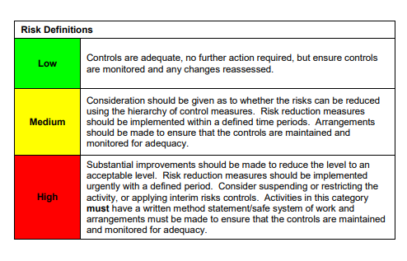

ACKNOWLEDGEMENT OF RISK ASSESSMENT Version:

PLEASE READ THE NOTICE BELOW BEFORE SIGNING THIS FORM
I acknowledge that I have read and understood the Risk Assessment/s associated with this task/event/equipment etc

Forename | Surname | Employee Signature | Date | Manager’s Signature

