

RISK ASSESSMENT FINDINGS

Department/Service
Date
Assessor
Approved By
Review Date

Relevant Legislation:

The Management of Health and Safety at Work Regulations 1999

RISK ASSESSMENT RECORD

ACTIVITY and/or ENVIRONMENT TO BE ASSESSED: School Production
DATE:

KEY (People at risk) | Likelihood (L) | Severity (S) | Risk Calculation | Risk Rating
E = Employee YP = Young Persons  P = Public  C = Contractors  V = Visitors  EM = Expectant Mothers | 1. Very Low (rare/very unlikely)  2. Low (unlikely)  3. Medium (could occur/possible)  4. High (likely to occur/probable)  5. Very High (near certain to occur) | 1. Insignificant (nuisance/discomfort)  2. Minor (no lost time)  3. Moderate (time loss)  4. Significant (serious/incapacity to work)  5. Major (Death) | Likelihood x Severity  =  Rating | 1- 6 LOW RISK Monitor  - MEDIUM RISK Monitor, review & reduce risk where possible  14-25 HIGH RISK Further Action Required

1.Hazards Identified and potential harm it could cause | 2. People  At Risk | 3.Controls in Place | 4.Risk Rating |  |  |  | 5. Further Action Required/ Recommendations | 6.Target Date for Completion
1.Hazards Identified and potential harm it could cause | 2. People  At Risk | 3.Controls in Place | L | S | Score | Risk | 5. Further Action Required/ Recommendations | 6.Target Date for Completion

General risks |  | See also main hall risk assessment
Fire/Emergency requiring evacuation |  | Ensure you have a fire / emergency evacuation plan and pre identified assembly points |  |  |  |  | Ensure visitors are informed of these arrangements and procedures at the start of the event. Disabled persons should have their own personal emergency evacuation plan
Faulty/damaged electrical/ mechanical equipment |  | Ensure you have a schedule of inspection / testing of equipment as a requirement of PUWER. |  |  |  |  | Liaise with guests if taking any equipment to site re: safety of it e.g. PAT up to date – do they conduct their own inspection of facility user equipment etc.
Overcrowding of venue |  | Venue will have a maximum capacity – pre-determined by a risk assessment. This may also include seating layout plans etc. Liaise with Building Manager. |  |  |  |  | Liaise with performers/guest speakers where appropriate re capacity/seating plans etc.
Slips/trips |  | Ensure you have a housekeeping regime in situ to minimise slip and trip hazards. |  |  |  |  | Liaise with all parties re housekeeping rules, storage etc.
Trailing cables etc. |  | Venue should have sufficient amount of plug sockets in appropriate places. |  |  |  |  | Avoid use of extension leads where possible, use cable covers where there is a potential trip hazard.
Raised stage area – falls |  | No unauthorised/unsupervised access to stage area. Stage edgings should be clearly defined/screened. |  |  |  |  | Ensure persons accessing/ leaving staged area are supervised appropriately.
Large numbers of people congregating – insufficient escape/crushing |  | Venue seating plans should be adhered to, walkways to be kept clear, signage of potential areas. Ensure capacity not exceeded.
Open windows – falls |  | All windows above ground level should be fitted with window restrictors when they can be opened.
Hot radiators – burns |  | Low surface temperature radiators / appropriate guards should be fitted.
Inappropriate behaviour – damage to property/Injury |  | Supervision |  |  |  |  | Ensure young people are adequately supervised, supervision level should be of an appropriate level to deal with any incidents / emergencies.
Security of site/safety of children |  | Ensure you have a safety/ security procedure e.g. signing in/out, out of bounds areas, no entry points etc. |  |  |  |  | These should be adhered to at all times.
First aid |  | Ensure you have resources to deal with first aid emergencies. |  |  |  |  | Attendees with specific medical needs need to be considered when supervision levels are assessed.
Car Park – RTA |  | Ensure you have car park safety procedures that must be followed. |  |  |  |  | Adhere to signage in car parks, follow pedestrian routes, ensure children are appropriately supervised.

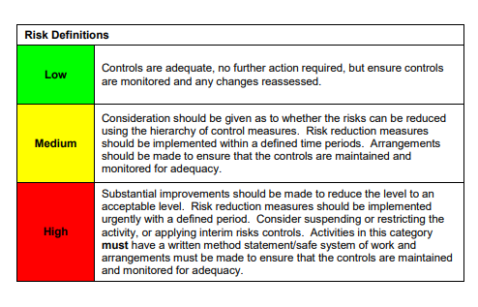

ACKNOWLEDGEMENT OF RISK ASSESSMENT Version:

PLEASE READ THE NOTICE BELOW BEFORE SIGNING THIS FORM
I acknowledge that I have read and understood the Risk Assessment/s associated with this task/event/equipment etc

Forename | Surname | Employee Signature | Date | Manager’s Signature

