

RISK ASSESSMENT FINDINGS

Department/Service
Date
Assessor
Approved By
Review Date

Relevant Legislation:

The Management of Health and Safety at Work Regulations 1999

RISK ASSESSMENT RECORD

ACTIVITY and/or ENVIRONMENT TO BE ASSESSED: Storage Areas
DATE:

KEY (People at risk) | Likelihood (L) | Severity (S) | Risk Calculation | Risk Rating
E = Employee YP = Young Persons  P = Public  C = Contractors  V = Visitors  EM = Expectant Mothers | 1. Very Low (rare/very unlikely)  2. Low (unlikely)  3. Medium (could occur/possible)  4. High (likely to occur/probable)  5. Very High (near certain to occur) | 1. Insignificant (nuisance/discomfort)  2. Minor (no lost time)  3. Moderate (time loss)  4. Significant (serious/incapacity to work)  5. Major (Death) | Likelihood x Severity  =  Rating | 1- 6 LOW RISK Monitor  - MEDIUM RISK Monitor, review & reduce risk where possible  14-25 HIGH RISK Further Action Required

1.Hazards Identified and potential harm it could cause | 2. People  At Risk | 3.Controls in Place | 4.Risk Rating |  |  |  | 5. Further Action Required/ Recommendations | 6.Target Date for Completion
1.Hazards Identified and potential harm it could cause | 2. People  At Risk | 3.Controls in Place | L | S | Score | Risk | 5. Further Action Required/ Recommendations | 6.Target Date for Completion

Hazardous substances – ill health |  | - Substances to be stored in accordance with product data sheet / risk assessment.  - Substance to be in original container.  - Store to be kept locked when not in use.
Flammable substances – fire / explosion |  | - Flammable substances to be stored in a purpose made, lockable, fire-resistant cabinet and appropriately labelled.  - Minimum amounts to be kept on premises.  - Kept away from sources of ignition.  - Safe disposal after use – risk assessment/data sheet for product.
Falling objects – personal injury |  | - Secure shelving provided.  - Shelves not overloaded.  - Storage to be organised with heavier objects at lower levels.
Reaching high shelves – Falls / strains |  | - Appropriate steps / kick stool provided.  - Store frequently used items at easily accessible locations.
Electrical equipment and sockets - electrocution |  | - Visual inspection.  - PAT Testing.  - Fixed appliance testing.

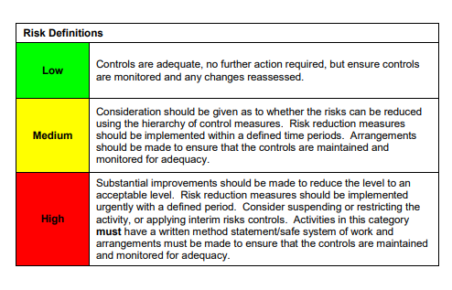

ACKNOWLEDGEMENT OF RISK ASSESSMENT Version:

PLEASE READ THE NOTICE BELOW BEFORE SIGNING THIS FORM
I acknowledge that I have read and understood the Risk Assessment/s associated with this task/event/equipment etc

Forename | Surname | Employee Signature | Date | Manager’s Signature

