

RISK ASSESSMENT FINDINGS

Department/Service
Date
Assessor
Approved By
Review Date

Relevant Legislation:

The Management of Health and Safety at Work Regulations 1999

RISK ASSESSMENT RECORD

ACTIVITY and/or ENVIRONMENT TO BE ASSESSED: Seasonal Decorations
DATE:

KEY (People at risk) | Likelihood (L) | Severity (S) | Risk Calculation | Risk Rating
E = Employee YP = Young Persons  P = Public  C = Contractors  V = Visitors  EM = Expectant Mothers | 1. Very Low (rare/very unlikely)  2. Low (unlikely)  3. Medium (could occur/possible)  4. High (likely to occur/probable)  5. Very High (near certain to occur) | 1. Insignificant (nuisance/discomfort)  2. Minor (no lost time)  3. Moderate (time loss)  4. Significant (serious/incapacity to work)  5. Major (Death) | Likelihood x Severity  =  Rating | 1- 6 LOW RISK Monitor  - MEDIUM RISK Monitor, review & reduce risk where possible  14-25 HIGH RISK Further Action Required

1.Hazards Identified and potential harm it could cause | 2. People  At Risk | 3.Controls in Place | 4.Risk Rating |  |  |  | 5. Further Action Required/ Recommendations | 6.Target Date for Completion
1.Hazards Identified and potential harm it could cause | 2. People  At Risk | 3.Controls in Place | L | S | Score | Risk | 5. Further Action Required/ Recommendations | 6.Target Date for Completion

Tree – unstable causing it to fall, setting fire, causing an obstruction |  | - Ensure tree is sturdy and set in a stable position using any stabilising accessories provided.  - Ensure tree is of a sensible height to reduce the risks from working at height.  - Ensure tree does not obstruct main access / egress routes (particularly fire routes).
Decorations – causing injury / fire. |  | - Ensure decorations are in a good condition, fire resistant and are secured to the tree etc. securely, and away from sources of heat.
Decorative lights. |  | - Ensure decorative lights conform to British Safety Standards (BSS / CE mark).  - Ensure lights are secured to the tree/display safely.  - Ensure lights are either new or recently PAT tested.  - Ensure lights are switched off at plug socket when not required.
Cables – trip hazard, fire risks. |  | - Ensure cables are not placed in a position where they are likely to create a trip hazard.  - Ensure cables are not damaged.  - Ensure all equipment is PAT tested
Decorating – trimming of tree. |  | - Ensure appropriate equipment is used to trim trees/display e.g. select appropriate step ladders etc. and use them as per manufacturer’s recommendations.  - When decorating tree/display etc. using steps ensure a second person is on hand / assisting. (See model working at height risk assessment for more information).
Use of Christmas crackers at school parties. |  | - Ensure Christmas crackers are ‘age appropriate’ for pupils in relation to content e.g. small toys etc.  - Ensure crackers are purchased from a reputable company / retailer.  - Ensure pupils are adequately supervised.  - Should the ‘cracker strip’ potentially disturb / upset a child, this should be removed prior to use

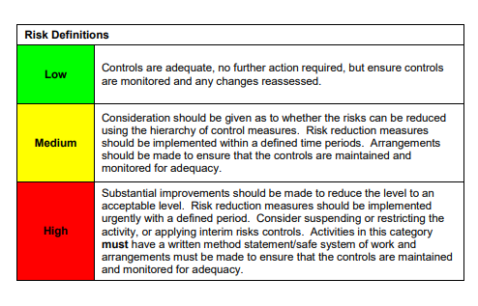

ACKNOWLEDGEMENT OF RISK ASSESSMENT Version:

PLEASE READ THE NOTICE BELOW BEFORE SIGNING THIS FORM
I acknowledge that I have read and understood the Risk Assessment/s associated with this task/event/equipment etc

Forename | Surname | Employee Signature | Date | Manager’s Signature

