

RISK ASSESSMENT FINDINGS

Department/Service
Date
Assessor
Approved By
Review Date

Relevant Legislation:

The Management of Health and Safety at Work Regulations 1999

RISK ASSESSMENT RECORD

ACTIVITY and/or ENVIRONMENT TO BE ASSESSED: Staff Room
DATE:

KEY (People at risk) | Likelihood (L) | Severity (S) | Risk Calculation | Risk Rating
E = Employee YP = Young Persons  P = Public  C = Contractors  V = Visitors  EM = Expectant Mothers | 1. Very Low (rare/very unlikely)  2. Low (unlikely)  3. Medium (could occur/possible)  4. High (likely to occur/probable)  5. Very High (near certain to occur) | 1. Insignificant (nuisance/discomfort)  2. Minor (no lost time)  3. Moderate (time loss)  4. Significant (serious/incapacity to work)  5. Major (Death) | Likelihood x Severity  =  Rating | 1- 6 LOW RISK Monitor  - MEDIUM RISK Monitor, review & reduce risk where possible  14-25 HIGH RISK Further Action Required

1.Hazards Identified and potential harm it could cause | 2. People  At Risk | 3.Controls in Place | 4.Risk Rating |  |  |  | 5. Further Action Required/ Recommendations | 6.Target Date for Completion
1.Hazards Identified and potential harm it could cause | 2. People  At Risk | 3.Controls in Place | L | S | Score | Risk | 5. Further Action Required/ Recommendations | 6.Target Date for Completion

Slips, trips, falls – personal injury. |  | - Defect reporting and prompt repair.  - Good housekeeping procedures.  - Safe storage of articles.  - Walkways kept clear.  - Prompt cleaning of spillages.
Hot water – scalds/burns. |  | - Kettles / boilers suitably sited.  - Appropriate drink preparation area.
Poor hygiene standards – illness/infection. |  | - Good housekeeping procedures.  - Regular cleaning of work surfaces, fridges etc.  - Regular removal of waste.
Electrical equipment – electrocution |  | - Visual user checks.  - PAT testing.  - Fixed appliance testing.
Defective furniture / equipment – personal injury. |  | - Furniture and equipment to be kept in good condition.  - Reporting procedure for defects.  - Prompt repair/replace procedures.

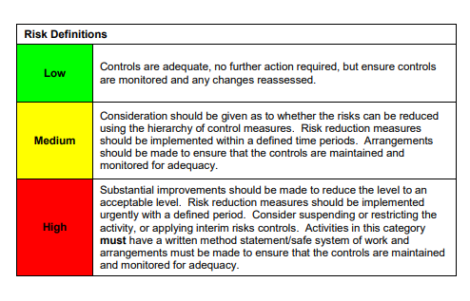

ACKNOWLEDGEMENT OF RISK ASSESSMENT Version:

PLEASE READ THE NOTICE BELOW BEFORE SIGNING THIS FORM
I acknowledge that I have read and understood the Risk Assessment/s associated with this task/event/equipment etc

Forename | Surname | Employee Signature | Date | Manager’s Signature

