

RISK ASSESSMENT FINDINGS

Department/Service
Date
Assessor
Approved By
Review Date

Relevant Legislation:

RISK ASSESSMENT RECORD

ACTIVITY and/or ENVIRONMENT TO BE ASSESSED: Lithium-ion Batteries (Generic)
DATE:

KEY (People at risk) | Likelihood (L) | Severity (S) | Risk Calculation | Risk Rating
E = Employee YP = Young Persons  P = Public  C = Contractors  V = Visitors  EM = Expectant Mothers | 1. Very Low (rare/very unlikely)  2. Low (unlikely)  3. Medium (could occur/possible)  4. High (likely to occur/probable)  5. Very High (near certain to occur) | 1. Insignificant (nuisance/discomfort)  2. Minor (no lost time)  3. Moderate (time loss)  4. Significant (serious/incapacity to work)  5. Major (Death) | Likelihood x Severity  =  Rating | 1- 6 LOW RISK Monitor  - MEDIUM RISK Monitor, review & reduce risk where possible  14-25 HIGH RISK Further Action Required

1.Hazards Identified and potential harm it could cause | 2. People  At Risk | 3.Controls in Place | 4.Risk Rating |  |  |  | 5. Further Action Required/ Recommendations | 6.Target Date for Completion
1.Hazards Identified and potential harm it could cause | 2. People  At Risk | 3.Controls in Place | L | S | Score | Risk | 5. Further Action Required/ Recommendations | 6.Target Date for Completion

Fire, smoke and fumes, burns from an overheated battery pack, corrosive burns from escaping electrolyte. Fragments from an exploding battery pack (worse case). |  | No Smoking Policy that includes Vapes.  Behaviour Policy that prohibits the carrying and use of vapes in school.  Storage in an airtight metal container stored away from any flammable material ideally in a cool dry place. Storage at high temperatures should be avoided |  |  |  |  | Co2 Fire extinguisher in proximity  Staff training on the risks of Lithium-Ion fires  External Storage in a metal container on open metal shelving.  The device and battery should be stored between 18oC and 30oC. If the device is exposed to extreme temperatures above 30oC, carelessly handled or the battery is punctured  this can lead to dangerous consequences.
Electrical Shock |  | Battery must be kept inside the device
Battery leak |  | First aid measures  - Eye: Flush eyes with plenty of water for at least 15 minutes, occasionally lifting the upper and lower eyelids. Get medical aid.  - Skin: Remove contaminated clothes and rinse skin with plenty of water.  - Inhalation: Remove from exposure and move to fresh air immediately.  - Ingestion: Give at least 2 glasses of milk or water. Induce vomiting unless patient is unconscious. Call 999.
Transportation and Disposal |  | Vapes are not to be disposed with general waste.  Approved collector of Waste Electrical and Electronic Equipment (WEEE) waste appointed

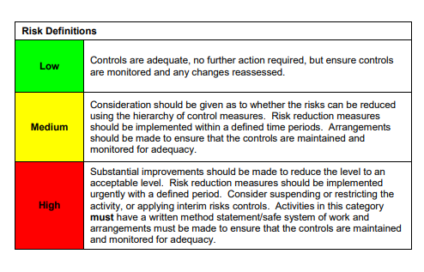

ACKNOWLEDGEMENT OF RISK ASSESSMENT Version:

PLEASE READ THE NOTICE BELOW BEFORE SIGNING THIS FORM
I acknowledge that I have read and understood the Risk Assessment/s associated with this task/event/equipment etc

Forename | Surname | Employee Signature | Date | Manager’s Signature

