

RISK ASSESSMENT FINDINGS

Department/Service
Date
Assessor
Approved By
Review Date

Relevant Legislation:

The Management of Health and Safety at Work Regulations 1999

RISK ASSESSMENT RECORD

ACTIVITY and/or ENVIRONMENT TO BE ASSESSED: Walking Bus
DATE:

KEY (People at risk) | Likelihood (L) | Severity (S) | Risk Calculation | Risk Rating
E = Employee YP = Young Persons  P = Public  C = Contractors  V = Visitors  EM = Expectant Mothers | 1. Very Low (rare/very unlikely)  2. Low (unlikely)  3. Medium (could occur/possible)  4. High (likely to occur/probable)  5. Very High (near certain to occur) | 1. Insignificant (nuisance/discomfort)  2. Minor (no lost time)  3. Moderate (time loss)  4. Significant (serious/incapacity to work)  5. Major (Death) | Likelihood x Severity  =  Rating | 1- 6 LOW RISK Monitor  - MEDIUM RISK Monitor, review & reduce risk where possible  14-25 HIGH RISK Further Action Required

1.Hazards Identified and potential harm it could cause | 2. People  At Risk | 3.Controls in Place | 4.Risk Rating |  |  |  | 5. Further Action Required/ Recommendations | 6.Target Date for Completion
1.Hazards Identified and potential harm it could cause | 2. People  At Risk | 3.Controls in Place | L | S | Score | Risk | 5. Further Action Required/ Recommendations | 6.Target Date for Completion

General safety of route used |  | All walking routes to be assessed individually by volunteers & Road Safety staff
Road traffic - crossing roads |  | Volunteers to be trained in crossing procedures by Road Safety staff
Narrow pavements |  | Walk in single file |  |  |  |  | Choose alternative route if possible
Inability to be seen clearly |  | All to wear fluorescent/reflective waistcoats
Children dashing into road |  | Maximum Ratio of 1:4 KS1  And 1:8 KS2 at all times  All children to know their responsibilities
Potholes/bins etc. |  | Volunteers to supervise children around the hazard |  |  |  |  | Report hazard to Streetpride for action
Wet leaves/hazards on pavements |  | Close supervision
Child falling or other accident |  | Mobile phone must be carried by a volunteer |  |  |  |  | To be reported to school immediately and entered in accident book. Notification to the Road Safety unit within 24 hrs
Shortage of staff to operate the walking bus |  | - Contact reserve volunteers if any.  - Parents to be notified.  - Number of ‘passengers’ reduced or parents asked to accompany their child. |  |  |  |  | Recruit volunteers as reserves
Inclement weather –  high winds, snow/ice on pavements |  | Close supervision |  |  |  |  | If the conditions are considered dangerous by the walking bus leaders the bus should not operate

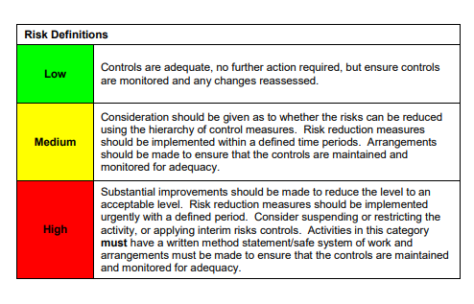

ACKNOWLEDGEMENT OF RISK ASSESSMENT Version:

PLEASE READ THE NOTICE BELOW BEFORE SIGNING THIS FORM
I acknowledge that I have read and understood the Risk Assessment/s associated with this task/event/equipment etc

Forename | Surname | Employee Signature | Date | Manager’s Signature

