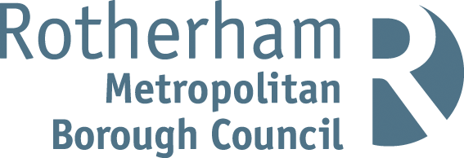

RISK ASSESSMENT FINDINGS

Department/Service
Date
Assessor
Approved By
Review Date

Relevant Legislation:

The Management of Health and Safety at Work Regulations 1999

RISK ASSESSMENT RECORD

ACTIVITY and/or ENVIRONMENT TO BE ASSESSED: Woodwork
DATE:

KEY (People at risk) | Likelihood (L) | Severity (S) | Risk Calculation | Risk Rating
E = Employee YP = Young Persons  P = Public  C = Contractors  V = Visitors  EM = Expectant Mothers | 1. Very Low (rare/very unlikely)  2. Low (unlikely)  3. Medium (could occur/possible)  4. High (likely to occur/probable)  5. Very High (near certain to occur) | 1. Insignificant (nuisance/discomfort)  2. Minor (no lost time)  3. Moderate (time loss)  4. Significant (serious/incapacity to work)  5. Major (Death) | Likelihood x Severity  =  Rating | 1- 6 LOW RISK Monitor  - MEDIUM RISK Monitor, review & reduce risk where possible  14-25 HIGH RISK Further Action Required

1.Hazards Identified and potential harm it could cause | 2. People  At Risk | 3.Controls in Place | 4.Risk Rating |  |  |  | 5. Further Action Required/ Recommendations | 6.Target Date for Completion
1.Hazards Identified and potential harm it could cause | 2. People  At Risk | 3.Controls in Place | L | S | Score | Risk | 5. Further Action Required/ Recommendations | 6.Target Date for Completion

Contact with cutter – severe injury |  | - Saw blades/machine cutter enclosed by adjustable guards so far as is reasonably practicable  - Emergency procedures/ emergency stops |  |  |  |  | Push bar used
Ejection of wood from machinery |  | - Appropriate tools available  - Anti-kickback devices on machinery where appropriate  - Appropriate guarding in place where applicable  - Emergency procedures/ emergency stops
Moving belt drive – trapping |  | Securely fixed guards in place
Wood dust – inhalation, fire hazard |  | - Local exhaust ventilation removes dust from machine  - Adequate housekeeping arrangements to remove dust deposits from surfaces |  |  |  |  | Provision of appropriate Personal Protective equipment for tasks  Regular inspection and maintenance of extraction / ventilation systems and all machinery.
Noise – hearing damage |  | - Regular inspection/ maintenance of machinery  - Designated hearing protection zone |  |  |  |  | Provision of appropriate Personal Protective equipment for tasks  Regular inspection and maintenance of extraction / ventilation systems and all machinery.
Electricity – electric shock |  | - Readily accessible emergency stops and other  controls  - Circuit breaker systems fitted to machinery  - Lockable isolators fitted to machinery |  |  |  |  | Regular inspection and maintenance of extraction / ventilation systems and all machinery.
Sharp hand tools – injury, cuts |  | - Tool storage area  - Supervised use of tools  - Supervised collection/return of tools |  |  |  |  | Provision of appropriate Personal Protective equipment for tasks
Inappropriate behaviour of pupils leading to injury |  | - Adequate supervision of pupils  - Procedures in place to deal with inappropriate behaviour
 |  |  |  |  |  |  | Refer to CLEAPSS guidance where necessary.

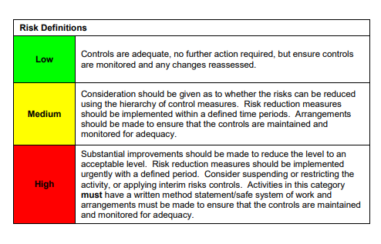

ACKNOWLEDGEMENT OF RISK ASSESSMENT Version:

PLEASE READ THE NOTICE BELOW BEFORE SIGNING THIS FORM
I acknowledge that I have read and understood the Risk Assessment/s associated with this task/event/equipment etc

Forename | Surname | Employee Signature | Date | Manager’s Signature

