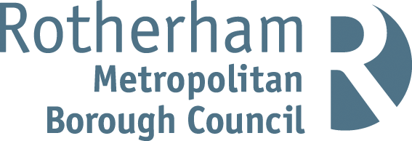

RISK ASSESSMENT FINDINGS

Department/Service
Date
Assessor
Approved By
Review Date

Relevant Legislation:

The Management of Health and Safety at Work Regulations 1999

RISK ASSESSMENT RECORD

ACTIVITY and/or ENVIRONMENT TO BE ASSESSED: Use of Kiln
DATE:

KEY (People at risk) | Likelihood (L) | Severity (S) | Risk Calculation | Risk Rating
E = Employee YP = Young Persons  P = Public  C = Contractors  V = Visitors  EM = Expectant Mothers | 1. Very Low (rare/very unlikely)  2. Low (unlikely)  3. Medium (could occur/possible)  4. High (likely to occur/probable)  5. Very High (near certain to occur) | 1. Insignificant (nuisance/discomfort)  2. Minor (no lost time)  3. Moderate (time loss)  4. Significant (serious/incapacity to work)  5. Major (Death) | Likelihood x Severity  =  Rating | 1- 6 LOW RISK Monitor  - MEDIUM RISK Monitor, review & reduce risk where possible  14-25 HIGH RISK Further Action Required

1.Hazards Identified and potential harm it could cause | 2. People  At Risk | 3.Controls in Place | 4.Risk Rating |  |  |  | 5. Further Action Required/ Recommendations | 6.Target Date for Completion
1.Hazards Identified and potential harm it could cause | 2. People  At Risk | 3.Controls in Place | L | S | Score | Risk | 5. Further Action Required/ Recommendations | 6.Target Date for Completion

Heat  Metal casing of kiln/firing objects |  | - Hot materials handled with tongs or other suitable tools.  - Safety Gloves to be worn when removing items whilst kiln still warm  - Kilns situated in working areas should be caged/isolated
Fire |  | - Detailed Fire Risk Assessment conducted and reviewed annually  - Rubbish not allowed to accumulate. Located in separate room/area.  - Flammable materials are not to be stored in the kiln room.  - Clear circulation space is maintained at all times (450mm).  - Appropriate fire extinguisher present in vicinity
Electrocution  Electrical shock  Burns |  | - No access to live heating elements - interlocking device where the kiln door cannot be opened before the mains supply is switched off.  - Installed by a competent electrician.  - Accessible and labelled isolation point.  - Extension leads / multiway plugs not to be used to connect kiln.  - Visual inspection conducted pre-use.  - Kiln must be regularly inspected by a competent person.
Use of ceramic materials |  | - Less hazardous chemicals/materials used wherever possible.  - No food or drink to be prepared or consumed in any area used for pottery.  - Effective hand washing after using ceramics materials and chemicals.  - All materials are properly labelled and stored, and appropriate warnings are included in the labelling.  - Material Safety Data Sheet for substances obtained from supplier and guidance followed.  - COSHH Assessment completed for all hazardous chemicals and control measures implemented.  - Immediate cleaning up of any spillage
Non authorised use |  | - Used only by competent operators  - Students use only under supervision  - Kiln sited in a lockable, specialist room which has an external red warning light / warning system.  - Written procedures on safe use and emergency procedures posted next to kiln.
Ceramic lining/asbestos lining (Ingestion of toxic substances, skin irritation/ sensitization) |  | - Check Site asbestos log information for location of asbestos containing material.  - Regular monitoring to ensure that the asbestos is not damaged.  - Specialist advice to be sought if work planned on a kiln which could disturb asbestos.
Inhalation of dusts including pottery glazes causing harm to health. |  | - Cleaning routines used limit the generation of dusts.  - Dry materials stored in sealed containers, spillages cleaned up immediately.  - Area regularly cleaned to prevent build-up of clay dust. Floors wet moped daily.  - Tables and surfaces to be cleaned whilst clay is damp.  - Aprons regularly laundered.
Fumes  Irritation/sensitisation to respiratory tract |  | - Good natural ventilation e.g. through doors /windows or extraction fan  - Do not used lead-based glazes.
Glazes to be used with foodstuffs (Ingestion of toxic /harmful substances) |  | - Do not use lead-based glazes.  - Ensure glazes or colour do not release metallic compounds when they come into contact with acids contained in food stuffs.  - Ensure glazes are used in accordance with the manufacturer’s instructions.
Spray application glazes (Irritation/sensitisation to respiratory tract) |  | - Spray glazes should only be used in properly designed spray booth or in outside areas.  - Operator should wear a mask.
Slips/Trips |  | - Ensure good housekeeping in the kiln room.  - Provide wet floor signs when floor is moped.  - Dry mop floors after spillages.
Manual handling loading / unloading ware |  | - Teachers or technicians should normally load kilns.  - Pupils carefully supervised and correct procedures for loading and unloading strictly observed.  - Appropriate footwear worn  - Mechanical lifting aids available (trolleys etc.)  - Heavy items stored at waist level.

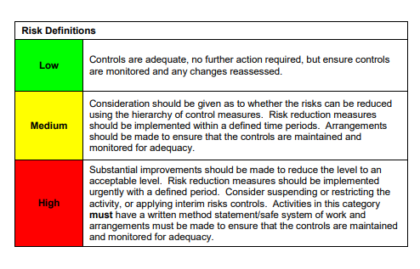

ACKNOWLEDGEMENT OF RISK ASSESSMENT Version:

PLEASE READ THE NOTICE BELOW BEFORE SIGNING THIS FORM
I acknowledge that I have read and understood the Risk Assessment/s associated with this task/event/equipment etc

Forename | Surname | Employee Signature | Date | Manager’s Signature

