Flood and water management act 2010 section 19

Summer Storms 2023

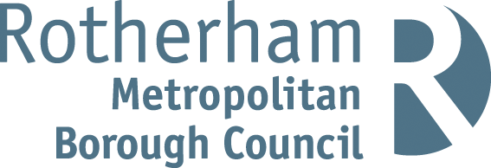`

Contents

Introduction 2

Legislation 2

Local Flood Risk Management Strategy 3

Overview 3

Rick Management Authorities 6

Internal Flooding 6

Local Flood Risk Management Strategy 11

Risk Management options. 12

Summary 12

Appendix 13

Flood event timeline 14

Flooding locations 15

## Introduction

In the summer of 2023, Rotherham experienced intense and prolonged heavy rainfall on the 18th of June and 8th of July. This led to severe flooding. The rainfall experienced exceeded the capacity of the drainage system, affecting 17 properties in various areas of the Borough with internal flooding. July was the wettest in England since 2009 and this flooding impacted the lives of residents and businesses. The aftermath prompted a collective response, with ongoing efforts since the night of June 18th to address the challenges posed by the flood event. The Council provided residents assistance during the event to minimise the extent of flooding and support residents and businesses in recovery. Since the event the Council has carried out a number of projects to reduce the flood risk to properties and worked with residents and business to provide resilience against future events.

## Legislation

Pitt Review (2008) - Flood and Water Management Act (2010)

The Pitt Review was published in 2008 following the catastrophic floods in 2007 which resulted in 13 fatalities and widespread destruction. The review contained 92 recommendations from lessons learnt. These were addressed to the government, local authorities, Local Resilience Forums (LRF), insurers, the public, and providers of essential services.

In response to the Pitt Review, a new Act of Parliament called The Flood and Water Management Act was implemented.

The Flood and Water Management Act was published in 2010 to take forward the Pitt Review recommendations and create a national approach to flood risk management across England and Wales. The creation of Lead Local Flood Authorities (LLFA) formed part of the Act along with Risk Management Authorities (RMA) all of whom have responsibilities in the management of flood risk.

As LLFA, Rotherham Metropolitan Borough Council is responsible for the coordination and management of local flood risk (ordinary watercourses, surface water, and groundwater) and is required to work in cooperation with relevant authorities and RMAs. Other agencies and authorities defined as the RMAs (Part 1.1 Section 6) included for the purpose of this rainfall event:

* Yorkshire Water

Under Section 19 of the act (Part 1.3 Section 19), as the LLFA, RMBC has the duty to investigate flood incidents and publish the results of the investigation.

The act states that:

On becoming aware of a flood in its area, a LLFA must, to the extent that it considers it necessary or appropriate, investigate—

which Risk Management Authorities (RMA’s) have relevant flood risk management functions,

and b) whether each of those RMA’s has exercised, or is proposing to exercise, those functions in response to the flood.

Where an authority carries out an investigation under subsection (1) it must—

publish the results of its investigation.

b) notify any relevant RMA’s.

The extent to which a particular flood is investigated is determined on a case-by-case basis considering factors such as the source, duration, geographical spread, and severity of impact. In some circumstances, a flood enquiry triggers a formal investigation. The trigger for a formal investigation is when the enquiry meets or exceeds locally agreed criteria. Previous section 19 reports can be found on Rotherham Council website.

## Local Flood Risk Management Strategy

This Local Flood Risk Management Strategy was originally produced by Rotherham Metropolitan Borough Council in 2014 and has been updated taking into consideration the recent devasting floods of 2019 and recent changes from climate change. This is to set out how the local flood risk within the borough will be managed.

The general principles of the Local Flood Risk Strategy are:

Community focus & partnership working

Sustainability

Risk Based Approach

Multiple benefits

[Flood Risk Management Strategy – Rotherham Metropolitan Borough Council](https://www.rotherham.gov.uk/water-management-flooding/flood-risk-management-strategy)

The Strategy identifies objectives that have recently been achieved and how they have been achieved. Including new objectives more suited to the ever-changing climate.

## Overview

The flooding on 18th June and 8th of July 2023 resulted from a combination of factors, primarily characterised by intense and prolonged heavy rainfall. This rainfall exceeded the capacity of many drainage systems, causing water to flow from fields, highways, and footways into residential and commercial properties.

As a result, 17 properties in various parts of Rotherham were affected by the surface water flooding internally. July was a very wet month, the wettest July in England since 2009, with all catchments receiving above average rainfall and the north-west recording the wettest July on record, using data from 1891. Soil moisture deficits decreased across England, with soils across much of the country wetter than expected for the end of July. River flows were above normal or higher, at more than half of the reported sites, particularly those in the northwest as they responded to the wet weather.

Although summer 2023 will be considered a poor one, it was actually close to average in regard to temperatures. Rainfall, however, was above average. This may be due to the joint warmest June on record being followed by a very wet July and an indifferent mixed weather in August. The UK flirted very closely with extreme temperatures during July and August fortunately these stayed on the other side of the channel. The region narrowly missed most of the thundery weather so a generally quiet summer in that regard.

Rainfall intensities in this period surpassed the capacity of the designed drainage systems. This weather event resulted in excessive flooding as the infrastructure struggled to cope with the overwhelming volume of water. The drainage system, originally designed to manage typical rainfall patterns, proved insufficient in the face of the extraordinary downpours. Consequently, a substantial overflow of water occurred, exacerbating the flooding situation, and posing significant challenges to the affected areas.

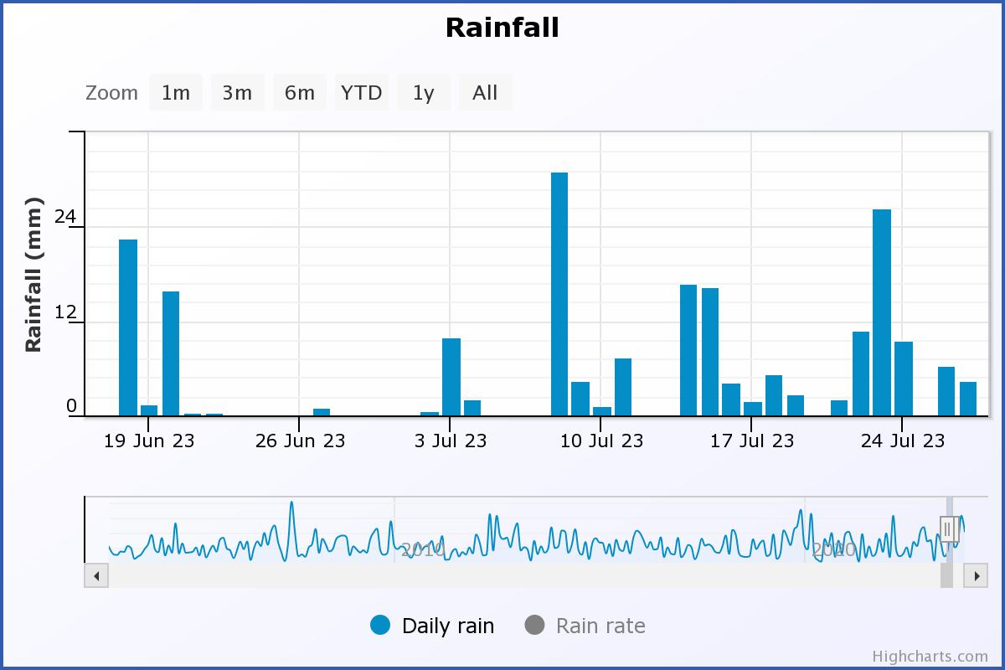

Figure 2 shows rainfall data between 19 June and 24 July

June started very dry with a single thunderstorm on the 5th. The wet period of the month then started on the 17th to the 20th leaving the remainder of the month dry.

Rainfall for July was well above average coming in at 255.1% of the average rainfall. The 2nd wettest July on record and one of the reasons why summer overall was considered poor.

|  |  |
| --- | --- |
| **Date** | **Rainfall (mm)** |
| 1St June – 16th June 2023 | 5mm |
| 17th June 2023 | 8.9mm |
| 18th June 2023 | 12.5mm |
| 20th June 2023 | 14.4mm |
| 21st June – 30th June 2023 | 2.2mm |
| 8th July 2023 | 27.9mm |
| 12th July 2023 | 12.5mm |
| 14th July 2023 | 14.3mm |
| 15th July 2023 | 15.1mm |
| 23rd July 2023 | 33.9mm |
| 26th July 2023 | 11.8mm |

## Rick Management Authorities

### Internal Flooding

|  |  |  |
| --- | --- | --- |
| **Residential Property address** | **Number of properties flooded internally** | **Risk Management Authority Responsible** |
| East Bawtry Road, Whiston, Rotherham | 1 | Yorkshire Water |
| Gladys Street, Clifton | 1 | Rotherham MBC as LLFA |
| Broom Valley Road, Broom | 2 | Yorkshire Water |
| Ash View, Greasbrough | 1 | Rotherham MBC as LLFA |
| Chesterhill Avenue, Dalton | 1 | Rotherham MBC as LLFA |
| Keppel view road, Kimberworth | 1 | Rotherham MBC as LLFA |
| Queen street, Swinton | 1 | Yorkshire Water |
| St Stephen’s drive, Aston | 4 | Yorkshire Water |
| Firth Road, West Melton | 1 | Rotherham MBC as LLFA |
| Chestnut Road, Swallownest | 1 | Rotherham MBC as LLFA |
| Netherfield Lane, Rawmarsh | 1 | Rotherham MBC as LLFA |
| Simmonite Road, Wingfield | 1 | Rotherham MBC as LLFA |
| Green Acres, Rawmarsh | 1 | Rotherham MBC as LLFA |

Several locations which were flooded have been affected before, but little information was readily available. This Section 19 will provide records for the future. Investigations into minor flooding incidents should also be recorded formally to ensure that any information gained is easily accessible to assist in the management of flood risk. The Local Flood Risk Management Strategy sets out how it is proposed to record and map flooding, ordinary watercourses, drainage assets, etc.

The flooding incidents investigated for this report followed a similar pattern. Highway drainage systems were overwhelmed by the high intensity of the rainfall over a short period of time, which led to water flowing from the highway toward residential properties. The presence of dropped kerbs allows water to flow off the highway more often and in greater quantities. Flood routes around properties have been blocked by extensions, outbuildings, walls or raised driveways.

Rotherham Councils Section 19 policy states that investigations will be carried out if there are 5 or more properties flooded internally. Rotherham Council have adopted the Planning Portal definition relating to internal flooding. This defines a habitable room, above floor level. It states ‘any room used or intended to be used for sleeping, cooking, living, or eating purposes. Enclosed spaces such as bath or toilet facilities, service rooms, corridors, laundries, hallways, utility rooms or similar spaces are excluded from this definition’.

## Summary

The flooding experienced was as a result of continuous rainfall through periods in June and July that saturated the catchment increasing surface water run-off that could not be managed by existing drainage systems. This led to flooding 17 properties internally.

# Appendix

Section 19 Flood Investigation+

## Time of events following the first report of rainfall.Flood event timeline

Figure 3 illustrates the main events that took places in response to the flooding.

## Flooding locations

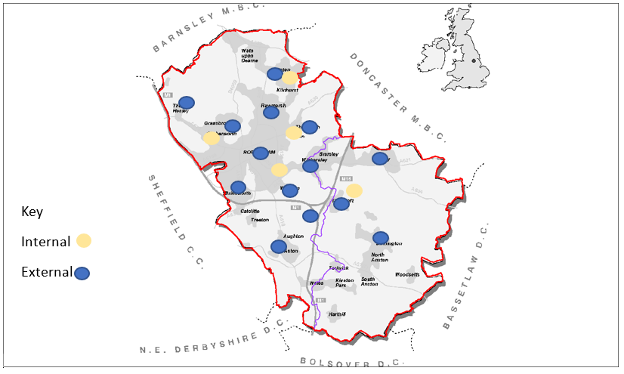

The map illustrates areas impacted by both internal and external flooding in the Rotherham Metropolitan Borough.