Rotherham draft

2025-2028 Pharmaceutical Needs Assessment

Contents
Acronyms 5
Executive Summary 6
1. Introduction 10
1.1. Introduction to pharmaceutical needs assessments 10
1.1.1. Legislative context and statutory requirements 10
1.2. Process summary 12
1.2.1 Governance 12
1.1.2 Gathering health and demographic data 12
1.1.3 Pharmaceutical services information 13
1.1.4 Public and contractor engagement 13
1.1.5 Data analysis – to be updated 14
1.1.6 Consultation 19
2 Rotherham: Demographic overview and summary of local health need 20
2.1 Rotherham: Demographic overview and summary of local health needs 20
2.2 Population: Current population and forecasts 21
2.3 Population health needs in Rotherham 22
2.3.1 Cancer (QOF) 22
2.3.2 Cardiovascular disease and risk factors 22
2.3.3 Diabetes (QOF) 23
2.3.4 Dementia 23
2.3.5 Respiratory disease (QOF) 24
2.3.6 Alcohol 24
2.3.7 Liver disease 24
2.3.8 Drug use 25
2.3.9 Mental health 25
2.3.10 Smoking (APS) 26
2.3.11 Weight 26
2.3.12 Physical activity 26
2.3.13 Sexual health 27
2.3.14 Limiting long term illness and disability 28
2.3.15 Vision, hearing and physical impairments 28
2.3.16 Multiple morbidities 29
2.4 The role of pharmacy in addressing inequality in Rotherham 29
2.4.1 Socioeconomic deprivation 29
2.4.2 Age 30
2.4.3 Disability 30
2.4.4 Pregnancy and maternity 31
2.4.5 Race 31
2.4.6 Religion 31
2.4.7 Sex 32
2.4.8 Sexual orientation 32
2.4.9 Gender reassignment 32
2.4.10 Marriage and civil partnership 32
2.4.11 Asylum seekers and refugees 32
2.4.12 Gypsy, Roma and Traveller communities 33
2.4.13 People with drug and/or alcohol dependence 33
2.4.14 Homeless people and rough sleepers 34
2.4.15 Those in contact with the criminal justice system 34
2.4.16 Sex workers 34
2.4.17 Visitors to the area for business or to visit friends and family 34
3 Current provision of pharmaceutical services in Rotherham 35
4 Assessment of service availability 41
4.1 Pharmaceutical service providers per 100,000 people – to be added 41
4.2 Availability and access according to distance and travel time 42
4.2.1 Walk time 43
4.2.2 Walk distance 46
4.2.3 Drive time 48
4.2.4 Access to cross-border pharmaceutical services 48
4.3 Availability according to opening times 50
4.3.1 Weekday opening 50
4.3.2 Weekend opening hours 51
4.3.2 Evening opening 55
4.4 Availability by service type 58
4.4.1 Pharmaceutical services: an overview 58
4.4.2 Service availability in Rotherham 64
4.5 Views and experiences of local people (Healthwatch Rotherham survey) 72
4.5.1 Demographics 72
4.5.2 Pharmaceutical services and choice of pharmacy 73
4.5.3 Access to a pharmacy 76
4.5.4 Deprivation 78
5 Other considerations 83
5.1 Housing developments – to be completed when data shared 83
5.2 Access to other services 84
5.2.1 Hospital pharmacies 84
5.2.2 Personal administration of items by GP practices 84
5.2.3 GP out of hours service 85
5.2.4 Flu vaccination by GP practices 85
5.2.5 Walk-in centres and minor injury units 86
6 Conclusions and Statements 87
Annexes 91
Annex 1: Consultation Report – to be added with the questions and responses after consultation has taken place. 91
Annex 2: Rotherham Health & Wellbeing Pharmaceutical Needs Assessment (PNA) Steering Group Draft Terms of Reference 91
Annex 3: Summary of pharmaceutical service provision by Rotherham ward by number of professional fees Jan 2024-December 2024 94
Annex 4: List of pharmaceutical service providers as of January 2025 105
Annex 5: Locally commissioned service provision maps 110
Annex 6: Advanced services service provision maps 113

Acronyms
CPCF Community Pharmacy Contractual Framework
CHD Coronary Heart Disease
EHC Emergency Hormonal Contraception
HES Hospital Episode Statistics
HWB Health and Wellbeing Board
ICB Integrated Care Board
IMD Indices of multiple deprivation
LSOA Lower super output area
NDRS National Disease Registration Service
NHSE/I NHS England / NHS Improvements
NHS BSA NHS Business Services Authority
NRT Nicotine Replacement Therapy
NSP Needle and Syringe Provision
OHID Office for Health Improvement and Disparities
ONS Office for National Statistics
PNA Pharmaceutical Needs Assessment
PSNC Pharmaceutical Services Negotiating Committee
RMBC Rotherham Metropolitan Borough Council
TRFT The Rotherham NHS Foundation Trust
QOF Quality Outcomes Framework

Executive Summary
What are Pharmaceutical Needs Assessments?
Legislation requires that Health and Wellbeing Boards produce an assessment of the need for pharmaceutical services. These assessments (Pharmaceutical Needs Assessments, or PNAs) are due every three years. The last PNA was published September 2022.
PNAs describe:
- current need for pharmaceutical services within a locality,
- current pharmaceutical services provision,
- whether current need is met by existing service provision or could be improved,
- potential future need, and
- potential need for new services.
How was this PNA produced?
Data regarding the provision of existing pharmaceutical services was gathered from NHS England / NHS Improvements and Rotherham Metropolitan Borough Council. This data was collated into a single master spreadsheet.
Data was analysed using the Department of Health and Social Care Strategic Health Asset Planning and Evaluation Place Atlas (SHAPE) – a web-enabled application that informs and supports the strategic planning of services and assets across a whole health economy. SHAPE maps pharmacy locations against demographic information and indicators of health status and need.
The health and pharmaceutical need of the Rotherham population were identified based on data from a range of sources including the Joint Strategic Needs Assessment, recent health needs assessments, and other local intelligence. The current provision of pharmacy and pharmaceutical services was compared with current and potential future demographic and health needs.
In line with statutory requirements, a 60- day consultation on the PNA is being undertaken from 14th July 2025. This consultation will be sent to the list of stakeholders as defined by the regulations. Feedback from the consultation will be incorporated into the PNA. Oversight of the PNA development was provided by a Steering Group, the purpose of which was to advise on the production of, and consultation on, the PNA on behalf of the Health and Wellbeing Board. The final PNA will be reviewed by the Health and Wellbeing Board in September 2025.
What are the health and wellbeing needs of the Rotherham population?
Rotherham borough covers an area of 110 square miles and has a population of 270,000. Around half of the borough’s population lives in the urban, central part of the borough. Others live in many outlying small towns, villages and rural areas. Rotherham is a diverse borough with a mixture of people, cultures and communities. There are densely populated multi-ethnic inner urban areas, large council-built housing estates, leafy private residential suburbs, industrial areas, rural villages, and farms.
Rotherham people live shorter lives, in poorer health than the UK average and there is substantial variation between different groups in terms of underlying health needs, ability to access services, experience of services and health outcomes. The points below give a flavour of the challenges and opportunities Rotherham faces over the next decade and are accurate as of May 2025 unless otherwise specified. A live, dynamic analysis of this and further information can be found in the Rotherham JSNA (https://www.rotherham.gov.uk/data/).

Population
- Rotherham has an age structure that is slightly older than the national average and a below-average percentage of people aged 18 to 29 because of students leaving Rotherham to study elsewhere, and young adults leaving the area for work.
- The population is growing due to there being more births than deaths, and more people moving to Rotherham to live.

Health Inequality
- 36% of the population live in the most deprived quintile and deprivation is a major cause of health inequalities.
- English is an additional language to 4.1% of our population.
- Over 11,000 children in Rotherham are living in absolute poverty.
- Over 3,700 people are currently accessing adult social care services, with around half of these over the age of 75.
- Over 23,000 people provide unpaid care, with over half of these doing so for more than 35 hours per week, and a third of adult carers feel socially isolated.
- In 2023, 1,236 families were identified as being at risk of homelessness.
- Life expectancy is lower than average for the people of Rotherham, and there is an inequalities gap of over 10 years between the most deprived and least deprived.
- Our residents develop poor health earlier than average and live longer in poor health than average; healthy life expectancy in 2021-23 in Rotherham is 56 years for males and females.

Health and health behaviours
- The prevalence of depression has risen to 17% in 2022, and 25% of school children reported problems with mental wellbeing in 2024.
- Deprivation significantly impacts patient experience and outcomes of chronic pain, mental health issues, diabetes, cardiovascular and other long-term conditions.
- Smoking is still the primary cause of morbidity and early mortality. Although smoking rates remain high, every year more people are successfully quitting.
- The percentage of physically active adults has decreased to 59% in 2023/24 and conditions such as stroke, coronary heart disease and hypertension remain higher than regional and national comparators.
- 40% of 11-year-old children and 72% of adults are overweight or obese.
- Adult community substance and alcohol services are able to support more people and have increased to over 950 people reached per year.
- Around 800 people engage in problem gambling, and around 3,200 in moderate risk gambling.

Access to care
- Screening uptake rates have generally been good in Rotherham compared to England, but for breast and cervical cancer, screening rates have not yet returned to pre-covid levels.
- Those in the most deprived areas are more likely to miss appointments and experience difficulties in accessing healthcare.

What are the main findings of the PNA?
As of January 2025, there were 65 pharmaceutical service providers for the area of Rotherham Health and Wellbeing Board. This includes:
- 61 Pharmacies
- 1 dispensing appliance contractor (DAC)
- 3 dispensing GP Practices
A local population of 268,267 (mid-2022 – most recent estimate for local areas) indicates 22.7 pharmacies per population head in Rotherham. The range within Rotherham is from 60.0 per 100,000 in Boston Castle ward to 9.6 per 100,000 in Brinsworth ward.
In Rotherham, 23% of our population do not have access to a car or van in their household (26,000 of 114,000 households) therefore access has been reviewed to include walking time and walking distance alongside drive time:
- 83.4% of the population of Rotherham live within a 15-minute walk of a Rotherham-based pharmaceutical service provider.
- Including cross-border pharmacies has a marginal impact on the proportion of Rotherham residents within 15 minutes’ walk, or 1.6km (1 mile) walk, of a pharmaceutical services provider.
- The proportion of Rotherham residents within 15 minutes’ walk increases from 84.2% to 84.8% when including these cross-border pharmacies (a further 1,590 people).
- The proportion of Rotherham residents within 1.6km (1 mile) walk increases from 95.5% to 96.6% when including these cross-border pharmacies (a further 2,980 people).
- 100% of Rotherham-based residents live within a 10-minute drive of a Rotherham based pharmaceutical services provider during rush hour.

Essential Services are those services offered by all pharmacy contractors. As such, access to Essential Services within Rotherham equates to access to pharmacies overall and the Rotherham PNA steering group agreed that the Essential Services would make up the Necessary Services for the PNA alongside some advanced services based on health need in Rotherham. These are the advanced services of Pharmacy First, hypertension case-finding, flu vaccination, and contraception service.
Conclusions and Statements
Overall, access to pharmaceutical services is Rotherham is good. Most of the population live within easy access of a pharmacy and good physical access is supplemented by increasing growth in national online service provision.
In consideration of all the information available at the time of writing, the Health and Wellbeing board concluded that:
- Based on the information presented herein, the Rotherham health and wellbeing board is satisfied that there is sufficient choice with regard to obtaining pharmaceutical services in Rotherham.
- The health and wellbeing board has identified that there would be need for pharmaceutical provision if one of the four 100-hour pharmacies reduced their opening hours to no longer cover evenings (17:00 onwards) or weekends (Saturday and Sunday). This would be because the geographical spread of the four pharmacies mean that a large proportion of the population would find it difficult to access pharmaceutical provision during evenings and weekends. The health and wellbeing board would expect that either existing pharmacy contractors will adjust their opening hours to address such changes in the future or the integrated care board will direct pharmacies to open to meet any differences in opening hours. If there is a need to direct pharmacies to increase their hours, the location should be in a similar place to where there has been loss of hours, or within an area that is easily accessible on public transport, such as the town centre. The health and wellbeing board would expect the replacement pharmacy, or hours covered by other pharmacies, to cover the same hours and services as the current provision in this assessment.
- There are no new housing developments of significant size during the lifetime of the document, and the population projections are not predicted to increase to sufficient size to create unmet pharmaceutical need providing services remain as are at the time of writing.
- The health and wellbeing board has noted the number of pharmacies that have signed up to provide, and are providing, the advanced and enhanced services of Lateral Flow Device Tests Supply Service, New Medicine Service, Emergency Hormonal Contraception, Needle and Syringe Provision Needle Exchange, Palliative Care, Supervised Consumption, and Over The Counter Medication Labelling Scheme, and are satisfied that the current demand can and will be met by the existing providers.

Introduction

Introduction to pharmaceutical needs assessments
The purpose of a Pharmaceutical Needs Assessment (PNA) is to assess and set out how the provision of pharmaceutical services can meet the health needs of the population of a Health and Wellbeing Board’s (HWB’s) area for a period of up to three years.
PNAs are primarily used to make commissioning and development decisions. Under the guidance on the NHS (pharmaceutical and local pharmaceutical services) (amendment) regulations 2023, where a person wishes to open a pharmacy or dispensing appliance contractor premises and provide pharmaceutical services; apply to relocate existing premises, or; buy an existing business, they must first apply to the relevant ICB to be included in the pharmaceutical list in respect of the HWB in whose area the premises are or are to be located.
Under the NHS (Pharmaceutical and Local Pharmaceutical Services) Regulations, a person who wishes to provide pharmaceutical services must apply to NHS England and NHS Improvement (NHSE/I) to be included in the relevant pharmaceutical list by proving they are able to meet a need for, or improvements or better access to, pharmaceutical services as set out in the relevant PNA. There are exceptions to this, such as applications for benefits not foreseen in the PNA or to provide pharmaceutical services on a distance-selling (internet or mail order only) basis. A robust PNA will ensure those who commission services from pharmacies and dispensing appliance contractors can ensure services are targeted to areas of health need; and will reduce the risk of overprovision in areas of less need. PNAs should not be a stand-alone document. This PNA is designed to contribute to and become an integral part of the Rotherham Joint Strategic Needs Assessment (JSNA) – available for review at https://www.rotherham.gov.uk/data/.

Legislative context and statutory requirements
The Health and Social Care Act 2012 established HWBs. It also transferred responsibility to develop and update PNAs from primary care trusts to HWBs with effect from April 2013. At the same time, responsibility for using PNAs as the basis for determining market entry to a pharmaceutical list transferred from primary care trusts to NHSE/I.
The NHS Pharmaceutical Services and Local Pharmaceutical Services Regulations 2013, (the ‘2013 Regulations’) set out the minimum information that must be contained within a PNA and outlines the process that must be followed in its development. This report covers the requirements of the 2013 Regulations as follows:

A series of statements are given in Section 6 (Conclusions and Statements) with regards to:
- The pharmaceutical services that the HWB has identified as services that are necessary to meet the need for pharmaceutical services,
- The pharmaceutical services that have been identified as services that are not provided but which the HWB is satisfied need to be provided in order to meet the current or future need for a range of pharmaceutical services or a specific pharmaceutical service,
- The pharmaceutical services that the Health and Wellbeing Board has identified as not being necessary to meet the need for pharmaceutical services but have secured improvements or better access,
- The pharmaceutical services that have been identified as services that would secure improvements or better access to a range of pharmaceutical services or a specific pharmaceutical service, either now or in the future and,
- Other NHS services that affect the need for pharmaceutical services or a specific pharmaceutical service.

As required by the 2013 Regulations, this PNA also contains details of:
- How the Health and Wellbeing Board has determined the localities in its area (Section 1.2.5)
- How it has accounted for the different needs of the different localities, and the different needs of those who share protected characteristics (Section 2.3.16, Section 1.2.5 and throughout Section 4)
- A report on the consultation process (Annex 1)
- A map that identifies the premises at which pharmaceutical services are provided (Section 3, Map 3)
- Information on the demography of the area (Section 2)
- Whether there is sufficient choice with regard to obtaining pharmaceutical services (Section 6)
- Any different needs of the different localities (Section 2.1, Section 2.2 and throughout Section 4)
- The provision of pharmaceutical services in neighbouring HWB areas (Section 4.2.4).
The structure and content of the report is based on guidance provided in 2021 by the Department of Health and Social Care.

Process summary

1.2.1 Governance
A PNA Steering Group was established for the PNA updated in 2022 whose purpose was to advise on the production of, and consultation on, the Rotherham PNA, on behalf of the HWB with the aim of ensuring that a PNA for Rotherham was published in compliance with the 2013 regulations and the needs of the local population. This steering group have continued to meet as required since this publication and have additionally met for the purpose of producing the 2025 document. Full terms of reference, including a list of members, for the Steering Group is provided at Annex 2.

Gathering health and demographic data
Annual population estimates for Rotherham were obtained from the Office of National Statistics (ONS) Mid-2022 estimates published November 2024. The population data included population sub-groups, gender, age and split by Lower Super Output Area (LSOA). Population and Indices of multiple deprivation (IMD) by Rotherham’s new ward boundaries apply a best fit model.
Birth rates and death registrations and occurrence data were obtained from ONS – birth rates at local authority level and death registrations data by local authority and place of death. Data on life expectancy and IMD were obtained from Office for Health Improvement and Disparities (OHID) Fingertips, numerator and denominator data from ONS annual death extracts and ONS mid-year population estimates. The IMD 2019 was used to define the deprivation deciles for this document.
Data for cancer, cardiovascular disease, diabetes, dementia, respiratory disease, and mental health are available at an Integrated Care Board (ICB) and national level. The cancer data are collated by the National Disease Registration Service (NDRS) and the cardiovascular profiles are created and maintained by the National Cardiovascular Intelligence Network. The data used for the indicators on diabetes comes from different sources, including routine primary care data, national survey data, national clinical audit data and hospital records. Respiratory data comes from OHID (based on ONS source data) for mortality and QOF, NHS Digital for prevalence of asthma.
Data for alcohol, liver disease, drug use, smoking, obesity and healthy weight and sexual health are available at a local authority level. The alcohol data are part of a series of products by The UK Health Security Agency (UKHSA) that provide local data alongside national comparisons to support local health improvement and data for liver disease are calculated by the OHID. Health and social care data was used from OHID Fingertips where data are derived from NHS Digital, Hospital Episode Statistics (HES) and ONS, Mid-year Population Estimates.

Pharmaceutical services information

Data on pharmaceutical services for this PNA were taken from multiple sources:
- A list of pharmaceutical service providers operating in Rotherham as of January 2025 was obtained from NHS Business Services Authority (NHS BSA) records, which was filtered by HWB. Clarifications about whether some pharmacies are located in Rotherham or neighbouring authorities were made using this list. Although it is acknowledged that there could be changes to the list of service providers since January 2025, this cut off point was chosen to enable time for data cleaning, upload, and analysis.
- Information on the number of items dispensed by Pharmacy and Appliance Contractors as of January 2025 which includes Advanced Services declared by each pharmacy and dispensing appliance contractor, along with activity for some of the advanced services was obtained from the NHS Business Services Authority website, Pharmacy and appliance contractor dispensing data, using data from calendar year 2024. The organisation data codes for all the services that generate prescriptions were obtained from NHS Digital. This data is accurate as of January 2025 and covers data from January 2024-December 2024.
- Information on advanced services claimed for were reviewed as fees for Appliance use review, Covid-19 lateral flow device distribution service, what was known as the Community Pharmacist Consultation service and is now the Pharmacy First service, Hepatitis C testing service, Hypertension case-finding service, New Medicine Service, Smoking cessation service, and Stoma Appliance Customisation Service. These were obtained from the NHS Business Services Authority website, April 2025, and covered the period January 2024-December 2024.
- Information on prescriptions generated, and dispensed, in Rotherham to identify the total number of items prescribed in a fixed period by each practice and service was obtained from the NHS Business Services Authority website practice prescribing dispensing data, using data from the calendar year 2024. This includes data for the Electronic Prescription Service. This data is accurate as of April 2025 and covers data from January 2024-December 2024.

Public and contractor engagement
Healthwatch Rotherham (HWR) invited Rotherham residents to complete an online questionnaire, about their experiences of and views on pharmacies locally. 57 people living in Rotherham completed the survey.

Data analysis – to be updated
Localities
The regulations require the HWB decide which localities to divide its area into for analysis.
Data on pharmaceutical service availably were compiled at Ward level to enable comparisons between Wards. Data on deprivation was compiled at LSOA level and aggregated to Ward level. There are 170 LSOAs in Rotherham and 25 wards.
The HWB determined to analyse information for the PNA primarily at borough-level, due to the relatively small total population and geographical area covered by the Rotherham HWB and the paucity of health-related data available at ward, Lower or Middle Super Output Area. However, deprivation and ward split were considered throughout the document. This is in keeping with the previous Rotherham PNAs (2018 and 2022). The HWB is mindful that the localities should not be so large that they mask variations in need, and consideration has been given to the practicality of dividing Rotherham into smaller geographical areas such as ward and deprivation deciles.
A table showing LSOA to ward best-fit is provided below in table 1.
LSOA Code | LSOA Name | Ward Name
E01007786 | Dinnington South | Anston & Woodsetts
E01007658 | North Anston West | Anston & Woodsetts
E01007662 | North Anston Central | Anston & Woodsetts
E01007657 | Anston Greenlands | Anston & Woodsetts
E01007661 | South Anston West | Anston & Woodsetts
E01007659 | Anston Park | Anston & Woodsetts
E01007660 | North Anston East | Anston & Woodsetts
E01007663 | South Anston East | Anston & Woodsetts
E01007664 | Woodsetts | Anston & Woodsetts
E01007748 | Todwick Outer | Aston & Todwick
E01007670 | Aston East | Aston & Todwick
E01007673 | Aston Lodge | Aston & Todwick
E01007674 | Swallownest South | Aston & Todwick
E01007669 | Aston North | Aston & Todwick
E01007672 | Aston South | Aston & Todwick
E01034250 | Orgreave West | Aughton & Swallownest
E01007668 | Aston North West | Aughton & Swallownest
E01007666 | Aughton North & Ulley | Aughton & Swallownest
E01007667 | Swallownest North | Aughton & Swallownest
E01007671 | Swallownest Central | Aughton & Swallownest
E01007714 | Town Centre | Boston Castle
E01007677 | Canklow North | Boston Castle
E01007680 | Wellgate | Boston Castle
E01007675 | Broom Valley | Boston Castle
E01007767 | Clifton West | Boston Castle
E01007679 | Broom East | Boston Castle
E01007678 | Moorgate West | Boston Castle
E01007765 | Clifton East | Boston Castle
E01007691 | Ravenfield Common | Bramley & Ravenfield
E01007692 | Ravenfield | Bramley & Ravenfield
E01007681 | Bramley Grange | Bramley & Ravenfield
E01007683 | Bramley North | Bramley & Ravenfield
E01007684 | Bramley South West | Bramley & Ravenfield
E01007689 | Bramley South East | Bramley & Ravenfield
E01007676 | Canklow South | Brinsworth
E01007707 | Brinsworth Whitehill | Brinsworth
E01007705 | Brinsworth West | Brinsworth
E01007704 | Brinsworth Manor | Brinsworth
E01007703 | Brinsworth North | Brinsworth
E01007702 | Brinsworth North East | Brinsworth
E01007706 | Brinsworth Howarth | Brinsworth
E01007720 | Thrybergh North & Hooton Roberts | Dalton & Thrybergh
E01007737 | East Herringthorpe North | Dalton & Thrybergh
E01007721 | Dalton | Dalton & Thrybergh
E01007723 | East Herringthorpe East | Dalton & Thrybergh
E01007719 | Thrybergh South | Dalton & Thrybergh
E01007727 | Thrybergh East | Dalton & Thrybergh
E01034251 | Laughton North | Dinnington
E01007789 | Laughton South & Dinnington North West | Dinnington
E01007785 | Dinnington South East | Dinnington
E01007790 | Dinnington Central | Dinnington
E01007791 | Dinnington East | Dinnington
E01007788 | Dinnington North East | Dinnington
E01007792 | Dinnington South West | Dinnington
E01034252 | Laughton West | Dinnington
E01007732 | Rockingham West | Greasbrough
E01007728 | Greasbrough East | Greasbrough
E01007733 | Rockingham East | Greasbrough
E01007730 | Wingfield | Greasbrough
E01007731 | Greasbrough North | Greasbrough
E01007729 | Munsbrough | Greasbrough
E01007685 | Hellaby | Hellaby & Maltby West
E01007762 | Maltby West - High School | Hellaby & Maltby West
E01007755 | Maltby West - Dale Hill | Hellaby & Maltby West
E01007756 | Maltby West - Explorers | Hellaby & Maltby West
E01007761 | Maltby West - Addison Road | Hellaby & Maltby West
E01007754 | Maltby West - Amory's Holt | Hellaby & Maltby West
E01007696 | Wentworth & Harley | Hoober
E01034246 | West Melton North | Hoober
E01007698 | West Melton South | Hoober
E01007695 | Brampton South | Hoober
E01007697 | West Melton West | Hoober
E01007694 | Brampton North | Hoober
E01007801 | Thorpe Common & Scholes | Keppel
E01007740 | Kimberworth Park East | Keppel
E01007742 | Kimberworth North West | Keppel
E01007807 | Kimberworth Park South | Keppel
E01007802 | Thorpe Hesley Central | Keppel
E01007803 | Thorpe Hesley West | Keppel
E01007808 | Thorpe Hesley East | Keppel
E01007805 | Kimberworth Park Roughwood | Keppel
E01007804 | Kimberworth Park West | Keppel
E01007806 | Kimberworth Park Central | Keppel
E01007772 | Kilnhurst South & Sandhill East | Kilnhurst & Swinton East
E01007777 | Kilnhurst Meadow View | Kilnhurst & Swinton East
E01007794 | Swinton South | Kilnhurst & Swinton East
E01007798 | Swinton South East | Kilnhurst & Swinton East
E01007795 | Kilnhurst Piccadilly | Kilnhurst & Swinton East
E01007764 | Maltby East - Birks Holt | Maltby East
E01007763 | Maltby East - Town Centre | Maltby East
E01007757 | Maltby East - Grange Lane | Maltby East
E01007759 | Maltby East - Highfield Park | Maltby East
E01007760 | Maltby East - Muglet Lane | Maltby East
E01007758 | Maltby East - Salisbury Road | Maltby East
E01007783 | Rawmarsh South | Rawmarsh East
E01007773 | Ryecroft North | Rawmarsh East
E01007776 | Rawmarsh South West | Rawmarsh East
E01007775 | Rawmarsh North East | Rawmarsh East
E01007771 | Ryecroft West | Rawmarsh East
E01007774 | Ryecroft South | Rawmarsh East
E01007784 | Parkgate | Rawmarsh West
E01007782 | Rawmarsh North | Rawmarsh West
E01007781 | Rawmarsh Monkwood | Rawmarsh West
E01007779 | Manor Farm | Rawmarsh West
E01007780 | Rawmarsh Victoria Park | Rawmarsh West
E01007778 | Upper Haugh | Rawmarsh West
E01034248 | Waverley | Rother Vale
E01034249 | Orgreave East | Rother Vale
E01007700 | Treeton East | Rother Vale
E01007699 | Catcliffe | Rother Vale
E01007701 | Treeton West | Rother Vale
E01007769 | Eastwood Village | Rotherham East
E01007768 | Eastwood Central | Rotherham East
E01007708 | Herringthorpe South | Rotherham East
E01007736 | Eastwood East | Rotherham East
E01007738 | East Dene North East | Rotherham East
E01007770 | East Dene North West | Rotherham East
E01007766 | East Dene South | Rotherham East
E01007735 | East Herringthorpe South | Rotherham East
E01007739 | East Dene East | Rotherham East
E01007734 | Herringthorpe North | Rotherham East
E01007716 | Masbrough | Rotherham West
E01007718 | Meadowbank | Rotherham West
E01007715 | Ferham | Rotherham West
E01007717 | Bradgate | Rotherham West
E01007744 | Kimberworth South | Rotherham West
E01007741 | Kimberworth North East | Rotherham West
E01007743 | Dropping Well | Rotherham West
E01007746 | Blackburn | Rotherham West
E01007745 | Richmond Park | Rotherham West
E01034253 | Whiston South & Morthen | Sitwell
E01007713 | Moorgate East | Sitwell
E01007712 | Broom South | Sitwell
E01007711 | Stag South | Sitwell
E01007710 | Herringthorpe East | Sitwell
E01007811 | Whiston North | Sitwell
E01007812 | Whiston East | Sitwell
E01007709 | Stag North | Sitwell
E01007800 | Swinton Central & Bridge | Swinton Rockingham
E01007796 | Swinton North | Swinton Rockingham
E01007818 | Swinton North West & Warren Vale | Swinton Rockingham
E01007799 | Swinton West | Swinton Rockingham
E01007793 | Swinton South West | Swinton Rockingham
E01007797 | Bow Broom | Swinton Rockingham
E01007810 | Thurcroft East | Thurcroft & Wickersley South
E01007690 | Wickersley South | Thurcroft & Wickersley South
E01007687 | Wickersley East | Thurcroft & Wickersley South
E01007815 | Thurcroft Central & Brampton | Thurcroft & Wickersley South
E01007809 | Thurcroft South West | Thurcroft & Wickersley South
E01007750 | Wales West | Wales
E01007749 | Kiveton Park North & Todwick Central | Wales
E01007747 | Wales East | Wales
E01007751 | Wales South & Woodall | Wales
E01007752 | Kiveton Park South & Harthill North | Wales
E01007753 | Harthill South & Thorpe Salvin | Wales
E01007821 | Wath North East | Wath
E01007820 | Wath North | Wath
E01007816 | Wath South East | Wath
E01034247 | Manvers | Wath
E01007822 | Wath Central & Newhill | Wath
E01007819 | Wath South | Wath
E01007817 | Wath South West | Wath
E01007724 | Brecks | Wickersley North
E01007686 | Wickesley West | Wickersley North
E01007688 | Listerdale | Wickersley North
E01032927 | Sunnyside South | Wickersley North
E01007682 | Bramley West | Wickersley North
E01007726 | Flanderwell | Wickersley North
E01007725 | Sunnyside East | Wickersley North
E01032926  Table 1: Lower Layer Super Output Area code and name to ward best fit in Rotherham. | Woodlaithes Village | Wickersley North

Assessment of service availability and access
To assess service availability and access, pharmaceutical services data was compiled into a Master Spreadsheet and compared to the data on the Department of Health and Social Care Strategic Health Asset Planning and Evaluation Place Atlas (SHAPE) – a web-enabled application that informs and supports the strategic planning of services and assets across a whole health economy. SHAPE maps pharmacy locations against demographic information and indicators of health status and need. To assess the sufficiency of pharmaceutical services in Rotherham, analysis was made in terms of:
- Choice of pharmacies: Number of pharmacies per 100,000 residents (Section 4.1)
- Geographical access: SHAPE was used to identify walk-time, walk-distance, and drive time to pharmaceutical service providers (Section 4.2).
- Opening hours: Data on opening hours was tabulated to compare access in the week, at weekends and in the evenings (Section 4.3).
- Service type: Data were compiled for the number of outlets providing advanced and locally commissioned services to identify any areas of under-provision (Section 4.4).
Data from the HWR survey were used to complement this, asking participants questions about their ability to access a pharmacy, including method and time to travel to it and which days and times were convenient to visit.
Analysis of excluded populations and protected characteristics
To identify whether there are any disparities in access to pharmaceutical services according to characteristics such as deprivation and age (which are associated with greater health needs and poorer health outcomes), SHAPE was used to compare the profile of populations excluded from pharmaceutical provision with the demographic profile of Rotherham as a whole.
Unfortunately, data is not available to enable detailed analysis of whether people with most protected characteristics are disproportionately excluded from access to pharmaceutical services. For example, detailed and up-to-date data on the prevalence of disability at LSOA level is not available to enable analysis of whether access to pharmaceutical services is worse for people living with a disability. However, because SHAPE does include IMD domains at LSOA level, analysis of access by the Health and Disability domain is used as a proxy indicator in analysis of access for several protected characteristics including disability.
Additionally, the HWR survey asked participants questions around protected characteristics, including deprivation and disability.

Consultation

A 60-day public consultation is being conducted from 14th July 2025. A consultation report will be provided in Annex 1.

Rotherham: Demographic overview and summary of local health need

Rotherham: Demographic overview and summary of local health needs
Rotherham borough covers an area of 110 square miles and has a population of 270,000. Around half of the borough’s population lives in the urban, central part of the borough. Others live in many outlying small towns, villages and rural areas. Rotherham is a diverse borough with a mixture of people, cultures and communities. There are densely populated multi-ethnic inner urban areas, large council-built housing estates, leafy private residential suburbs, industrial areas, rural villages, and farms.
Rotherham people live shorter lives, in poorer health than the UK average and there is substantial variation between different groups in terms of underlying health needs, ability to access services, experience of services and health outcomes. The points below give a flavour of the challenges and opportunities Rotherham faces over the next decade and are accurate as of May 2025 unless otherwise specified. A live, dynamic analysis of this and further information can be found in the Rotherham JSNA (https://www.rotherham.gov.uk/data/).

Population
- Rotherham has an age structure that is slightly older than the national average and a below-average percentage of people aged 18 to 29 because of students leaving Rotherham to study elsewhere, and young adults leaving the area for work.
- The population is growing due to there being more births than deaths, and more people moving to Rotherham to live.

Health Inequality
- 36% of the population live in the most deprived quintile and deprivation is a major cause of health inequalities.
- English is an additional language to 4.1% of our population.
- Over 11,000 children in Rotherham are living in absolute poverty.
- Over 3,700 people are currently accessing adult social care services, with around half of these over the age of 75.
- Over 23,000 people provide unpaid care, with over half of these doing so for more than 35 hours per week, and a third of adult carers feel socially isolated.
- In 2023, 1,236 families were identified as being at risk of homelessness.
- Life expectancy is lower than average for the people of Rotherham, and there is an inequalities gap of over 10 years between the most deprived and least deprived.
- Our residents develop poor health earlier than average and live longer in poor health than average; healthy life expectancy in 2021-23 in Rotherham is 56 years for males and females.

Health and health behaviours
- The prevalence of depression has risen to 17% in 2022, and 25% of school children reported problems with mental wellbeing in 2024.
- Deprivation significantly impacts patient experience and outcomes of chronic pain, mental health issues, diabetes, cardiovascular and other long-term conditions.
- Smoking is still the primary cause of morbidity and early mortality. Although smoking rates remain high, every year more people are successfully quitting.
- The percentage of physically active adults has decreased to 59% in 2023/24 and conditions such as stroke, coronary heart disease and hypertension remain higher than regional and national comparators.
- 40% of 11-year-old children and 72% of adults are overweight or obese.
- Adult community substance and alcohol services are able to support more people and have increased to over 950 people reached per year.
- Around 800 people engage in problem gambling, and around 3,200 in moderate risk gambling.

Access to care
- Screening uptake rates have generally been good in Rotherham compared to England, but for breast and cervical cancer, screening rates have not yet returned to pre-covid levels.
- Those in the most deprived areas are more likely to miss appointments and experience difficulties in accessing healthcare.

Population: Current population and forecasts
The population of Rotherham borough is 271,200 with an age structure that is slightly older than the national average (2023 estimate of population, though please note that due to data availability, a mid-2022 population has been used in this document where geographies are represented for smaller areas such as wards). Rotherham has a below average percentage of people aged 18 to 29 as a result of students leaving Rotherham to study elsewhere and young adults leaving the area for work. The high proportion of residents aged 50-64 is largely a reflection of high birth rates in the 1960s and early 1970s. Demographic change is likely to result in subsequent changes to demand for health and care services. The Rotherham population has increased steadily from an estimated 261,400 in 2014 to 271,200 in 2023 (+3.8%). This steady increase was a result of more births than deaths occurring locally, coupled with high net inward migration. The oldest age groups are the fastest growing, mainly those aged 75+.
The population of Rotherham is projected to grow as well as continue to change in age structure (figure 1). There will be an overall estimated 277,000 people living in Rotherham in 2030 and 290,000 people in 2040, with noted projected increases in those aged 70 years old and above.

Figure 1: Rotherham population projections by age band.

Population health needs in Rotherham

2.3.1 Cancer (QOF)
In the period 2023/24, there were 10,363 people living with cancer registered to a Rotherham GP (QOF prevalence data). This equates to 3.8%, 0.2 percentage points greater than the prevalence for England. This is also 0.6 percentage points higher than the proportion at the previous PNA in 2022. New cancer cases, 2022/23, were 1,805 equating to 669 per 100,000. This is higher than the national rate at 548 per 100,000, and 27 people per 100,000 higher than the crude incidence rate in Rotherham at the previous PNA in 2022.

Cardiovascular disease and risk factors
The prevalence of cardiovascular diseases such as Coronary Heart Disease (CHD) and Heart Failure are higher in Rotherham than England (QOF prevalence), both of which have considerable impacts on health with CHD being the single most common cause of premature death in the UK. In the period 2023/24, a total of 10,309 people, 3.8%, were on the CHD register in Rotherham, compared to 3.0% for England. During the same period, there were 3,016 patients with heart failure, equivalent to 1.1% of the Rotherham population, the same as the proportion for England.

Hospital admissions for CHD for all persons were 1,685 in total, equivalent to 615 per 100,000, worse than that for England at 390 per 100,000. There was a consistent trend towards a decreasing rate of admissions in Rotherham between 2003/04 and 2020/21, however there has been a steady increase in the rate of admissions from 566 per 100,000 in 2021/22 to 615 per 100,000 in 2023/24. Admissions for heart failure were slightly higher in Rotherham than England, 184.9 per 100,000 and 179.6 per 100,000 respectively. There has been a steady increase in the rate of admissions in both Rotherham and England since 2020/21 to 2023/24.

During 2023/24, 2.3% of Rotherham residents had experienced a stroke, a total of 6,404, higher than the England prevalence at 1.9%. Risk factors for cardiovascular disease include smoking and hypertension, both of which have a greater QOF prevalence in Rotherham than England. In 2020/21, 46,489 residents (all ages) were living with hypertension, 17.0 %, compared to 14.8% in England. During the same period, 35,901 people, 16.1% of the population smoked compared to an England value of 14.5%. It is estimated that the prevalence of undiagnosed adult hypertension in Rotherham is 8.9% and in England is 8.6%.

Diabetes (QOF)
Diabetes mellitus is one of the common endocrine diseases affecting all age groups with over three million people in the UK having the condition. In 2023/24, 19,315 in Rotherham were living with diabetes, equivalent to 8.8 % (patients aged 17 years and over with diabetes mellitus, as recorded on practice disease registers). This has been increasing since 2012/13 and has remained above the England value throughout this time, with prevalence currently at 7.7%. The gap between the prevalence of diabetes in Rotherham compared to England has widened over the period, from 0.3 to 1.1 percentage points between 2016/17 and 2023/24. It is likely that the true prevalence is higher, and some will remain undiagnosed; in the 2022 Health Survey for England, the national prevalence of diabetes was 10%, comprised of approximately 5% of adults with doctor-diagnosed diabetes and a further 5% with undiagnosed diabetes.

Dementia
The prevalence of dementia increases with age and is estimated to be approximately 20% at 80 years of age. For those aged 90 and above, the annual incidence of Alzheimer’s type of dementia rises to 34.3 per 100 person years at risk; the prevalence is higher in women due to increased lifespan. In a third of cases, dementia is associated with other psychiatric problems.

In Rotherham, a total of 2,941 people were recorded as having dementia in 2020/21, a prevalence of 1.1%, higher than the value for England which was 0.8 %. (Recorded dementia prevalence is the number of people with dementia recorded on GP practice registers as a proportion of the people registered at each GP practice). Recorded prevalence in those aged 65 years old and above was also higher for Rotherham, 4.5% compared to 3.97% for England.

Respiratory disease (QOF)
The annual percentage of registered deaths where respiratory disease was the underlying cause in 2020 was 12.4% for Rotherham, higher than the England value which was 10.2%. For emergency hospital admissions for respiratory disease, 2022/23, Rotherham had 2,670 persons, a rate of 4,965 per 100,000, which is significantly worse than the England rate of 711 per 100,000. The under 75 mortality rate from respiratory disease in 2022 was 52 per 100,000, a total of 128 deaths. This is higher than the England value of 30.7 per 100,000.

Alcohol
Misuse of alcohol can have significant health implications, impacting on both the individual and the wider community. Nationally, the Health Survey for England 2022 showed 32% of men and 15% of women were drinking at a level of increased harm (over 14 units of alcohol a week). In Rotherham, in 2019/20, the estimate of number of alcohol dependent adults, was 1.69 per 100 compared to 1.37 nationally.

In 2022/23, there were a total of 5,892 admission episodes for alcohol-related conditions (broad definition), of which 4,159 were males and 1,733 were females. This is a rate of 2,201 per 100,000 – (3,240 for males and 1,271 for females) – all of which are significantly worse than the national average, which is a rate of 1,705 per 100,000 overall, 2646 for males and 881 for females. For both Rotherham and England, there is a substantially higher rate of admissions for men than women, which is consistent with data for previous years. In Rotherham, in 2022/23, the rate of admissions was 2.5 times higher for males than females, whereas it was 3 times higher for England. In Rotherham, there has been a gradual increase in the rate of admissions since 2016/17 across all three categories, however there was a slight decline between 2021/22 and 2022/23 (from 2,362 to 2,201 for persons).

In addition, for alcohol-specific conditions during the same period, there were 2,286 admissions of which 1,520 were male and 645 females. This is a rate of 866 per 100,000 for persons, 1,194 per 100,000 for males and 555 per 100,000 for females, all of which are significantly worse than the England rates of 581 per 100,000, 819 per 100,000 and 355 per 100,000 respectively. As with alcohol-related conditions, men have a substantially higher rate for alcohol-specific admissions than women. In Rotherham, in 2022/23, the rate of admissions is 2.2 times higher for males than females, where it is 2.3 times higher for England. In Rotherham, there was a notable increase in the rate of admissions since 2019/20 across all three categories, however there was a slight decline between 2021/22 and 2022/23 (from 1,017 to 866 for persons). There was a greater decline in the rate of admissions for men than for women.

Liver disease
Liver disease is one of the top causes of death in England and is having an impact on much younger people. Most liver disease is preventable and is often influenced by alcohol and obesity. The hospital admission rate due to liver disease in Rotherham, 2022/23, was 202.1 per 100,000 (persons). This value was higher in males at 246.6 per 100,000, and lower in females at 160.1 per 100,000. The rates for Rotherham were higher (worse) across all three groups compared to the England average, where the hospital admission rate due to liver disease was 155.2 per 100,000 for persons, 194.8 per 100,000 for males and 118.6 per 100,000 for females.

The age-standardised, under 75 mortality rate from liver disease (persons, 1 year range), was 28.1 per 100,000 in 2023 compared to the value for England at 21.9 per 100,000. This has fluctuated in Rotherham since 2018, although it has trended towards increase since 2001. The under 75 mortality rate from alcoholic liver disease (persons, 3-year range), was 12.3 per 100,000 in 2021-23, which is slightly worse than the England value of 11.7 per 100,000. In Rotherham, this has increased consistently since the rate for 2018-20 and has trended towards increase overall throughout the data period.

Drug use
In 2019/20 there were 25 admission episodes (10 male and 15 female) where there was a primary diagnosis of drug related mental and behavioural disorders in Rotherham. This equates to 10 admissions per 100,000 population. This is lower than the England admission rate which is 13 per 100,000. During the same period, there were 685 admissions episodes with a primary or secondary diagnosis of drug related mental and behavioural disorders which amounts to 276 admissions per 100,000 population. This is higher than the regional rate, which is 191 per 100,000 and the national rate, which is 181 per 100,000. Admission episodes with a primary diagnosis of poisoning by drug misuse were 80, a rate of 31 per 100,000 - equivalent to that of the national average.

In terms of dual diagnosis, in Rotherham in 2022/23, 76.1% of clients entering into drug treatment identified as having a mental health treatment need were also receiving treatment for their mental health. This is consistent with previous years and is marginally higher than the England average of 74.8%.

Mental health
The Adult Psychiatric Morbidity Survey (2014), found around one in six adults (17%) surveyed in England met the criteria for a common mental disorder and 39% of adults aged 16-74 with conditions such as anxiety or depression, were accessing mental health treatment. This figure has increased from 24% since the previous survey (2007). The data and report for the Adult Psychiatric Morbidity Survey (2023/24) will be release in July 2025.

In primary care in Rotherham 2022/23, the recorded prevalence of depression (aged 18+) was 17.3% a total of 36,892 persons. This is higher than the England value of 13.2% and has been increasing in Rotherham since 2012/13. This indicator was retired after 2022/23, so there is no data for the following year. The incidence of new diagnoses during 2023/24 (the most recent period) was 1.5%, a total of 3,145 persons, the same as the England value. Previously, the Rotherham incidence rate was greater than the England rate. This incidence has fluctuated in Rotherham since being recorded in 2013/14, with an overall trend towards decrease since a peak of 2% in 2015/16.

Smoking (APS)
Smoking is the most important cause of preventable ill health and premature mortality in the UK. It is a risk factor for many diseases such as cancer, COPD and heart disease. Tobacco control measures can assist in reducing the prevalence of smoking in the population. In the Adult Population Survey (APS) Rotherham in 2023, the prevalence smokers aged 15 years and over was 14.5%, an increase from 14.0% in 2022.

The prevalence in Rotherham has decreased overall throughout the data period since 2013/14, from 21.9% to 14.5% in 2022/23, a decrease of 7.4 percentage points.

In Rotherham 2022/23, the rate of people who self-reported successfully quitting at 4 weeks of treatment in NHS Stop Smoking Services was 3,156 per 100,000 smokers aged 16 and over, double from 1,580 per 100,000 in 2018/19. This is substantially higher than the England average of 1,620 per 100,000.

There has also been a decrease in the number of mothers smoking during pregnancy, dropping from 12.5% in 2022/23 to 10.8% in 2023/24. The Rotherham prevalence in 2023/24 was higher than the England average of 7.4%. Smoking in pregnancy has well known detrimental effects for the growth and development of the baby and health of the mother. The prevalence in Rotherham has decreased throughout the data period since 2010/11, from 23.0% to 10.8%, a decrease of 12.2 percentage points based on the number of maternities where smoking status is known.

Weight
The prevalence of excess weight has been increasing over time, both locally and nationally. Rotherham has a higher prevalence of excess weight than the national average. In 2022/23, 74.0% of adults in Rotherham were classified overweight or obese, compared to 67.2% regionally and 64.5% nationally – this equates to around 154,356 adults in Rotherham with excess weight. Of children in Rotherham schools, both excess weight in reception and excess weight in Year 6 aged children are above the national average. 24.7% of reception age children were overweight or obese in 2023/24, compared to 22.1% nationally and 40.5% of Year 6 children were overweight or obese in 2023/24, compared to 35.8% nationally (National Child Measurement Programme). The proportions of reception and Year 6 students who are overweight or experiencing obesity have fluctuated over the data period since 2007/08.

Physical activity
In 2023/24, 58.8% of adults in Rotherham were meeting the national physical activity guideline, while in England 67.4% of adults were attaining the recommended level (at least 150 minutes of moderate intensity activity each week or at least 75 minutes of vigorous intensity activity per week). In Rotherham, this decreased from 64.1% in 2022/23, a 5.3 percentage point decrease. Prior to this, the proportion of physically active adults had stayed consistent since 2019/20.

In 2023/24, 44% of children and young people were meeting the national physical activity guideline (an average of at least 60 minutes moderate to vigorous intensity activity per day across the week), lower than the England average of 47.8%. In Rotherham, this was a decrease from 48.7% in 2022/23. Over the data period, since 2017/18, the proportion of children in Rotherham meeting the national physical activity guideline has fluctuated between approximately 42% and 49%.

Sexual health
As of 2023, Rotherham had a smaller rate than England for all STI diagnoses, with 1,614 diagnoses equating to 601 per 100,000 in Rotherham compared to 704 per 100,000 in England. This difference between Rotherham and England is consistent with previous years. The rate of all STI diagnoses in both areas has increased since 2021, and in Rotherham the rate in 2023 was similar to pre-Covid levels with 614 diagnoses per 100,000 in 2019, compared to 601 in 2023.

HIV testing is integral to the treatment and management of HIV infection and awareness of HIV status can assist with improving survival rates, improving quality of life and can reduce the risk of onward transmission. The HIV testing rate for Rotherham was significantly worse than the England average, at 2,355 per 100,000 in Rotherham compared to 2,771 per 100,000 in England in 2023. It should be noted that this does not take community testing into account.

The HIV diagnosed prevalence rate for those aged 15 to 59, 2023, was 1.70 per 1,000 in Rotherham, better than the England rate of 2.40 per 1,000. Rotherham’s diagnosed rate has consistently been lower than England, although it has increased across the data period, from 0.97 in 2011 to 1.70 in 2023. For the same period, the new HIV diagnosis rate per 100,000, which includes people of all ages, was better in Rotherham than the England, with a rate of 8.5 diagnoses per 100,000 population in Rotherham compared to 10.4 per 100,000 in England. The rate in Rotherham has fluctuated throughout the period, but increased substantially from 3.7 diagnoses per 100,000 population in 2022 to 8.5 per 100,000 in 2023. Both the Rotherham and England rates have increased since 2020.

Both the syphilis and gonorrhoea diagnostic rate in Rotherham were significantly better than the England rate at 11.2 per 100,000 and 111 per 100,000 compared to 16.7 per 100,000 and 149 per 100,000 respectively. The syphilis diagnostic rate in Rotherham decreased between 2022 and 2023, after having increased substantially between 2020 and 2022. The gonorrhoea diagnostic rate in Rotherham has increased substantially since 2021, from 38 per 100,000 in 2021 to 111 per 100,000 in 2023, and is nearly 3 times larger.

The chlamydia detection rate for those ages 15 to 24, was statistically better in Rotherham than England in 2023; 2,549 per 100,000 for Rotherham compared to 1,962 per 100,000 for England. The detection rate in Rotherham has been increasing since 2022, after decreasing substantially in 2020. However, it is not yet back at pre-Covid levels; 3,040 per 100,000 in 2019.

Limiting long term illness and disability
A relatively high proportion of Rotherham's population have a long-term condition or are living with a disability. In the 2021 Census in Rotherham, 56,177 people (21.1%) reported having a limiting disability, defined by long-term physical or mental health conditions or illnesses. This was 2.8 percentage points higher than England as a whole (17.3%). Caution should be taken when making comparisons between 2011 and 2021 because of changes in question wording and response options. Of the people in Rotherham with a limiting disability, 26,118 people (9.8%) had a disability that limited their day-to-day activities a lot, whilst 30,059 (11.3%) had a disability that limited their day-to-day activities a little. The percentage of people who were identified as being disabled and limited a lot in Rotherham decreased by 2.1 percentage points between the 2011 and 2021 Census.

In the Rotherham School Survey in 2023/24, 1,337 (29.5%) students answered ‘yes’ to having a long-term illness, medical condition or disability that has been diagnosed by a doctor, compared to 21% in 2022/23 and 25% of young people nationally in 2021/22.²

In 2014-15, 14.9% of Rotherham residents were living with a long-term illness, disability or medical condition diagnosed by a doctor at aged 15. In 2011, 31,001 people (12%) in Rotherham said that they provided unpaid care to family members, friends or neighbours with either long-term physical or mental ill-health/disability or problems related to old age.

Vision, hearing and physical impairments
A greater risk of sight loss is associated with increased age and Rotherham has a higher proportion of older age groups compared to the average of England. Poor health and other health conditions can be linked to sight loss such as smoking and obesity which can increase the risk of developing diabetes leading to sight loss.

In Rotherham, there are an estimated 9,150 people, 3.4% of the population, living with sight loss; 5,880 people living with mild sight loss, 2,050 with moderate sight loss, 1,230 with severe sight loss.³

8.1% of people reported deafness or hearing loss in Rotherham in the GP Patient Survey in 2024, significantly greater than the England average of 5.8% (a 2.3 percentage point difference).⁴ With the exception of 2017, Rotherham has consistently had a significantly larger proportion of people reporting deafness or hearing loss than England.

1.2% of people registered to a Rotherham GP reported having a learning disability in the GP Patient Survey, data updated 2021.

Multiple morbidities
Multimorbidity is almost universal in older adults, and prevalence increases with age. Although multi-morbidities have been researched extensively, one precise definition does not exist and the number, type (physical or mental health) and selection criteria for conditions included in multi-morbidity indices vary. Measures of multi-morbidity and frailty are being developed on Fingertips. ⁵ In a good-quality retrospective cohort study in England (with 403,985 participants), the overall prevalence of multimorbidity was 27.2%. ⁶ Females had a higher prevalence of 30%, compared to 24.4% for males.

General practice data suggests that, for a total of 268,849 registered patients, 38.7% of patients had at least 1 co-morbidity.

The role of pharmacy in addressing inequality in Rotherham
This section of the assessment focusses on the pharmaceutical needs of those most likely to experience inequalities and barriers to accessing care in Rotherham and the ways in which community pharmacy can address these needs. This includes consideration of:
- People living in the 20% most deprived communities (according to IMD, 2019)
- Those with one or more protected characteristics defined within the Equality Act 2010 (age, disability; pregnancy and maternity; race which includes colour, nationality, ethnic or national origins; religion (including a lack of religion) or belief; sex; sexual orientation; gender re-assignment; marriage and civil partnership.)
- Inclusion health groups, such as:
  - Asylum seekers and refugees
  - Gypsy, Roma and Traveller communities
  - Homeless people and rough sleepers
  - People with drug or alcohol dependence
  - Those in contact with the criminal justice system
  - Sex workers

It should be noted that geography can also be a key driver of inequality, but detailed analysis of geographical factors influencing access to pharmacies in Rotherham is covered in Section 4.2.

2.4.1 Socioeconomic deprivation
Socioeconomic deprivation is a major driver of health inequalities in Rotherham, with 36% of communities living in the 20% most deprived communities in England according to IMD, 2019. Those living in areas of high deprivation are more likely to experience poor health outcomes and live with chronic disease than those living in areas of lower deprivation. This means that areas of high deprivation may have a high level of pharmaceutical need.
However, whilst the need may be high, there are several barriers for deprived communities seeking to access pharmaceutical services:
- Financial barriers. This can include the cost of medication, but also the ‘hidden costs’ associated with accessing pharmacy services (such as the cost of transport.) Pharmacists should provide advice on eligibility criteria for free prescriptions. As outlined in Section 4.2, ensuring that residents in Rotherham can access a pharmacy within a short walk or via public transport is also important.
- Shift and/or insecure work. People living in the most deprived communities are more likely to do shift or casual/insecure work, which is generally less flexible than other types of work and can make accessing services outside of working hours more challenging. Section 4.3 considers availability of pharmacies according to opening hours and has taken this into account.
- Digital exclusion. Those living in areas of high deprivation are more likely to have no internet at home and/or to be digitally excluded. While digital provision such as online ordering can help improve access to pharmaceutical services for some groups, it should not be at the expense of physical provision, as this could widen health inequalities.
Section 3 outlines the distribution of pharmacies in Rotherham.

Age
Age can influence medicine choice and the route of administration, meaning pharmacies must be able to flex to address differing needs by age.
Older people are also more likely to have a higher prevalence of illness, and subsequently may take more medication. Medication management in older age groups can be complex due to multiple disease, polypharmacy and metabolism changes due to the ageing process. Pharmacy services can help to meet the needs of older people through medication ordering and reordering support, home delivery and compliance aids such as reminder charts. Pharmacies can also support independence in older age by supplying daily living aids and signposting to additional support systems.
Similarly, younger people have a different ability of metabolism and drug elimination. For children and young people, advice can be given to parents on medicine/appliance usage and the different routes of drug administration.
Certain provisions within community pharmacies are targeted to certain age cohorts, such as the flu vaccine. These provisions are purposefully targeted in order to address inequalities that are influenced by age (such as deaths or serious illness from flu).

Disability
The needs of disabled people in accessing pharmacy services are extremely diverse and vary by disability.
For those with mobility issues, physically accessing pharmacy services has the potential to be challenging. Ensuring that pharmacies have both disabled parking and other accessibility measures such as ramps and sufficient space within the pharmacy for wheelchairs can help to mitigate barriers to access. Pharmacies may also provide a delivery service.
For those with visual impairments (as well as for those with mobility issues), it would be beneficial for pharmacies to ensure that the pathway is clear and unobstructed. Additionally, lighting, contrasting colours and the use of tactile signage, such as Braille may be supportive for those with visual impairments.
Pharmacists may need to adjust their approach to communication for those with certain disabilities, such as some learning disabilities or those with hearing impairments.
If a client has a physical or mental impairment that impacts their ability to manage their medication, pharmacies could apply reasonable adjustments to packaging or instructions to support.

Pregnancy and maternity
This group may require advice on safe use of medication in pregnancy and breastfeeding. There are also many common health problems that are associated with pregnancy and the post-partum period, which pharmacies can provide advice and guidance on.
Additionally, ensuring that pharmacies are wheelchair accessible has the additional benefit of making them pram accessible, which may make pharmacies easier to access for those with young children.

Race
Ethnic minority communities experience health inequalities and generally worse health outcomes than the overall population (although patterns vary for each health condition and some groups have worse health than others.) Deprivation is likely to be a driving factor in this inequality, meaning that some of the barriers in the section on socioeconomic deprivation section may apply.
Particularly for those who were born outside of the UK, there may be additional barriers, such as language and a lack of understanding of how the UK healthcare system works. Where appropriate, pharmacies should consider translated materials and/or services and should take care to ensure patients understand the services and support that are available to them.

Religion
Religious belief may influence the medications that an individual is willing to take, such as medications including animal products. Certain customs such as fasting or specific prayer times may also impact a patient’s adherence to treatment plans. Pharmacies should provide sensitive advice and guidance to patients and find alternative options where appropriate.

Sex
Some services provided by pharmacies are sex-specific, such as female contraception.
Women are more likely to provide unpaid care, so may be more likely to access pharmacy services on behalf of older or younger relatives. Some of the mitigations outlined in the age section of this assessment may also benefit unpaid carers, such as home delivery and advice and guidance on the appropriate use of medications based on age.

Sexual orientation
LGBTQ people are more likely to engage in certain behaviours that are associated with poor health outcomes, such as smoking. Pharmacies should offer advice or signpost to relevant support such as smoking cessation services where appropriate.
Pharmacies should offer advice or signpost to relevant support such as smoking cessation services where appropriate.
Men who have sex with men may also be at greater risk of HIV and may benefit from targeted, preventative treatment (such as Pre-Exposure Prophylaxis).

Gender reassignment
Medication often plays a critical role in gender reassignment, making it important that pharmacists have a good understanding of the health needs of this group. This group may experience stigma, which could influence their access to and experience of healthcare services. On this basis, it is recommended that pharmacists consider ways to ensure that pharmacies are inclusive spaces for transgender and gender-diverse individuals.
Transgender and non-binary people may also be at greater risk of certain health conditions and may benefit from targeted preventative treatment (such as Pre-Exposure Prophylaxis to reduce the risk of getting HIV).

Marriage and civil partnership
No specific pharmaceutical needs have been identified in relation to this protected characteristic.

Asylum seekers and refugees
Asylum seekers and refugees are amongst the most vulnerable groups within society, with often complex health and social care needs. Many asylum seekers arrive in relatively good health but the most common health problems affecting asylum seekers include:
- Communicable diseases – immunisation coverage level may be poor or non-existent for asylum seekers from countries where healthcare facilities are lacking
- Sexual health needs – Uptake of family planning services is low, which may reflect some of the barriers to accessing these services by women
- Chronic diseases such as diabetes or hypertension, which may not have been diagnosed in the country of origin, perhaps due to a lack of healthcare services
- Dental disorders – dental problems are commonly reported amongst refugees and asylum seekers.
- Consequences of injury and torture.
- Trauma and poor mental health.
Asylum seekers and refugees may need additional support in navigating the healthcare system and understanding what they have access to from a pharmaceutical perspective. Where appropriate, pharmacies should consider translated materials and/or services.

Gypsy, Roma and Traveller communities
Gypsy, Roma and Traveller communities face some of the highest levels of health deprivation, with significantly lower life expectancy, higher infant mortality, and higher maternal mortality alongside mental health issues, substance, misuse and diabetes. These issues are representative of various lifestyle factors alongside lack of integration with mainstream support services and a lack of trust in such institutions. Pharmacies building trust with this community may be challenging but could be critical in improving health outcomes.

People with drug and/or alcohol dependence
Drug and alcohol dependence is associated with a number of adverse health outcomes and lower life expectancy. Pharmacological support can play an integral role in an individual’s recovery and there are enhanced/locally commissioned services that are specifically targeted at supporting this group, such as needle exchange and supervised consumption.
As a vulnerable population group, it is important that this group has access to pharmacy services, including these locally commissioned services. It is recommended that the coverage for this population group is carefully considered in any decisions taken around pharmacy provision.

Homeless people and rough sleepers
Homeless people and rough sleepers are more likely to experience poor health outcomes and have complex and intersecting health needs, including serious mental illness. Long-term physical health conditions are also common in this population, as are communicable diseases, such as hepatitis or tuberculosis.
This group may also lack trust in health services, which is a barrier to access. Pharmacies building trust with this community may be challenging but could be critical in improving health outcomes.
Homeless people and rough sleepers are more likely than the general population to experience drug and/or alcohol dependence. As above, it is recommended that the access to pharmacies and the coverage of enhanced services around supervised consumption and needle exchange is carefully considered to ensure the needs of this vulnerable group are met.

Those in contact with the criminal justice system
Poor mental health is higher for those in contact with the criminal justice system, as are other health issues, including certain communicable diseases, such as Hepatitis B and C and HIV. They are also more likely than the overall population to engage in certain behaviours that are associated with poor health, such as smoking.
Those in contact with the criminal justice system are more likely than the general population to experience drug and/or alcohol dependence. As above, it is recommended that access to pharmacies and the coverage of enhanced services around supervised consumption and needle exchange is carefully considered to ensure the needs of this vulnerable group are met.

Sex workers
Sex workers are at a higher risk for a number of health issues, including violence, poor mental health and STIs. Stigma and discrimination can also inhibit sex workers from accessing support and healthcare services. Pharmacies building trust with this community may be challenging but could be critical in improving health outcomes.
Sex workers are more likely than the general population to experience drug and/or alcohol dependence. As above, it is recommended that access to pharmacies and the coverage of enhanced services around supervised consumption and needle exchange is carefully considered to ensure the needs of this vulnerable group are met.

Visitors to the area for business or to visit friends and family
It is not anticipated that the health needs of this patient group are likely to be very different to those of the general population of Rotherham. As they are only in the county for a short while their health needs are likely to be:
- Treatment of an acute condition which requires the dispensing of a prescription
- The need for repeat medication
- Support for self-care or
- Signposting to other health services such as a GP or dentist

Current provision of pharmaceutical services in Rotherham

As of January 2025, there were 65 pharmaceutical service providers for the area of Rotherham Health and Wellbeing Board (maps 1-5). This includes:
- 61 Pharmacies
- 1 dispensing appliance contractor (DAC)
- 3 dispensing GP Practices.
A full list of pharmaceutical service providers is provided in Annex 4. The distribution of service providers across Rotherham is visually provided at Maps _.

Map 1: Premises at which pharmaceutical services are provided in Rotherham
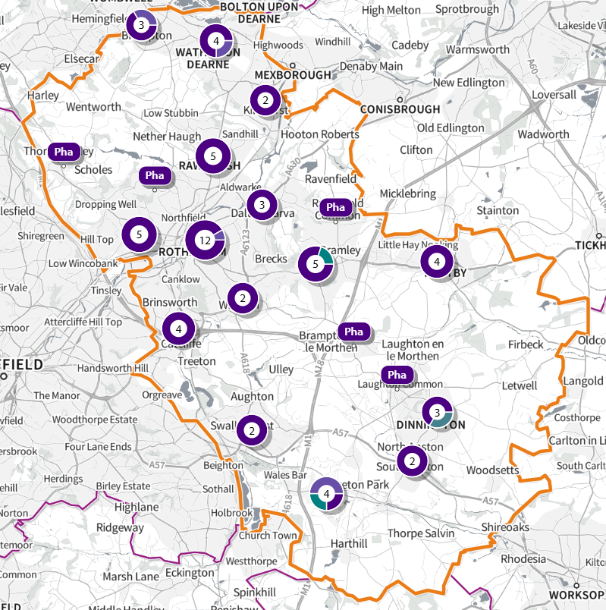
© Crown copyright and database rights 2024 Ordnance Survey 100016969 | parallel | Mapbox | OpenStreetMap contributors

Key
Single Pharmacy
 Multiple pharmacies located too close together to be able to display separately without increasing the resolution
 Pharmacy/ies and Dispensing GP/s which are located too close together to be able to display separately without increasing the resolution (here, there are three providers in total – two pharmacies, and one Dispensing GP)

Map 2: North Rotherham: Premises at which pharmaceutical services are provided
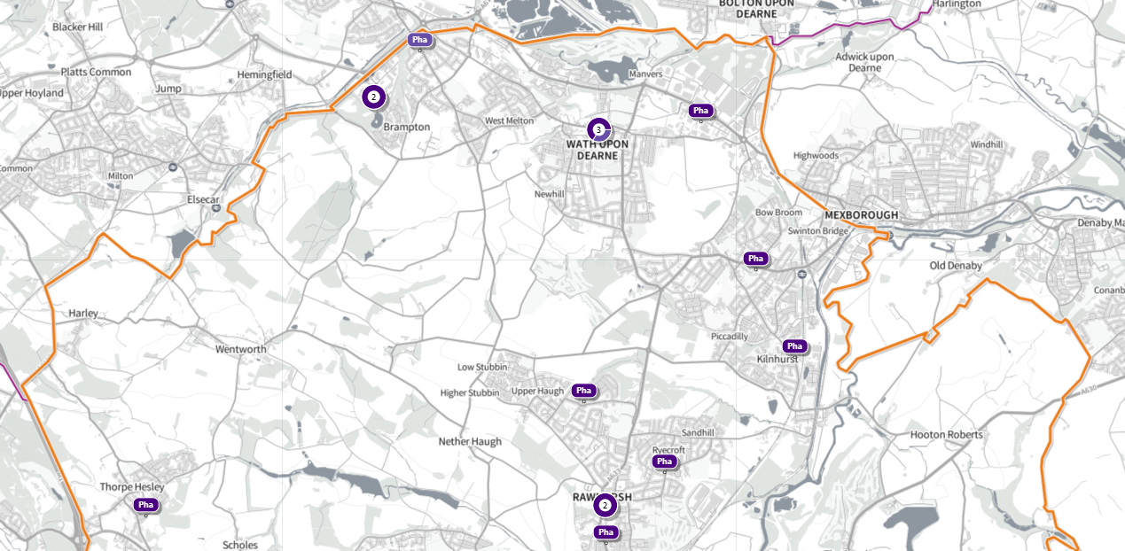
© Crown copyright and database rights 2024 Ordnance Survey 100016969 | parallel | Mapbox | OpenStreetMap contributors

Map 3: Central / West Rotherham: Premises at which pharmaceutical services are provided
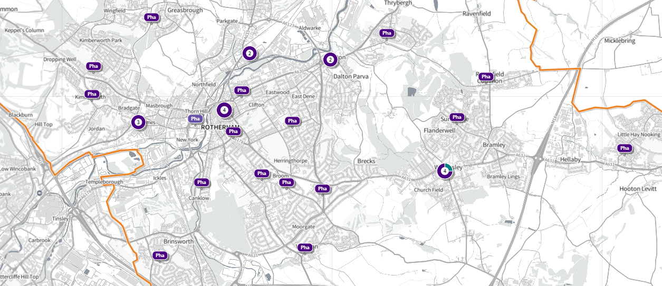
© Crown copyright and database rights 2024 Ordnance Survey 100016969 | parallel | Mapbox | OpenStreetMap contributors

Map 4: Central East Rotherham: Premises at which pharmaceutical services are provided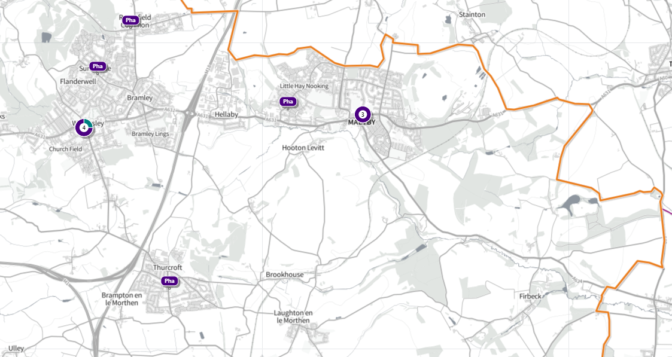
© Crown copyright and database rights 2024 Ordnance Survey 100016969 | parallel | Mapbox | OpenStreetMap contributors

Map 5: South Rotherham: Premises at which pharmaceutical services are provided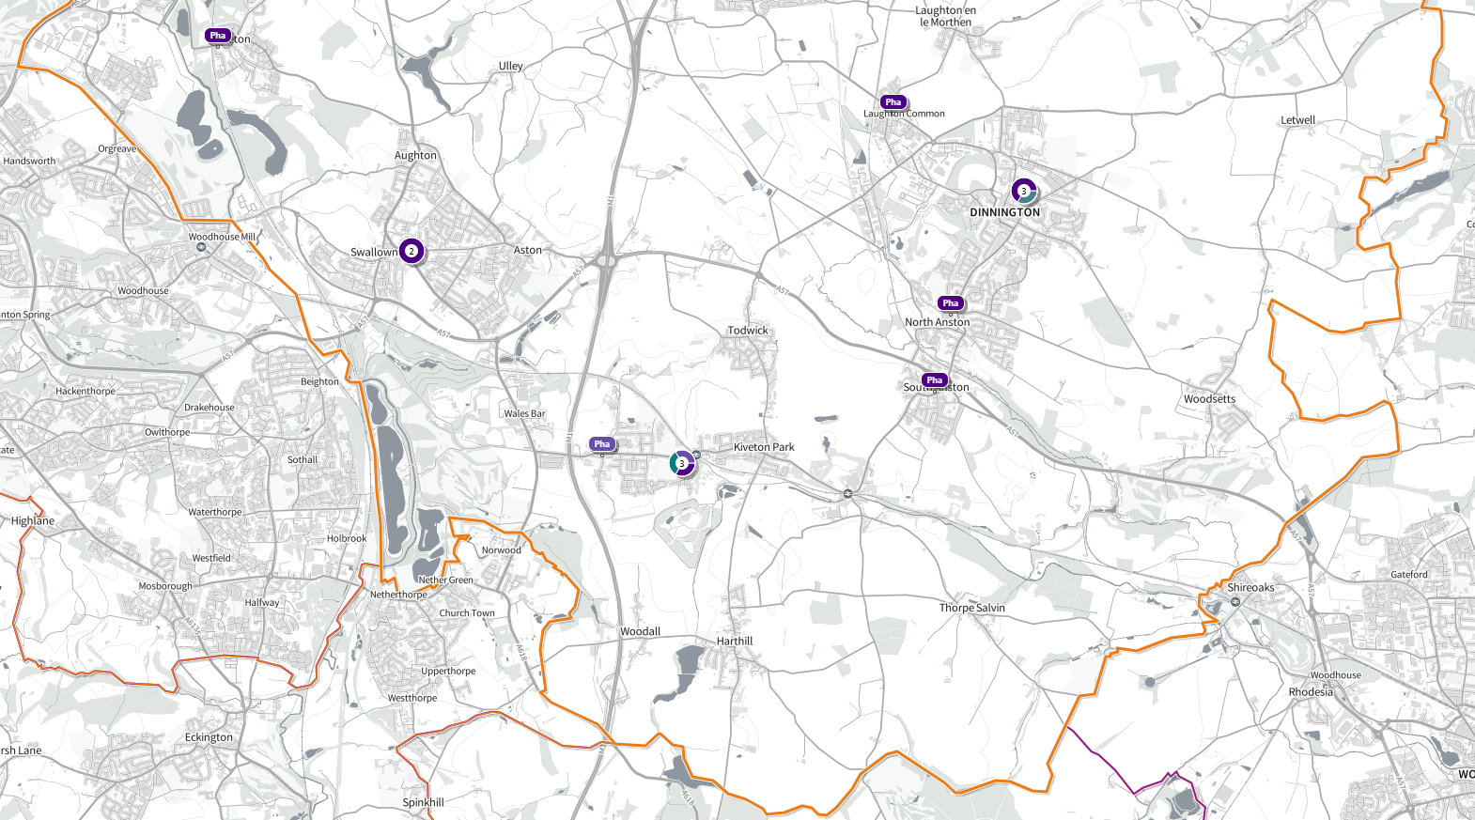
© Crown copyright and database rights 2024 Ordnance Survey 100016969 | parallel | Mapbox | OpenStreetMap contributors

Assessment of service availability

Pharmaceutical service providers per 100,000 people – to be added

For the purposes of determining whether the number of pharmacies in Rotherham is sufficient for the population size of Rotherham and whether there is sufficient choice, it was determined that the total number of pharmacies per head of population should be comparable with, or better than, the national average. In England, 2023/24, there were 12,009 active community pharmacies, and a population of 57,690,323 (mid-2023). This indicates 20.8 pharmacies per 100,000 population head.
There are 61 community pharmacies in Rotherham, and a population of 268,267 (mid-2022 – most recent estimate for local areas) indicating 22.7 pharmacies per population head. The range within Rotherham is from 60.0 per 100,000 in Boston Castle ward to 9.6 per 100,000 in Brinsworth ward. 15 wards have a rate of pharmacies per 100,000 population head below the Rotherham average (below is worse) (table 2).
The wards with the highest rate are Boston Castle, Rawmarsh West and Rawmarsh East (60.0, 42.1, and 34.0 per 100,000 respectively). The wards with the lowest rates are Brinsworth, Bramley & Ravenfield, and Aston & Todwick (9.6, 10.7, and 10.7 respectively).
Ward | Index of Multiple Deprivation Score  (Red = most deprived,  green = least deprived) | Number of pharmacies | Population | Average population per pharmacy | Pharmacies per 100,000 population head
Rother Vale | 24.9 | 2 | 9980 | 4990.0 | 20.0
Boston Castle | 36.9 | 9 | 14989 | 1665.4 | 60.0
Aston & Todwick | 14.9 | 1 | 9307 | 9307.0 | 10.7
Dalton & Thrybergh | 54.4 | 3 | 8957 | 2985.7 | 33.5
Rawmarsh East | 36.8 | 3 | 8820 | 2940.0 | 34.0
Wath | 30.7 | 4 | 12207 | 3051.8 | 32.8
Rotherham West | 39.2 | 3 | 14438 | 4812.7 | 20.8
Rawmarsh West | 30.8 | 4 | 9490 | 2372.5 | 42.1
Hoober | 24.9 | 3 | 11027 | 3675.7 | 27.2
Sitwell | 13.7 | 2 | 13439 | 6719.5 | 14.9
Rotherham East | 57.5 | 2 | 16638 | 8319.0 | 12.0
Wales | 15.7 | 3 | 10302 | 3434.0 | 29.1
Kilnhurst & Swinton East | 27.7 | 1 | 7792 | 7792.0 | 12.8
Dinnington | 29.4 | 3 | 11941 | 3980.3 | 25.1
Anston & Woodsetts | 16.3 | 2 | 12170 | 6085.0 | 16.4
Maltby East | 44.6 | 2 | 9528 | 4764.0 | 21.0
Thurcroft & Wickersley South | 29.5 | 2 | 9789 | 4894.5 | 20.4
Keppel | 26.0 | 2 | 13933 | 6966.5 | 14.4
Greasbrough | 43.7 | 1 | 7817 | 7817.0 | 12.8
Wickersley North | 18.9 | 3 | 11645 | 3881.7 | 25.8
Hellaby & Maltby West | 17.7 | 2 | 8395 | 4197.5 | 23.8
Bramley & Ravenfield | 14.3 | 1 | 9366 | 9366.0 | 10.7
Brinsworth | 20.8 | 1 | 10407 | 10407.0 | 9.6
Aughton & Swallownest | 25.1 | 1 | 7513 | 7513.0 | 13.3
Swinton Rockingham | 29.3 | 1 | 8377 | 8377.0 | 11.9
Total |  | 61 | 268267 | 4397.8 | 22.7
Table 2: Pharmacy availability per population head, Rotherham and Rotherham wards.

Availability and access according to distance and travel time
For the purposes of determining whether residents require better access and towards identifying improvements for pharmaceutical services the proportion of the population within 15-minute walk of a provider pharmaceutical services was reviewed. This indicator was selected because rates of car ownership are not uniform across the population.

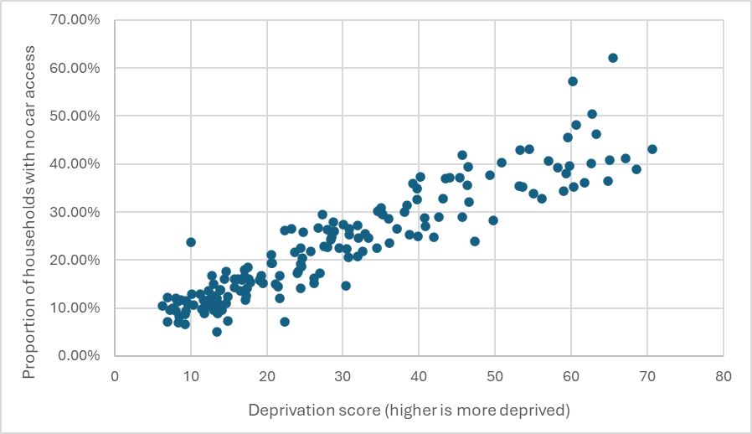
In Rotherham, 23% of our population do not have access to a car or van in their household (26,000 of 114,000 households). The range across the borough is 5% to 62%, and if grouped into deprivation, this is 40% in the most deprived decile through 10% in the least deprived. There is a correlation, figure 2, showing a more deprived area has a greater proportion of the population that does not have access to a car or van and therefore may require access to a pharmacy be either a walk or on public transport.
Figure 2: LSOA deprivation score and proportion of households with no car access.

Two additional indicators of geographical access were also considered:
- the proportion of the population within a 1.6km walk of a provider of pharmaceutical services; and
- the proportion of the population within a 10-minute drive (during rush hour) of a provider of pharmaceutical services.
Included and excluded populations are calculated using LSOA geographic boundaries and a LSOA is excluded from the count of population if the LSOA centroid is not within the travel catchment selected.
In analysing availability, consideration was given to whether there is sufficient access to pharmaceutical services across the population as a whole and also how access differs according to deprivation and age – both factors which are associated with poorer health.
There is no national guidance or definition of sufficient access, but where possible, comparisons were made with figures included in the 2022 PNA.
For the sake of simplicity, the detailed analysis outlined below focuses primarily on Rotherham-based providers although it is possible Rotherham residents access pharmaceutical providers outside of Rotherham.

4.2.1 Walk time
Map 6 shows how walk time to pharmacies varies across Rotherham. The darker the shading, the less time it takes to walk to a pharmaceutical service provider.

Map 6: Walk time to Rotherham-based provider of pharmaceutical services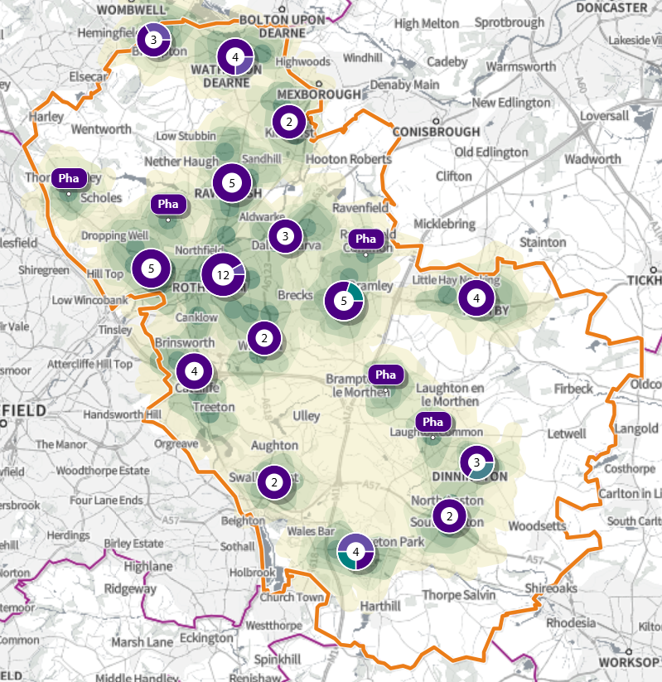
© Crown copyright and database rights 2024 Ordnance Survey 100016969 | parallel | Mapbox | OpenStreetMap contributors
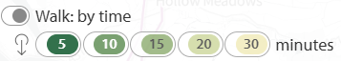

From Table 3, we see that 83.4% of the population of Rotherham live within a 15-minute walk of a Rotherham-based pharmaceutical service provider. This is 3.9 percentage points lower than the proportion in the 2022 PNA.

Table 3: Walk time to a Rotherham-based provider of pharmaceutical services
 | Included Rotherham residents | Included Rotherham residents | Excluded Rotherham residents | Excluded Rotherham residents
Walk time to a  Rotherham-based provider  of  pharmaceutical  services | Number | % | Number | %
5 mins | 92,875 | 34.6% | 175,392 | 65.4%
10 mins | 187,527 | 69.9% | 80,740 | 30.1%
15 mins | 225,776 | 84.2% | 42,491 | 15.8%
20 mins | 254,684 | 94.9% | 13,583 | 5.1%
30 mins | 261,979 | 97.7% | 6,288 | 2.3%

Figure 3 provides detail about the demographic profile of those Rotherham residents living more than 15 minutes-walk from a provider of pharmaceutical services – referred to as ‘the excluded’.
The areas that are excluded, due residents living more than 15 minutes’ walk from a Rotherham-based pharmaceutical services provider, are a population of 42,491 residents from 28 LSOAs. This is an increase of 5,183 people and 4 LSOAs compared to the 2022 PNA.

Deprivation and age
93.2% (87,883) of residents who live in the 20% most deprived LSOAs are within a 15-minute walk of a pharmacy. 6.8% (6,401) are further than a 15-minute walk from a pharmacy.
Of LSOAs with population excluded, 1 had an IMD score of 1 (most deprived), 3 had a score of 2, 2 with a score of 3, 3 with a score of 4, 3 with a score of 5, 5 with a score of 6, 7 with a score of 7, 2 with a score of 8 and 2 with a score of 9 (least deprived) (table 4).
IMD decile | Number of LSOAs with some population excluded
1 (most deprived) | 1
2 | 3
3 | 2
4 | 3
5 | 3
6 | 5
7 | 7
8 | 2
9 (least deprived) | 2

The proportion of the population aged over 65 in Rotherham is 19.8%, higher than the England average of 18.7%. Of the 28 LSOAs with excluded population, 21 have a greater percentage of the population over 65 years old compared to Rotherham (ranging from 20.5% to 36.9%). Of the 4 excluded LSOAs which were in the most deprived quintile, 2 have a greater population of those aged 65 than the Rotherham average.

Figure 3: Demographic characteristics of population living more than 15 minutes’ walk from a Rotherham-based pharmaceutical services provider.
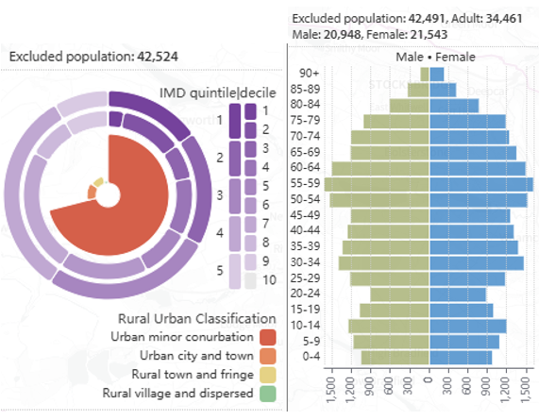
© Crown copyright and database rights 2024 Ordnance Survey 100016969 | parallel | Mapbox | OpenStreetMap contributors

Due to the dispersed geography of these excluded LSOAs, there are no obvious single geographies excluded, that have a high population density, where a new service provider would reduce the volume of people excluded.

4.2.2 Walk distance
Map 7 and table 5 show the walk distance to pharmaceutical services in Rotherham. The darker the shading, the closer the population is to a provider of pharmaceutical services.
Map 7: Walk distance to Rotherham-based provider of pharmaceutical services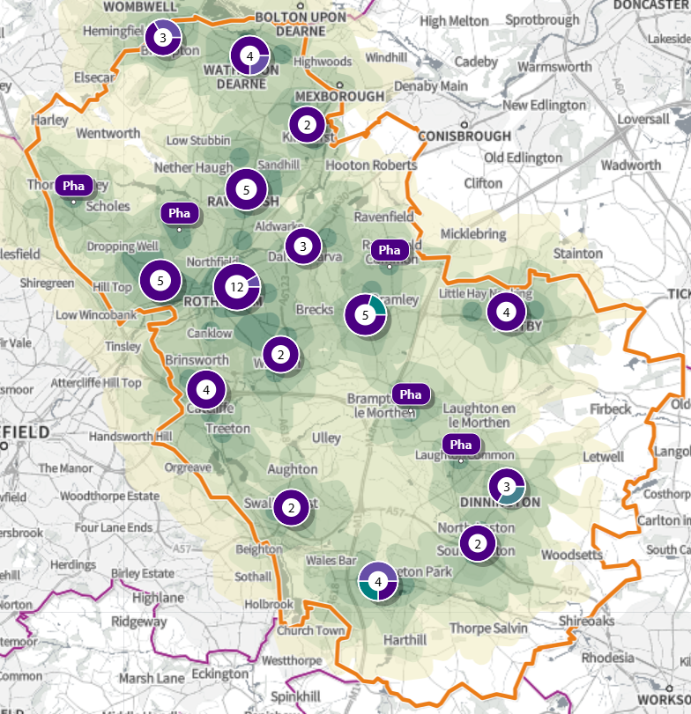
© Crown copyright and database rights 2024 Ordnance Survey 100016969 | parallel | Mapbox | OpenStreetMap contributors
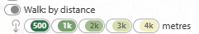

 | Population included within this radius | Population included within this radius | Population living beyond this radius | Population living beyond this radius
Walk distance  Rotherham-based provider  of  pharmaceutical  services | Number | % | Number | %
500m | 147,355 | 54.9% | 120,912 | 45.1%
1.6km (1 mile) | 256,105 | 95.5% | 12,162 | 4.5%
3km | 266,433 | 99.3% | 1,834 | 0.7%
4km | 268,267 | 100.0% | 0 | 0.0%
Table 5: Walking distance to a Rotherham pharmaceutical provider.

4.2.3 Drive time
As shown in Table 6, 100% of Rotherham-based residents live within a 10-minute drive of a Rotherham based pharmaceutical services provider during rush hour.

 | Rotherham population living within this drive time of a Rotherham-based provider of pharmaceutical services | Rotherham population living within this drive time of a Rotherham-based provider of pharmaceutical services | Rotherham population living outside this drive time of a Rotherham-based provider of pharmaceutical services | Rotherham population living outside this drive time of a Rotherham-based provider of pharmaceutical services
Drive  time (in  rush  hour) | No. | % | No. | %
5 mins | 263,464 | 98.2% | 4,803 | 1.8%
10 mins | 268,267 | 100.0% | 0 | 0.0%
Table 6: Driving time to a Rotherham pharmaceutical provider.

4.2.4 Access to cross-border pharmaceutical services
Patients have a choice of where they access pharmaceutical services. This may be close to their doctors, their home, their place of work, or where they go for shopping, recreational or other reasons. Rotherham shares borders with several other local authorities each with their own HWB and associated PNA. It is common for Rotherham residents to access services in areas served by neighbouring HWBs, and for people from neighbouring areas to access services within Rotherham.
To account for the cross-border movement of individuals between Rotherham and neighbouring areas, analysis of the time and distance to pharmaceutical services, including Rotherham-based pharmacies, and those within 1.6km of the Rotherham border, has been conducted in the SHAPE mapping tool. Once pharmacies that lie within this range are included (see Map 8), the total number of pharmacies increases to 104.
Map 8: Pharmaceutical services in Rotherham, and within 1.6km of the Rotherham boarder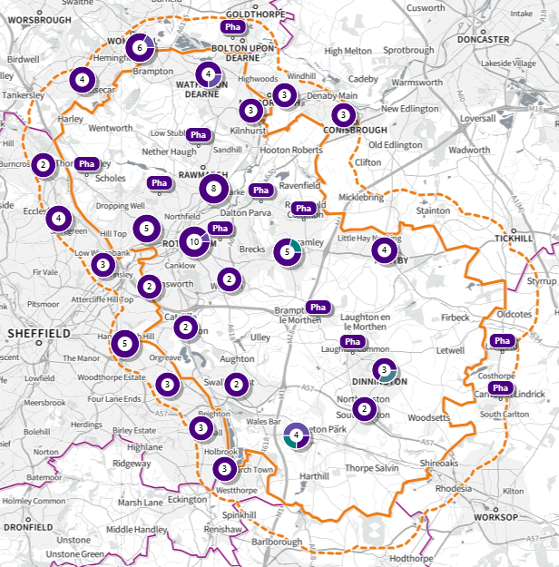
© Crown copyright and database rights 2024 Ordnance Survey 100016969 | parallel | Mapbox | OpenStreetMap contributors

Including these cross-border pharmacies has a marginal impact on the proportion of Rotherham residents within 15 minutes’ walk, or 1.6km (1 mile) walk, of a pharmaceutical services provider. The proportion of Rotherham residents within 15 minutes’ walk increases from 84.2% to 84.8% when including these cross-border pharmacies (a further 1,590 people). The proportion of Rotherham residents within 1.6km (1 mile) walk increases from 95.5% to 96.6% when including these cross-border pharmacies (a further 2,980 people). As all Rotherham residents were within a 10-minute drive at rush hour of a pharmaceutical services provider without including these cross-border pharmacies, including these pharmacies has no impact.

Availability according to opening times
Each Community Pharmacy is required to be open for 40 hours a week minimum (referred to as Core Hours). There are four 100-hour pharmacies; at the previous PNA in 2022, there were five.
Pharmacy owners who want to change their supplementary opening hours are required by their terms of service to notify the relevant ICB. If a pharmacy owner wants to:
- increase supplementary opening hours at the pharmacy, notification of the change must be given to the ICB in advance of the increase but there is no notice period.
- decrease supplementary opening hours at the pharmacy, How long a period of notice is to be given will depend on how the contractor wishes to change their supplementary opening hours.
Pharmacy owners are encouraged to give the ICB as much notice of changes as they can of any changes to supplementary opening hours
For the purposes of assessing opening hours, the HWB considered access to a pharmacy or dispensing GP of primary importance during normal working hours (9am-5pm) during the week. This generally coincides with the opening hours of GP surgeries, when people are likely to receive prescriptions. The HWB also considered access at weekends, and out of hours.
Out of hours, when pharmacies and GPs are closed, people’s remaining options to access Pharmacy First services would be to access referrals through NHS 111 (online and via telephone), or through urgent and emergency care settings.

4.3.1 Weekday opening
Figure 4 shows the number of hours Rotherham pharmacies are open Monday – Friday. Similar patterns of opening hours are seen across all weekdays, with most pharmacies open for 8-10hours per day. Most of Rotherham’s pharmacies open between 8.30am-9.00am Monday to Friday with some opening much earlier (for example, between 6.30am-8.00am). Most pharmacies close between 5.00pm and 6.00pm. Two pharmacies open at 8am, whilst no pharmacies open earlier.
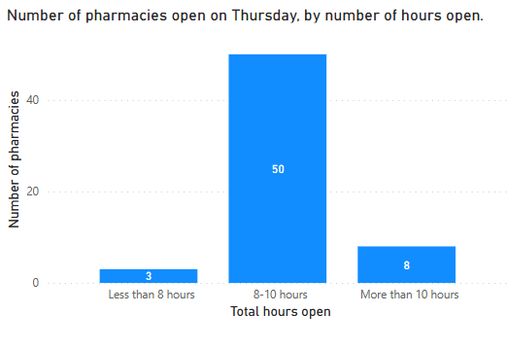
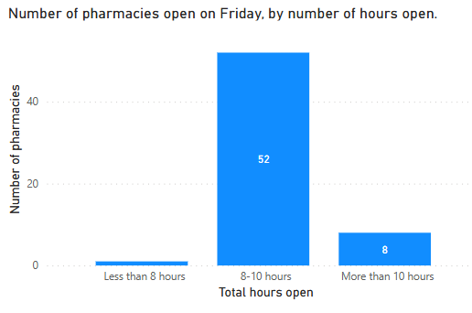
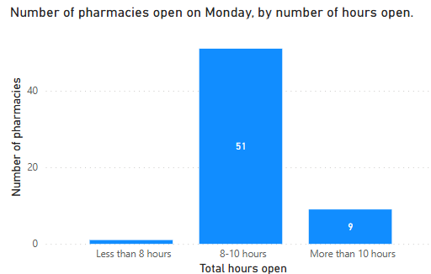
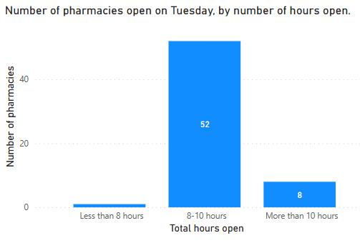
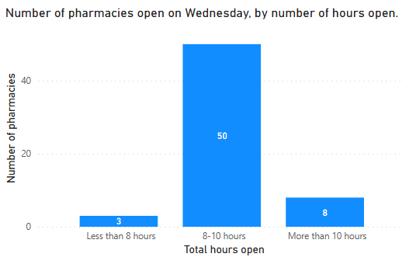

Figure 4: Pharmacy opening hours by day – weekday.

Weekend opening hours
Of the 61 community pharmacies operating in Rotherham as of January 2025, 39 pharmacies (63.9%) are open on a Saturday, and 9 pharmacies (14.8%) are open on a Sunday (figure 5).
Of the 39 pharmacies open on a Saturday, 27 (69.2%) are open for less than 8 hours. The majority of these are open for 4 hours or less, closing by 1pm.
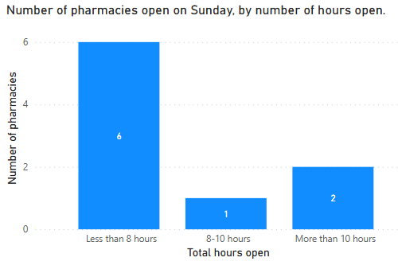
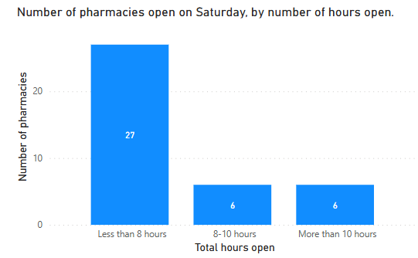

Figure 5: Pharmacy opening hours by day – weekend.

Analysis of populations with access to Saturday and Sunday opening shows that there is a reduction in access over the weekend – particularly on Sundays. Almost 100% of Rotherham residents live within 10 mins drive of an open pharmacy on Saturdays, however this decreases to nearly three quarters of residents on Sundays (73.9%). There is a larger difference in the proportion of residents within a 15-minute walk or a 1 mile walk on Saturdays and Sundays (table 7 and map 9).
This is within the context that there is limited out of hours prescriptions coverage on a Sunday at primary care level. There are two pharmacies open late on a Sunday: Rawmarsh Pharmacy (open until 9pm) and Wickersley Pharmacy (open until 9:45pm). Urgent primary care support is also available at the Urgent and Emergency Care Centre for those who need management of a primary care problem within the next 48 hours. The urgent primary care service runs from 8am to 10pm every day. When urgent primary care closes at 10pm, urgent access to primary care services is through NHS 111. As part of this service, people can request a limited emergency supply of a regular prescription they have completely run out of.

 | Included population | Included population
 | No. of people | %
Saturday opening
Walk time of 15mins | 187,456 | 69.9%
Walk distance of  1.6km (1 mile) | 241,151 | 89.9%
Drive time of 10 mins | 266,888 | 99.5%
Sunday opening
Walk time of 15mins | 54,575 | 20.3%
Walk distance of  1.6km | 97,814 | 36.5%
Drive time of 10 mins  Table 7: Included population by weekend day and travel type. | 198,314 | 73.9%

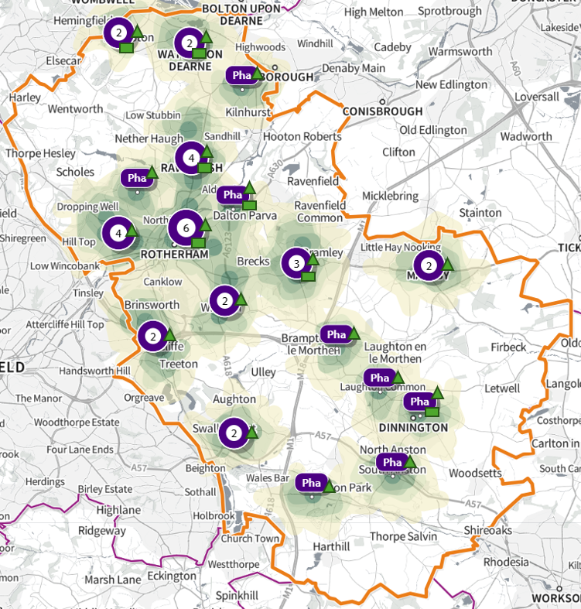
Map 9: Pharmacies open at weekends and included population by walk time
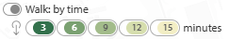
© Crown copyright and database rights 2024 Ordnance Survey 100016969 | parallel | Mapbox | OpenStreetMap contributors
Saturday opening Sunday opening

4.3.2 Evening opening
There are four 100-hour pharmacies in Rotherham (map 10). There has been a reduction in evening pharmacies provision since the previous PNA in 2022; there were previously five 100-hour pharmacies. There are now no pharmacies in Rotherham open later than 9pm Monday to Friday, compared to five at the previous PNA. There are also no pharmacies in Rotherham open later than 9pm Saturday, compared to five at the previous PNA (table 8).
Map 10: Rotherham pharmacies with a 100-hour contract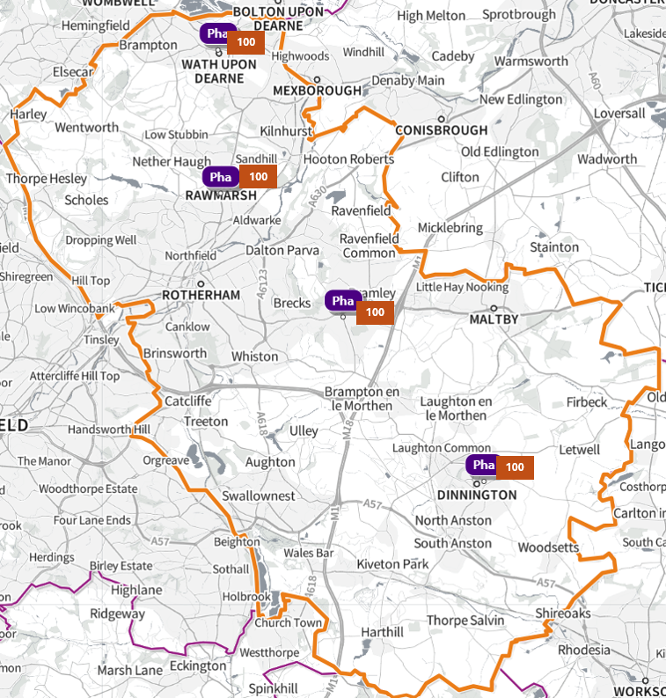
© Crown copyright and database rights 2024 Ordnance Survey 100016969 | parallel | Mapbox | OpenStreetMap contributors
Under the National Health Service (Pharmaceutical Services) Regulations 2005 (regulation 13(1)(b)), primary care trusts were required to grant applications for inclusion in a pharmaceutical list where the applicant undertook to provide pharmaceutical services for at least 100 hours per week. Such pharmacies have became known as “100-hour pharmacies”.
Whilst the ability to apply to open a new 100-hour pharmacy was removed from the regulations with effect from 1 September 2012, the requirement on these pharmacies to continue to be open for 100 hours per week was carried into the National Health Service (Pharmaceutical and Local Pharmaceutical Services) Regulations 2013. NHS England could not vary or remove this “100 hours condition” (regulation 65(3)). With effect from 25 May 2023, the 2013 regulations have been amended so that a pharmacy contractor can now apply to the relevant Integrated Care Board (ICB) to reduce the total core opening hours of their 100-hour pharmacy. These applications must be granted where they meet the requirements of the regulations. The requirements are that the pharmacy will still have:
- at least 72 core opening hours per week;
- core opening hours between 5pm and 9pm Monday to Saturday;
- core opening hours on a Sunday between 11am and 4pm, if the pharmacy currently has core hours at these times. The contractor may introduce a rest break provided it is no longer than one hour, and starts at least three hours after the pharmacy opens and ends at least three hours before it closes, and
- the changes must not reduce the total number of core opening hours on a Sunday.
Additionally, the contractor must provide the ICB with at least five weeks’ notice of the proposed changes.
The four 100-hour pharmacies in Rotherham reduced their opening hours following a valid application to the ICB and one 100-hour pharmacy has closed (Maltby Pharmacy (FAA29) closed on 17/09/2023). The four 100-hour pharmacies are:
- Dinnington Pharmacy
- Rawmarsh Pharmacy
- Tesco Pharmacy (Wath upon Dearne)
- Wickersley Pharmacy
For a full list of pharmacies and their opening hours, please see Annex 4.

Table 8: Comparison of pharmacies open after 9pm and on Sundays between the 2023 and 2025.
Opening Times | 1st January  2023 | 1st January  2025 | Narrative
Later than 21:00 Monday to Friday | 5 | 0 | There are now no pharmacies open later than 21:00 Monday-Friday in Rotherham
Later than 21:00 on Saturday | 5 | 0 | There are now no pharmacies open later than 21:00 Saturday in Rotherham
Open on a Sunday | 9 | 9 | There are the same number of pharmacies open on a Sunday

Availability by service type
Data for pharmacies operating in Rotherham is up to date as of the beginning of January 2025, using the Quarter 3 2024/25 list of pharmacies from NHS Business Services Authority. Data for services provided by pharmacies in Rotherham and the number of deliveries covers January to December 2024, from NHS Business Services Authority.
As of January 2025, there were 61 pharmacies, 1 DAC and 3 dispensing GPs operating in Rotherham.

Pharmaceutical services: an overview

Essential services
Table 9: Essential services
Service | Description
Dispensing medicines | This service involves the supply of medicines and appliances ordered on NHS prescriptions, together with information and advice, to enable safe and effective use by patients and carers, and maintenance of appropriate records.
Dispensing repeat prescriptions | This involves dispensing prescriptions which contain more than one month’s supply of drugs on them. For example, an electronic repeatable prescription may say that the prescription interval is every 28 days and it can be repeated six times. This would give a patient approximately six months’ supply of medication, dispensed every 28 days with the prescriber only needing to authorise them once.
Discharge Medicines Service | This service aims to reduce the risk of medication problems when a person is discharged from hospital. Under this service a pharmacist will review a person’s medicines on discharge and ensure that any changes are actioned accordingly.
Disposal of unwanted medicines | Community pharmacy owners are obliged to accept back unwanted medicines from patients. The local NHS contract management team will make arrangements for a waste contractor to collect the medicines from pharmacies at regular intervals.
Healthy Living Pharmacies | The Healthy Living Pharmacy (HLP) framework aims to achieve a consistent provision of a broad range of health promotion interventions through community pharmacies to meet local need, improving the health and wellbeing of the local population and helping to reduce health inequalities.
Support for self-care | This service involves the provision of information to people visiting the pharmacy, who require further support, advice or treatment which cannot be provided by the pharmacy, on other health and social care providers or support organisations who may be able to assist the person.  To enhance access and choice for people who wish to care for themselves or their families. People, including carers, are provided with appropriate advice to help them  self-manage a self-limiting or long-term condition, including advice on the selection and use of any appropriate medicines.
Signposting | This service involves the provision of information to people visiting the pharmacy, who require further support, advice or treatment which cannot be provided by the pharmacy, on other health and social care providers or support organisations who may be able to assist the person.
Public health (promotion of healthy lifestyles) | Each financial year (1st April to 31st March), pharmacies are required to participate in up to six health campaigns at the request of NHS England. This generally involves the display and distribution of leaflets provided by NHS England; see further details below.  In addition, pharmacies are required to undertake prescription-linked interventions on major areas of public health concern, such as encouraging smoking cessation.  This service involves the provision of opportunistic healthy lifestyle advice and public health advice to patients receiving prescriptions who appear to: a) have diabetes; or b) be at risk of coronary heart disease (especially those with high blood pressure); or c) who smoke; or d) are overweight, and pro-active participation in six health campaigns where requested to do so by NHS England and NHS Improvement.
Adapted from Community Pharmacy England.

Advanced Services
Advanced Services are those which that require accreditation of the pharmacist providing the service and/or specific requirements to be met regarding premises. A description of each Advanced Service is provided below.
Table 10: Advanced services
Service | Description
Appliance Use Review (AURs) | AURs should improve the patient’s knowledge and use of any ‘specified appliance‘ by establishing the way the patient uses the appliance and the patient’s experience of such use; identifying, and resolving poor or ineffective use of the appliance by the patient; advising the patient on the safe and appropriate storage of the appliance; and advising the patient on disposal of the appliance/s.
Community Pharmacist Consultation Service (CPCS) | The CPCS aimed to relieve pressure on the wider NHS by connecting patients who have a minor illness or need an urgent supply of a medicine with a community pharmacy. As well as referrals from GPs, the service takes referrals from NHS 111, Integrated Urgent Care Clinical Assessment Services and in some cases, via the 999 service.  The two previous elements of the CPCS were incorporated into the Pharmacy First service when it launched on 31st January 2024 (see below) – urgent medicines supply and minor illness.
Flu vaccination service | This service involves running a seasonal flu vaccination campaign (March to September) aiming to vaccinate all patients who are at risk of developing more serious complications from the virus
Hypertension case-finding service | This service has two stages: 1) identifying people at risk of hypertension and offering them blood pressure measurement (a ‘clinic check’); 2) where clinically indicated, offer 24-hour ambulatory blood pressure monitoring. The blood pressure test results will then be shared with the patient’s GP
Lateral Flow Device (LFD) Tests Supply Service | The Lateral flow device tests supply service for patients potentially eligible for COVID-19 treatments (LFD service) was commissioned as an Advanced service from 6th November 2023.  This service is to offer at risk patients eligible for COVID-19 treatments, access to LFD tests to enable testing at home for COVID-19, if they develop symptoms of infection. A positive LFD test result will be used to inform a clinical assessment to determine whether the patient is suitable for and will benefit from NICE recommended COVID-19 treatments.
New Medicine Service | The service provides support for people with long-term  conditions newly prescribed a medicine to help improve  medicines adherence; it is focused on specific patient groups and conditions.
Smoking Cessation Advance Service | This service has been designed to enable NHS trusts to undertake a transfer of care on patient discharge, referring patients (where they consent) to a community pharmacy of their choice to continue their smoking cessation treatment, including providing medication and support as required. In Rotherham the QUIT programme has been rolled out to ensure access to nicotine addition services whist accessing secondary care. This service will help ensure continuity of care upon discharge
Stoma Appliance Customisation Service | The aim of the service is to ensure proper use and comfortable fitting of a stoma appliance and to improve the duration of usage, thereby reducing waste.
Pharmacy Contraception Service (PCS) | The PCS commenced on 24th April 2023, allowing the on-going supply of oral contraception (OC) from community pharmacies. From 1st December 2023, the service expanded to include both initiation and on-going supply of OC.  From October 2025, subject to the introduction of IT updates to community pharmacy clinical services IT systems, the service will be expanded to include Emergency Hormonal Contraception (EHC). There will be no age restrictions within the national service that will prevent supply.
Pharmacy First | The Pharmacy First service builds on the NHS Community Pharmacist Consultation Service which ran since October 2019.  The new Pharmacy First service, launched 31st January 2024, adds to the existing consultation service and enables community pharmacies to complete episodes of care for 7 common conditions following defined clinical pathways.  The two previous elements of the CPCS were incorporated into the Pharmacy First service (see below) – urgent medicines supply and minor illness.  The local pharmacy can now supply prescription-only treatment, if they believe you need it, for the following conditions:  - Sinusitis (for patients aged 12 years and over only)  - Sore throat (aged 5+)  - Earache (aged 1 year-17)  - Infected insect bite (aged 1 year+)  - Impetigo (aged 18 years+)  - Shingles (aged 18 years+)  - Uncomplicated urinary tract infections (women aged 16 to 64)

Enhanced and Locally Commissioned Services
Table 11: Enhanced and Locally Commissioner Services

Service | Description
Emergency Hormonal Contraception (EHC) | Free emergency oral contraception is available for Rotherham residents at select pharmacies as part of sexual health services commissioned by RMBC. Where pharmacies are not signed up to deliver free EHC it can purchased. Pharmacies will offer a user-friendly, non-judgmental, client-centred and confidential service.  The pharmacy will provide support and advice to clients accessing the service, including advice on the avoidance of pregnancy and sexually transmitted infections (STIs) through safer sex and condom use, advice on the use of regular contraceptive methods and provide onward signposting to services that provide long-term contraceptive methods and diagnosis and management of STIs.
Needle and Syringe Provision (NSP) – needle exchange | This service involves the provision of access to sterile needles and syringes, and sharps containers for return of used equipment. Pharmacies will offer a user-friendly, non-judgmental, client-centred and confidential service.  Pharmacies will provide support and advice to the user, including referral to other health and social care professionals and specialist drug and alcohol treatment services where appropriate.
Nicotine Replacement Therapy (NRT) for pregnancy | You can use nicotine replacement therapy (NRT) during pregnancy if it will help you stop smoking and you're unable to stop without it.  NRT in pregnancy support is provided as part of the Rotherham Foundation Trust maternity services by the stopping smoking in pregnancy team. All pregnant smokers will be referred to the stopping smoking in pregnancy team. You can also buy it over the counter without a prescription from a pharmacy.
Over the Counter (OTC) Medication Labelling Scheme | The Community Pharmacy Labelling OTC Medication Scheme enables community pharmacies to label over the counter (OTC) medicines purchased for self-care, allowing them to be administered in settings such as schools or by care workers—without the need for a GP-issued NHS prescription.
Palliative care | The Palliative Care Scheme ensures that participating pharmacies keep a stock of certain palliative care drugs.
Supervised consumption / administration | This service will require the pharmacist to supervise the consumption of prescribed medicines at the point of dispensing in the pharmacy, ensuring that the dose has been administered to the patient. Pharmacies will offer a user-friendly, non-judgmental, client-centred and confidential service.  Pharmacies will provide support and advice to the patient, including referral to primary care or specialist centres where appropriate.
Varenicline – smoking cessation support | Varenicline (previously called Champix) is a medicine used to help stop smoking in adults. It reduces nicotine cravings and helps with withdrawal symptoms. Varenicline is not recommended if you’re pregnancy. This is because there is little safety information on its use in pregnancy. Nicotine replacement therapy (NRT), such as nicotine patches and gum, can be used during pregnancy.

Service availability in Rotherham
Essential Services are those services offered by all pharmacy contractors. As such, access to Essential Services within Rotherham equates to access to pharmacies overall – as covered in sections 4.1 and 4.2 above.
The Rotherham PNA steering group agreed that the Essential Services would make up the Necessary Services for the PNA alongside some advanced services based on health need in Rotherham. These are the advanced services of Pharmacy First, hypertension case-finding, flu vaccination, and contraception service.
Because not all service providers register to provide any / all Advanced or Locally Commissioned Services, access to these services differs by service type. Table 12 below provides a breakdown of the number and proportion of Rotherham pharmacies which provide each service. Annex 3 provides the same information at Ward level.
For Essential and Advanced Services, the number of pharmacies providing each service was calculated based on the number of pharmacies that had provided that service once or more in 2024. The number of deliveries of each service was based on the number of times a service was declared by each pharmacy, or the number of fees for a service, each of which equate to one delivery of the service. For instance, one Stoma Appliance Customisation fee would equate to this service being delivered once.
Locally Commissioned Services data was provided by contractors and the Strategic Commissioning team in Adult Care, Housing and Public Health at RMBC.

Table 12: Advanced, Enhanced and Locally Commissioned Service availability and service provision
Advanced Services
 | Service provision | Service provision | Service provision
Service | No. of Pharmacies delivering service during 2024 | Proportion of eligible pharmacies and Dispensing Appliance Contractors providing this service (%) (Jan 2025) | Services provided (Jan – Dec 2024)
Appliance Use Review (AURs) | 0 | - | -
Community Pharmacist Consultation Service (CPCS) | 40 | 66% | 500
Flu vaccination service | 50 | 84% | 17,648
Hypertension case-finding service | 50 | 82% | 16,405
Lateral Flow Device (LFD) Tests Supply Service | 36 | 59% | 7,736
New Medicine Service | 60 | 98% | 35,325
Smoking Cessation Advance Service | 1 | 2% | 1
Stoma Appliance Customisation Service | 3 | 5% | 12,013
Pharmacy Contraception Service (PCS) | 32 | 52% | 1,628
Pharmacy First (all services) | 59 | 97% | 18,929
Emergency Hormonal Contraception (EHC) | 14 | 23% | Data not available
Needle and Syringe Provision (NSP) – needle exchange | 10 | 16% | Data not available
Nicotine Replacement Therapy (NRT) for pregnancy | N/A | N/A | Data not available
Over the Counter (OTC) Medication Labelling Scheme | 18 | 30% | Data not available
Palliative care | 34 | 55% | Data not available
Supervised consumption / administration | 43 | 71% | Data not available
Varenicline (formerly Champix) | N/A | N/A | Data not available

4.4.2.1 Essential services

Number of items on prescriptions
This is the number of times a product appears on a prescription, meaning that if a person’s prescription contains multiple medications, these are individually counted.
All 61 community pharmacies that were operating in Rotherham as of January 2025 had delivered prescriptions in 2024. There were 6,694,073 prescriptions dispensed in Rotherham during this period.
The majority of prescriptions are processed through the Electronic Prescription Service (EPS). All 61 pharmacies that were operating in Rotherham as of January 2025 processed prescriptions through the EPS in 2024. 6,334,312 items were processed through the EPS during this period.

Discharge Medicines Service
As of February 2025, 22 of the 61 pharmacies in Rotherham had provided this service once or more in 2024 (36.1% of pharmacies in Rotherham). There were 174 complete Discharge Medicine Services provided during this period. 60 (34.5%) of these were provided by one pharmacy. There were also 100 incomplete Discharge Medicine Services in the period.

4.4.2.2 Advanced services

New Medicine Service (NMS) interventions
60 (98.4%) of the pharmacies operating in Rotherham as of January 2025 declared NMS interventions in 2024. 35,325 NMS interventions were declared during this period.

Appliance Use Review
NHS BSA records show that no pharmacies that were operating in Rotherham as of January 2025 had provided Appliance Use Reviews in 2024, either at the premises or in the user’s home.

Medicine Use Reviews (MURs) declared
NHS BSA records show that no pharmacies that were operating in Rotherham as of January 2025 had provided Medicine Use Reviews in 2024.

Influenza (flu) vaccinations – to add full data
Fees are given for each influenza (flu) vaccination administered. 51 (83.6%) of the pharmacies operating in Rotherham as of January 2025 declared flu vaccinations in the 2024/25 season (September 2024 to March 2025). 17,648 flu vaccinations were declared during this period.

Lateral Flow Device (LFD) Test Supply Service
36 (59.0%) of the 61 pharmacies that were operating in Rotherham as of January 2025 had supplied Lateral Flow Device (LFD) tests in 2024. This was delivered 7,736 times during this period. Five pharmacies provided the vast majority of the tests (88.4%, 6,837).

Hypertension case-finding service
50 (82.0%) of the pharmacies operating in Rotherham as of January 2025 carried out at least one type of blood pressure check in 2024. In total, there were 16,405 checks carried out during the period.

Community Pharmacy Clinic Blood Pressure checks
This is a simple recording of your blood pressure that is taken for a short period of time.
50 (82.0%) of the pharmacies operating in Rotherham as of January 2025 carried out clinic blood pressure checks in 2024. There were 15,754 checks carried out during this period. 12.3% (1,940) of these were carried out by Green Arbour Pharmacy.

Community Pharmacy Ambulatory Blood Pressure Monitoring (ABPM)
This is a simple recording of your blood pressure that requires you to wear a cuff on your arm and a small box on a belt around your waist, typically for 24 hours.
31 (50.8%) of the pharmacies operating in Rotherham as of January 2025 provided ABPM in 2024. There were 651 measurements carried out during this period.

Pharmacy Contraceptive Service (PCS)

Community Pharmacy Contraceptive Initiation Consultations
28 (45.9%) of the pharmacies operating in Rotherham as of January 2025 carried out this service in 2024. There were 172 consultations carried out during this period.

Community Pharmacy Contraceptive Ongoing Consultations
32 (51.6%) of the pharmacies operating in Rotherham as of January 2025 carried out this service in 2024. There were 1,456 consultations carried out during this period.

Hepatitis C Antibody Testing Service
NHS BSA records show that no pharmacies that were operating in Rotherham as of January 2025 had provided the Hepatitis C Antibody Testing Service in 2024.

Community Pharmacy Smoking Cessation consultations
Pharmaceutical smoking cessation services are primarily carried out through a locally commissioned service Stop Smoking service, with few pharmacies using the national NHS Community Pharmacy Smoking Cessation service. One of the pharmacies operating in Rotherham as of January 2025 carried out one smoking cessation consultation in 2024.

Pharmacy First
59 pharmacies in Rotherham provided a Pharmacy First service as of February 2025 (96.7% of pharmacies in Rotherham).

Minor Illness Referrals
59 (96.7%) of the pharmacies operating in Rotherham as of January 2025 delivered referral(s) in 2024. There were 4,678 Minor Illness Referrals completed during this period. Nearly half of these were delivered by Archway Pharmacy (48.4%, 2,266).

Urgent Medicine Supply consultations
59 (96.7%) of the pharmacies operating in Rotherham as of January 2025 provided these consultation(s) in 2024. There were 3,638 Urgent Medicine Supply consultations completed during this period. 16.1% of these consultations were completed by Wickersley Pharmacy.

Acute Otitis Media – Clinical Pathways consultations
This is an infection in the middle ear. 52 (85.2%) of the operating in Rotherham as of January 2025 delivered this service in 2024. There were 1,282 consultations during this period, just under a fifth of which were delivered by two pharmacies (19.8%, 254).

Acute Sore Throat – Clinical Pathways consultations
56 (91.8%) of the pharmacies operating in Rotherham as of January 2025 delivered this service in 2024. There were 3,487 consultations during this period, just over a fifth of which were delivered by two pharmacies (20.9%, 729).

Impetigo – Clinical Pathways consultations
53 (86.9%) of the pharmacies operating in Rotherham as of January 2025 delivered this service in 2024. There were 497 consultations during this period.

Infected Insect Bite – Clinical Pathways consultations
56 (91.8%) of the pharmacies operating in Rotherham as of January 2025 delivered this service in 2024. There were 1,307 consultations during this period.

Sinusitis – Clinical Pathways consultations
55 (90.2%) of the pharmacies operating in Rotherham as of January 2025 delivered this service in 2024. There were 1,015 consultations during this period.

Shingles – Clinical Pathways consultations
49 (80.3%) of the pharmacies operating in Rotherham as of January 2025 delivered this service in 2024. There were 335 consultations during this period.

Uncomplicated UTI – Clinical Pathways consultations
56 (91.8%) of the pharmacies operating in Rotherham as of January 2025 delivered this service in 2024. There were 2,666 consultations during this period.

Stoma Customisation
2 of the community pharmacies that were operating in Rotherham as of January 2025 had delivered this service in 2024. This was provided twice by community pharmacies during this period.
The main provider of this service was South Yorkshire Ostomy Supplies Ltd. This is a Dispensing Appliance Contractor (DAC), which has a contract focused on dispensing medical appliances, not medications, and specialises in stoma customisation. This DAC provided Stoma Customisation 12,011 times during 2024.

4.4.2.3 Locally commissioned services

Palliative care
As of April 2025, 34 (54.8%) of the pharmacies operating in Rotherham as of January 2025 offered the Palliative Care Scheme.
Pharmacies offering the Palliative Care Scheme can be found here.

Over-The-Counter Medication Labelling Scheme
As of June 2025, 18 (29.5%) of the pharmacies operating in Rotherham as of January 2025 offered the over-the-counter labelling scheme.

Nicotine Replacement Therapy (NRT) for pregnancy
As pregnant patients access NRT directly through the Smoking in Pregnancy team in Maternity services at Rotherham TRFT, there wouldn't be a need for them to access through pharmacy, so there is not a list of pharmacies providing this.
The Rotherham Community Stop Smoking service has a nurse prescriber role who can provide patients with prescriptions for varenicline as required for collection from pharmacies. NRT and vapes are provided direct to patients without a required pharmacy visit.

Varenicline – smoking cessation support
Rotherham residents can get a prescription through their GP, or through the non-medical prescriber who sits within the Stop Smoking service when they have accessed this service. They can then pick up their prescription from a local pharmacy. The non-medical prescriber replaces the need for this service to be provided by individual pharmacies.

Needle and Syringe Provision (NSP) – needle exchange
The drug and alcohol treatment provider, We Are With You, have subcontracting arrangements with pharmacies for Needle and Syringe Provision (NSP). The Council commission the treatment service provider.
As of May 2025, 10 (16.4%) of the pharmacies operating in Rotherham as of January 2025 were supplying NSP under the subcontracting arrangements of We Are With You.

Supervised Consumption
As of May 2025, 43 (70.5%) of the pharmacies operating in Rotherham as of January 2025 were providing the supervised consumption service under the subcontracting arrangements of We Are With You.

Emergency Hormonal Contraception (EHC)
14 (23.0%) of the pharmacies operating in Rotherham as of January 2025 were providing out-of-hours free emergency oral contraception for Rotherham residents under 25.
Access to the locally commissioned EHC service was limited in the South and East of the borough, although this may increase as EHC is due to become part of the Advanced Service of Pharmacy Contraception Service.

4.4.2.4 Dispensing doctors – prescriptions
In 2024, 202,119 prescriptions were dispensed and/or personally administered in England by Dispensing Doctor Practices and Prescribing Doctor Practices. 27 (96.4%) of the 28 GPs operating in Rotherham dispensed prescriptions during 2024. Three dispensing GPs dispensed nearly three quarters of these prescriptions (72.7%, 146,999 prescriptions):
- Kiveton Park Medical Practice
- Dinnington Group Practice
- Morthen Road Surgery.

Views and experiences of local people (Healthwatch Rotherham survey)

Demographics
58 participants completed the survey, with 57 living in Rotherham. The responses by Rotherham residents have been used in analysis. All participants responded to questions about protected characteristics.
For gender:
- Just under two thirds of participants were women (63.2% 36).
- A third were men (33.3%, 19).
- One participant was gender fluid.
- The remaining participant said they preferred not to say.
For gender identity:
- Almost all participants said their gender identity was the same as their sex recorded at birth (94.7%, 54).
- Other participants preferred not to say (5.26%, 3).

For sexual orientation:
- The vast majority of participants said they identified as heterosexual (84.5%, 49).
- 7 participants said they identified as another sexuality, including bisexual, pansexual, asexual and fluid (12.3%).
- The remaining two participants preferred not to say.

For ethnicity:
- The vast majority of participants said they were white (91.2%, 52).
- Three participants said they were ‘mixed or multiple’ (5.3%)
- One participant said they were Asian/Asian British.
- One participant preferred not to say.

For age:
- Older people made up a higher proportion of the participants than younger people.
- Just under a third of participants were aged 65 years or older (31.6%, 18).
- For younger participants, four were aged 18-24, two were aged 25-34 and seven were aged 35-44.
For disabilities:
- 63.2% (36) of participants reported having a disability, a long-term condition, and/or being a carer for someone else.
- 14.0% (8) of participants reported having a disability.
  - All but one of participants who reported having a disability also reported having a long-term condition (87.5%, 7).
  - No participants reported to being a carer.
- Just under half of participants reported to having a long-term condition (45.6%, 26).
  - Just over a quarter of participants who reported having a long-term condition also reported having a disability (26.9%, 7).
  - Four participants who reported having a long-term condition also reported to being a carer (15.4%).
- Just over a fifth of participants reported to being a carer (22.8%, 13).

47 of the 57 Rotherham participants provided full postcodes, meaning their IMD decile could be identified. Of the 47, 21.3% (10) participants lived in the two most deprived deciles.

Pharmaceutical services and choice of pharmacy
When asked why they usually visited a pharmacy, participants were asked to say 'yes' or 'no' to given reasons. All 57 participants responded:
- The vast majority of participants said for they went for their prescriptions, which was the most common reason given by far (93.0%, 53).
- The next most common reason was to buy over-the-counter medicines, which was true for over half of the participants (52.6%, 30).
- Just under a quarter of participants said they went to their local pharmacy for vaccinations (24.6%, 14).
- Just over a fifth said they went for consultations, Pharmacy First services or 111 advice (20.7%, 12).
- All participants responded "No" when asked whether they usually visited a pharmacy for emergency contraception, or separately, for needle exchange or supervised consumption.
- A small number of participants said they visited a pharmacy for any other reason, specifying this was for toiletries.

Later in the survey, when asked if there was anything else they wished to add, three participants highlighted issues they had with receiving their prescriptions. This included the time for prescriptions to be ready to be collected, or time to be delivered. One participant said they had issues with “prescriptions not being ready for over a week and having to go to and from home”.

When responding to the same question, several participants said they would like their pharmacy to provide more services, so that they had an alternative to their GP. This emphasises the appetite for Pharmacy First or a similar offer. One participant said, “I would love my pharmacy to offer more routine treatments instead of needing a GP appointment.” Another participant said the same, whilst adding they would also like “a clear guide of when it's appropriate to use my pharmacy instead of my GP or A&E”. One participant specified a negative experience with their pharmacy, saying that “[When] I ask about Pharmacy First and [my pharmacy] always tell me [they] can't deal with my issue even though there's posters up for it and go see your GP”. In contrast, another participant responding to the same question said “I have had help and advice from the pharmacist on several occasions which has been really helpful”. When asked what influences their choice of pharmacy, a participant highlighted their pharmacy had “a private consultation room to discuss personal matters or to access emergency support”.

In a separate question, no participants answered whether emergency contraception was free at their local pharmacy, suggesting they didn't know.

Participants were asked what influenced their choice of pharmacy in their own words, with the majority of participants responding (51 of 57 participants). Access was the most important theme for participants; the majority of participants emphasised convenience as important.
- Just under two thirds of participants who responded to this question said that convenience of location was important (64.7%, 33). Participants often specified this was how close the pharmacy was to their home, although in some cases this included distance from their GP.
  - Distance also depended on the participants' own circumstances. One participant who said their pharmacy was "close to home" also said "If I didn’t drive I wouldn’t be able to get to the pharmacy", whilst several participants specified it was good that their pharmacy was "within walking distance", with one person specifying “I have emphasemia” in context of this.
  - Related to location, a few participants also identified the importance of pharmacies having parking. When asked in another question how they travelled to a pharmacy, driving was the most commonly cited method, jointly with walking (55.6% of participants who responded to the question). Later in the survey, when asked why they didn’t go to the closest pharmacy to them, two participants cited this was due to lack of parking or free parking.
- Nearly a quarter of participants said that good customer service from staff was also important (23.5%, 12). There were two key aspects of this.
  - The way that staff treated customers mattered, with participants highlighting how staff being “accommodating”, “helpful” and “friendly” was a factor in what pharmacy they went to. One participant said this helped them with issues, as their pharmacy had “good customer services when things aren't quite right”, meaning issues could be sorted out.
  - Another aspect was the skill and ability of staff, with participants highlighting that staff were “knowledgeable” and “efficient”.
- Along with location, another key factor in convenience was opening times of the pharmacy, which just over a fifth of participants said was important (21.6%, 11).
  - Two participants specifically highlighted that it was useful to be able to pick up medication “late at night” or at the weekend.
  - Participants who identified opening times as an important factor often also identified the importance of location.
- Several participants also identified the level of stock and the reliability in their pharmacy as being important, as this meant they were less likely to risk running out of their medication.
  - One participant said their pharmacy “generally have stock to fill prescriptions [on the] same day and if not will order for the following day”.
  - Other participants highlighted that a benefit of their pharmacy was that it didn’t take long for them to get their prescriptions, with one participant highlight their pharmacy did “Timely prescription filling”.

Participants were asked whether there was a more convenient and/or closer pharmacy that they don't use. 53 of 57 participants responded:
- Over three quarters of participants reported there wasn't, meaning they used the closest/most convenient pharmacy (77.4%, 41).
- One fifth of participants said there was a more convenient and/or closer pharmacy that they don't use (22.6%, 12).

Participants who said they didn’t use the closest or more convenient pharmacy to them were asked to explain why in their own words. Participants mainly focused on why they didn’t go to the closer pharmacy, rather than why they went to the pharmacy that was further away.
- More than half of these participants cited a lack of access as the reason, due to the opening times being unsuitable for them and/or a lack of parking.
- Several participants said the pharmacy they lived closest to sometimes or always had shortages of medication, whilst a few participants said there were issues with staff or customer service.
- However, two participants said that they went to a pharmacy that was further away for positive reasons.

54 of the 57 participants responded when asked whether they used the same pharmacy or different pharmacies:
- Almost all participants used the same pharmacy all the time or often (94.4%, 51).
  - The majority of participants said they always use the same pharmacy (59.3%, 32).
  - A large minority said they often did (35.2%, 19).
- Only three participants said they never use the same pharmacy.

Access to a pharmacy

Day and time
When asked how often they use a pharmacy, 54 of the 57 participants responded:
- The majority of which said they used a pharmacy once a month (59.3%, 32).
- 2-4 times a year, (22.2%, 12)
- Just under 10% of participants said they used a pharmacy once every two months (10.9%, 6).
- Just over 5% of participants said they used a pharmacy once every week.
- Less than 5% said they used it once a year or less.

When asked the most convenient time to use a pharmacy, 54 of 57 participants responded, and were able to say “yes” or “no” to multiple time periods. All time periods except for one were convenient for less than half of the participants who responded:
- Evening (5pm-8.59pm); this was most convenient time, with over half of participants (53.7%, 29).
- Afternoon (12pm-4.59m); this was the next most convenient time, with 42.6% fifth of participants (23).
- Morning (9am-11.59pm); this was convenient for just under a third of participants (31.5%, 17)
- Early morning (before 9am); this was convenient for just over a fifth of participants (22.2%, 12).
- Late (after 9pm); this was the least convenient time, with less than 10% of participants (9.3%, 5).

In addition to this, participants were asked which days of the week were the most convenient for them to use a pharmacy, with the option of saying “yes” or “no” to each day. 54 of the 57 participants responded:
- Saturday was the most popular, with two thirds of participants (66.7%, 36) responding “yes”.
- This was substantially more popular than the second most popular day, Monday, which was convenient for just over half the participants who responded (53.7%, 29).
- All other days were convenient for under half of the participants who responded, ranging from 23 to 25 participants (42.6-46.3%).

Transport

When asked how they travelled to a pharmacy, participants were given different options and asked to say "yes" or "no". 54 of 57 participants responded.
- The most commonly-used modes of transport were walking or using a mobility aid, and driving, with the same number of positive responses (55.6%, 30).
  - 12 participants reported to travelling to a pharmacy using both modes of transport.
  - There were 18 participants who walked to a pharmacy and did not drive, or who drove to a pharmacy and did not walk.
- There were fewer than five participants who said "yes" to taking other modes of transport; two participants said they cycled and three said they used public transport, whilst no participants said they got a taxi/ someone else takes them.
- Six participants reported that they relied on delivery of medication, although two of these participants also reported to travelling to a pharmacy.
  - All six participants who said they relied on delivery reported to having a disability or a long-term health condition, with four participants reporting they had both.
- Two participants reported that others visit the pharmacy on their behalf, and one of these also reported that they relied on delivery.

Participants were also asked how long it to them to travel to a pharmacy. 54 of 57 participants responded:
- 92.6% of participants said they travelled to a pharmacy (50), with the remaining participants reporting they did not travel (7.4%, 4).
- Of the participants who said they travelled to a pharmacy:
  - The vast majority said it took up to 15 minutes but no longer (94.0%, 47).
  - The remaining participants said it took them over 15 minutes but less than 30 minutes (6.0%, 3).

Deprivation
47 of the 57 Rotherham participants provided full postcodes, meaning their IMD decile could be identified. Of the participants who provided a postcode, 21.2% (10) participants lived in the two most deprived deciles.

Demographics
All participants in the two most deprived deciles, and those living in less deprived areas, responded to questions about protected characteristics.
In terms of gender:
- 60% of participants living in the two most deprived deciles were women, compared to 64.9% of participants living in less deprived deciles.
- 40% of participants living in the two most deprived deciles were men, compared to 29.7% of participants living in less deprived deciles.

In terms of gender identity:
- All participants in the two most deprived deciles said their gender identity was the same as their sex recorded at birth, compared to 94.6% of participants living in less deprived deciles.
- 5.4% of participants living in less deprived deciles preferred not to say.

In terms of sexual orientation:
- 90% of participants living in the two most deprived deciles identified as heterosexual, compared to 81.0% of participants living in less deprived areas
- 10% of participants living in the two most deprived deciles identified as bisexual; 13.5% of participants living in less deprived areas identified as bisexual or another sexuality.

In terms of ethnicity:
- 90% of participants living in the two most deprived deciles were white, compared to 91.9% of participants living in less deprived areas.
- 10% of participants living in the two most deprived deciles were ‘mixed or multiple’, compared to 2.7% of participants living in less deprived areas.

In terms of health and disability:
- 80.0% of participants living in the two most deprived deciles reported having a disability, a long-term condition, or being a carer for someone else. Participants living in less deprived areas were less likely to report any of these (62.2%).
- Participants living in the two most deprived deciles were slightly less likely to report having a disability than participants living in less deprived areas (10.0% compared to 13.5%).
- Over half of participants living in the two most deprived deciles reported having a long-term condition (60.0%), compared to less than half of participants living in less deprived areas (46.0%).
- Just over a third of participants living in the two most deprived deciles reported being a carer for someone else (30.0%). Participants living in less deprived areas were less likely (21.6%).

In terms of age:
- Participants living in the two most deprived deciles were similarly likely to be 65 years old or over, compared to participants living in less deprived deciles (30% compared to 33.3%).

Pharmaceutical services and choice of pharmacy
When asked why they used a pharmacy, all 10 participants living in the two most deprived deciles responded:
- Participants living in the two most deprived deciles were similarly likely to use a pharmacy for prescriptions than participants living in less deprived areas (100% compared to 97.3%).
- Participants living in the two most deprived deciles were slightly less likely to report to using a pharmacy to buy over the counter medicines than participants living in less deprived areas (40.0% compared to 51.4%).
- Participants living in the two most deprived deciles were slightly less likely to report to using a pharmacy for vaccinations than participants living in less deprived areas (20.0% compared to 27.0%).
- No participants living in the two most deprived deciles reported to using a pharmacy for consultations, Pharmacy First services, or 111 advice, compared to just under a quarter of participants in other deciles (24.3%).
- As with all participants in the survey, no participants living in the two most deprived deciles or those living in less deprived areas reported to using pharmacies for emergency contraception or needle exchange.

Participants living in the two most deprived deciles were less likely to use the closest pharmacy to them than participants in less deprived areas. 9 of the 10 participants living in the two most deprived deciles responded.
- 40.4% of participants living in the two most deprived deciles said there was a more convenient and/or closer pharmacy that they don't use. This compares to 17.4% for participants in other deciles.

When asked whether they used the same pharmacy or different pharmacies, 10 of the 11 participants living in the two most deprived deciles responded:
- All participants living in these areas reported they always or often used the same pharmacy, and were more likely to than participants in less deprived areas (100% compared to 91.7%).
- Participants in these areas were slightly less likely to report to always using the same pharmacy than participants in less deprived areas (55.60% compared to 63.9%).
- Participants in these areas were more likely to report to often using the same pharmacy than participants in less deprived areas (44.4% compared to 27.8%).
- Three of the 36 participants in less deprived areas reported to ‘never’ using the same pharmacy, whilst no participant living in the two most deprived deciles reported this.

Access to a pharmacy

Day and time
When asked how often they visit a pharmacy, participants living in the two most deprived deciles were also less likely to report to using pharmacies frequently. 9 of the 10 participants in these areas responded:
- 55.5% of participants living in the two most deprived deciles reported using a pharmacy once every month or once every week,
- This was lower than the proportion of participants in other deciles, two thirds (66.7%).

When asked which days of the week were the most convenient for them to use a pharmacy, 9 of the 10 participants living in the two most deprived deciles answered the question.
- Saturday was most popular day of the week participants said was convenient to visit a pharmacy (66.7%). Participant in the two most deprived deciles were more likely to find this day convenient than participants in other deciles (58.3%).
- Sunday was the second most popular day, with over half of the participants finding it convenient (55.6%) higher compared to a third of participants in less deprived deciles (33.3%).
- In contrast, Monday was convenient for just over a fifth of participants living in the two most deprived deciles (22.2%), three times lower than the proportion of participants in less deprived deciles (61.1%).
- Participants living in the two most deprived were less likely than participants in other deciles to find other days of the week convenient to visit a pharmacy. Less than a third of participants reported finding other days of the week convenient to visit a pharmacy (11.1%-33.3%), compared to approximately half of the participants in other deciles who answered the question (44.4%-52.8%).

9 of the 10 participants living in the two most deprived deciles responded when asked what times of the day were convenient to visit a pharmacy. Participants in these areas were less likely to different times in the day convenient to visit a pharmacy.
- Morning (9am-11.59am); no participant living in these areas found this time convenient, compared to 41.7% of participants in less deprived areas.
- Late (after 9pm); no participant living in these areas found this time convenient, compared to 5.6% of participants in less deprived areas.
- Evening (5pm-8.59pm); participants living in these areas were more likely to find this time convenient than of participants in less deprived areas (55.6% compared to 41.7%).
- Afternoon (12pm-4.59pm); participants living in these areas were just as likely to find this time convenient than participants in less deprived areas (both 44.4%).
- Early morning (before 9am); participants living in these areas were just as likely to find this time convenient than participants in less deprived areas (both with 22.2%).

Transport
When asked how they travelled to a pharmacy, 9 of the 10 participants living in the two most deprived deciles responded. Participants in these were less likely to find different methods of transport
- The most common method was driving, although this was slightly less likely for participants living in the two most deprived deciles than those living in less deprived areas (55.6% compared to 58.3%).
- Walking was the next most common method, although participants in these areas were less likely to walk to a pharmacy than those in less deprived areas (44.4% compared to 55.6%).
- Participants living in the two most deprived deciles were as likely to rely on delivery from a pharmacy as those in less deprived areas (11.1% for both). However, no participants living in the two most deprived deciles reported others visited their pharmacy on their behalf, compared to 5.6% of participants in less deprived areas.
- Participants living in the two most deprived deciles were slightly more likely to cycle or take public transport to a pharmacy than those in less deprived areas (11.1% for both modes of transport compared to 2.8% for both modes of transport).

With regards to time taken to travel to a pharmacy, 9 of the 10 participants living in the two most deprived deciles responded.
- When comparing only those who travelled to a pharmacy, these participants were slightly less likely to report that it took them up to 15 minutes to travel to a pharmacy than participants in less deprived areas (88.9% compared to 96.9%).
- Four of the 36 participants in less deprived areas reported they did not travel to a pharmacy, whilst no participant living in the two most deprived deciles reported this.

Other considerations

Housing developments – to be completed when data shared
The Local Plan (2013-2028) is the Council’s 15-year plan to provide for future development needs for the borough. It sets out how many houses need to be built to keep pace with forecasted population growth and allocates land for new homes and jobs. The Local Plan underpins other key Council strategies, such as the Economic Growth Plan and the Housing Strategy.
The plan is made up of two parts:
- Core Strategy, which sets out the headline numbers and strategic policies, was approved by a Government Inspector (adopted by the Council in 2014), and
- Sites and Policies document, which identifies individual sites for development and provides detailed policies to assess all proposed future development against (adopted in 2018)
The Sites and Policies document identifies sites for over 14,000 indicative homes that are anticipated for development in Rotherham to meet the vision of the Local Plan.
The PNA will be considered in as part of the evidence base for any standard housing development applications. Access to services, including pharmaceutical services are considered at the planning stage and NHS colleagues are part of the formal consultation process for planning applications. The government is aiming to build 1,111 new homes in Rotherham as part of a proposed new method of local housing targets. This would be an increase from the previous target of 544 homes. Rotherham Council is continuing to honour its commitment to deliver more new homes for the borough through an ambitious Housing Delivery Programme.
In 2024, the government announced plans to tackle the housing crisis and meet its own commitment to deliver 1.5 million more homes. Under a proposed new method of local housing targets, Rotherham's target would increase from 544 to 1,111.
Since April 2024, nearly 60 new homes have been delivered for Council rent or shared ownership, taking the total to 575 homes since January 2018. A further 129 are currently under construction or in the process of being purchased. The Council’s Cabinet has approved further updates to the Housing Programme which looks to address the borough’s continuing need for more affordable homes across the borough. An additional ten schemes have been added to the housing programme, delivering homes on both Council owned sites and through strategic acquisitions. Sites at Kiveton Park, Thrybergh, Bramley, Harthill and Herringthorpe have been identified and are in pre-procurement.

When a large-scale housing development is being proposed, a number of factors may influence the potential need for additional pharmaceutical service providers. To ensure that pharmaceutical services are commissioned in line with population need, the HWB partners will monitor the development of major housing sites and, if necessary, provide supplementary statements in accordance with regulations.
The development of a totally new community is an exception to this general rule. Within the Sites and Policies Document, the upcoming housing development which is likely to have the most impact on the capacity of pharmaceutical service providers is the Bassingthorpe Farm development. This will comprise of around 2,400 homes, however the first phrase of development is unlikely to be completed within the lifetime of this PNA (i.e., before 2028). If there are any major impacts on pharmaceutical provision within the lifetime of this PNA, these will be reviewed in a Supplementary Update.

Access to other services
The 2013 regulations then require PNAs to include a statement of the other NHS services that the HWB considers affect the need for pharmaceutical services. Those NHS services that may affect the need for pharmaceutical services, in Rotherham are outlined below.

Hospital pharmacies
Hospital pharmacies are departments or services in a hospital responsible for the supply of medications to hospital wards as well as ambulatory patients. The department is headed by a senior pharmacist who directly supervises and ensures the correct dispensing, compounding, and distribution of medication to in and out-patients. Rotherham Hospital is an acute general hospital in Rotherham. It is managed by the Rotherham NHS Foundation Trust. Rotherham Hospital has 370+ beds providing a range of hospital-based Medical, Surgical, Paediatric and Obstetric & Gynaecological services. Patients attending these, on either an inpatient or outpatient basis, may require prescriptions to be dispensed.

Personal administration of items by GP practices
Under their medical contract with NHS England there will be occasion when a GP practice personally administers an item to a patient. When a patient requires a medicine or appliance, their GP will give them a prescription which they take to their preferred pharmacy. In some instances, the GP will supply the item against a prescription, and this is referred to as personal administration as the item that is supplied will then be administered to the patient by the GP or a nurse. This is different to the dispensing of prescriptions and only applies to certain specified items for example vaccines, anaesthetics, injections, intra-uterine contraceptive devices and sutures. For these items the practice will produce a prescription, however the patient is not required to take it to a pharmacy, have it dispensed and then return to the practice for it to be administered.

GP out of hours service
The out-of-hours period is from 6.30pm to 8am on weekdays and all day at weekends and on bank holidays. GPs can choose whether to provide 24-hour care for their patients or to transfer responsibility for out-of-hours services to NHS England, which is responsible for providing a high-quality service for the local population. GP out-of-hours services affect the level of need for pharmaceutical services depending on whether GPs provide a prescription, or alternatively provide patients a course of treatment directly.
In Rotherham, all practices opt out of the out of hours service provision in the core contract and it is provided for the majority by TRFT, therefore there is no change in demand in community pharmacies, due to out-of-hours services. The GP Out of Hours Service is open when community GP practices close. It operates every day from 6:30pm to 8am, and 24 hours a day at weekends and bank holidays. The service also provides cover for Rotherham GP practices when they are closed for staff training. The GP Out of Hours Service provides care that would usually be provided by your GP practice and cannot wait until your GP practice opens again. The service does not undertake any tests or investigations. If these are required urgently you will be directed to a more suitable service.
This is also located within the Urgent and Emergency Care Centre at The Rotherham Foundation Trust and can be accessed through NHS 111. It is appointment only.

Extended access
Extra appointments are available for all Rotherham patients and are designed to help people who struggle to attend their GP practice during the working week. Appointments can be booked by contacting your practice or by using the NHS Health App. Connect Healthcare Rotherham CIC regularly reviews the services we can offer and will be updating the website and social media platforms when we can offer a wider range of services. You can find out the current extended access provision from: Extended Access – Connect Healthcare Rotherham.

Flu vaccination by GP practices
Populations who are eligible for a free flu vaccine through the NHS, you can book an appointment at a GP surgery, or a pharmacy that offers it on the NHS. In Rotherham, there are 28 main GP practices registered in Rotherham CCG who constitute to the Primary Care Network practices (as of late May 2025). Previously, there were 29, with Queens Medical Centre closed
However, there are 50 GP practices codes within Rotherham of which, some are linked to main practices outside the Rotherham boundary.
Of the 28 main GP practices in Rotherham, all provide flu vaccination service – thus reducing demand on this service in community pharmacies.
The GP enhanced service specifications for the seasonal influenza vaccination programme and childhood seasonal influenza vaccination are published on the website NHS GP contract web page.

Walk-in centres and minor injury units
A walk-in clinic is a medical facility that accepts patients on a walk-in basis and with no appointment required. A number of healthcare service providers fall under the walk-in clinic umbrella including urgent care centres, retail clinics and even many free clinics or community health clinics. The extent to which a walk-in centre and minor injury unit impacts on need for pharmaceutical services depends on whether centres issue a prescription that would then increase the demand for pharmaceutical services. In Rotherham, there are 0 urgent care walk-in centres and all emergency activity takes place at the Urgent and Emergency Care Centre at The Rotherham Foundation Trust.

Conclusions and Statements
Conclusions for the purpose of schedule 1 to The NHS (Pharmaceutical and Local Pharmaceutical Services) Regulations 2013, as amended
The Rotherham pharmaceutical needs assessment has considered the provision of pharmaceutical services across Rotherham inline with demographic and health needs. It has analysed whether current provision meets the needs of the population of Rotherham and whether there are any potential gaps in pharmaceutical service provision either now or within the lifetime of the document.
Rotherham has 65 pharmaceutical service providers for the area of Rotherham Health and Wellbeing Board. This includes 61 Pharmacies, 1 dispensing appliance contractor and 3 dispensing GP Practices. 4 of the community pharmacies are 100-hour. Many pharmacies provide locally commissioned services and many advanced services.
Overall, the geographical spread of pharmacies in Rotherham is good as they are spread across all localities (wards).
The population of Rotherham is currently 271,200 and is projected to increase including through the development of new housing. The pharmaceutical needs assessment has therefore considered whether the current provision of pharmaceutical services will continue to meet the needs of the population during its three-year lifetime (2025-2028).
A supplementary PNA will be produced if the health and wellbeing board identifies significant changes to the need for pharmaceutical services. This could include changes to:
- the number of people in the area who require pharmaceutical services,
- the demography of the area, or
- risks to the health or wellbeing of people in the area (both residents and visitors).
Necessary services – current provision
The health and wellbeing board has defined necessary services as:
- Essential services provided at all premises included in the pharmaceutical lists
- The advanced services of Pharmacy First, hypertension case-finding, flu vaccination, and contraception service
Sections above have set out the provision of these services in Rotherham.

Necessary services – gaps in provision
Access to essential services
In order to assess the provision of essential services against the needs of the population the health and wellbeing board considered access (walking times and opening hours) as the most important factor in determining the extent to which the current provision of essential services meets the needs of the population. Walking time has been chosen as 23% of our population do not have access to a car or van in their household.
The health and wellbeing board has identified that 84.2% of the Rotherham population live within 15-minute walk and 97.7% in a 30-minute walk.
Of the 61 community pharmacies operating in Rotherham as of January 2025, 39 pharmacies are open on a Saturday, and 9 pharmacies are open on a Sunday.
The Rotherham resident’s questionnaire showed that evenings, 17:00-20:59, is the most convenient time to visit a pharmacy with over half of respondents selecting this as a preferred option. In addition to this, participants were asked which days of the week were the most convenient for them to use a pharmacy and Saturday was the most popular day followed by Monday.
The health and wellbeing board has identified that there would be need for pharmaceutical provision if one of the four 100-hour pharmacies reduced their opening hours to no longer cover evenings (17:00 onwards) or weekends (Saturday and Sunday). This would be because the geographical spread of the four pharmacies mean that a large proportion of the population would find it difficult to access pharmaceutical provision during evenings and weekends. The health and wellbeing board would expect that either existing pharmacy contractors will adjust their opening hours to address such changes in the future or the integrated care board will direct pharmacies to open to meet any differences in opening hours. If there is a need to direct pharmacies to increase their hours, the location should be in a similar place to where there has been loss of hours, or within an area that is easily accessible on public transport, such as the town centre. The health and wellbeing board would expect the replacement pharmacy, or hours covered by other pharmacies, to cover the same hours and services as the current provision in this assessment.

Based on the information available at the time of developing this pharmaceutical needs assessment, no current or gaps in the provision of essential services within or outside normal working hours have been identified.
Access to advanced services
The advanced services are:
- Appliance Use Review (AURs)
- Community Pharmacist Consultation Service (CPCS)
- Flu vaccination service
- Hypertension case-finding service
- Lateral Flow Device (LFD) Tests Supply Service
- New Medicine Service
- Smoking Cessation Advance Service
- Stoma Appliance Customisation Service
- Pharmacy Contraception Service (PCS)
- Pharmacy First (all services)
This pharmaceutical needs assessment has detailed the distribution of these within Rotherham and the wards in which the pharmacies are based on activity levels from January 2024-December 2024. Based on the data available the health and wellbeing board is satisfied that there is sufficient capacity to meet the demand for these advanced services.
The health and wellbeing board has identified that there would be need for pharmaceutical provision if one of the four 100-hour pharmacies reduced their opening hours to no longer cover evenings (17:00 onwards) or weekends (Saturday and Sunday). This would be because the geographical spread of the four pharmacies mean that a large proportion of the population would find it difficult to access pharmaceutical provision during evenings and weekends. The health and wellbeing board would expect that either existing pharmacy contractors will adjust their opening hours to address such changes in the future or the integrated care board will direct pharmacies to open to meet any differences in opening hours. If there is a need to direct pharmacies to increase their hours, the location should be in a similar place to where there has been loss of hours, or within an area that is easily accessible on public transport, such as the town centre. The health and wellbeing board would expect the replacement pharmacy, or hours covered by other pharmacies, to cover the same hours and services as the current provision in this assessment.

Future provision of necessary services
The health and wellbeing board has reviewed population growth in line with forecasts and housing developments that will deliver new homes within the timeframe of the document.
There are no new housing developments of significant size during the lifetime of the document, and the population projections are not predicted to increase to sufficient size to create unmet pharmaceutical need providing services remain as are at the time of writing.

Other relevant services
The Rotherham Health and Wellbeing Board has identified that two Advanced Services (Lateral Flow Device Tests Supply Service and New Medicine Service) and five locally Commissioned and Enhanced services (Emergency Hormonal Contraception; Needle and Syringe Provision Needle Exchange, Palliative Care, Supervised Consumption, and Over The Counter Medication Labelling Scheme) which, whilst not necessary to meet the need for pharmaceutical services in its area, have secured improvements or better access in its area.
Sections in this document have set out the provision of these services in Rotherham.
Improvements and better access – gaps in provision
The health and wellbeing board has noted the number of pharmacies that have signed up to provide, and are providing, the advanced and enhanced services listed below:
- Lateral Flow Device Tests Supply Service
- New Medicine Service
- Emergency Hormonal Contraception
- Needle and Syringe Provision Needle Exchange
- Palliative Care
- Supervised Consumption
- Over The Counter Medication Labelling Scheme
It is satisfied that the current demand can and will be met by the existing providers.

Future provision of other relevant services
The health and wellbeing board has reviewed population growth in line with forecasts and housing developments that will deliver new homes within the timeframe of the document.
There are no new housing developments of significant size during the lifetime of the document, and the population projections are not predicted to increase to sufficient size to create unmet pharmaceutical need providing services remain as are at the time of writing.

Annexes

Annex 1: Consultation Report – to be added with the questions and responses after consultation has taken place.

Annex 2: Rotherham Health & Wellbeing Pharmaceutical Needs Assessment (PNA) Steering Group Draft Terms of Reference
Background
If someone (typically a pharmacist, a dispenser of appliances, or a GP) wants to provide NHS pharmaceutical services, they must apply for inclusion on a pharmaceutical list by providing that they are able to meet the pharmaceutical needs of the area in which they want to operate. The pharmaceutical needs of an area are defined in Pharmaceutical Needs Assessments – a report produced every three years by Health and Wellbeing Boards.
The content of PNAs is set out in Schedule 1 to the NHS (Pharmaceutical and Local Pharmaceutical Services) Regulations 2013.
A PNA must contain:
- A statement of the pharmaceutical services provided that are necessary to meet needs in the area;
- A statement of the pharmaceutical services that have been identified by the HWB that are needed in the area, and are not provided (gaps in provision);
- A statement of the other services which are provided, which are not needed, but which have secured improvements or better access to pharmaceutical services in the area;
- A statement of the services that the HWB has identified as not being provided, but which would, if they were to be provided, secure improvements or better access to pharmaceutical services in the area;
- A statement of other NHS services provided by a local authority, the NHS Commissioning Board (NHS England), a Clinical Commissioning Group (CCG) or an NHS Trust, which affect the needs for pharmaceutical services;
- An explanation of how the assessment has been carried out (including how the consultation was carried out); and
- A map of providers of pharmaceutical services.

- Purpose
The functions of the group are to:
The purpose of the Pharmaceutical Needs Assessment Steering Group is to advise on the production of, and consultation on, the Rotherham Pharmaceutical Needs Assessment (PNA), on behalf of the Health and Wellbeing Board. The PNA must be published by October 2025.

- Responsibilities:
The primary role of the group is to advise on the compilation and publication of an evidence based and up to date PNA, building on expertise from across the local healthcare community. The compilation of the PNA itself will be the responsibility of Rotherham Metropolitan Borough Council’s Public Health Team. The steering group will act in an advisory capacity to the Council and the Health and Wellbeing Board.
Specifically, the Steering Group will:
- Advise on and agree the process for assessing the current provision of pharmaceutical services by pharmacies, appliance contractors and dispensing practices within Rotherham (and neighbouring areas);
- Advise on the process of consultation ensuring that this meets the requirements set out in the Regulations;
- Ensure that accurate maps identifying the premises where services are provided are produced;
- Agree the statement of the need for pharmaceutical services in Rotherham;
- Consider formal responses received during the formal consultation process, and advise on appropriate amendments to the PNA;
- Review, input to, and approve a consultation report as required by the Regulations and ensure that this is included within the final PNA;
- Submit the final PNA to the Health & Wellbeing Board for approval prior to publication

- Composition of the group

Membership of the Group shall be:
- Public Health Intelligence Principal
- Public Health Consultant
- Public Health Intelligence Analyst
- Operational commissioner (Public Health)
- Chief Executive Officer of Community Pharmacy South Yorkshire
- Pharmacy lead for NHSE
- Community pharmacy clinical lead
- Healthwatch representative
- Other staff members may be invited to attend meetings for the purpose of providing advice and/or clarification to the Group.

- Deputising
As appropriate

- Accountability

The members of the meeting will be accountable to the Rotherham Health and Wellbeing Board for the responsibilities set out in the terms of reference.

- Frequency of meetings

Bi-monthly.

- Meeting Support
Public Health Intelligence Analyst
- Agenda deadlines
Agenda and papers to be sent one week before the meeting takes place wherever possible. Papers may be circulated at a later date and/or tabled if required.

Annex 3: Summary of pharmaceutical service provision by Rotherham ward by number of professional fees Jan 2024-December 2024

Service | Boston Castle | Aston & Todwick | Wath | Rotherham West | Dalton & Thrybergh | Rawmarsh West | Sitwell | Hoober | Rotherham East | Rother Vale | Rawmarsh East | Dinnington | Thurcroft & Wickersley South | Keppel | Wales | Greasbrough | Kilnhurst & Swinton East | Anston & Woodsetts | Maltby East | Wickersley North | Aughton & Swallownest | Brinsworth | Swinton Rockingham | Hellaby & Maltby West | Bramley & Ravenfield
Number of Appliance Use Reviews (AURs) conducted at premises | 0 | 0 | 0 | 0 | 0 | 0 | 0 | 0 | 0 | 0 | 0 | 0 | 0 | 0 | 0 | 0 | 0 | 0 | 0 | 0 | 0 | 0 | 0 | 0 | 0
Number of Appliance Use Reviews (AURs) conducted in user's home | 0 | 0 | 0 | 0 | 0 | 0 | 0 | 0 | 0 | 0 | 0 | 0 | 0 | 0 | 0 | 0 | 0 | 0 | 0 | 0 | 0 | 0 | 0 | 0 | 0
Number of Community Pharmacist Consultation Service (CPCS) Fees | 40 | 18 | 26 | 33 | 28 | 28 | 17 | 32 | 0 | 7 | 36 | 0 | 77 | 1 | 21 | 6 | 6 | 9 | 4 | 14 | 75 | 5 | 8 | 7 | 2
Service | Boston Castle | Aston & Todwick | Wath | Rotherham West | Dalton & Thrybergh | Rawmarsh West | Sitwell | Hoober | Rotherham East | Rother Vale | Rawmarsh East | Dinnington | Thurcroft & Wickersley South | Keppel | Wales | Greasbrough | Kilnhurst & Swinton East | Anston & Woodsetts | Maltby East | Wickersley North | Aughton & Swallownest | Brinsworth | Swinton Rockingham | Hellaby & Maltby West | Bramley & Ravenfield
Number of Community Pharmacy Ambulatory Blood Pressure Monitoring (ABPM) | 0 | 94 | 93 | 2 | 12 | 37 | 27 | 28 | 0 | 1 | 35 | 45 | 93 | 22 | 8 | 10 | 41 | 2 | 6 | 34 | 16 | 0 | 37 | 1 | 7
Number of Community Pharmacy Clinic Blood Pressure checks | 1341 | 573 | 1247 | 785 | 617 | 541 | 223 | 429 | 11 | 1009 | 336 | 875 | 2911 | 275 | 293 | 279 | 405 | 402 | 187 | 946 | 248 | 238 | 807 | 334 | 437
Number of Community Pharmacy Contraceptive Initiation Consultations | 6 | 13 | 21 | 0 | 11 | 14 | 0 | 9 | 0 | 0 | 14 | 0 | 4 | 8 | 27 | 8 | 3 | 4 | 1 | 13 | 0 | 0 | 12 | 0 | 4
Service | Boston Castle | Aston & Todwick | Wath | Rotherham West | Dalton & Thrybergh | Rawmarsh West | Sitwell | Hoober | Rotherham East | Rother Vale | Rawmarsh East | Dinnington | Thurcroft & Wickersley South | Keppel | Wales | Greasbrough | Kilnhurst & Swinton East | Anston & Woodsetts | Maltby East | Wickersley North | Aughton & Swallownest | Brinsworth | Swinton Rockingham | Hellaby & Maltby West | Bramley & Ravenfield
Number of Community Pharmacy Contraceptive Ongoing Consultations | 27 | 223 | 96 | 0 | 61 | 192 | 0 | 103 | 0 | 5 | 255 | 1 | 8 | 16 | 183 | 24 | 107 | 26 | 2 | 61 | 0 | 0 | 38 | 0 | 28
Number of Community Pharmacy Hepatitis C Antibody Testing Service Fees | 0 | 0 | 0 | 0 | 0 | 0 | 0 | 0 | 0 | 0 | 0 | 0 | 0 | 0 | 0 | 0 | 0 | 0 | 0 | 0 | 0 | 0 | 0 | 0 | 0
Number of Community Pharmacy Smoking Cessation consultations | 0 | 1 | 0 | 0 | 0 | 0 | 0 | 0 | 0 | 0 | 0 | 0 | 0 | 0 | 0 | 0 | 0 | 0 | 0 | 0 | 0 | 0 | 0 | 0 | 0
Number of Complete Discharge Medicines Services | 41 | 2 | 15 | 0 | 2 | 47 | 0 | 19 | 0 | 0 | 5 | 1 | 7 | 4 | 6 | 0 | 2 | 0 | 9 | 3 | 0 | 0 | 10 | 1 | 0
Service | Boston Castle | Aston & Todwick | Wath | Rotherham West | Dalton & Thrybergh | Rawmarsh West | Sitwell | Hoober | Rotherham East | Rother Vale | Rawmarsh East | Dinnington | Thurcroft & Wickersley South | Keppel | Wales | Greasbrough | Kilnhurst & Swinton East | Anston & Woodsetts | Maltby East | Wickersley North | Aughton & Swallownest | Brinsworth | Swinton Rockingham | Hellaby & Maltby West | Bramley & Ravenfield
Number of COVID-19 Home Delivery Fees | 0 | 0 | 0 | 0 | 0 | 0 | 0 | 0 | 0 | 0 | 0 | 0 | 0 | 0 | 0 | 0 | 0 | 0 | 0 | 0 | 0 | 0 | 0 | 0 | 0
Number of Forms | 3E+05 | 91073 | 2E+05 | 2E+05 | 1E+05 | 2E+05 | 1E+05 | 1E+05 | 33306 | 67182 | 2E+05 | 2E+05 | 2E+05 | 95664 | 1E+05 | 88166 | 50853 | 80041 | 69891 | 2E+05 | 47977 | 62363 | 80297 | 1E+05 | 40389
Number of forms for Electronic Prescription Service (EPS) | 311129 | 88764 | 157525 | 207150 | 124215 | 150804 | 108450 | 96195 | 31693 | 65456 | 147150 | 161267 | 175317 | 91910 | 26177 | 84566 | 48217 | 75630 | 67576 | 179234 | 46223 | 59979 | 78198 | 122812 | 39484
Number of Incomplete Discharge Medicines Services | 11 | 13 | 27 | 0 | 1 | 6 | 0 | 7 | 0 | 0 | 0 | 3 | 13 | 0 | 6 | 8 | 0 | 0 | 2 | 1 | 0 | 0 | 0 | 2 | 0
Number of Influenza Administered Fees | 2184 | 862 | 1436 | 580 | 945 | 1565 | 959 | 450 | 446 | 400 | 335 | 1187 | 329 | 847 | 608 | 257 | 377 | 134 | 73 | 2062 | 0 | 0 | 299 | 616 | 364
Number of Items | 766356 | 205233 | 343687 | 492349 | 312390 | 386773 | 250401 | 212395 | 73142 | 144619 | 353958 | 383564 | 401003 | 206835 | 244719 | 183366 | 115425 | 179443 | 154537 | 426039 | 110476 | 127674 | 180491 | 274215 | 88656
Service | Boston Castle | Aston & Todwick | Wath | Rotherham West | Dalton & Thrybergh | Rawmarsh West | Sitwell | Hoober | Rotherham East | Rother Vale | Rawmarsh East | Dinnington | Thurcroft & Wickersley South | Keppel | Wales | Greasbrough | Kilnhurst & Swinton East | Anston & Woodsetts | Maltby East | Wickersley North | Aughton & Swallownest | Brinsworth | Swinton Rockingham | Hellaby & Maltby West | Bramley & Ravenfield
Number of Items processed via Electronic Prescription Service (EPS) | 746443 | 202465 | 337264 | 484471 | 286241 | 357821 | 246643 | 206587 | 70620 | 142658 | 345490 | 377133 | 392804 | 202609 | 57197 | 178923 | 111291 | 172013 | 151923 | 419364 | 108365 | 125036 | 178106 | 270819 | 87549
Number of Lateral Flow Device (LFD) Test Supply Service Fees | 904 | 23 | 33 | 1264 | 111 | 37 | 0 | 17 | 0 | 0 | 5 | 1001 | 3810 | 22 | 34 | 25 | 93 | 23 | 187 | 123 | 0 | 0 | 0 | 0 | 23
Number of Medicine Use Reviews (MURs) declared | 0 | 0 | 0 | 0 | 0 | 0 | 0 | 0 | 0 | 0 | 0 | 0 | 0 | 0 | 0 | 0 | 0 | 0 | 0 | 0 | 0 | 0 | 0 | 0 | 0
Number of New Medicine Service (NMS) interventions declared | 3276 | 1729 | 1742 | 2781 | 1835 | 2398 | 985 | 582 | 413 | 624 | 1540 | 2788 | 2944 | 1204 | 1563 | 797 | 623 | 782 | 683 | 2335 | 323 | 402 | 942 | 963 | 461
Service | Boston Castle | Aston & Todwick | Wath | Rotherham West | Dalton & Thrybergh | Rawmarsh West | Sitwell | Hoober | Rotherham East | Rother Vale | Rawmarsh East | Dinnington | Thurcroft & Wickersley South | Keppel | Wales | Greasbrough | Kilnhurst & Swinton East | Anston & Woodsetts | Maltby East | Wickersley North | Aughton & Swallownest | Brinsworth | Swinton Rockingham | Hellaby & Maltby West | Bramley & Ravenfield
Number of Pharmacy First Clinical Pathways Consultations - Acute Otitis Media | 53 | 37 | 94 | 131 | 64 | 61 | 33 | 43 | 18 | 33 | 32 | 114 | 141 | 36 | 50 | 36 | 24 | 49 | 17 | 106 | 13 | 37 | 26 | 21 | 12
Number of Pharmacy First Clinical Pathways Consultations - Acute Sore Throat | 206 | 94 | 200 | 426 | 156 | 144 | 63 | 102 | 33 | 116 | 190 | 225 | 359 | 78 | 188 | 114 | 67 | 96 | 92 | 158 | 41 | 66 | 68 | 64 | 45
Number of Pharmacy First Clinical Pathways Consultations - Impetigo | 42 | 17 | 32 | 42 | 18 | 36 | 8 | 27 | 1 | 7 | 25 | 29 | 45 | 8 | 10 | 19 | 13 | 12 | 21 | 43 | 2 | 13 | 12 | 11 | 3
Service | Boston Castle | Aston & Todwick | Wath | Rotherham West | Dalton & Thrybergh | Rawmarsh West | Sitwell | Hoober | Rotherham East | Rother Vale | Rawmarsh East | Dinnington | Thurcroft & Wickersley South | Keppel | Wales | Greasbrough | Kilnhurst & Swinton East | Anston & Woodsetts | Maltby East | Wickersley North | Aughton & Swallownest | Brinsworth | Swinton Rockingham | Hellaby & Maltby West | Bramley & Ravenfield
Number of Pharmacy First Clinical Pathways Consultations - Infected Insect Bites | 109 | 36 | 67 | 89 | 63 | 67 | 41 | 39 | 3 | 31 | 79 | 81 | 167 | 25 | 60 | 64 | 19 | 41 | 39 | 82 | 19 | 22 | 16 | 23 | 16
Number of Pharmacy First Clinical Pathways Consultations - Shingles | 20 | 16 | 26 | 28 | 6 | 11 | 11 | 7 | 2 | 4 | 19 | 18 | 39 | 14 | 12 | 4 | 10 | 14 | 6 | 27 | 2 | 9 | 13 | 12 | 5
Number of Pharmacy First Clinical Pathways Consultations - Sinusitis | 60 | 72 | 53 | 65 | 20 | 54 | 26 | 45 | 1 | 42 | 65 | 47 | 110 | 14 | 51 | 57 | 26 | 30 | 14 | 73 | 15 | 19 | 20 | 21 | 6
Service | Boston Castle | Aston & Todwick | Wath | Rotherham West | Dalton & Thrybergh | Rawmarsh West | Sitwell | Hoober | Rotherham East | Rother Vale | Rawmarsh East | Dinnington | Thurcroft & Wickersley South | Keppel | Wales | Greasbrough | Kilnhurst & Swinton East | Anston & Woodsetts | Maltby East | Wickersley North | Aughton & Swallownest | Brinsworth | Swinton Rockingham | Hellaby & Maltby West | Bramley & Ravenfield
Number of Pharmacy First Clinical Pathways Consultations - Uncomplicated UTI | 174 | 129 | 174 | 119 | 130 | 154 | 66 | 119 | 11 | 81 | 99 | 211 | 252 | 44 | 118 | 82 | 72 | 78 | 80 | 200 | 59 | 41 | 69 | 63 | 33
Number of Pharmacy First Minor Illness Referral Consultations | 164 | 291 | 221 | 2309 | 122 | 58 | 54 | 80 | 49 | 44 | 197 | 113 | 177 | 60 | 270 | 51 | 23 | 82 | 35 | 57 | 28 | 35 | 75 | 52 | 9
Number of Pharmacy First Urgent Medicine Supply Consultations | 364 | 30 | 298 | 229 | 307 | 164 | 100 | 119 | 40 | 30 | 298 | 349 | 629 | 49 | 42 | 43 | 20 | 60 | 104 | 64 | 27 | 43 | 91 | 49 | 5
Total pharmacy first | 1192 | 722 | 1165 | 3438 | 886 | 749 | 402 | 581 | 158 | 388 | 1004 | 1187 | 1919 | 328 | 801 | 470 | 274 | 462 | 408 | 810 | 206 | 285 | 390 | 316 | 134
Service | Boston Castle | Aston & Todwick | Wath | Rotherham West | Dalton & Thrybergh | Rawmarsh West | Sitwell | Hoober | Rotherham East | Rother Vale | Rawmarsh East | Dinnington | Thurcroft & Wickersley South | Keppel | Wales | Greasbrough | Kilnhurst & Swinton East | Anston & Woodsetts | Maltby East | Wickersley North | Aughton & Swallownest | Brinsworth | Swinton Rockingham | Hellaby & Maltby West | Bramley & Ravenfield
Number of Prescriptions (Professional Fees) (Standard discount rate) | 661604 | 177715 | 294873 | 423688 | 269848 | 331597 | 219784 | 182328 | 63301 | 123173 | 307636 | 331986 | 349447 | 180870 | 212360 | 158883 | 100645 | 159082 | 132574 | 372830 | 95855 | 111799 | 156460 | 240053 | 78593
Number of Prescriptions (Professional Fees) (Zero discount rate) | 125484 | 28723 | 51438 | 75681 | 47307 | 60634 | 32385 | 30908 | 10639 | 22354 | 52275 | 53127 | 53744 | 27921 | 33423 | 27443 | 15572 | 21930 | 23653 | 55353 | 16749 | 17088 | 26326 | 35363 | 10158
Number of Serious Shortage Protocol (SSP) Fees | 4 | 13 | 83 | 29 | 43 | 89 | 160 | 0 | 29 | 2 | 85 | 85 | 3 | 58 | 96 | 85 | 41 | 15 | 36 | 40 | 44 | 54 | 36 | 176 | 0
Number of Stoma Customisation Fees | 0 | 0 | 0 | 0 | 0 | 0 | 0 | 0 | 0 | 1 | 0 | 0 | 0 | 0 | 0 | 0 | 0 | 0 | 0 | 0 | 0 | 0 | 0 | 1 | 0
Total number of Prescriptions (Professional Fees) | 787088 | 206438 | 346311 | 499369 | 317155 | 392231 | 252169 | 213236 | 73940 | 145527 | 359911 | 385113 | 403191 | 208791 | 245783 | 186326 | 116217 | 181012 | 156227 | 428183 | 112604 | 128887 | 182786 | 275416 | 88751
Service | Boston Castle | Aston & Todwick | Wath | Rotherham West | Dalton & Thrybergh | Rawmarsh West | Sitwell | Hoober | Rotherham East | Rother Vale | Rawmarsh East | Dinnington | Thurcroft & Wickersley South | Keppel | Wales | Greasbrough | Kilnhurst & Swinton East | Anston & Woodsetts | Maltby East | Wickersley North | Aughton & Swallownest | Brinsworth | Swinton Rockingham | Hellaby & Maltby West | Bramley & Ravenfield
Number of Community Pharmacy Completed Transactions for Covid-19 Lateral Flow Device Distribution Service | 0 | 0 | 0 | 0 | 0 | 0 | 0 | 0 | 0 | 0 | 0 | 0 | 0 | 0 | 0 | 0 | 0 | 0 | 0 | 0 | 0 | 0 | 0 | 0 | 0

Annex 4: List of pharmaceutical service providers as of January 2025

 |  |  |  | Day of the week
No. | Pharmacy | Post Code |  | Monday | Tuesday | Wednesday | Thursday | Friday | Saturday | Sunday
1 | Abbey Pharmacy |  | S65 1JQ | 09:00-17:00 | 09:00-17:00 | 09:00-17:00 | 09:00-17:00 | 09:00-17:00 | 09:00-13:00 | CLOSED
2 | Allied Pharmacy Aston |  | S26 4WD | 09:00-18:00 | 09:00-18:00 | 09:00-18:00 | 09:00-18:00 | 09:00-18:00 | 09:00-12:00 | CLOSED
3 | Allied Pharmacy Church Street |  | S63 7QY | 09:00-13:00, 13:20-17:30 | 09:00-13:00, 13:20-17:30 | 09:00-13:00, 13:20-17:30 | 09:00-13:00, 13:20-17:30 | 09:00-13:00, 13:20-17:30 | 09:00-12:00 | CLOSED
4 | Archway Pharmacy |  | S61 1AB | 08:45-18:30 | 08:45-18:30 | 08:45-18:30 | 08:45-18:30 | 08:45-18:30 | 09:00-13:00 | CLOSED
5 | Asda Pharmacy |  | S65 3SW | 09:00-20:00 | 09:00-20:00 | 09:00-20:00 | 09:00-20:00 | 09:00-20:00 | 09:00-20:00 | 10:00-16:00
6 | Boots |  | S60 4LA | 09:00-18:00 | 09:00-18:00 | 09:00-18:00 | 09:00-18:00 | 09:00-18:00 | 09:00-17:00 | CLOSED
7 | Boots |  | S60 1TG | 09:00-18:00 | 09:00-18:00 | 09:00-18:00 | 09:00-18:00 | 09:00-18:00 | 09:00-18:00 | 11:00-16:30
8 | Boots |  | S73 0TB | 09:00-17:00 | 09:00-17:00 | 09:00-17:00 | 09:00-17:00 | 09:00-17:00 | 09:00-17:00 | CLOSED
9 | Brookside Pharmacy |  | S60 4HY | 09:00-17:30 | 09:00-17:30 | 09:00-13:00 | 09:00-17:30 | 09:00-17:30 | 09:00-12:30 | CLOSED
10 | Clifton Pharmacy |  | S65 2QN | 09:00-18:00 | 09:00-18:00 | 09:00-18:00 | 09:00-18:00 | 09:00-18:00 | 09:00-12:30 | CLOSED
11 | Cohens Chemist |  | S60 5PN | 09:00-18:00 | 09:00-18:00 | 09:00-18:00 | 09:00-13:00 | 09:00-18:00 | CLOSED | CLOSED
12 | Cryer A |  | S65 1AB | 08:45-16:15 | 08:45-16:15 | 08:45-16:15 | 08:45-16:15 | 08:45-16:15 | 09:00-11:30 | CLOSED
13 | Dalton Pharmacy |  | S65 3HD | 09:00-18:00 | 09:00-18:00 | 09:00-18:00 | 09:00-18:00 | 09:00-18:00 | CLOSED | CLOSED
14 | Darren Senior Ltd |  | S62 6FA | 09:00-13:00, 14:00-18:00 | 09:00-13:00, 14:00-18:00 | 09:00-13:00, 14:00-18:00 | 09:00-13:00, 14:00-18:00 | 09:00-13:00, 14:00-18:00 | 09:00-13:00 | CLOSED
15 | Day Lewis Pharmacy |  | S62 7HX | 09:00-17:30 | 09:00-17:30 | 09:00-17:30 | 09:00-17:30 | 09:00-17:30 | 09:00-12:30 | CLOSED
16 | Day Lewis Pharmacy |  | S62 5HD | 09:00-13:00, 14:00-18:00 | 09:00-13:00, 14:00-18:00 | 09:00-13:00, 14:00-18:00 | 09:00-13:00, 14:00-18:00 | 09:00-13:00, 14:00-18:00 | CLOSED | CLOSED
17 | Dinnington Pharmacy |  | S25 2EZ | 09:00-13:30, 14:00-21:00 | 09:00-13:30, 14:00-21:00 | 09:00-13:30, 14:00-21:00 | 09:00-13:30, 14:00-21:00 | 09:00-13:30, 14:00-21:00 | 09:00-13:00, 14:00-21:00 | 08:00-18:00
18 | Doncaster Gate Pharmacy |  | S65 1DA | 08:30-18:00 | 08:30-18:00 | 08:30-18:00 | 08:30-18:00 | 08:30-18:00 | CLOSED | CLOSED
19 | Good Measure Pharmacy |  | S60 1EW | 08:30-16:30 | 08:30-16:30 | 08:30-16:30 | 08:30-16:30 | 08:30-16:30 | CLOSED | CLOSED
20 | Green Arbour Pharmacy |  | S66 9DD | 09:00-20:00 | 09:00-18:30 | 09:00-18:30 | 09:00-18:30 | 09:00-18:30 | 09:00-13:00 | CLOSED
21 | Heritage Pharmacy |  | S25 3SA | 09:00-18:00 | 09:00-18:00 | 09:00-18:00 | 09:00-18:00 | 09:00-18:00 | 09:00-13:00 | CLOSED
22 | Kimberworth Pharmacy |  | S61 3QH | 09:00-18:00 | 09:00-18:00 | 09:00-18:00 | 09:00-18:00 | 09:00-18:00 | 10:00-12:30 | CLOSED
23 | Kiveton Delivery Pharmacy |  | S26 6LR | 09:00-13:00, 14:00-18:00 | 09:00-13:00, 14:00-18:00 | 09:00-13:00, 14:00-18:00 | 09:00-13:00, 14:00-18:00 | 09:00-13:00, 14:00-18:00 | CLOSED | CLOSED
24 | Lo's Pharmacy |  | S64 5UP | 09:00-18:00 | 09:00-18:00 | 09:00-18:00 | 09:00-17:00 | 09:00-18:00 | CLOSED | CLOSED
25 | Lo's Pharmacy |  | S61 4RD | 08:30-18:00 | 08:30-18:00 | 08:30-18:00 | 08:30-18:00 | 08:30-18:00 | 09:00-12:00 | CLOSED
26 | Medwin Pharmacy |  | S61 1EE | 09:00-17:00 | 09:00-17:00 | 09:00-17:00 | 09:00-17:00 | 09:00-17:00 | 09:00-12:30 | CLOSED
27 | Morrisons Pharmacy |  | S60 1TG | 09:00-19:00 | 09:00-19:00 | 09:00-19:00 | 09:00-19:00 | 09:00-19:00 | 09:00-18:00 | 11:00-17:00
28 | Morrisons Pharmacy |  | S73 0TB | 09:00-19:00 | 09:00-19:00 | 09:00-19:00 | 09:00-19:00 | 09:00-19:00 | 09:00-18:00 | 10:00-16:00
29 | New Street Pharmacy |  | S25 2EX | 09:00-18:00 | 09:00-18:00 | 09:00-18:00 | 09:00-18:00 | 09:00-18:00 | CLOSED | CLOSED
30 | North Anston Pharmacy |  | S25 4DB | 09:00-13:00, 14:00-18:00 | 09:00-13:00, 14:00-18:00 | 09:00-13:00, 14:00-18:00 | 09:00-13:00, 14:00-18:00 | 09:00-13:00, 14:00-18:00 | CLOSED | CLOSED
31 | Parkgate Pharmacy |  | S62 6DP | 09:00-18:00 | 09:00-18:00 | 09:00-18:00 | 09:00-18:00 | 09:00-18:00 | 09:00-13:00 | CLOSED
32 | Pharmacydelivered4U |  | S60 2NN | 09:00-17:00 | 09:00-17:00 | 09:00-17:00 | 09:00-17:00 | 09:00-17:00 | CLOSED | CLOSED
33 | Pickfords Pharmacy |  | S73 0TW | 09:00-17:30 | 09:00-17:30 | 09:00-17:30 | 09:00-17:30 | 09:00-17:30 | 09:00-13:00 | CLOSED
34 | Pickfords Pharmacy |  | S63 7QB | 09:00-18:00 | 09:00-18:00 | 09:00-18:00 | 09:00-18:00 | 09:00-18:00 | 09:00-13:00 | CLOSED
35 | Rawmarsh Pharmacy |  | S62 6LW | 09:00-21:00 | 09:00-21:00 | 09:00-21:00 | 09:00-21:00 | 09:00-21:00 | 09:00-21:00 | 08:00-21:00
36 | Rex Pharmacy |  | S66 8LA | 09:00-13:00, 14:00-18:00 | 09:00-13:00, 14:00-18:00 | 09:00-13:00, 14:00-18:00 | 09:00-13:00, 14:00-18:00 | 09:00-13:00, 14:00-18:00 | CLOSED | CLOSED
37 | Rotherchem |  | S60 2JH | 09:00-13:00, 14:00-18:00 | 09:00-13:00, 14:00-18:00 | 09:00-13:00, 14:00-18:00 | 09:00-13:00, 14:00-18:00 | 09:00-13:00, 14:00-18:00 | CLOSED | CLOSED
38 | Silverwood Pharmacy |  | S66 3QT | 09:00-18:00 | 09:00-18:00 | 09:00-18:00 | 09:00-18:00 | 09:00-18:00 | 09:00-13:00 | CLOSED
39 | South Anston Pharmacy |  | S25 5DT | 09:00-13:00, 14:00-18:00 | 09:00-13:00, 14:00-18:00 | 09:00-13:00 | 09:00-13:00, 14:00-18:00 | 09:00-13:00, 14:00-18:00 | 09:00-13:00 | CLOSED
40 | Swift Pharmacy |  | S60 2QY | 09:00-18:15 | 09:00-18:15 | 09:00-18:15 | 09:00-18:15 | 09:00-18:15 | CLOSED | CLOSED
41 | Tesco Instore Pharmacy |  | S65 1HY | 08:00-19:00 | 08:00-19:00 | 08:00-19:00 | 08:00-19:00 | 08:00-19:00 | 08:00-19:00 | 10:00-16:00
42 | Tesco Instore Pharmacy |  | S63 7DA | 09:00-21:00 | 09:00-21:00 | 09:00-21:00 | 09:00-21:00 | 09:00-21:00 | 09:00-21:00 | 10:00-16:00
43 | The Online Chemist |  | S63 5DB | 09:00-17:00 | 09:00-17:00 | 09:00-17:00 | 09:00-17:00 | 09:00-17:00 | CLOSED | CLOSED
44 | Wales Square Pharmacy |  | S26 5QN | 09:00-17:30 | 09:00-17:30 | 09:00-17:30 | 09:00-17:30 | 09:00-17:30 | CLOSED | CLOSED
45 | Weldricks Pharmacy |  | S60 5BS | 09:00-13:30, 14:30-18:00 | 09:00-13:30, 14:30-18:00 | 09:00-13:30, 14:30-18:00 | 09:00-13:30, 14:30-18:00 | 09:00-13:30, 14:30-18:00 | 09:00-13:00 | CLOSED
46 | Weldricks Pharmacy |  | S26 6RA | 08:30-19:00 | 08:30-19:00 | 08:30-19:00 | 08:30-19:00 | 08:30-19:00 | 09:00-17:30 | CLOSED
47 | Weldricks Pharmacy |  | S26 4TT | 09:00-18:00 | 09:00-18:00 | 09:00-18:00 | 09:00-18:00 | 09:00-18:00 | 09:00-12:30 | CLOSED
48 | Weldricks Pharmacy |  | S64 8QA | 09:00-18:00 | 09:00-18:00 | 09:00-18:00 | 09:00-18:00 | 09:00-18:00 | 09:00-13:00 | CLOSED
49 | Weldricks Pharmacy |  | S66 8JE | 08:30-19:00 | 08:30-19:00 | 08:30-19:00 | 08:30-19:00 | 08:30-19:00 | 09:00-13:00 | CLOSED
50 | Weldricks Pharmacy |  | S66 7BN | 09:00-18:00 | 09:00-18:00 | 09:00-18:00 | 09:00-18:00 | 09:00-18:00 | 09:00-16:00 | CLOSED
51 | Weldricks Pharmacy |  | S66 8DP | 09:00-18:00 | 09:00-18:00 | 09:00-18:00 | 09:00-18:00 | 09:00-18:00 | CLOSED | CLOSED
52 | Weldricks Pharmacy |  | S60 5SR | 09:00-13:00, 14:00-18:00 | 09:00-13:00, 14:00-18:00 | 09:00-13:00, 14:00-18:00 | 09:00-13:00, 14:00-17:00 | 09:00-13:00, 14:00-18:00 | 09:00-12:00 | CLOSED
53 | Well |  | S66 1AA | 09:00-18:00 | 09:00-18:00 | 09:00-18:00 | 09:00-18:00 | 09:00-18:00 | 09:00-13:00 | CLOSED
54 | Well |  | S61 2QP | 09:00-18:00 | 09:00-18:00 | 09:00-18:00 | 09:00-18:00 | 09:00-18:00 | CLOSED | CLOSED
55 | Well |  | S66 2JQ | 08:00-18:00 | 08:00-18:00 | 08:00-18:00 | 08:00-18:00 | 08:00-18:00 | CLOSED | CLOSED
56 | Well |  | S65 4BT | 09:00-18:00 | 09:00-18:00 | 09:00-18:00 | 09:00-18:00 | 09:00-18:00 | CLOSED | CLOSED
57 | Well |  | S65 4PU | 09:00-12:30, 13:30-18:00 | 09:00-12:30, 13:30-18:00 | 09:00-12:30, 13:30-18:00 | 09:00-12:30, 13:30-18:00 | 09:00-12:30, 13:30-18:00 | CLOSED | CLOSED
58 | Whitworth Chemist Ltd |  | S60 3EW | 08:30-18:30 | 08:30-18:30 | 08:30-18:30 | 08:30-18:30 | 08:30-18:30 | CLOSED | CLOSED
59 | Wickersley Pharmacy |  | S66 1EU | 08:30-13:00, 14:00-21:00 | 08:30-13:00, 14:00-21:00 | 08:30-13:00, 14:00-21:00 | 08:30-13:00, 14:00-21:00 | 08:30-13:00, 14:00-21:00 | 09:00-13:00, 14:00-21:00 | 08:00-21:45
60 | Winterhill Pharmacy |  | S61 1NL | 08:45-18:00 | 08:45-18:00 | 08:45-18:00 | 08:45-18:00 | 08:45-18:00 | 09:00-13:00 | CLOSED
61 | York Road Pharmacy |  | S65 1PW | 09:00-18:00 | 09:00-18:00 | 09:00-18:00 | 09:00-18:00 | 09:00-18:00 | CLOSED | CLOSED
Dispensing Appliance Contractors
62 | South Yorkshire Ostomy Supplies Ltd |  | S61 1EE | 09:00-15:00 | 09:00-15:00 | 09:00-15:00 | 09:00-15:00 | 09:00-15:00 | CLOSED | CLOSED
Dispensing GPs
63 | Dinnington Group Practice |  | S25 2EZ | 08:00-18:30 | 08:00-18:30 | 08:00-18:30 | 08:00-18:30 | 08:00-18:30 | CLOSED | CLOSED
64 | Kiveton Park Medical Practice |  | S26 6QU | 08:00-18:30 | 08:00-18:30 | 08:00-18:30 | 08:00-18:30 | 08:00-18:30 | CLOSED | CLOSED
65 | Morthen Road Surgery |  | S66 1EU | 08:00-18:30 | 08:00-18:30 | 08:00-18:30 | 08:00-18:30 | 08:00-18:30 | CLOSED | CLOSED

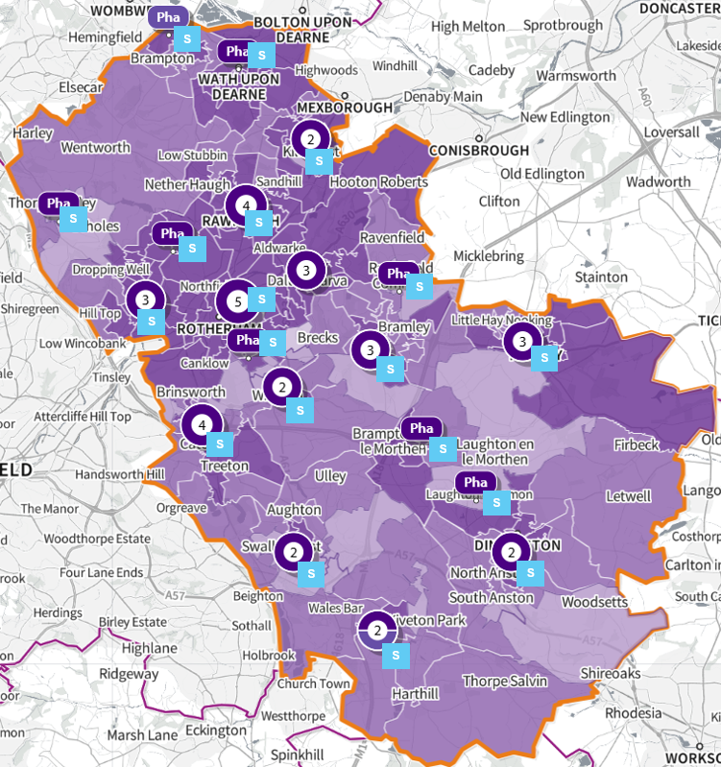
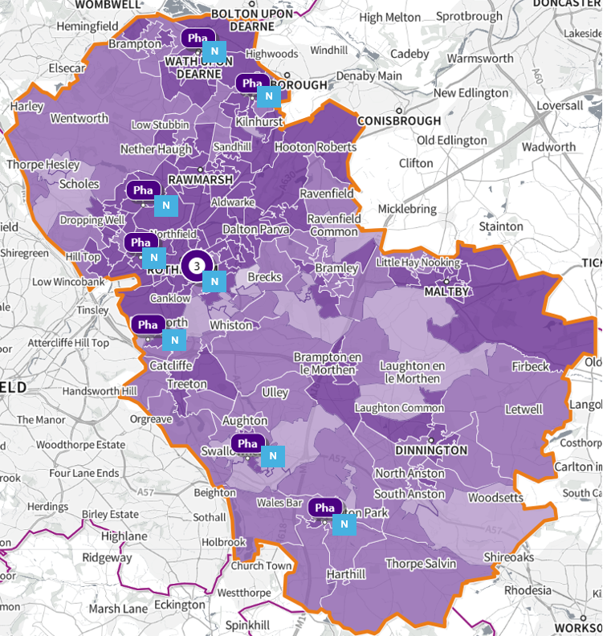
Annex 5: Locally commissioned service provision maps
Map A: Supervised consumption service by most deprived areas under the IMD 2019 Health Deprivation and Disability domain

Map B: Needle exchange services by the most deprived areas under the IMD 2019 Health Deprivation and Disability domain

© Crown copyright and database rights 2024 Ordnance Survey 100016969 | parallel | Mapbox | OpenStreetMap contributors
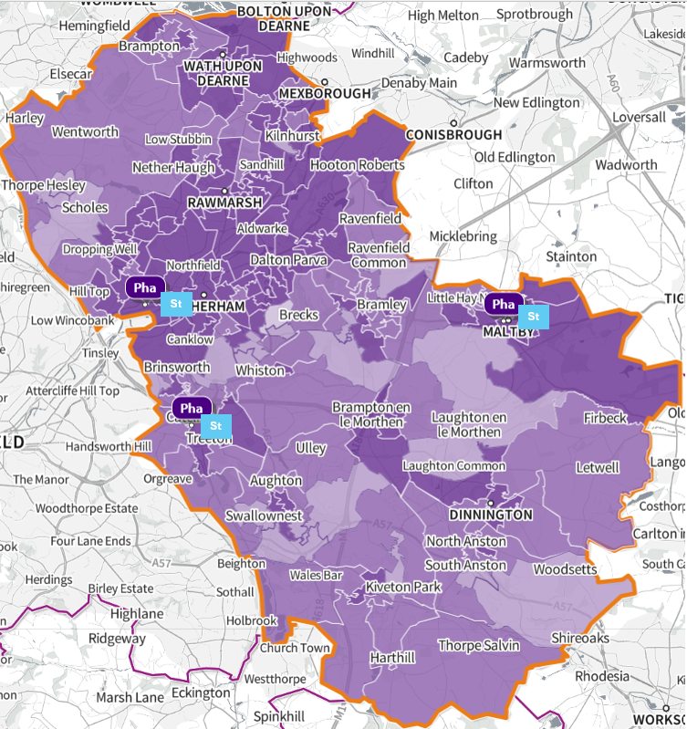
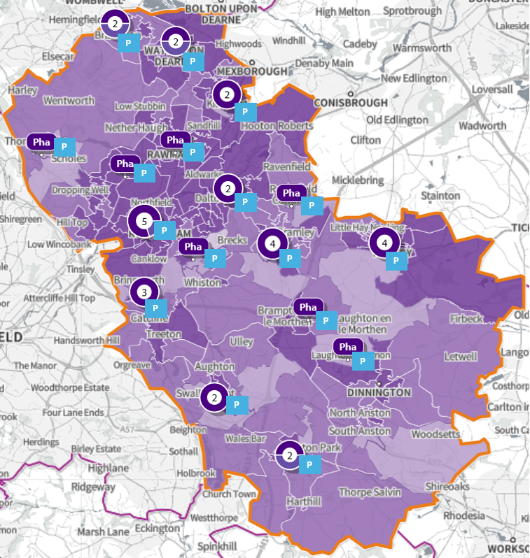
© Crown copyright and database rights 2024 Ordnance Survey 100016969 | parallel | Mapbox | OpenStreetMap contributors
Map D: Stoma customisation services by the most deprived areas under the IMD 2019 Health Deprivation and Disability domain

Map C: Palliative Care Drugs service by most deprived areas under the IMD 2019 Health Deprivation and Disability domain

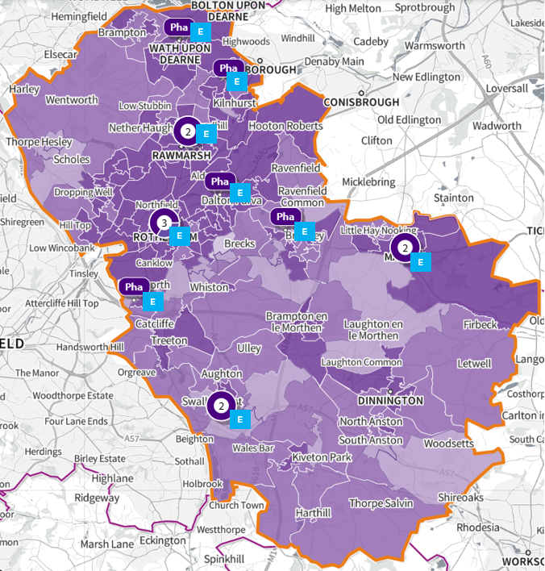
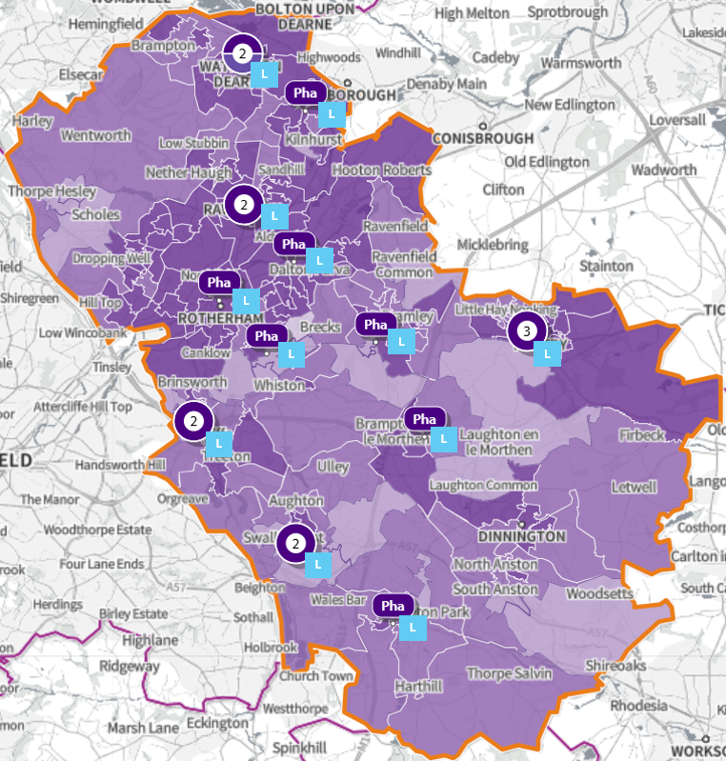
Map E: Over The Counter Medication Labelling Service services by most deprived areas under the IMD 2019 Health Deprivation and Disability domain

Map F: EHC service by most deprived areas under the IMD 2019 Health Deprivation and Disability domain

© Crown copyright and database rights 2024 Ordnance Survey 100016969 | parallel | Mapbox | OpenStreetMap contributors

Annex 6: Advanced services service provision maps
Map H: Flu vaccination service by most deprived areas under the IMD 2019 Health Deprivation and Disability domain

Map G: Pharmacy Contraceptive Service by most deprived areas under the IMD 2019 Health Deprivation and Disability domain

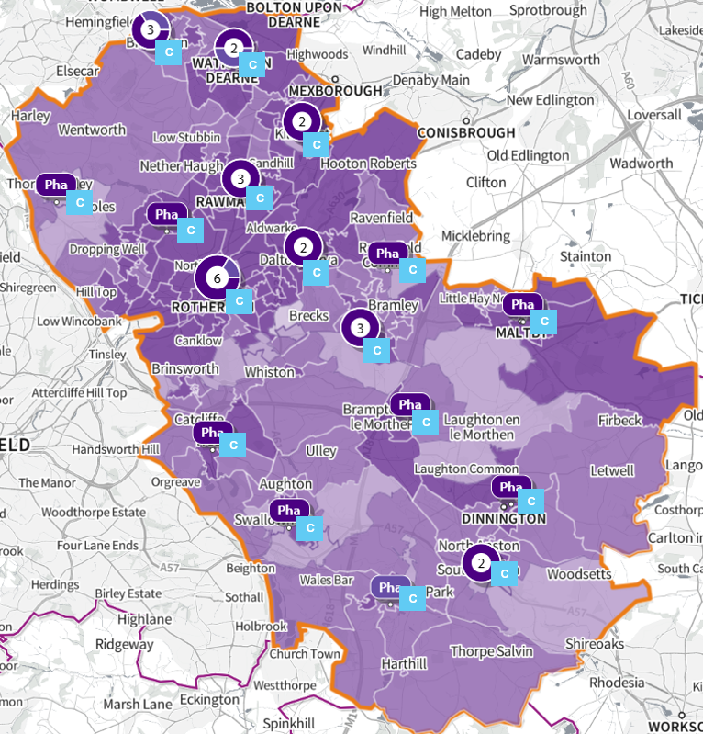
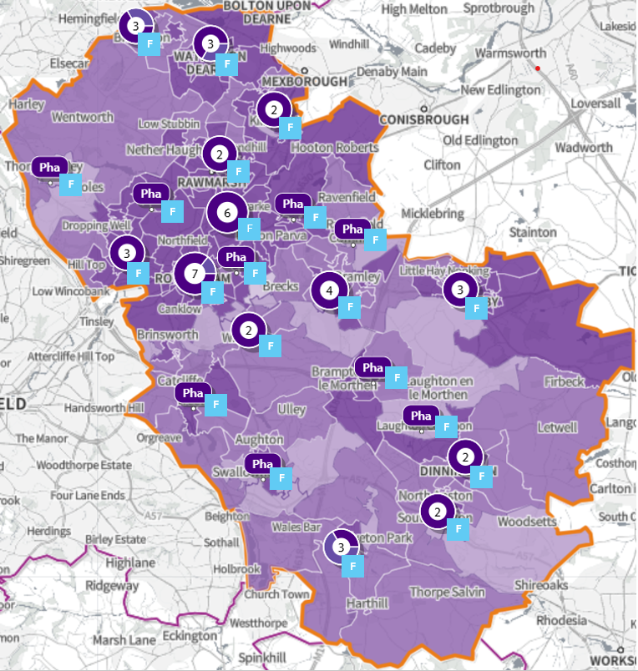

© Crown copyright and database rights 2024 Ordnance Survey 100016969 | parallel | Mapbox | OpenStreetMap contributors
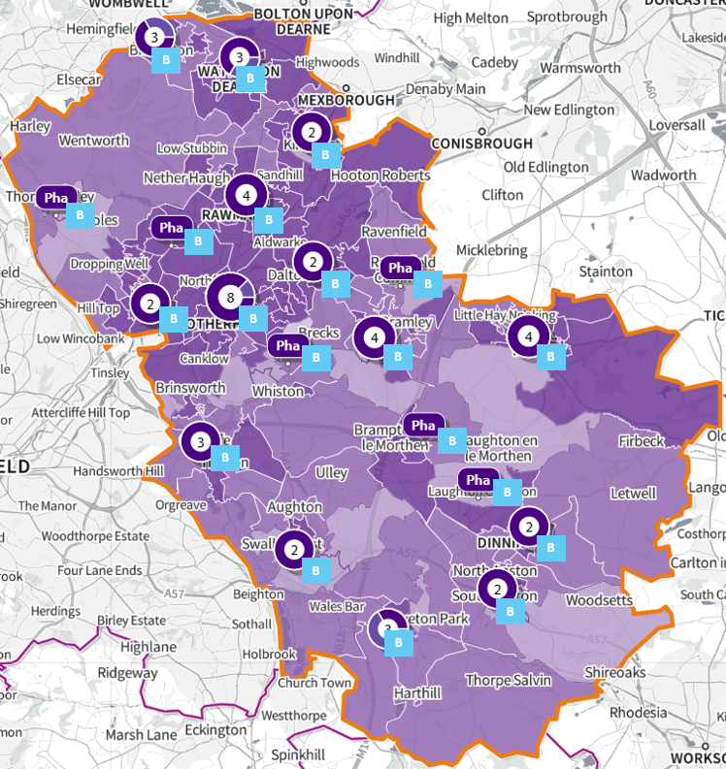
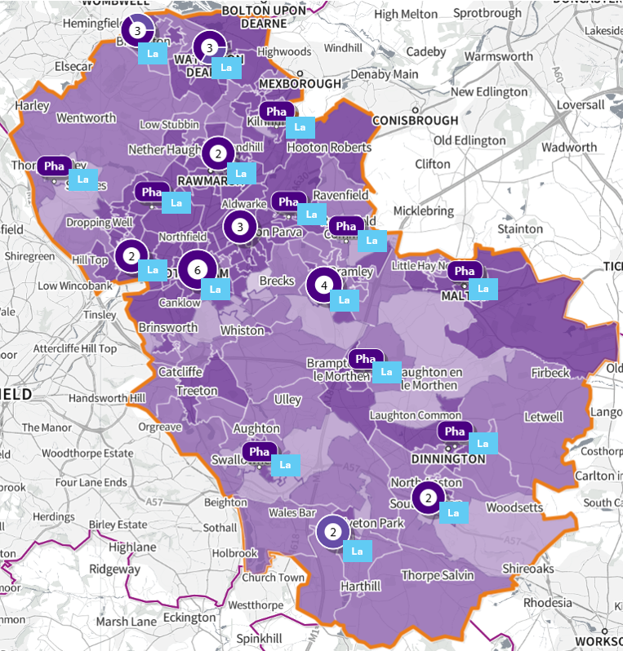
Map J: Blood Pressure checks service by most deprived areas under the IMD 2019 Health Deprivation and Disability domain

Map I: Lateral Flow Device (LFD) Test Supply Service services by most deprived areas under the IMD 2019 Health Deprivation and Disability domain

© Crown copyright and database rights 2024 Ordnance Survey 100016969 | parallel | Mapbox | OpenStreetMap contributors
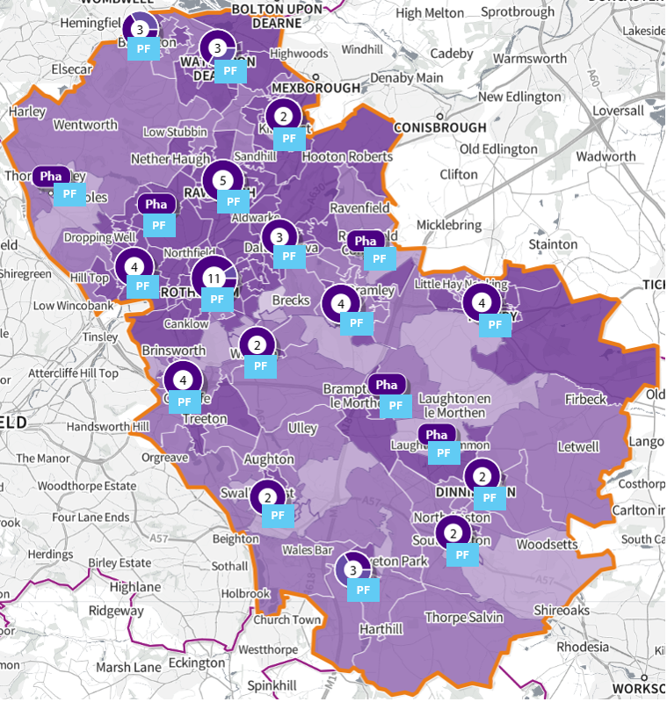
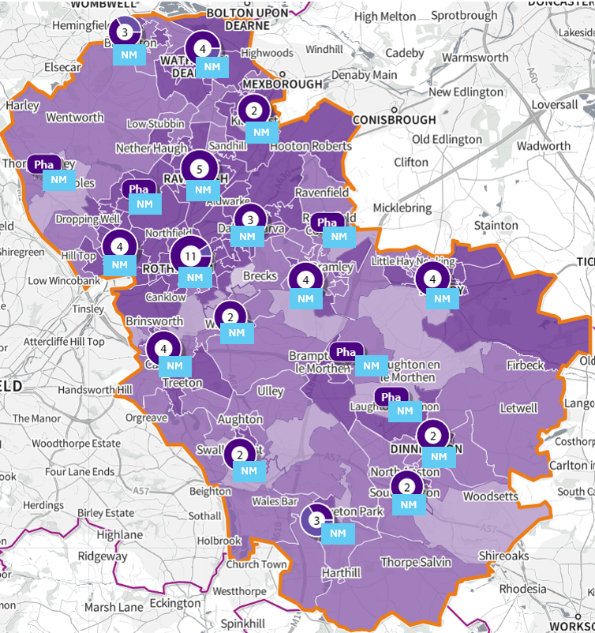
Map L: Pharmacy First service by most deprived areas under the IMD 2019 Health Deprivation and Disability domain

Map K: New Medicine Service service by most deprived areas under the IMD 2019 Health Deprivation and Disability domain

© Crown copyright and database rights 2024 Ordnance Survey 100016969 | parallel | Mapbox | OpenStreetMap contributors

Pharmaceutical needs assessments: Information pack for local authority health and
Consolidated Pharmaceutical List - Datasets - Open Data Portal
Department of Health and Social Care, Strategic Health Asset Planning and Evaluation Place Atlas (SHAPE), https://shapeatlas.net/
General Pharmaceutical Services in England 2015-16 - 2023-24, General Pharmaceutical Services in England 2015-16 - 2023-24 | NHSBSA
Estimates of the population for England and Wales - Office for National Statistics
Changing Supplementary Opening Hours - Community Pharmacy England
NHS England » Guidance on the NHS (pharmaceutical and local pharmaceutical services) (amendment) regulations 2023. Chapter 4.4.1
NHS England » Guidance on the NHS (pharmaceutical and local pharmaceutical services) (amendment) regulations 2023. Chapter 4.4
NHS England » Pharmacy First
What to expect when in the Urgent and Emergency Care Centre | The Rotherham NHS Foundation Trust
Emergency prescriptions - NHS 111
Consolidated Pharmaceutical List - Open Data Portal
Dispensing contractors' data | NHSBSA
Essential services - Community Pharmacy England
Advanced services - Community Pharmacy England
Adapted from: Pharmacy Contraception Service (PCS) - Community Pharmacy England
Adapted from: Emergency contraception | The Rotherham NHS Foundation Trust
Adapted from: Needle & Syringe Exchange - Community Pharmacy England
Stop smoking in pregnancy - NHS
Adapted from: Supervised Administration - Community Pharmacy England
Varenicline – a medicine to help you stop smoking - NHS
Pregnancy, breastfeeding and fertility while taking varenicline - NHS
Data for Essential and Advanced service provision was taken from the ‘Pharmacy and appliance contractor dispensing data’ on the NHS BSA, accessed April 2025: Dispensing contractors' data | NHSBSA
With the exception of the flu vaccination service, where the data period was the most recent flu season, September 2024 – March 2025, accessed May 2025.
The Appliance Use Review Service and the Stoma Appliance Customisation Service can be provided by both pharmacies and appliance contractors (62 locations in total), all other services are provided by pharmacies only (61 locations in total).
The two previous elements of the CPCS were incorporated into the Pharmacy First service when it began on 31st January 2024 – urgent medicines supply and minor illness.
Pharmaceutical smoking cessation services are primarily carried out through the locally commissioned Stop Smoking service: Tobacco Treatment Team | The Rotherham NHS Foundation Trust
This service took over from the CPCS from 31st January 2024, as well as add other services. For further detail
Available through the Smoking in Pregnancy team at TRFT.
Support to stop smoking is available locally through your GP or the local Stop Smoking service.
Data collected from NHS Catalyst:
Pharmacies offering the Palliative Care Scheme can be found at Palliative Care Scheme – South Yorkshire LPC
Emergency contraception | The Rotherham NHS Foundation Trust
Agenda item for Bassingthorpe development for Cabinet – 20th January 2025
What to expect when in the Urgent and Emergency Care Centre | The Rotherham NHS Foundation Trust

