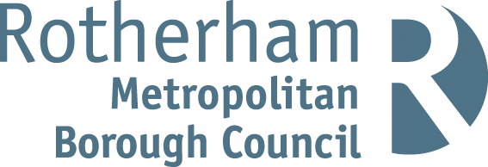

Housing Annual Report 2024-2025
What we’ve achieved in the past year and a glimpse of what’s ahead.
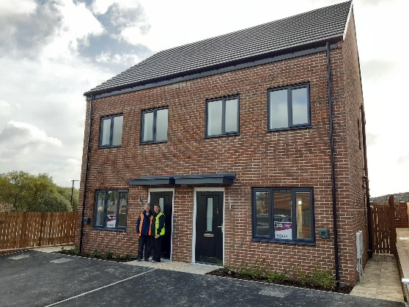
www.rotherham.gov.uk/housing

Welcome to the Housing Annual Report for 2024/25
I’m delighted to introduce this year’s Housing Annual Report for the first time as the new Cabinet Member for Housing. The report reflects on our work and performance from April 2024 to March 2025 and highlights the progress we’ve made together with our tenants, staff, and community. Over the past year, we’ve continued to improve homes, strengthen communities, and support residents.
In the past you have told us to focus on providing safe, warm, and high-quality homes. This year, we’ve delivered 156 new affordable homes, invested over £29 million in property improvements, and celebrated the delivery of our 650th new home since 2018. We also investigated more than 4,000 cases of damp and mould, referring the most serious to specialists and installing over 3,400 fans to help prevent future issues. Our Compliance Team has helped us ensure we meet our responsibilities as a landlord, and we’ve continued to maintain 100% completion rates for key safety checks.
We know the rising cost of living is a challenge for many of our tenants. That’s why we’ve assisted over 3,400 residents with tenancy advice, benefits assistance, and employment support to ensure individuals get the help they need. We’ve also helped prevent 46 tenants from being evicted and secured over £600,000 in welfare benefits for tenants.
Your voice matters to us. 150 tenants have taken part in tenant groups and provided the valuable feedback we need to make real improvements to our services. Many of you also helped organise 53 community events, attended by over 1,000 residents. We’re also really pleased to see so many areas of tenant satisfaction improving and we’ll keep listening and acting on your feedback to make our services better.
Inside this report, you’ll find statistics, updates and stories from across our housing services and a glimpse of what’s ahead. We appreciate the time tenants dedicate to shaping our housing services. See page 10 to 13 for more information about how you can get involved. We hope you enjoy reading the report.

Councillor Linda Beresford
Cabinet Member for Housing

78.2% are satisfied with the overall service we provide. (Last year - 76.9%)
77.7% are satisfied that their homes are well-maintained. (Last year – 77.6%)
81.0% are satisfied that their homes are safe. (Last year 81.1%)

Welcome to the 24-25 Housing Annual Report. I’m Chair of the Housing Involvement Panel and I am a Trustee of Rotherfed.
Parts of this report have been put together by tenants – we’ve got to work together and play our part.
I’ve had a positive experience engaging with housing teams at the Council.
If there are challenges, there are opportunities to find solutions, but to solve them, you need to speak up. Tenants get involved to shape things; it’s up to a tenant to help make changes. With our help, improvements can happen. If you come along, you will also join residents from across our areas and meet new or possibly old friends. Please get involved and help us.
Thank you for taking the time to read this report, it means a lot to tenants to have our views shared.
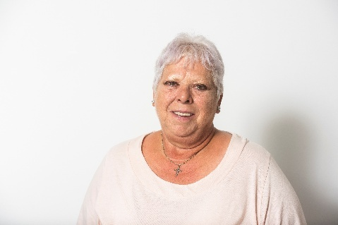

Stella, Housing Involvement Panel Chair

Our achievements

Snapshot of the year 2024-2025

What we’ve achieved over the past 12 months:

- 3,478 residents supported (Tenancy support, money and benefits advice and Employment Solutions)
- £794,250 paid out to tenants and residents in the Energy Crisis Scheme.
- 6310 households had a minor or major adaptation or fixing.
- 1236 homes let.
- 150 tenants involved in engagement groups with housing services.
- 128 mutual exchanges (home swaps).
- 348 tenancy transfers.
- 31 days to re-let properties.
- 393 lets for homeless households and care leavers.

How we use what we know about you
We’re committed to providing services that reflect your individual needs, including health, disability, age, pregnancy, finances, and life events, and we’re working to make sure these are considered in our services. For example, we understand that a tenant with mobility or hearing difficulties may need more time to answer the door.

To help us do this, we collect information when you join the housing register, sign your tenancy, or have a Tenancy Health Check. If anything changes, please call 01709 336009 or update your details on Housing Online.

Some information about our tenants:

- 62% of our tenants are female.
- 41% of our tenants are aged 60+
- 62% of the tenants who have provided this information advised they had a disability.
- 1,204 tenants told us they are from an Ethnic Minority background.
- 7,767 tenants told us they follow a religion or belief.

Our commitment to building and tenant safety

During the past 12 months, we have demonstrated our commitment to ensuring all tenant homes are safe. In 2024, we formed a Compliance Team dedicated to this. Their work has ensured all processes are in place to meet building and fire safety obligations. We track and audit all safety actions to maintain high standards.



Our zero-tolerance approach to damp and mould
Rotherham Council takes a zero tolerance, proactive approach to damp, mould and condensation within Council-owned properties, and supports other landlords in the borough to do the same. When damp and mould is reported or noticed by a member of staff during a visit, our repairs service will take prompt action.
Every report is inspected through a three-stage process. This process allows us to identify the root cause, diagnose the issue and take appropriate steps to resolve it. Wherever possible, we strive to fix the problem the first time to ensure your home remains safe and comfortable.
If you need to report damp or mould, call us on 01709 336009.
In 24/25:
4062 damp and mould referrals.
2,151 cases referred to specialists.
3430 extractor fans installed to prevent damp and mould reoccurrence.

Beeversleigh Flats safety group commences
The Compliance Team and Rotherfed have started regular meetings with the residents of Beeversleigh Flats to give them a stronger voice in how fire safety is managed in their building. These include two safety meetings a year and monthly drop-in sessions with the fire safety team. At the first meeting, 19 residents attended and shared their views. We’re tracking all concerns and will share updates in the next meeting. We’ve already received positive feedback on the new digital locks fitted to bin chute areas which prevents them being used by non-residents and allows residents to feel safer in their homes.
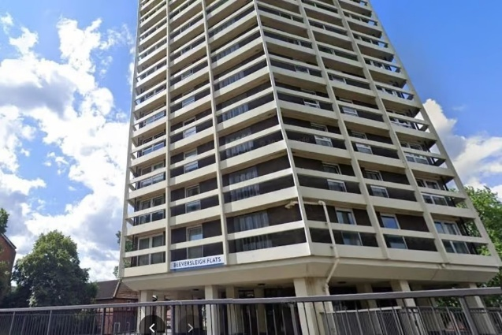
7.2% of our homes do not meet the Decent Homes Standard (Last year 12%)
100% of gas safety checks have been completed. (Last year 99.9%)
100% of fire safety checks have been carried out. (Last year 100%)
100% of fire risk assessments have been carried out.
100% of asbestos checks have been completed (Last year 100%)
100% of water safety (legionella) assessments have been completed. (Last year 100%)
100% of lift safety checks have been completed (Last year 100%)
96.6% of electrical systems inspected within 5 years.

IN THE NEXT 12 MONTHS, WE PLAN TO:
- Have an online reporting form making it quicker and simpler for tenants to report damp and mould.
- Engage more residents living in buildings above 11m in height with building safety work.

Improving the quality of homes

78.6% of tenants are satisfied with the repairs service (Last year 74.1%)
77.6 % of these are satisfied with the time taken to complete most recent repair. (Last year – 72.1%)
98.8% of emergency repairs were completed within target timescale (Last year – 99.0%)
96.7% of non-emergency repairs completed within target timescale (Last Year 97.0%)

Rotherham Council’s repair service:
We are here to look after your home and keep it in good condition. While tenants are responsible for minor repairs and maintenance, our everyday repairs service covers a wide range of issues to keep your home safe and in good condition. This service is delivered in partnership with Mears and Equans, along with specialist contractors for specific jobs. Emergency repairs are attended within four hours to protect your safety and security. Standard repairs are booked within 28 days, with appointment times chosen by you. We are focused on making repairs quick and hassle free and we always try to fix the issue on the first visit.
To book a repair job, please call us on 01709 336009 or visit: www.rotherham.gov.uk/improvements-repairs/council-housing-repairs or scan the QR code.


Investing in homes
In 2024/25, Rotherham Council invested over £29 million to improve more than 4,000 council homes. This included major external works in Thurcroft, East Herringthorpe and Dalton as well as upgrades to around 500 empty properties before they were re-let.
Here’s a look at what was delivered:
- 343 new kitchens
- 396 new bathrooms
- 7 additional secondary bathrooms
- 1,819 heating system upgrades
- 245 new roof finishes
- 532 homes with improved loft insulation
- 99.8% of homes installed with Carbon Monoxide Detectors

Investing in the communal areas
£800,000 has been invested in improving shared outdoor areas across 16 estates in Rotherham. These environmental works are all about making spaces more welcoming, safer and better for the environment. One example is Acorn Place in Rawmarsh where old brick planters were removed to open up the communal space. Large tarmac areas were replaced with grass to reduce flood risk from rainwater and create a greener, more pleasant environment for residents to enjoy. 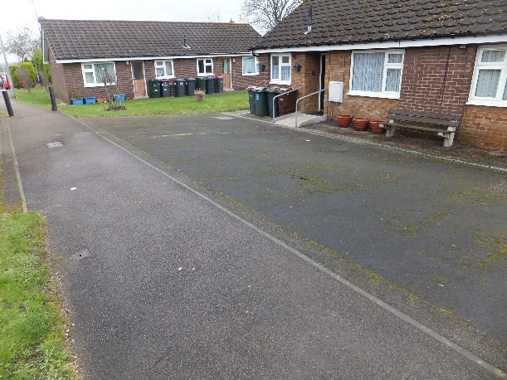 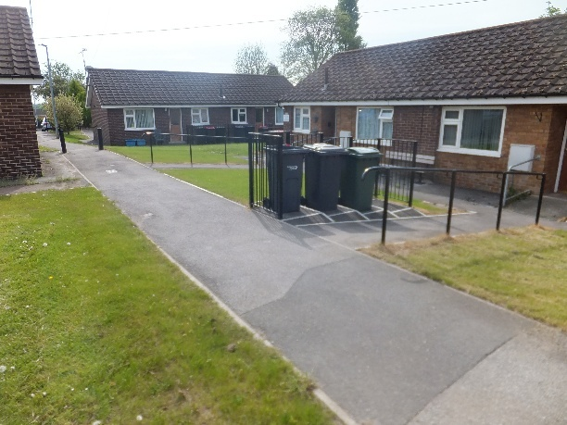

Stock Condition Surveys Underway
We’re surveying all 20,000 of our Council homes to help plan future maintenance and home improvement works and to make sure your home is safe. A specialist company, MLCS3, is carrying out the surveys which involves checking things like kitchens, bathrooms, windows, doors, heating systems, and energy efficiency or safety issues. The surveyors carry ID and will treat your home with respect. You’ll receive a letter with your appointment date and time before the visit. Thank you to everyone who’s already taken part! If you receive an appointment, please allow the surveyor access.
Visit www.rotherham.gov.uk/housing/stock-condition-survey or scan the QR code to find out more.

In 24/24:
51,304 repairs raised.
94.53% first fix repairs.
£22,767,533 spent on repairs and maintenance.
£29 million invested on improving tenant homes.

IN THE NEXT 12 MONTHS, WE PLAN TO:
- Launch the Warm Homes Programme funded by the Social Housing Decarbonisation Fund and the Council to cut household energy bills down by an average of £231.
- Install 3147 energy efficiency measures in 996 properties over the next 4 years including 287 loft insulations, 868 solar panels and 996 ventilation upgrades.

Investing in new homes

Celebrating 650 new homes
In February 2025, we delivered the 650th new home since launching our development programme in 2018. This marks a major milestone in our commitment to quality, affordable housing helping to ensure everyone has a safe, secure place to live. We’ll continue to deliver high-quality new homes across the borough to meet local needs either by building new homes, purchasing properties or working with private developers.
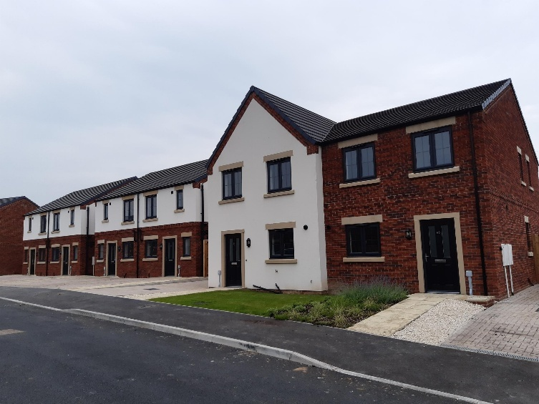

£5m in grant funding
We’ve secured over £3.5 million from the Homes England Affordable Homes Programme and £400k from the Brownfield Housing Fund to support the delivery of homes, including apartments for older people, modern bedrooms, and larger family homes. In addition to this, £1.3m from the Local Authority Housing Fund has been used for 20 new temporary accommodation homes for homeless residents.
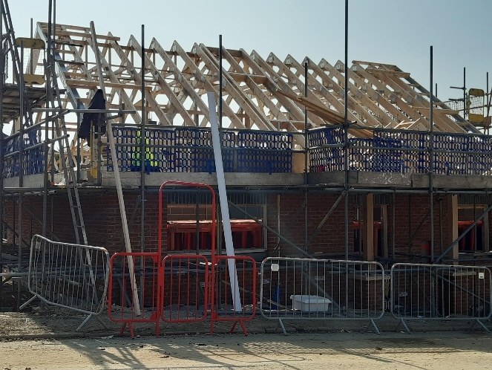

In 24/25:
- 156 properties built/acquired.
- 147 Council Build properties in development.

Award-Winning Homes Making a Difference
Rotherham Council has won Best Affordable Housing Development (up to £5m) at the 2025 Northern Housing Awards for delivering ten high-quality, energy-efficient homes in East Herringthorpe. The development includes the borough’s first one-bed houses and a specially designed four-bed bungalow for families with complex health needs.
These homes were built specifically for Council tenants and include a mix of house types. Features like energy-efficient heating systems, solar panels, underfloor heating and ventilation systems help reduce energy bills while improving comfort and air quality.
Residents say the homes have changed their lives. One tenant shared: “This move has improved my mental health, decreased my anxiety, and reduced my bills – it’s life changing.” The Housing Team has also been shortlisted for two Municipal Journal Awards including Innovation in Housing for the new homes on Infirmary Road, Parkgate.
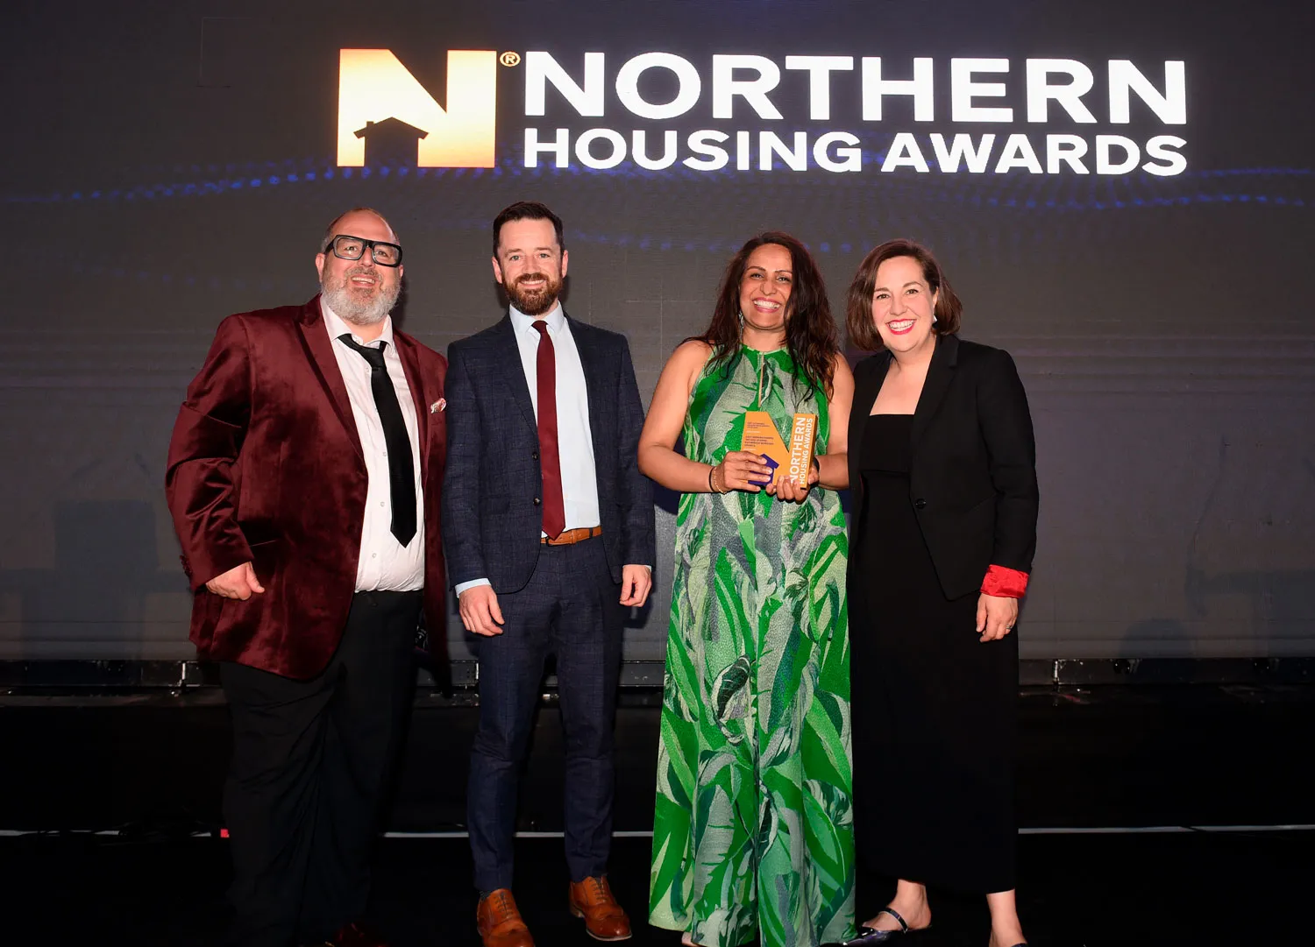
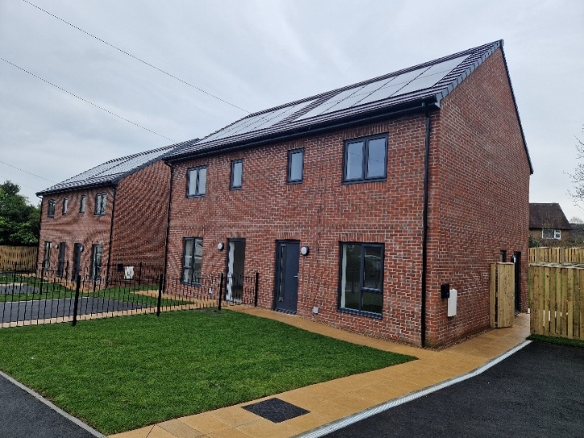

IN THE NEXT 12 MONTHS, WE PLAN TO:
- Start construction of new-build council homes at locations including Maltby, Eastwood and Wath.
- Start building council homes delivered through our Small and Medium Enterprise scheme at the former Albert Club in West Melton, Clement Street in Kimberworth.
- Deliver 110 new homes in 2025/26.

Listening to tenants and acting on your feedback

76.8% of tenants are satisfied we keep them informed about things that matter to them. (Last year 74.0%).
71.5% of tenants are satisfied that we listen to their views and act on them. (Last year 70.5%)
83.0% of tenants agree that we treat them fairly and with respect. (Last year 83.6%)
Our housing services at Rotherham Council are committed to listening to tenants and using your feedback to improve our services.

Housing Involvement Panel (HIP)
The HIP meets every month at Riverside House to help shape better homes and services.
Tenant voice: Callum
“I enjoy the speaking aspect of engagement and giving my input. I did a small segment at the last tenant convention and explained what we do at the HIP. If you want to see a change or get involved in current practices, it’s worth seeing if you can join. The Council needs diverse feedback from different people.”
Tenant Voice: Mohammed
“I’ve been part of the engagement group since 2011/2012. I first popped down to observe a meeting, then came to my first one – and I’ve been coming ever since. I’m a carer and volunteer around my caring duties. I have a Black and Minority Ethnic background and I’ve been involved to help target the different communities. We’ve given feedback on complaints, repairs, the contact centre and the information pack when you move in.”
You said: “The online Housing Performance Dashboard needs to be clearer, with the most important information easy to find.”
We did: Redesigned the dashboard based on your feedback to improve clarity and understanding. Visit https://www.rotherham.gov.uk/council-social-housing/housing-service-performance or scan the QR code for more information.


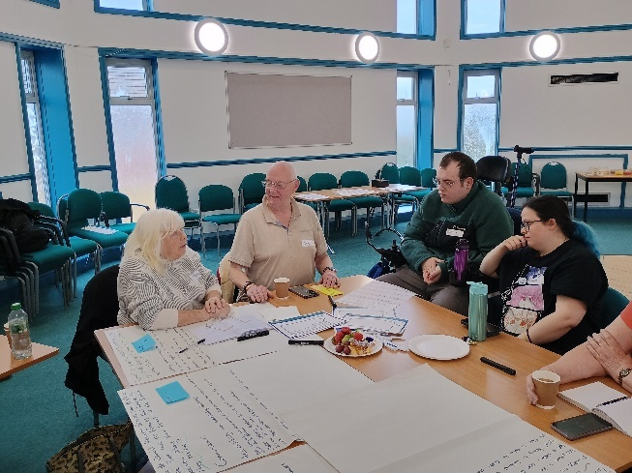

Screen Team
The Screen Team meets online every month to help make Council letters, emails, and website content clearer and easier to understand.
Tenant voice: Dale
“I got involved as I am neurodiverse so I can get stuck on long passages of text. If it’s accessible, I can read the text a lot quicker. I wanted to help the Council make their communication easier to understand. Also, after a serious motorbike accident made me homeless, Rotherham Council came to my rescue and found my forever home.
In Screen Team meetings, we get to look at things on the website before it goes live and suggest changes. Recently, we helped improve a District Heating guidebook. It’s good to have members of the public looking and checking.”
You said: “Improve stock condition survey letters with more information about the company that is carrying out the surveys.”
We did: Updated the letter to include details of the visit from MLCS3 and the ID worn by the contractors.
You said: “The Home Matters magazine should feature more articles about local events to highlight what’s happening in the community.”
We did: In the Spring 2025 edition, we included articles on the Children’s Capital of Culture, The Rotherham in Bloom Garden Competition, and a preview of what’s coming to Forge Island. Find the newest edition here Home Matters Magazine – Rotherham Metropolitan Borough Council or scan the QR code.


Tenant Scrutiny Panel
The Tenant Scrutiny Panel works with Rotherfed to review our housing services and makes suggested improvements.
Tenant voice: Mary
“I’ve been a volunteer for a lot of years and like to find out what is happening and tell other people. I like meeting people from different areas and hearing their views. Every meeting is interesting. I think we make a difference because people listen and act on what we say. Things have really improved since I started volunteering.”
You Said: “Tenants should receive their affordability check document when they are matched to a property.”
We Did: We now send a personalised breakdown of the affordability assessment and rent payment options to every new tenant.
You said: “There isn’t enough information online describing what happens during a Tenancy Health Check.”
We did: Improved the Tenancy Health Check webpage so there is clear information about what will happen during the visit from your Area Housing Officer. Find the webpage here https://www.rotherham.gov.uk/private-housing/tenancy-health-check or scan the QR code.


Focus group spotlight – Individual Needs framework
A group of 12 tenants helped shape our new Individual Needs Framework, which aims to ensure housing services are accessible to all, and tailored to everyone’s individual needs, especially those with diverse needs. Their experiences and insights will support the Council in delivering more effective and equitable services.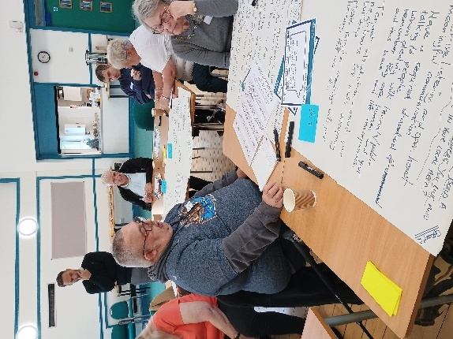

Community highlights spotlight – Fitzwilliam Estate TARA
Tenant voice: Nicola
Why did you want to support the community?
“Me and my friend grew up on the estate. There wasn’t a lot for kids then and there still isn’t, but we have a good relationship with the community. We wanted to build community spirit, bring people together, and help kids make friends.”
How did you get involved in community groups?
“Me and my friend grew up on the estate. There wasn’t a lot for kids then and there still isn’t, but we have a good relationship with the community. We wanted to build community spirit, bring people together, and help kids make friends.”
Which community events have you been a part of?
“We did a pumpkin painting event in October, with donated Halloween costumes, and there was a raffle and tombola. At Easter, we had an event with arts and crafts. We also took 106 residents to Cleethorpes on two coaches! We’re now looking at ways to engage teenagers as they’re showing an interest too.”
What effect is the group having on the community?
It’s had a positive impact on the community spirit – bringing people together, helping new tenants make friends and making families feel more secure and involved.

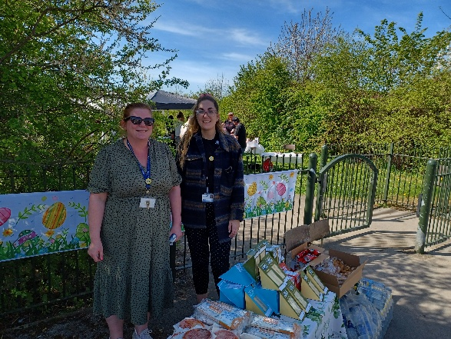

Connectors pool
The Connectors Pool is for tenants who want to stay informed and involved without attending regular meetings. Members receive monthly housing and tenant news updates and can join consultations or events when they choose. Since March 2024, 165 tenants have joined, with 13 going on to join panels or events.

Thank you to our tenants
24-25 Stats
- 150 tenants involved in panels, focus groups and from home.
- 34 consultation topics discussed.
- 53 community events attended (with 1,090 residents attending).
- 7 digital support volunteers gave 90 hours, supporting 196 people.
We really value the time and input from our tenants. To say thank you, we hosted a celebration with a three-course meal and quiz. Those who couldn’t attend received a thank you card and gift voucher.
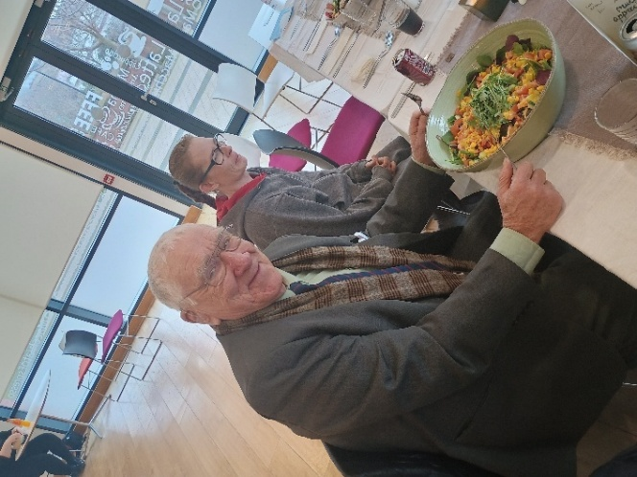

Want to get involved?
Visit our website at https://www.rotherham.gov.uk/tenant-involvement or scan the QR code.

Alternatively, contact Rotherfed on 01709 368515 or info@rotherfed.org.

Handling your complaints with care

Overview of our complaints mission
At Rotherham Council, we see complaints as a valuable way to improve the services we provide. Every complaint is recorded, taken seriously, and used to help us make positive changes. We investigate issues, take action to fix problems, and learn from what went wrong. This helps us improve our services for everyone. As your landlord, we’re committed to meeting high standards and doing things right. We also work closely with the Housing Ombudsman to make sure our complaints process is fair and follows national guidelines.

- 34.5% of tenants are satisfied with our approach to complaints handling. (Last year 36.2%)
- 368 Stage 1 & Stage 2 complaints were received during the year. Out of these, 365 complaints were Closed, with 97 being upheld.
- 78.1% of stage 1 complaints were handled within the Housing Ombudsman’s timescales. (Last year 82.3%)
- 37.5% of stage 2 complaints were handled within the Housing Ombudsman’s timescales. (Last year 55.5%)

Housing Ombudsman investigations
- Total Investigations Received: 6 cases (5 involving council tenants)
- Upheld Investigations: 4 cases were upheld

Top 4 complaints themes:
- Quality of Service
- Delay in Service
- Lack of Service
- Conduct/Attitude of Staff

Acting on your feedback
You said: “Rubbish and materials were not removed after repair work was completed.”
We did: We worked with our contract partners to ensure timely removal of any leftover materials and to inform tenants when materials will be removed.

You Said: “Communication needed improving in our Aids and Adaptations service.” We did: We’ve made changes to help keep you better informed. We’ve added clear timescales to the booklet we’ve printed, so you’ll know what to expect and when. We’ve also updated our process to make sure we contact you at the very start, explaining what will happen and how long things should take.

Compliments:
280 Housing Compliments were received in the year April 2024 to March 2025.
Compliment for Mears repairs contractors “I would like to take a moment to express my deepest gratitude to you and the entire team for the incredible support you’ve provided in getting my roof repairs sorted. Your swift action and dedication have made such a significant difference, and I can’t thank you enough for your time and effort.”
Compliment for Housing “All of the repairs workers that come to my house are always respectful of me and my home and they are always willing to put on shoe covers.”
Compliment for the Income Recovery Team “Your help and communications with me since my personal stresses and mental health have been fantastic. I cannot thank and praise you enough.”

Newly formed Complaints Panel
Our Housing Complaints Panel was set up to strengthen the partnership between tenants and Rotherham Council’s Complaints Team. It gives tenants a real voice in how we handle and learn from complaints. The Panel reviews real-life complaints and challenges how our housing services respond. At the first meeting in March, topics included communication with tenants, contractor customer service, and the condition of homes at move-in. The Panel will meet every three months to help us learn from tenant feedback and improve the way we work.

If you have a complaint, there are a number of ways you can get in touch to tell us.
- Complete a web form: www.rotherham.gov.uk/complaints
- Email complaints@rotherham.gov.uk
- Text 07860 021 447
- Call 01709 382121
- Post:
The Complaints Manager
Rotherham Metropolitan Borough Council
(FREEPOST RTCT-XKLS-ZHAZ)
Riverside House
Main Street
Rotherham
S60 1AE
We’d also love to hear from you if you are happy with a service or member of our team.
Email complaints@rotherham.gov.uk or call, text or write using the details above. Further information can be found at www.rotherham.gov.uk/complaints or scan the QR code.


Supporting our neighbourhoods and communities

68.1% of tenants are satisfied communal areas are clean and well-maintained. (Last year 71.6%)
71.2% of tenants are satisfied that the landlord makes a positive contribution to neighbourhoods. (Last year 72.4%)
63.3% of tenants are satisfied with our approach to handling anti-social behaviour. (Last year 64.9%)
70.4 anti-social behaviour cases (per 1000 homes), 0.4 of anti-social behaviour cases involved hate crime (per 1000 homes).

Tackling Anti-Social Behaviour (ASB)
We know anti-social behaviour can seriously affect your quality of life and sense of safety. That’s why we take every report seriously and support victims from the first complaint to the resolution. Our housing officers work closely with South Yorkshire Police and the Community Safety Team to prevent ASB and build safer communities. We take a fair, step-by-step approach with offenders and use all available powers to stop their disruptive behaviour.

ASB behaviour themes
Total ASB cases in 2024-2025: 1413
ASB category | Number of cases
Garden nuisance | 403
Verbal abuse / harassment / threats | 256
Noise | 252
Drugs / substance misuse / dealing | 134
Pets and animal nuisance | 92
Misuse of communal area / public space | 80
Litter / rubbish / fly-tipping | 50
Vandalism and damage to property | 43
Nuisance from vehicles | 39
Criminal behaviour | 20
Physical violence | 14
Alcohol related | 11
Hate related incident | 9
Domestic abuse | 7
Prostitution/sexual acts | 3

Case Study: Tackling ASB in Greasbrough
After repeated reports of noise and tenancy breaches at a property in Greasbrough, our Housing Team and Community Protection Unit (CPU) took action. Despite early challenges gathering evidence, the CPU issued a Noise Abatement Notice ordering the tenant to stop. Due to his aggressive behaviour, future visits were carried out with South Yorkshire Police. The tenant failed to comply and was fined nearly £1,000, but the disruption continued. In March 2025, the Council secured a Notice Seeking Possession, leading to eviction the following month, ensuring a better outcome for neighbours and the wider community.

Improvements in Munsbrough
A recent walkabout with council staff, Streetpride, local councillors, and estate caretakers helped identify issues in the Munsbrough area including fly-tipping, overflowing bins, and overgrown paths.
What’s been done:
- Bin areas have been checked, and locks added to recycling bins to help stop contamination
- A new fly-tipping team has cleaned up the area and cleared pathways
- Streetpride has cut back overgrown grass in hard-to-reach places

Neighbourhood Centres Refreshed
Elizabeth Parkin Centre
After requests from tenants and residents, the centre has been redecorated. It’s now a warm and welcoming space where people come together for TV nights, games, and lunches — a real community living room.
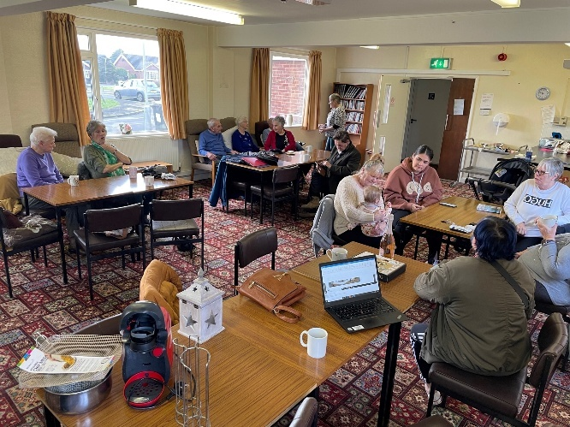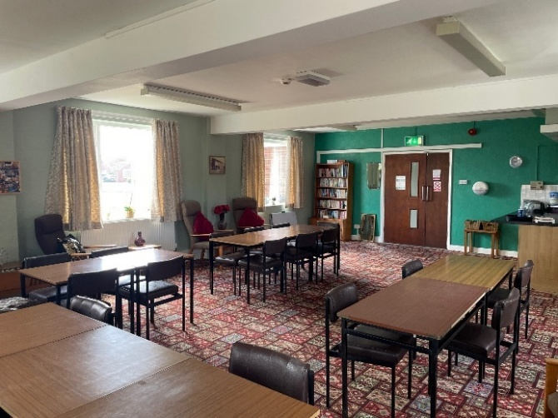
St Mary’s View
This centre has also been redecorated, with fresh paint in a modern white and grey theme, fire safety improvements, and newly recovered chairs. Rotherfed recently consulted local tenants for feedback on how the new centre could be used for social events and activities.
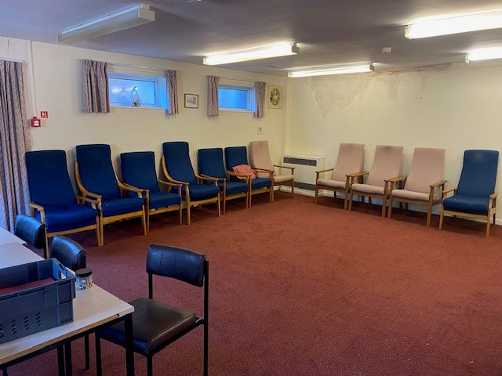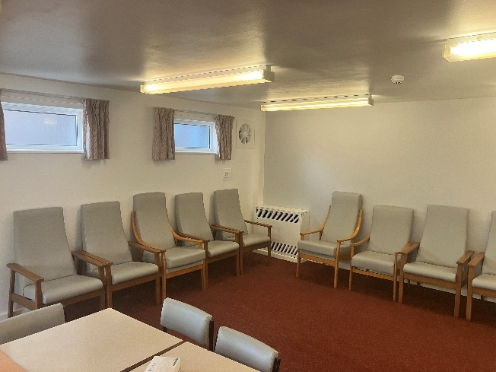

Ensuring support for all tenants

Your wellbeing is our priority. We’re here to help you feel safe, secure, and supported in your home, whether you need help paying rent, managing life’s challenges, or finding work or training.

Tenancy support
Our Tenancy Support team is here to help you maintain your tenancy long term. We offer practical support from the start of your tenancy, including help with debt, mental health, or substance use. When you’re struggling to pay rent, our Income and Support teams work together to help you avoid eviction.

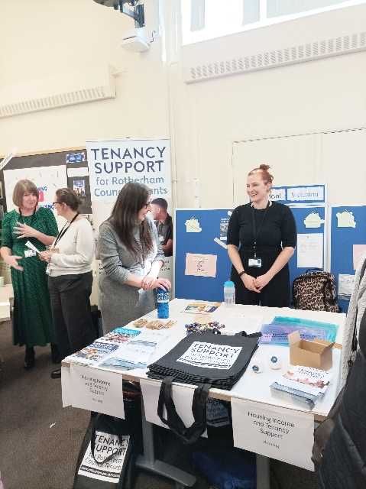

92% of tenants remain in their home after threat of eviction with tenancy support assistance.
1360 tenancy support referrals received in 2024/2025.
£639,896 Welfare Benefits claimed on behalf of tenants.

Tenancy Support success stories

A new start in a suitable home
A tenant with learning difficulties, mobility issues, and deafness was struggling to manage a large, unsuitable, and costly three-bedroom home after losing both parents. Our Tenancy Support and Lettings teams helped secure Band 1 priority for a move to a more suitable and affordable property. A Discretionary Housing Payment (short-term financial support) covered the rent during the wait, and support continued until he was settled in his new home.

A helping hand through difficult times
After losing her mum and not having family to rely on, one tenant became isolated and stopped engaging with services. She struggled with her health, lost her Universal Credit, and built up thousands in rent arrears. With support from her tenancy support officers, her benefits were reinstated and backdated so the arrears were fully paid off. She’s now continuing to receive support to maintain her tenancy.

A safer home with support every step of the way
An elderly tenant with serious mobility issues was struggling in a large home that no longer met his needs and was being financially exploited by a family member. With help from Adult Social Care and Tenancy Support, he was supported through the process of moving to a more suitable bungalow. The team helped with arranging care, setting up bills, and making sure the new tenancy was affordable and manageable.

For more information about Tenancy Support, visit https://www.rotherham.gov.uk/housing/tenancy-support (or scan the QR code) or call us on 01709 336009 and ask for a member of the Tenancy Support team.



Employment Solutions: Helping you to find work and training

Our Employment Solutions service supports Rotherham residents who are unemployed or on a low income to find jobs, access training and improve their financial wellbeing. Over the last year, our team have supported 133 residents into employment and 86 into training. You can access our service through our hub on the ground floor of Riverside House or contact us on 01709 249600 or employmentsolutionsteam@rotherham.gov.uk



Ann’s Story
After 22 years in the same job, Ann’s workplace was closing so she turned to Employment Solutions for help. The team supported her with completing a job application and preparing for an interview. Within days, Ann was offered a role as a School Crossing Patrol Warden. She’s now loving her new job and says the support gave her confidence and made her feel valued: “Megan was there for me when I was at my lowest. She treated me like a person, not a statistic.”

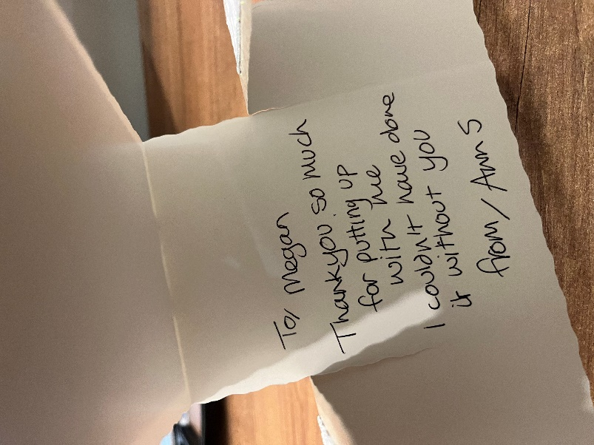

RK’s Story
After three years out of work caring for her children, RK felt overwhelmed and unsure where to start. Referred by the Job Centre, she worked with Employment Solutions to rebuild her confidence and explore flexible job options. With support, she applied for a part-time Council role through job sharing. After interview prep and guidance, RK was offered the job and now works part-time in Customer Services. She says: “Thank you so much for your help and support… work is great!”

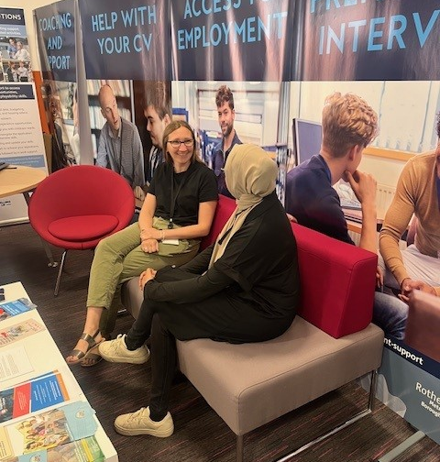

Making sense of the money

Making sense of the money

Rotherham Council owns and manages 19,942 council homes. In 2024/25, the income was £106,466,880.
Below is an overview of how your rent was spent during the year.

Capital Charges* | £45,135,461 | 44%
Repairs & Maintenance | £22,767,533 | 23%
Estate Management | £1,519,086 | 2%

Staff & Service Charges
Housing Management | £5,575,288 | 6%
Anti-Social Behaviour | £123,398 | 0%
Central Services** | £10,923,075 | 11%
Income Management | £1,437,702 | 1%
Tenant Involvement | £96,100 | 0%
New Housing and Housing Strategy | £1,939,003 | 2%
Housing Options, Allocations and Homelessness | £7,669,974 | 8%
Housing Property Services | £3,471,424 | 3%
Total Expenditure | £ 100,658,044 | 100%
*Money borrowed to pay for major building improvements, including interest on debt and funds for new builds.
**Management, admin, and business support for the service.

Focus on Income
Most of the income comes from rent but tenants and leaseholders are also charged for services and facilities that the Council provides.
House rents | £95,920,664
Garages and ground Rent | £812,063
Furnished packages | £6,489,776
District heating | £968,078
Communal facility charges | £595,040
Right to Buy receipts | £114,400
Leaseholder contributions to services | £346,969
Aids and adaptations | £415,512
Miscellaneous income | £804,378
Total Income | £106,466,880
Transferred to reserves | £5,808,836
Total funds used | £100,658,044

For every £1 of rent you pay
- 44 p is used for funding major improvements and other important investments.
- 23p goes towards day-to-day repairs to fix and maintain homes.
- 20p is allocated to managing estates and tenancies including house lettings, rent collection and general estate services.
- 2p is dedicated to developing new, affordable housing.
- 11p is used for central services like management, administration, and business support to keep services running smoothly.

In 2023/24, we spent £1,687 on average to manage and maintain each council home in Rotherham. This figure covers repairs, safety checks, tenancy services, and planned improvements.
2024/25 costs were not available at the time of printing.

