



Date published:

Local highways maintenance transparency report

The Department for Transport expects all local highways authorities to publish information about their highways maintenance activities to help local taxpayers see the difference that funding is making in their areas.

# Our highway network

Rotherham Metropolitan Borough Council (RMBC) is the Highway Authority responsible for the maintenance of 744 miles (1,191km) of roads, 1,039 miles (1,667 km) of footway and 258 miles (415 km) of Public rights of Way. 202 highway structures, bridges, Culverts (greater than 900mm diameter) and subways, (greater than 1.5m span), 119 signalised junctions and crossings – Pelican, Toucan and Puffin activated 36,929 street lighting columns and 46,880 road gullies, grids, and soakaways.

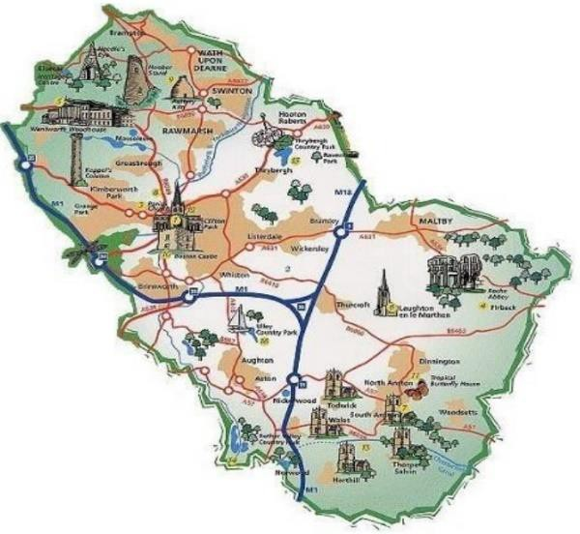The Council has calculated the total asset value in accordance with requirements of the whole Government accounts to be gross replacement cost of over £1.93 billion and the depreciation replacement cost to be over £1.5 billion.

The highway network that is managed by RMBC, represents the biggest financial asset that the Council is responsible for, it is therefore essential that it is well managed and maintained.

|  |  |  |  |  |  |
| --- | --- | --- | --- | --- | --- |
| *Rotherham Council Length of highway Network and PRoWs (km)* | | | | | |
| *A Road* | *B and C roads* | *U roads* | *Total Roads* | *Footways* | *Public rights of way* |
| *136.7 km* | *279.3 km* | *775.0 km* | *1191.0 km* | *1666.4 km* | *416 km* |

# Highways maintenance spending figures

|  |  |  |  |  |  |
| --- | --- | --- | --- | --- | --- |
| **Highway maintenance spending** | | | | | |
| Year | **Capital allocated by DfT (£,000s)** | **Capital spend (£,000s)** | **Revenue spend (£,000s)** | **Estimate of % spent on preventative maintenance** | **Estimate of % spent on reactive maintenance** |
| 2025/26  (projected) | £4,000 CRSTS  £1,961 (LHMF) | £3,000 u/c  £1,200 fw | £952.25 | 90.63%  25/26 est | 9.37%  25/26 est |
| 2024/25 | £4,000 CRSTS  £1,100 (NNRRF) | £3,000 u/c  £1,200 fw | £964.69 | 89.63% | 10.37% |
| 2023/24 | £4,000 CRSTS  £826 (Pothole Fund) | £6,000 u/c | £726.72 | 93.29% | 6.71% |
| 2022/23 | £4,000 CRSTS | £6,000 u/c | £673.30 | 93.27% | 6.73% |
| 2021/22 | £4,000 CRSTS  £1,200 (Pothole Fund) | £6,000 u/c | £750.06 | 93.30% | 6.70% |
| 2020/21 | £4,000 CRSTS  £2,300 (Pothole Fund) | £6,000 u/c | £749.61 | 93.91% | 6.09% |

Additional information on spending

Since 2015/2016 the Council has committed a Capital investment into its Unclassified Road Network to address the rise in poor condition. The initial investment provided £5m Over a two-year period, followed by £10m over a three-year period.

2020/2021 saw the start of a £24m Capital investment spanning a four-year period. These investments also provided the Highways Asset team sufficient resource to be able to work close with Ward Members to repair roads that they identified as a priority.

A continued £12m Capital investment commitment starting in 2024/2025 is continuing to improve the Unclassified Network.

Investment, Collaborative working and good Asset management principles has seen an improvement in the condition of the Unclassified Network from its peak at 24% in 2015 to 11% in March 2025. (Lower being better).

To maintain our highway asset in its entirety in the best way we can, Rotherham Council use a pallet of repair treatments available. The rationale behind this is part of the whole life maintenance. Timely intervention is more efficient and economically viable and helps to maximise budgets.

Repairs can range from Surface treatments (which Seals and protects the surface and provides an enhanced Skid resistance), Multi-Hog patch repairs (Targeting defects within specific areas), Resurfacing (Removing and Replacing the top layer(s) of the Carriageway), Reconstruction (Deep Carriageway repairs that repair lower layers of failure).

The Council try to balance roads in a very poor state and roads at the right time to have cost effective maintenance. Balancing repairs across the different highway conditions helps to provide more control of the need for ‘reactive / pothole’ repairs. Safety is always our priority, and dangerous defects are always given a high priority.

Km of Road repaired

|  |  |  |  |  |
| --- | --- | --- | --- | --- |
| 2020/21 | 2021/22 | 2022/23 | 2023/24 | 2024/25 |
| 79.68 | 78.63 | 60.87 | 50.36 | 49 |

|  |  |  |  |  |
| --- | --- | --- | --- | --- |
| Estimate of number of potholes filled | | | | |
| 2020/21 | 2021/22 | 2022/23 | 2023/24 | 2024/25 |
| 19585 | 20021 | 16758 | 20166 | 15936 |

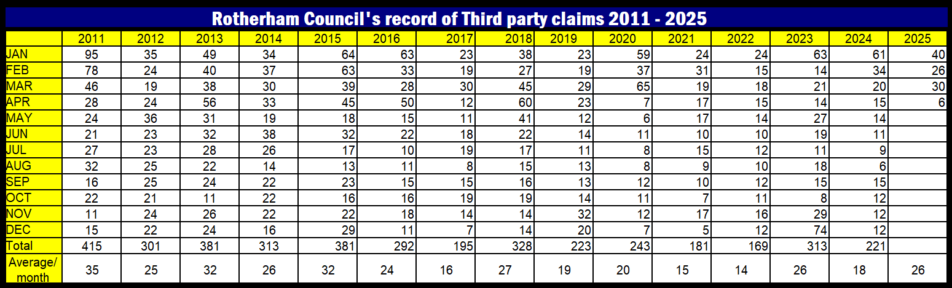

# Condition of local roads

|  |  |  |  |
| --- | --- | --- | --- |
| **Year** | **Percentage of A roads in each condition category** | | |
| **Red** | **Amber** | **Green** |
| 2020/21 | 1.84% | 17.16% | 81.00% |
| 2021/22 | 2.4% | 17.88% | 80.42% |
| 2022/23 | 2.41% | 18.22% | 79.37% |
| 2023/24 | 2.57% | 17.34% | 80.10% |
| 2024/25 | 2.67% | 16.28% | 81.05% |

Rotherham Council collects condition data of 100% our A class Road Network through a scanner survey over a two-year cycle.

|  |  |  |  |
| --- | --- | --- | --- |
| **Year** | **Percentage of B and C roads in each condition category** | | |
| **Red** | **Amber** | **Green** |
| 2020/21 | 2.49% | 18.89% | 78.62% |
| 2021/22 | 3.28% | 21.45% | 75.28% |
| 2022/23 | 2.78% | 20.24% | 76.98% |
| 2023/24 | 2.34% | 19.11% | 78.55% |
| 2024/25 | 2.56% | 18.98% | 78.46% |

Rotherham Council collects condition data of 100% our B & C class Road Network through a scanner survey over a two-year cycle.

|  |  |
| --- | --- |
| **Year** | **Percentage of Unclassified roads in each condition category** |

|  |  |  |  |
| --- | --- | --- | --- |
|  | **Red** | **Amber** | **Green** |
| 2020/21 | 18.89% | 26.02% | 55.09% |
| 2021/22 | 15.78% | 22.59% | 61.63% |
| 2022/23 | 14.28% | 21.51% | 64.21% |
| 2023/24 | 12.69% | 23.10% | 64.21% |
| 2024/25 | 10.93% | 22.09% | 66.98% |

Rotherham Council collects condition data of 100% our Unclassified class Road Network through a Condition Visual Survey over a four-year cycle

The Council measures the condition of its ‘Green’ condition of its Network in its Council plan. The target for each category is;

Principle = 72% Green

Non-Principle = 66% Green Unclassified = 60% Green

Our current (01 April 2025) Condition is; Principle = 81.05% Green

Non-Principle = 78.46% Green Unclassified = 66.98% Green

The Councils performance management framework can be found at the following link; <https://www.rotherham.gov.uk/roads-pavements/highways-asset-management>

## Additional information on condition

Rotherham Council collects condition data of 100% our Unclassified Road Network (Estate Type Roads) through Coarse Visual Inspections over a 4-year cycle. The Coarse Visual Inspection (CVI) is usually carried out on foot and allows 25% (or a return period of once every four years) of the Unclassified Network (approximately 195km) to be assessed each year. Some roads, such as Rotherway and parts of the A57, are inspected from a slow- moving vehicle.

Road condition assessments on the local classified road network in England are currently made predominantly using Surface Condition Assessment for the National Network of Roads (SCANNER) laser-based technology.

A number of parameters measured in these surveys are used to produce a road condition indicator which is categorised into three condition categories:

* Green – No further investigation or treatment required
* Amber – Maintenance may be required soon
* Red – Should be considered for maintenance

From 2026/27 a new methodology will be used based on the BSI PAS2161 standard. Local Highway Authorities will be required to use a supplier that has been accredited against PAS2161. This new standard will categorise roads into five categories instead of three to help government gain a more detailed understanding of road condition in England.

Further details are available at [https://www.gov.uk/government/statistical-data-sets/road-](https://www.gov.uk/government/statistical-data-sets/road-condition-statistics-data-tables-rdc#condition-of-local-authority-managed-roads-rdc01) [condition-statistics-data-tables-rdc#condition-of-local-authority-managed-roads-rdc01](https://www.gov.uk/government/statistical-data-sets/road-condition-statistics-data-tables-rdc#condition-of-local-authority-managed-roads-rdc01)

The Council committed to invest into the Unclassified Road Network in the 2015/2026 financial year with £5m over a two-year period, this Investment arrested the deterioration during this period. A further investment of £10m over three years followed by £24m over four

years enabled the Highway Asset team, through good asset management principles, improve the condition by nearly 50% of its peak in 2015. The Council has continued its investment in the Unclassified Network and has commitment £12m over a four-year period that started 2024/2025.

The graph below shows the effect that the additional funding has had on the condition of Rotherham’s Road Network. Starting in 2011, The Graph shows that the Unclassified Network (estate type roads) were on a steady incline of a worsening condition prior to Council Capital Investments.

The higher percentage the worse the condition.

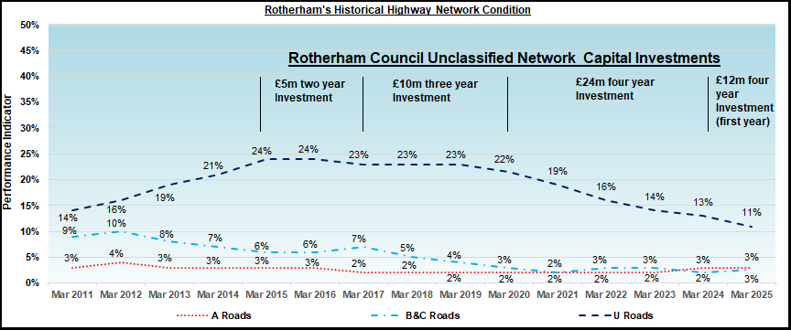

# Plans

## Overall strategy

Rotherham Council’s overall Strategy and decision-making process takes different elements into account. Scheme prioritisation decisions will commonly depend on a number of parameters. For example, decisions about carriageway resurfacing prioritisation takes into account, Condition, Recommended Treatments, Funding options, Impacts and Co- ordination, Risks, Repetitive reactive repairs, Customer reports, and Ward member collaborative working,

Traditionally, the capital maintenance programme has been determined on condition indicators from UKPMS Scanner surveys, CVI’s, along with an element of engineering judgement.

A variety of repair options are available to ensure the appropriate selection of Treatment or constructional repair is identified. Repairs range from cost effective Surface treatments such as Surface dressing, Patch repairs, Resurfacing or deeper constructional repair.

Through timely intervention and good asset management principles, Rotherham Council have moved away from ‘worst first’ planning to using resources to stem the decline of assets in better condition whilst maintaining the condition of the poorest condition assets.

Rotherham Council.

More information regarding the Councils Policy, Strategy and Highway Asset Management Plan can be found here; [https://www.rotherham.gov.uk/roads-pavements/highways-asset-](https://www.rotherham.gov.uk/roads-pavements/highways-asset-management) [management](https://www.rotherham.gov.uk/roads-pavements/highways-asset-management)

## Specific plans for 2025/2026

Rotherham Council plan to deliver repairs to over 187 Roads covering an estimated 48km of the Councils Road Network. Additionally, over 95 Footways will be repaired covering an estimated length of over 23km. These schemes will be delivered through a mix of Surface treatments (Micro Asphalt and Surface Dressing) and Traditional resurfacing and constructional repairs.

The Council also plan to install 35 pairs of Pedestrian Tactile dropped crossings during the 2025/26 financial year.

A link to the Councils Highway Repair Programme can be found here; <https://www.rotherham.gov.uk/directory/28/indicative-highway-repair-programme-2025-2026>

Streetlighting concrete replacement Programme and Drainage Programme can be seen in the Councils Highway Asset Management Plan at the following link; <https://www.rotherham.gov.uk/downloads/file/2119/highways-asset-management-plan-pdf->

Rotherham Council publish its Highways Levels of service and performance indicators on its Website. A copy of current and previous reports can be seen at the flowing link; <https://www.rotherham.gov.uk/downloads/download/46/highways-asset-management>

## Streetworks

Rotherham Council operates the ‘all streets Permit Scheme’ to minimise disruption on the Highway network.

The objectives of the permit scheme are:-

* To protect the structure of the street and the integrity of apparatus in it.
* To encourage proactive, rather than reactive, attitudes to activities by promoters. This results in the supply of more information to the Authority, which enables better management of the network, coordinate activities within the area and across adjacent authorities’ areas and reduce disruption to users of the highway. Information on road works and street works is provided to the general public enabling informed journey choices.
* To ensure safety for those using, living or working on the street, including those engaged in activities controlled by the Permit Scheme.
* To improve activity planning by all promoters.
* An aid to help public transport efficiencies.
* To make substantial progress towards a low-carbon transport system.
* To improve connectivity to support economic activity and economic growth.
* To enhance the quality of life of people in the diverse communities and visitors and commuters to the region (including health, safety, equality, air quality, noise and the natural environment). Any activity carried out in the street has the potential to cause disruption depending on how long it lasts, where it is carried out, its scale and potential relation to other activities which may be taking place. The permit scheme created an opportunity to realise a number of benefits to road users, local residents and businesses in the Yorkshire area through better control, planning and coordination of works, and a more robust framework for checking and challenging activities on the highway. The scheme ensures that the conditions of the permit promote the expeditious movement of traffic through road works, reducing disruption and promoting safety at road and street works sites.

## Climate change, resilience, and adaptation

Rotherham Council working in collaboration with SteelPhalt have installed the world’s first carbon negative asphalt on two of its main roads. The product uses recycled steel slag aggregate and a bi-product natural binder (the glue that holds the aggregate together).

Traditionally, SteelPhalts products contain 95% recycled aggregate from the steel making industry within Rotherham, the remaining 5% is bitumen. However, Bitumen comes from the processing of Oil and consequently is a big contributor to the carbon footprint of asphalt.

SteelPhalt’s new carbon neutral asphalt product, (called SteelSurf ECO+), uses a renewable bio-based substance as an alternative to bitumen dramatically reducing the product’s carbon footprint. This ground-breaking new bio-based bitumen uses a natural binder called Kraft Lignin which originates from trees. Lignin is within the cell walls of every tree. It Is a substance that provides the second biggest source of renewable carbon on the planet. One of the main building blocks of a tree, it is biobased and can be used as a responsible alternative to many fossil-based materials.

Combining the Bio based bitumen along with the carbon neutral slag aggregate supplied from local resources, and the reduced mixing temperature required for the material, Steelphalt also manufacture and supply the material direct from its local Rotherham based plant. The SteelSurf ECO+ product not only offsets the carbon used in manufacture but produces a carbon negative asphalt due to the carbon sync of Lignin.

The work that Rotherham Council and Steelphalt have delivered on this project has been recognised nationally and we are extremely pleased to have won the Innovation Award at the 2022 ALARM Risk Awards in July 2022 for the pioneering use of carbon negative asphalt in the borough.

This Eco asphalt demonstrates both Rotherham Council’s commitment to sustainability and innovation. It could reduce the climate impact substantially over the life cycle of the road.

The Council are continuing to trial this material with a major roundabout being resurfaced within the 2025/2026 period.

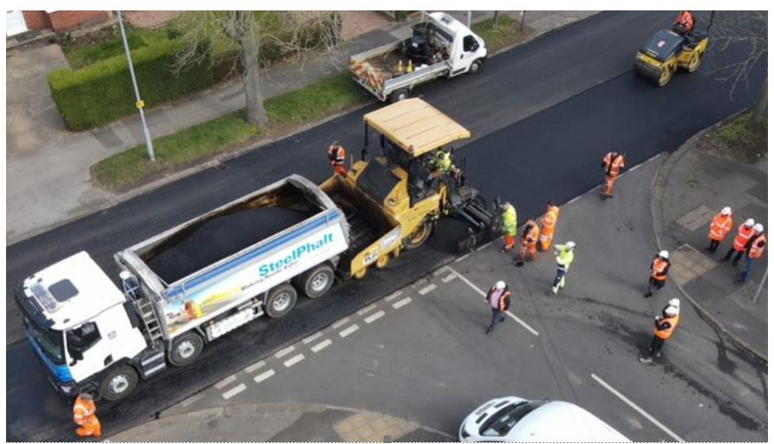

Rotherham Council look for innovations and are also using protective treatments to prolong the life of surface Dressings.