APPENDIX 1:

Guidance for Completing the BNG Small Sites Metric

This Appendix is intended as a guide to applicants and council officers when completing and assessing the BNG Small Sites Metric. The guidance is based on the current version of the metric and Natural England user guide at the time of publication (July 2025).

Site Details
Input all relevant data into the corresponding cells.

Net gain targeted % increase in units should be left as 10%, unless specified otherwise by the council.

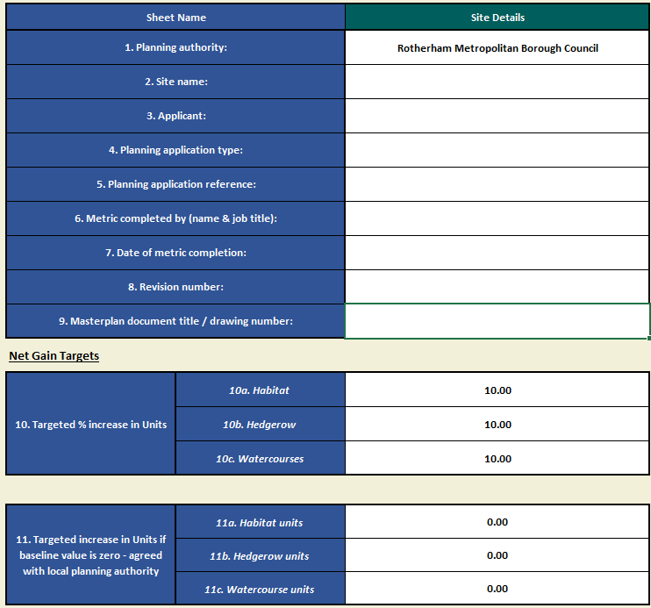
If there is no baseline value, for example, a site entirely comprised of sealed surface, then the development is exempt from mandatory BNG and a percentage net gain will not be possible. A target number of biodiversity units may be requested by Rotherham Metropolitan Borough Council (RMBC), and should be entered in section 11 if applicable.

Desktop assessment
This tab will confirm that the SSM is the correct metric to use for the development. If the site does not satisfy the requirements to use the SSM, the Main Metric will need to be completed.
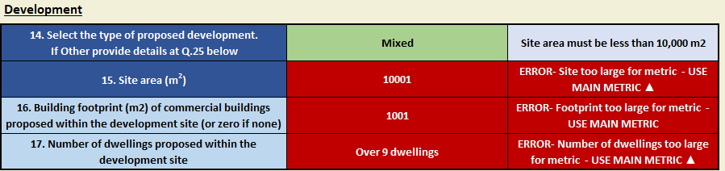
Outline the type and size of development.
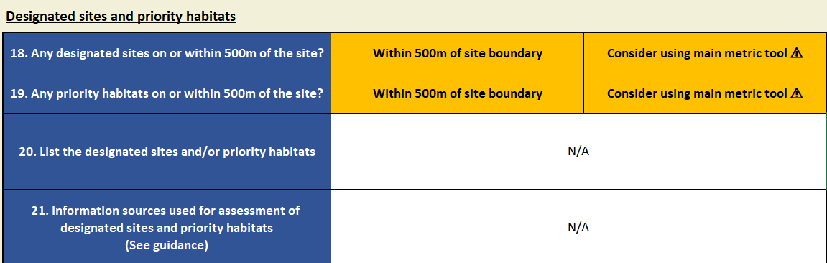
Confirm absence or presence of designated sites and priority habitats. The Defra tool (https://magic.defra.gov.uk/MagicMap.html) can be used to assist.
If statutory designated sites or priority habitats are located within 500m of the development, the applicant should consider if they require a professional ecologist and use the Main Metric. If this is the case, a list of sites or priority habitats and evidence will be required.
Next, complete the details of when the habitat assessment took place and who undertook it.
The SSM automatically assigns the site walkover’s ‘valid until date’ to six months after completion. RMBC will decide whether an updated site walkover is required if the SSM review takes place after the indicated date. 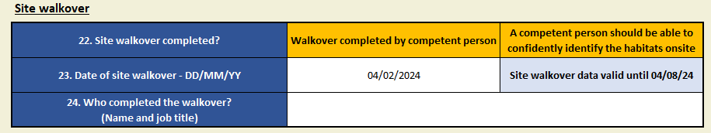

Supporting information
A photo of every baseline habitat recorded during the walkover is required.
Additional information should be entered describing the habitats and species present.

Area Habitats
Table 1a Baseline Habitats
Enter baseline habitat type and area, informed by the habitat survey and map.
Habitats should be appropriate for the Site location and size.
If a habitat type on site is not an option within the SSM, you will have to use the Main Metric.
Habitat selection and strategic significance should be justified in the ‘user comments’ column and supported by photos in the ‘supporting information’ tab. Habitat distinctiveness will automatically be applied based on the habitat type selected. Condition does not need to be entered.
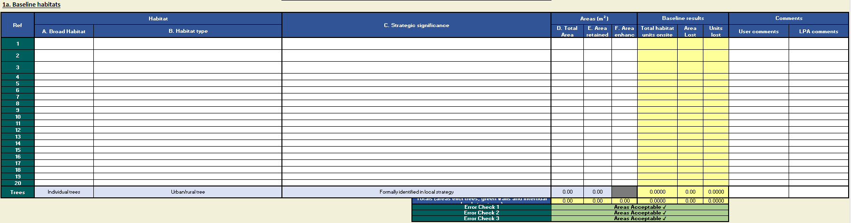

Ensure that the area of the habitats present matches the total site area in the desktop assessment.
Once post-development plans have been established, areas of habitat that are retained or enhanced can be populated – ensure that these areas do not exceed the total baseline habitat areas. From this the metric will automatically calculate the area lost.
Note - not all habitat types can be enhanced.
If you are planning to extend a habitat it will have to be entered under table 1b ‘Habitats to be created’.
Table 1a will calculate the number of baseline area habitat units the Site has.

Table 1b. Habitats to be created
Only certain habitats can be proposed within the SSM, these are listed in the ‘All Habitats + Multipliers’ tab.
This table is completed the same as above, outlining the proposed habitat type, area, and strategic significance. Additionally, the proposed condition of the habitat is required for certain habitats.
Habitat condition must be either ‘Moderate’ or ‘Good’ (the possible habitat conditions are outlined within the ‘Condition and Temporal’ tab) – the thresholds for conditions can be found within Natural England’s SSM HMMPT Habitat Guide V2.0 document. If a habitat is proposed to have ‘Poor’ condition, the Main Statutory Metric will have to be used. It is important that the target condition is appropriate for the site and design and that the individuals implementing the habitat are experienced and able to reach the desired habitat within the required timescale – this should be informed by a competent person. If the condition cannot be decided, the lowest possible option should be used.
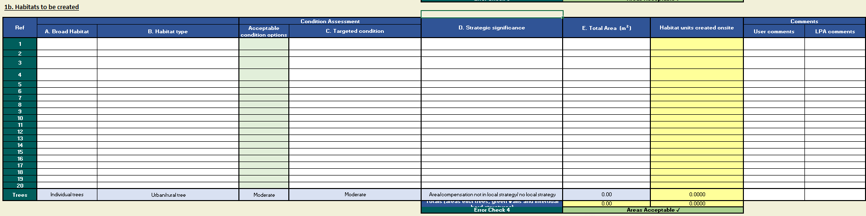

Table 1c Habitats to be enhanced
Any habitat specified to be enhanced within Table 1a will automatically populate columns in this table. Only certain habitats have the option to be enhanced, these are specified within the ‘Condition and Temporal’ tab. Habitats can be enhanced through an improvement in condition or distinctiveness.
Condition enhancements can be made from ‘Moderate’ to ‘Good’.
When enhancing to a higher distinctiveness, habitat condition must remain the same, or be improved.
As above, ensure all proposed enhancements are appropriate and achievable within the specified timeframe.
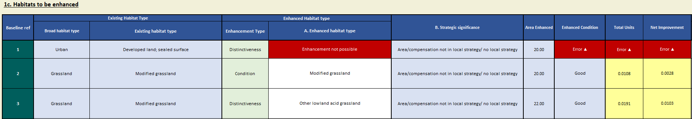
The SSM applies two of the risk multipliers to habitat enhancement and creation, specified within the ‘Condition and Temporal’ tab:
• difficulty risk
• temporal risk

Table 1d Tree area calculator
Within the BNG metric, trees are calculated as area habitats and add additional habitat units, overlapping the habitat beneath. Tree area is calculated from their diameter at breast height (dbh). Baseline trees with a dbh of less than 7.5cm should not be counted.
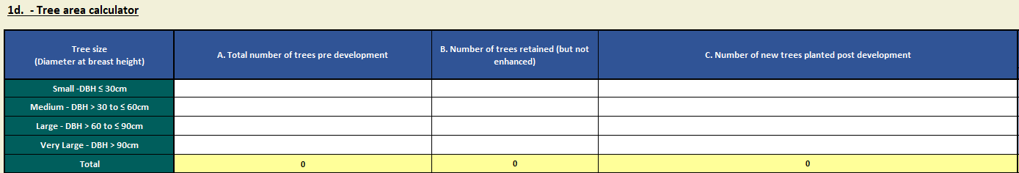
Proposed trees should be recorded as their size when planted. If a tree is planted and is under 7.5cm dbh, which is normally the case, it should be recorded as small.
Trees should not be recorded if they are present in a habitat characterised by their presence e.g. woodland.
You should not deduct the area of individual trees from other habitats recorded underneath the tree canopy.
Record all existing medium, large and very large trees within private gardens, within the ‘pre-development’ column. However, trees proposed to be planted in private gardens should not be counted as ‘creation’ within the ‘post-development’ column.
Urban trees in a line or group should be counted as individual trees.
Trees planted as part of hedgerow creation or enhancement should not be counted as individual trees, and instead as ‘hedgerow with trees’. However, if any medium, large or very large trees within a hedgerow or line of trees are being removed, they must be included within the ‘Total number of trees pre-development’ and excluded from the ‘number of trees retained’.

Table 1e. Trading Summary & Table 1f Habitat Trading Assessment
These tables will outline whether the metric’s trading rules have been satisfied (1e Trading Summary) and will summarise the number of biodiversity units gained or lost through the proposed development (1f Habitat Trading Assessment).
The baseline habitats and proposed retained, enhanced and created habitat areas will be cross checked in the metric to ensure that the areas post-intervention match the area at baseline.

Hedges & Lines of Trees and Watercourses
The Hedges & Lines of Trees and Watercourses tabs are completed the same as the Habitat Area tab.
These habitat types are recorded in meters.
For hedges and lines of trees you should:
- use the centre line of the feature
- mark hedge or tree planting on top of the area habitats below. Do not discount area habitats that fall under hedge or tree planting
- If a hedgerow has a ditch which meets the requirements of a watercourse ditch, it should not be associated with the hedgerow and instead recorded within the watercourse tab
For watercourses you should:
- use the centre line of the feature
- Include any watercourses where their riparian zone (10m from the top of each bank for canals or 5m from the top of each bank for ditches) crosses the development’s redline
- Where a watercourse is decreased in condition or distinctiveness, it should be recorded in relation to the impacted section
You can only enhance a watercourse if there is no proposed encroachment on the watercourse or riparian zone. If encroachment is expected, the main metric must be used.
A watercourse can be enhanced through the restoration of natural function, processes, and the enhancement of habitats.

Headline results
This shows the overall results from the three habitat type tabs, confirming if you have followed trading rules.
If a net gain is not achieved, it can be delivered off-site. However, this will have to be calculated using the Main Metric.
Review any errors highlighted in this tab.

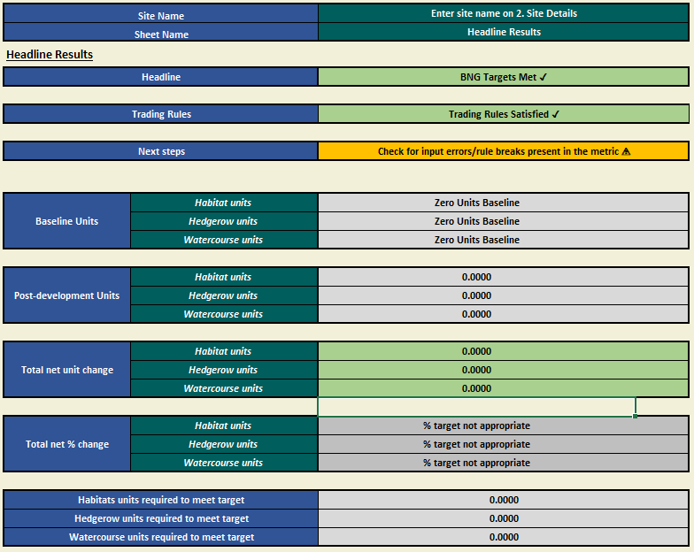

Statutory biodiversity metric tools and guides - GOV.UK
Habitat Management and Monitoring Plan Template - JP058

