Biodiversity Net Gain
Guidance Document
Rotherham Metropolitan Borough Council

Final V3



January 2025
Contents
1. Purpose 1
2. Introduction 1
2.1. What Is BNG 1
2.2. Biodiversity Gain Hierarchy 1
3. When is BNG Required? 2
3.1. Exemptions 2
3.2. Which Metric? 2
3.3. Statutory Metric 3
3.4. Small Sites Metric 3
3.5. Differences Between the Metrics 4
RMBC Competent Person Definition for the SSM 4
4. How is BNG Measured? 5
4.1. Baseline Assessment 5
4.2. Making Biodiversity Gain 6
Developments with Zero Baseline Biodiversity Units within RMBC 6

4.3. Survey and Design Summary Flow Chart 7
Figure 1. Flowchart showing the initial BNG process from project inception to design and BNG baseline calculation. 7
5. BNG in the Planning Process 8
5.1. Validation for Exempt Applications 8
Table 1. RMBC Validation Requirements for Exempt Applications 8
5.2. Validation for Non-Exempt Applications 9
Table 2. Statutory validation requirements 9
Table 3. RMBC additional validation recommendations for applicants using the SSM Error! Bookmark not defined.
Table 4. RMBC additional validation recommendations for applicants using the Main Statutory Metric, small sites with significant on-site gains, sites which require a large amount of off-site gain, or any Statutory Credits 11
Figure 2. Flowchart showing the validation process applicants must follow when submitting a planning application 12
5.3. Pre-commencement 13
Table 5. Statutory Pre-commencement Requirements within the BGP 13
RMBC Significant Gain Definition 14
6. Construction 15
7. Management and Monitoring 15
RMBC Monitoring Requirements 15
Figure 3. Flowchart showing the process applicants must follow pre-commencement and during the management and monitoring of a development to ensure BNG is secured. 16

Purpose

The purpose of this document is to provide clear guidance to decision-makers and applicants regarding the obligations of Biodiversity Net Gain (BNG) throughout the planning process.

The aim is to clarify the approval procedures required to achieve BNG. The guidance will outline the process by which Rotherham Metropolitan Borough Council (RMBC) will validate and review proposals that require BNG to ensure that an accurate and consistent approach is delivered.

This will help prospective applicants better understand planning submission requirements. In doing so, proposals will be better informed to demonstrate compliance with BNG throughout the development process.

Introduction

What Is BNG

The overarching aim of BNG is to ensure that habitats for wildlife are left in a measurably better state than they were in before development takes place. BNG aims to counter the current rate of biodiversity loss by promoting the restoration of habitats and the enhancement of ecological networks. To achieve BNG, developments must be designed in a way that provides benefits to biodiversity by creating or enhancing habitats as part of the development process.

BNG uses habitats as a proxy measure of biodiversity value. A metric has been developed to calculate “biodiversity units” from habitat information. This metric provides a consistent system to compare the biodiversity value of a development before and after its construction.

The statutory requirement of a development is to deliver a 10% net gain in biodiversity. This was made mandatory under the statutory framework introduced by Schedule 7A of the Town and Country Planning Act 1990. As part of this framework, all planning applications, unless exempt, will have the general Biodiversity Gain Condition applied as a pre-commencement condition.

It is important to note that BNG is a separate statutory framework that does not replace or change existing statutory legislation for protected sites, habitats, or protected species. Similarly, BNG does not replace current requirements for ecological assessments and surveys. Impacts to habitats or species subject to statutory protection and/or protection under planning policy will be considered outside the BNG system.

Biodiversity Gain Hierarchy

The Biodiversity Gain Hierarchy defines the favoured route developments should follow to achieve a 10% net gain. Following the hierarchy is essential to discharge the Biodiversity Gain Condition and, therefore, should be considered as early as possible in the development process.

The hierarchy outlines that developments should primarily achieve BNG on-site. Where it is clearly demonstrated that on-site gain is not possible, off-site gain can be sought. As a last resort, if off-site gains are proven to be unavailable, statutory credits can be purchased.

The Biodiversity Gain Hierarchy sets out the following priority actions:

Avoidance of adverse effects to medium, high, and very high distinctiveness
habitats
Mitigate for any adverse effects that cannot be avoided
Onsite habitat enhancements
Onsite habitat creation
Offsite biodiversity gains
Purchase Statutory Credits
1
2
3
4
5
6

Note: The Biodiversity Gain Hierarchy is emphasised for medium, high, and very high distinctiveness habitats. However, the principles are still of relevance for habitats of lower distinctiveness.

Mitigation Hierarchy
The Mitigation Hierarchy is a set of guidelines that outlines how developers can improve the biodiversity value of a project.⁵ The Mitigation Hierarchy states that applications should be refused if significant harm to biodiversity cannot be avoided, adequately mitigated, or, as a last resort, compensated for. The Biodiversity Gain Hierarchy does not substitute the Mitigation Hierarchy; instead, it works with and reinforces its principles.

When is BNG Required?

Exemptions

Not all developments require a 10% net gain in biodiversity units. The following is a list of development types that are exempt from the Biodiversity Gain Condition:
Existing planning applications
If a planning application for a development was made before the start of mandatory BNG (see 3.2).

Retrospective or amended planning permissions
Planning permissions made under section 73A and section 73 permissions where the original permission (which the section 73 relates to) was either granted before, or the application for the original permission was made before, 12/02/2024.
A section 73 permission cannot be used to vary or remove the Biodiversity Gain Condition.

Development subject to the de minimis exemption
A development that does not impact a priority habitat⁶ and impacts less than:
- 25m² of on-site habitat;
- 5 metres of on-site linear habitats.

Householder applications
These are applications made by householders as defined within article 2(1) of the Town and Country Planning (Development Management Procedure) (England) Order 2015.⁷

Small-scale self-build and custom-build applications
When it meets all the following thresholds:
- consists of no more than 9 dwellings;
- a site that has an area no larger than 0.5 hectares;
- consists exclusively of dwellings that are self-build or custom housebuilding as defined in section 1(A1) of the Self-build and Custom Housebuilding Act 2015.⁸

Development of a biodiversity gain site
Developments undertaken mainly for the purpose of fulfilling the BNG planning condition for another development.

Development related to the high speed rail transport network

Urgent crown developments

Development Order
Developments that are granted planning permission by a development order under section 59, Including permitted development rights.

All developments - even if exempt - must still provide opportunities for biodiversity enhancement as outlined in the Local Plan and Natural Environment SPD. Applicants should refer to Natural England’s Green Infrastructure Framework.

Which Metric?

There are two metrics for measuring BNG - the Main Statutory Metric and the Small Sites Metric. The size and scope of a proposed development determines which metric should be used.

BNG using the Main Statutory Metric applied to all major developments from 12 February 2024. Major developments are defined within The Town and Country Planning (Development Management Procedure) (England) Order 2010, as:
Non-Residential
- the provision of a building or buildings where the floor space is 1,000 square metres or more;
- development carried out on a site having an area of 1 hectare or more; or
- Mineral works or waste developments.

Residential
- the number of dwellings to be provided is 10 or more; or
- the development has an area of 0.5 hectares or more and the number of dwellings is unknown.

BNG became mandatory for non-major developments (‘small sites’) on 2 April 2024. These are defined as:
Non-Residential
- the provision of a building or buildings where the floor space is less than 1,000 square metres;
- development carried out on a site having an area of less than 1 hectare;
- development that is not the winning and working of minerals or the use of land for mineral-working deposits; or
- development that is not waste developments.

Residential
- development where the number of dwellings is between 1 and 9 on a site of an area 1 hectare or less; or
- or if the number of dwellings is unknown, the site area is less than 0.5 hectares.

‘Small Sites’ may still be required to use the Main Statutory Metric depending on the habitats and species present on-site. See Section 3.4 for thresholds for the Small Sites Metric (SSM).

Statutory Metric

The Main Statutory Metric is a spreadsheet-based tool used to determine the quantitative value of biodiversity. The tool uses habitat factors (outlined in Section 4.1) to calculate on-site baseline biodiversity units. Post-development biodiversity units are calculated in the metric with the proposed developments' habitat creation, enhancement, retention, loss, (outlined in Section 4.2) and off-site gains, if required. The metric calculates the change of the pre and post-development biodiversity units, confirming if a development would achieve net gain. This provides a standardised approach to achieve an evidenced, measurable net gain in biodiversity.

The metric tool will help advise development design iterations. Proposed habitat losses and gains will inform how different interventions impact biodiversity. Design iterations should be tested within the metric to encourage maximum biodiversity gain.

The metric has a set of rules and principles. Failure to follow these will result in a development that does not satisfy the Biodiversity Gain Condition.
Rule 1 | The trading rules of this biodiversity metric must be followed.
Rule 2 | Biodiversity unit outputs, for each type of unit (Area Habitat, Hedgerow, and Watercourses), must not be summed, traded, or converted between types. The requirement to deliver at least a 10% net gain applies to each type of unit.
Rule 3 | To accurately apply the biodiversity metric formula, you must use the statutory biodiversity metric calculation tool or small sites biodiversity metric tool (SSM) for small sites.  The tools remove the need for a user to manually calculate the change in biodiversity value.  The tool will summarise the results of the calculation and inform a user whether the biodiversity net gain objective has been met.
Rule 4 | In exceptional ecological circumstances, deviation from this biodiversity metric methodology may be permitted by the relevant planning authority.

The BNG principles should be used to inform the planning process. Applicants are required to demonstrate that these principles have been followed to satisfy the Biodiversity Gain Condition.

Principle 1 | The metric assessment should be completed by a competent person.
Principle 2 | The use of this biodiversity metric does not override existing biodiversity protections, statutory obligations, policy requirements, ecological mitigation hierarchy or any other requirements. This includes consenting or licensing processes, for example woodlands.
Principle 3 | This biodiversity metric should be used in accordance with established good practice guidance and professional codes.
Principle 4 | This biodiversity metric is not a complex or comprehensive ecological model and is not a substitute for expert ecological advice.
Principle 5 | Biodiversity units are a proxy for biodiversity and should be treated as relative values.
Principle 6 | This biodiversity metric is designed to inform decisions in conjunction with locally relevant evidence, expert input, or guidance.
Principle 7 | Habitat interventions need to be realistic and deliverable within a relevant project timeframe.
Principle 8 | Created and enhanced habitats should be, where practical and reasonable, local to any impact and deliver strategically important outcomes for nature conservation.
Principle 9 | This biodiversity metric does not enforce a minimum habitat size ratio for compensation of losses. Proposals should aim to:  - maintain habitat extent;  - supporting more, bigger, better and more joined up ecological networks;  - ensure that proposed or retained habitat parcels are of sufficient size for ecological function.

Small Sites Metric

The Small Sites Metric (SSM) is a simplified version of the Main Statutory Metric. It is designed to streamline the BNG process for non-major developments (see 3.2), whilst using the same principles. The same exemptions, outlined in Section 3.1., apply to the SSM.

There are additional thresholds for using the SSM. The SSM cannot be used if a development contains any of the following:
- A European Protected Species.
- Statutory protected sites or habitats.
- Priority habitat.⁶
- A habitat that is not included in the SSM.

If any of the above are present, the Main Statutory Metric must be used. Additionally, if a protected site or habitat is located within 500m of the development, using the main metric should also be considered.

Developments that meet the thresholds of the SSM can still use the Main Statutory Metric if preferred.

Differences Between the Metrics

The SSM follows the same rules and principles outlined in Section 3.3, except for Rule 4. However, calculating net gain within the SSM differs from the Main Statutory Metric. These differences are detailed below.

The SSM has a smaller range of ‘available’ habitats, with only "Very Low", "Low", and "Medium" distinctiveness habitats available.
Main Statutory Metric
- Size measured in hectares and km.
- Habitat distinctiveness ranges from very low to very high.
- Condition assessments, carried out by an ecologist, are required to determine the condition of habitats.
- There is an off-site section present within the metric.
- Appropriate habitat interventions are informed by an ecologist.
- The metric and baseline habitat assessments should be completed by a suitably qualified ecologist.

Small Sites Metric
- Size measured in m² and m.
- Habitat distinctiveness ranges from very low to medium.
- The condition of all habitats is automated.
- No off-site section within the metric (off-site units can still be allocated within the main metric).
- Only certain habitat interventions are available.
- Users need to be competent, however, do not have to be ecologists.

What is the Difference Between the Main Metric and SSM?

If a development qualifies for the SSM, it will not require condition assessments as part of a habitat survey (see Section 4.1). Instead, condition is a fixed value for all habitats within the SSM and is automatically applied to baseline habitats as either "Moderate", "N/A - Other", or "Condition Assessment N/A".

Habitat enhancement can only be made from "Moderate" to "Good" condition. Habitats that qualify as "N/A - Other" or "Condition Assessment N/A" cannot be enhanced.

Habitat creation can only aim for "Good" or "Moderate" condition.

RMBC Competent Person Definition for the SSM
The person completing the SSM does not need to be a qualified ecologist. Instead, the SSM requires a "Competent" person to complete the habitat assessment and advise habitat enhancement and creation. RMBC defines a competent person for completing a SSM as someone with appropriate knowledge and skills to:
- identify the habitat types present;
- specify the appropriate creation and enhancement of habitats; and
- create accurate to scale habitat plans.
However, RMBC encourages the use of a qualified ecologist for all sites, including those using the SSM. If, during the determination process, council officers do not believe that the individual that completed the habitat survey and BNG calculation is competent, the application will be refused.

The SSM does not have an off-site tab to calculate gains made outside of the redline boundary. In cases where a non-major development requires off-site units to reach a 10% net gain, the applicant can still use the SSM to measure baseline habitats and proposed on-site gains. However, any off-site gains will need to be submitted using the off-site tab within the main statutory metric.

How is BNG Measured?

Baseline Assessment

A field survey must be undertaken by a suitably qualified ecologist (or ‘competent person’ if using the SSM) to collect pre-development habitat data. RMBC’s preference is for this to be undertaken using the most current version of the UK Habitat Classification (UKHab) methodology, with translations into BNG habitat types where relevant. This survey should be conducted at the appropriate time of year for the habitats present on-site. The survey season is April through September. Habitat surveys should be in-date and generally completed within 18 months of the planning application submission.

Biodiversity units are split into three categories within the metrics - Area Habitats, Hedgerows, and Watercourses. The three categories are treated separately within the metrics. A 10% net gain will be required independently for each habitat category, and gains cannot be exchanged between them.
Watercourses are managed differently within the BNG process, with specific consideration given to riparian zones. Riparian zones are defined within BNG as areas that extend 10m from either side of a river, stream, or canal bank and 5m from a ditch. If the site boundary intersects a watercourse's riparian zone, the adjacent lengths of the watercourse must be included in baseline BNG calculations, and a 10% net gain is required - even if the watercourse lies outside the redline boundary.

Additionally, all watercourses, except ditches, require an additional assessment using a River Condition Assessment (River MoRPh survey methodology). A suitably qualified person, who is accredited in River MoRPh surveys, must complete this survey.

The surveyor will determine the habitats on-site using the UKHab classification system and identify the presence of irreplaceable habitats or designated sites.

Additionally, to calculate the biodiversity units delivered by an individual habitat, the following is required within the metrics:
Habitat Distinctiveness
Distinctiveness is assigned based on the habitat's distinguishing features, such as rarity, species richness, protection by designation, and the habitat's ability to support species rarely seen in other habitats. A distinctiveness score is automatically assigned to each habitat classification within the metric. Distinctiveness scores are designated as very low (0), low (2), medium (4), high (6), or very high (8). Only habitats of medium distinctiveness or lower are included within the SSM.

Habitat Area or Length
Habitat area (hectares or m² for SSM) and length (km or m for SSM) - for linear Hedgerow and Watercourse habitats - should be calculated using spatial mapping, e.g. QGIS.

Habitat Condition
Condition is a measure of the state of a habitat against its ecological optimum. An ecologist will measure habitat conditions using Statutory Condition Assessment Sheets. Condition is assigned on a scale of poor (1), moderate (2), or good (3). Some habitats have an automatically applied condition of "N/A - Other" (0) or “Condition Assessment N/A” (1). Condition is automatically applied in the SSM.
Condition Assessment Sheets assign scores to habitats based on whether a habitat matches a series of optimal condition criteria. This is measured through a pass-or-fail system. The number of criteria the habitat passes will determine the habitat's condition. Assessment sheets and the number of criteria required to achieve condition scores differ for each habitat type. Not all habitats require a condition assessment sheet.

The LNRS relevant to RMBC is currently being developed for South Yorkshire. At the time of writing, the following documents are relevant in determining strategic significance in Rotherham:
- Habitats within statutory or non-statutory designated sites¹⁸
- Biodiversity opportunity mapping (yet to be published)
- Priority Habitats
- Relevant habitats within the South Yorkshire Green Infrastructure Strategy and high-priority habitats within Rotherham Ecoscapes.¹⁸ ¹⁹
Once the LNRS is produced it will replace the final three bullet points.
Strategic Significance
Strategic significance is the local significance of a habitat and is decided by the LPA. It is assigned a multiplier score of “Formally identified in local strategy or High strategic significance” (1.15 multiplier), “Location ecologically desirable but not in local strategy or Medium strategic significance” (1.1), or “Area/compensation not in local strategy/ no local strategy or Low strategic significance” (1). This is determined by whether a habitat location or type is relevant to local strategy or policy, e.g. identified in Local Ecological Networks, Biodiversity Action Plans, or within a Local Nature Recovery Strategy (LNRS).

Making Biodiversity Gain

Applicants are encouraged to consider BNG in every stage of the planning process. RMBC operates a pre-application service that all applicants are encouraged to utilise. Understanding a development's baseline biodiversity value as early as possible is paramount to ensure that appropriate interventions and potential off-setting requirements are addressed.

Following the Biodiversity Gain Hierarchy (as outlined in Section 2.2), developments should prioritise achieving net gain on-site whenever possible. This involves the creation or enhancement of habitats through the implementation of well-informed, suitable soft landscaping, and green infrastructure. Within the BNG framework habitats can be:
Retained
There is no action to enhance and no change in habitat type, distinctiveness, or condition - habitats can be retained in part, or entirely.

Enhanced
The baseline habitat is retained and there is an improvement to condition and/or a change to a higher distinctiveness habitat. Changes to higher distinctiveness must remain within the same broad habitat group, e.g. grasslands.
Created
Where a baseline habitat is replaced with another habitat from a different broad habitat group.

If on-site gain options have been exhausted and a 10% gain is still not achieved, habitat gains will need to be delivered off-site. Off-site refers to land outside of the redline boundary. Off-site gains can be made on the developer's land outside of the redline boundary, or by purchasing off-site biodiversity units.

Off-site units can be purchased from a landowner, habitat bank, broker, or trading platform.

Off-site gains should be prioritised within the RMBC boundary, the same National Character Area (NCA), or within a waterbody’s catchment area. Gains acquired in a neighbouring LPA, NCA, or outside waterbody catchment (but within operational catchment) will be worth fewer biodiversity units than those within the RMBC boundary, NCA, or within a catchment area. Off-site gains beyond neighbouring LPAs, NCAs, or outside operational catchment will be worth even fewer biodiversity units within the metric.

There are two NCAs within the RMBC boundary: the Nottinghamshire, Derbyshire, and Yorkshire Coalfield to the northwest, and the Southern Magnesian Limestone to the southeast of the borough.

If applicants cannot achieve net gain through on-site and off-site gains, they must buy statutory biodiversity credits. Natural England is selling statutory credits on behalf of DEFRA. This must be a last resort, as outlined in the Biodiversity Gain Hierarchy. The costs of statutory credits are significantly higher than other off-site opportunities.

RMBC will require proof that statutory credits are required for a development to achieve 10% net gain. This should be outlined with the following:
- Show that all options for on-site BNG were considered and exhausted - provide reasoning why they were not possible.
- Proof that the developer has approached a number of off-site unit suppliers, showing that no off-site options were available.

Within both metrics, proposed habitat enhancement and creation have the following risk factors incorporated:
Difficulty Risk
Difficulty in creating a habitat is automatically applied within the metric depending on the proposed habitat type and condition. The risk factor will adjust the biodiversity units supplied by that habitat based on the uncertainty of methods to deliver the habitat type and condition.

Temporal Risk
The time-to-target condition is automatically applied within the metrics. It will adjust biodiversity unit returns based on the likely time between the start of habitat creation or enhancement and achieving the target outcome. Additionally, the metric can account for habitat created or enhanced in advance, e.g. if habitat enhancement or creation is delayed until the end of the construction.

Spatial Risk
Spatial risk is only applied to off-site habitat. The risk multiplier adjusts the number of biodiversity units based on the location of off-site habitat. Biodiversity units will be reduced if off-site gains are located outside the LPA, NCA, or a waterbody’s catchment area and further penalised if gains are beyond neighbouring LPAs, NCAs, or a waterbody’s operational catchment area.
Statutory biodiversity credits have the highest spatial risk multiplier, requiring two credits for every one biodiversity unit.

Most developments should target habitats that are appropriate for the context and require a practical and achievable level of maintenance to ensure that they are delivered to the proposed condition and distinctiveness. In cases where developments aim for higher distinctiveness habitats, it is necessary to consider local environmental factors, such as weather, soil pH, drainage, aspect, etc. Additionally, the frequency, intensity, and cost of managing rare habitats must be considered.

Developments with Zero Baseline Biodiversity Units within RMBC
Due to how the metrics operate, if a development has a baseline biodiversity unit value of zero, it will not require a net gain. However, RMBC still expects developments with no baseline units to provide habitats and opportunities for biodiversity enhancement. These enhancements would be described within the Ecological Impact Assessment / Preliminary Ecological Appraisal submitted with the planning application e.g. how the provision of any green space or tree planting has had regard for biodiversity improvement. These developments would not need to be measured in the metric.

Survey and Design Summary Flow Chart

Figure 1. Flowchart showing the initial BNG process from project inception to design and BNG baseline calculation.
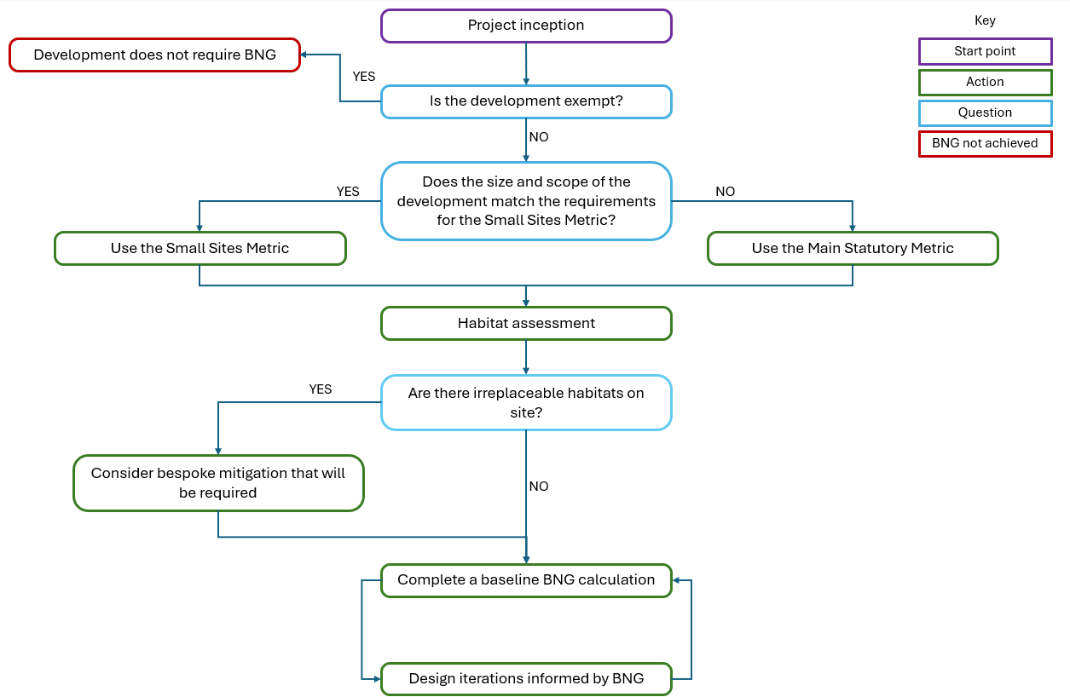

BNG in the Planning Process

Validation for Exempt Applications

The BNG section of the planning application form requires an applicant to confirm if the Biodiversity Gain Condition applies to the proposed development (see Section 3.1). If the applicant believes it is exempt, they are required to provide reasons concerning which exemptions they believe apply. The following table outlines the evidence that RMBC expects to be provided to support exemption types.

Table 1. RMBC Validation Requirements for Exempt Applications
Type of Exemption | Description | Evidence
De Minimis Exemption | The applicant must demonstrate that the proposed development will not impact any priority habitat and impacts less than 25m² of on-site habitat and less than 5 metres of linear habitat that has biodiversity value greater than zero (distinctiveness score of Very Low). | Photos of onsite habitats.  Plans showing measurements of on-site habitats.
Self-build or Custom-build | The development must consist of no more than 9 dwellings and be on a site that has an area no larger than 0.5 hectares.  Dwellings must be self-build or custom housebuilding as defined in section 1(A1) of the Self-build and Custom Housebuilding Act 2015. | A statement that the purpose of development is for self-build or custom housebuilding, i.e. that the individual/s buildings the house/s will occupy them as their home/s.  Plans showing area of the Site and number of dwellings.
Householder applications | The applicant must demonstrate that the development is the subject of a householder application. | The application must be for development for an existing dwellinghouse, or development within the curtilage of such a dwellinghouse for any purpose incidental to the enjoyment of the dwellinghouse but does not include an application for change of use or an application to change the number of dwellings in a building.
Existing planning applications and section 73 permissions | The applicant must demonstrate that the original planning application was made before or granted before 2 April 2024 for non-major developments, or before12 February 2024 for major developments. | Provide the submission date of the planning application.
Retrospective planning permissions | An application for retrospective planning permissions made under section 73A. | Justification that section 73A applies. Dated photographs showing that the development has been substantially completed.
Development Order | The applicant must demonstrate that the development is granted planning permission by a development order under section 59. | Evidence that the application falls under section 59.

If during the course of the determination of an application the proposed development is subsequently found to not be exempt, the application will be invalidated. If a proposed Self-build or Custom-build is found to be used for an alternate purpose after construction, the applicant will be required to provide BNG based on the biodiversity value before development (using statutory credits if required). This will be enforced via a planning condition.

Validation for Non-Exempt Applications

There are National Validation requirements planning applications must meet, as defined in Article 7 of The Town and Country Planning (Development Management Procedure) (England) Order 2015.

If an applicant has claimed exemption from the Biodiversity Gain Condition, they will be required to provide reasons within their planning application form, with reference to the exemption/s they believe apply. Evidence will be required, as described in Section 5.1. RMBC will confirm this exemption.

Table 2. Statutory validation requirements

BNG information required for Validation | Description
Confirmation that the applicant believes that planning permission for the development would be subject to the Biodiversity Gain Condition. If not, outline the exemption that relates to the application. | Confirmation that the proposed development is not exempt and therefore, will have to follow statutory framework for biodiversity net gain. If the applicant believes they are exempt, they will be required to state the exemption they believe applies and provide evidence (see Section 5.1)
If the applicant proposes an earlier date to calculate BNG, the chosen date and reason for proposing it. | The applicant will be required to identify the date used to calculate on-site baseline values. If the applicant provides an earlier date than the application date, they will have to provide reasoning and evidence as to why.
Statement confirming whether activities have been carried out before the application date or proposed earlier date that have resulted in the degradation of biodiversity value. If activities have resulted in degradation, information regarding the dates and pre-development biodiversity values will be required. | Statement confirming there has been no loss in biodiversity units. If there has been degradation they will have to provide:  - a statement confirming that these activities have been carried out  - the date immediately before degradation  - the pre-degradation biodiversity values and completed metrics of onsite habitats on the date prior to degradation  - any supporting evidence.  Degradation is improper management of on-site habitats (after 30 January 2020) e.g. mowing grassland that wouldn’t usually be managed, removing trees or clearing scrub.  If there is insufficient data outlining the habitats present and condition before degradation, onsite biodiversity value will be calculated as the highest value of habitats that is reasonably supported by any available evidence.
Description of any irreplaceable habitats within the proposed development site. | Irreplaceable habits are set out in column 1 of the Schedule to the Biodiversity Gain Requirements (Irreplaceable Habitat) Regulations 2024.
The pre-development biodiversity value on the date of application or an earlier proposed date | A statement of the Baseline Biodiversity Units calculated from a habitat survey and mapping. Completed using the relevant Biodiversity metric.
A completed up-to-date Statutory Biodiversity Metric Calculation Tool or Small Sites Metric Tool showing how baseline habitat units were calculated. | The correct metric submitted in Excel format with a completed ‘Start page’ and all on-site baseline habitat tabs completed (hedgerows, watercourses, and area habitats), where relevant.  RMBC will check the correct metric is being used based on the size and development type outlined in the application.
Plans showing all onsite habitat on the date of application, including any irreplaceable habitat. | Map created to an identified scale with a north arrow showing all habitats on site. The habitats should show UKHab/BNG habitat types and outlined in a clear key.

If an applicant believes the development is subject to the Biodiversity Gain Condition, they must provide the following information as a minimum in the planning application forms or within relevant, referenced, accompanying documents. Failure to provide the information in Table 2 below, or providing incorrect information, will result in the application being invalidated.

This information is the minimum statutory requirement. It has been recognised that additional information may be requested by LPAs to assist in the consideration of BNG within a planning application.

As outlined in Section 4.3, applicants must consider BNG from the onset of design to successfully discharge the Biodiversity Gain Condition. Providing as much information about proposed works at the application stage will help applicants make informed decisions about the design of developments. Additionally, it will ensure sufficient information is provided prior to determination, providing clarity for RMBC to assess whether an applicant has appropriately considered the Biodiversity Gain Condition.

Therefore, it is recommended by RMBC that further information is provided at the validation stage to reduce the risk of applications failing to discharge the Biodiversity Gain Condition after being granted planning permission. This is detailed in Tables 3 and 4. The second column of these tables shows whether it is a mandatory Local Validation Requirement, or non-mandatory but recommended to strengthen the application.

Table 3. RMBC additional validation recommendations for applicants using the SSM

Additional BNG information recommendations for validation of developments using the SSM | Mandatory or Recommended? | Description
BNG statement. | Recommended | A description of how BNG has been considered within the application. Highlight that proposed habitats are suitable and relevant to the local context. Justify any loss of habitats.  Demonstrate how calculations that do not reach a 10% gain on-site will likely overcome this. Confirmation of whether off-site units are likely to be required and justifications for using them.
Plans showing all proposed habitat. | Mandatory Local Validation Requirement | Map drawn to an identified scale with a north arrow showing all proposed habitats on site. The habitats must be UKHab/BNG habitat types and outlined in a clear key.  The map does not need to be a final landscape plan but should be in line with the most up-to-date plans provided within the accompanying documentation.
Completed SSM metric with proposed biodiversity gain at current stage of design. | Mandatory Local Validation Requirement | The SSM must include all proposed habitat enhancement, creation, and losses.  Details of off-site gains will not be required at this stage. Therefore, proving a 10% gain is not essential at this stage. However, confirmation of the intention of how net gain will be achieved should be outlined in the BNG statement, as above.

This additional information is being requested at validation to ensure sufficient evidence is provided prior to determination to allow RMBC to appropriately evaluate if an application is likely to satisfy the Biodiversity Gain Condition. If any information is found to be absent or incorrect it may result in the council refusing or invalidating the application. In addition to the RMBC Local Validation Requirements listed in Tables 3 and 4, RMBC may in certain circumstances request a Draft Habitat Management and Monitoring Plan (HMMP). This may be requested during the pre-application consultation. Further information regarding HMMPs is provided within Sections 5.3 and 7 of this document.

For sites using the SSM, where the scope for habitat creation and enhancement is limited, the information in Table 3 is requested by RMBC. For sites using the Main Statutory Metric, or small sites where there are significant on-site habitat enhancements (Section 5.2), or sites that likely require a large amount of off-site gain, or any Statutory Credits, the information in Table 4 is requested by RMBC.

Table 4. RMBC additional validation recommendations for applicants using the Main Statutory Metric, small sites with significant on-site gains, sites which require a large amount of off-site gain, or any Statutory Credits

Additional BNG information recommended for validation |  | Description
Draft Biodiversity Gain Plan | Recommended | Provide a draft Biodiversity Gain Plan (details of Biodiversity Gain Plans are provided within Section 5.2).  Address that the biodiversity gain hierarchy has been followed and how trading rules will be met.  Descriptions of plans to secure off-site gains or Statutory Credits, if required, and justifications for their use.
BNG statement. | Recommended | A description of how BNG has been considered within the application. Highlight that proposed habitats are suitable and relevant to the local context. Justify any loss of habitats.  Demonstrate how calculations that do not reach a 10% gain on-site will likely overcome this. Confirmation of whether off-site units are likely to be required and justifications for using them.
Plans showing all proposed habitat. | Mandatory Local Validation Requirement | Map drawn to an identified scale with a north arrow showing all proposed habitats on site. The habitats must be UKHab/BNG habitat types and outlined in a clear key.  The map does not need to be a final landscape plan but should be in line with the most up-to-date plans provided within the accompanying documentation.
Baseline Habitat Data | Mandatory Local Validation Requirement | Condition assessment sheets for all baseline habitats within the development boundary, where relevant.
Completed relevant BNG metric with proposed gain at current stage of design | Mandatory Local Validation Requirement | The metric must include all current proposed habitat enhancement, creation, and losses.  If off-site gains are required, the proposed gains, outlined in the Draft Biodiversity Gain Plan, must be included within the Statutory Biodiversity Metric Calculation Tool.
Bespoke mitigation plans | Mandatory Local Validation Requirement | If the proposed development impacts irreplaceable habitats, bespoke mitigation will be required. Mitigation should be discussed with RMBC and described within the Draft Biodiversity Gain Plan.

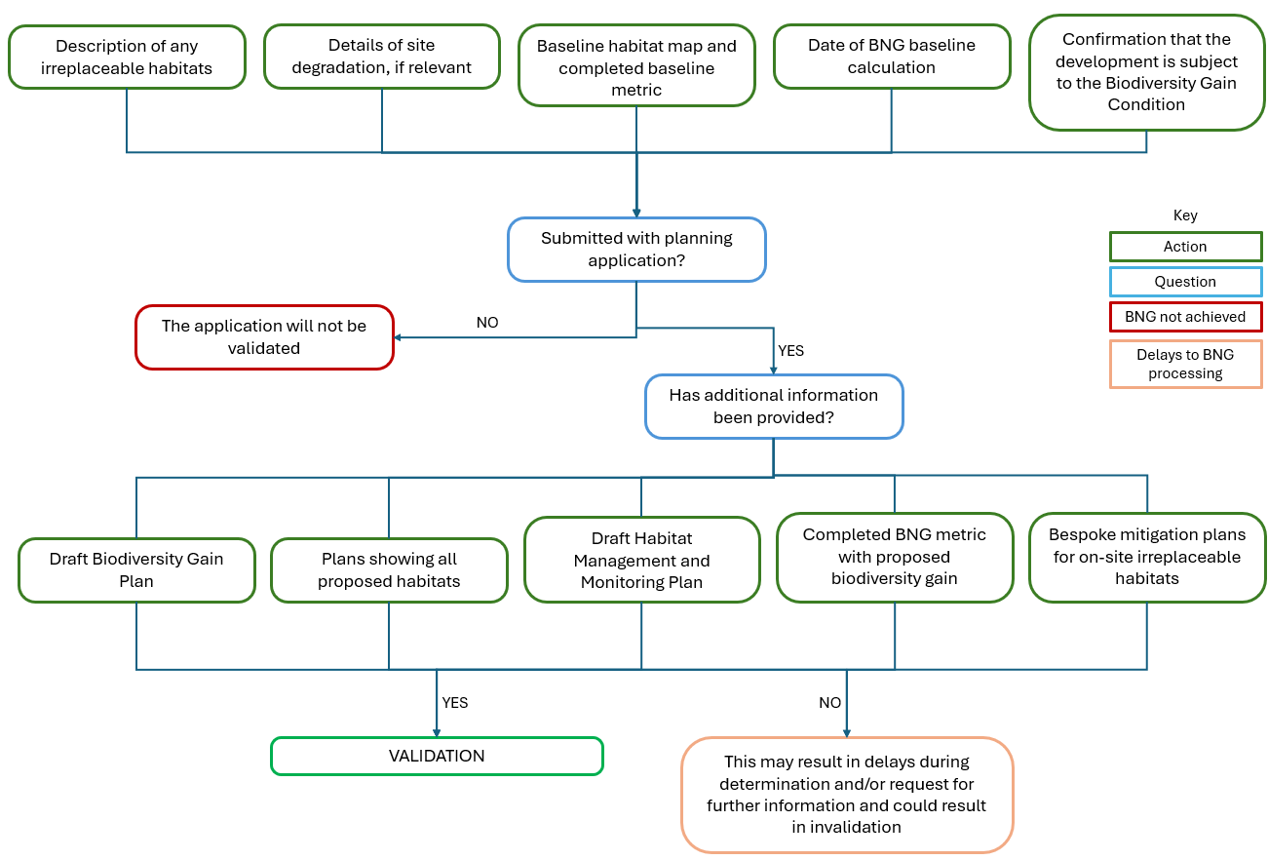
Figure 2. Flowchart showing the validation process applicants must follow when submitting a planning application.

Pre-commencement

Prior to commencement, the general Biodiversity Gain Condition will need to be discharged for development to commence. The applicant must provide all the information required under paragraph 14(2) of Schedule 7A of the Town and Country Planning Act 1990 and under Articles 37C(2) and 37C(4) of The Town and Country Planning (Development Management Procedure) (England) Order 2015.

Table 5. Statutory Pre-commencement Requirements within the BGP
Information required within BGP | Details
Baseline and post-development biodiversity value of the onsite habitat. | Calculated using the relevant metric.
Any registered off-site biodiversity gain allocated to the development and the biodiversity value of offsite habitats. | A legal agreement must be in place to secure off-site habitat units.  The units must be registered on Natural England’s biodiversity gain sites register by the provider.  Developers can create and supply their own off-site biodiversity units if they are registered on the biodiversity gain sites register.  The applicant must specify if any conditions attached to the allocation have been met or will be met by the time the development begins.
If statutory credits are required. | The type of statutory credits required, and proof of purchase must be provided.  Evidence that all on-site and off-site options have been exhausted.
Description of how the biodiversity gain hierarchy will be followed. | Description of the steps taken to minimise adverse effects to biodiversity onsite and to any other habitat.  Outline where the hierarchy cannot be followed if applicable.
The relevant date used when calculating the baseline biodiversity value of onsite habitats. | If the applicant proposes an earlier date, the chosen date and reason for proposing it.
A complete Statutory Biodiversity Metric Calculation Tool or Small Sites Metric Tool, stating the publication date of the tool. | The metric will detail the level of biodiversity net gain, with a minimum 10% gain in biodiversity units required.  The metric must satisfy the trading rules and principles outlined in Section 3.3.  If off-site compensation is required, this must be included within the ‘off-site’ tabs of the metric.  Complete Condition Assessment sheets that match the information provided within the metric.
Pre-development and post-development plans showing all on-site habitat, including any irreplaceable habitat. | Map created to an identified scale with a north arrow showing all habitats on site. The habitats should be UKHab/BNG habitat types and outlined in a clear key.  The habitat plan must be in line with the finalised, detailed, landscaping plans.
Description of any irreplaceable habitats within the proposed development site | Where planning permission is granted for a development with onsite irreplaceable habitat, bespoke mitigation plans must be provided and agreed by separate consultation with RMBC.
Statement confirming whether activities have been carried out before the application date or proposed earlier date that have resulted in the degradation of biodiversity value. If activities have resulted in degradation, information regarding the dates and pre-development biodiversity values will be required. | Statement confirming there has been no loss in biodiversity units. If there has been degradation they will have to provide:  - a statement confirming that such activities have been carried out;  - the date immediately before degradation;  - the pre-degradation biodiversity values and completed metrics of onsite habitats on the date prior to degradation;  - any supporting evidence.

The condition states that development cannot begin unless a Biodiversity Gain Plan (BGP) has been submitted to the planning authority and has been approved via a formal discharge of condition application. This should be submitted using the DEFRA Biodiversity Gain Plan template. The following information must be included within the BGP:

The DEFRA template includes fields to provide and prompt all the required information outlined above.

Additional information may be required to outline how trading rules have been satisfied within the metric and if bespoke mitigation plans have been agreed upon by RMBC.

Irreplaceable habitats
Irreplaceable habitats are those which are ecologically valuable and are difficult and/or take a significant length of time to restore, recreate or replace. Development resulting in the loss or deterioration of these habitats should be refused unless there are wholly exceptional reasons and suitable compensation is planned.

The Biodiversity Gain Requirements (Irreplaceable Habitat) Regulations 2024 provides the list of irreplaceable habitats for biodiversity net gain.

Irreplaceable habitats should be included within BNG Metrics pre-development and post-development. However, they will not be assigned biodiversity units unless enhanced.

The presence of these habitats and any enhancement or loss must be recorded in the irreplaceable habitats tab of the metric.

The Biodiversity Gain Plan is required to detail how adverse effects from developments to irreplaceable habitats will be mitigated. Appropriate bespoke mitigation and compensation would need to be agreed with RMBC through separate consultation.

In addition to the BPG, paragraph 9(3) under Schedule 7A states that habitats (unless they are deemed insignificant on-site habitats) must be maintained for at least 30 years after the development is complete.

A Habitat Management and Monitoring Plan (HMMP) details what is required to manage and monitor significant on-site habitat gains. Providing and implementing an HMMP will be legally secured by a separate planning obligation (Section 106 agreement), planning condition or conservation covenant, applied to developments that make significant on-site gains.

The HMMP will detail the establishment procedure and long-term management required to reach the proposed target habitat types and conditions for all on-site ‘significant’ gains. Furthermore, it will outline how the habitats will be monitored. The HMMP will be implemented for at least 30 years after the completion of development. The HMMP must detail responsible parties for the management and monitoring.

An HMMP is also required for all off-site habitats, however if the applicant proposes to use a site already registered on the Natural England off-site sites register then an HMMP will already be in place for the off-site habitat.

RMBC would prefer applicants to use Natural England’s Habitat Management and Monitoring Plan Template and Monitoring Report Template. The HMMP should provide sufficient information to confirm that habitats have been appropriately specified for the site’s environmental conditions and that suitable management and maintenance is planned for a minimum 30 years.

Environmental information such as hydrology, climate, and soil composition will be detailed within the HMMP. This information will inform how applicants have considered relevant constraints and opportunities as part of the design process and provide justification for how developments plan to reach their habitat target condition. This is especially important for High and Very High distinctiveness habitats that require specific environmental conditions.

Note: The creation/enhancement of any off-site habitats need to be legally secured for 30 years, even if they are not deemed ‘significant enhancements’.

RMBC Significant Gain Definition

Significant gains
Significant gains are habitats created or enhanced which contribute significantly to the proposed development’s BNG. As such, significance is relative to the development's baseline biodiversity value and depends on the context of the development.

When deciding significance and therefore whether an HMMP is required, RMBC will consider the cost vs benefit.

In general, minor development which meets the thresholds for the SSM would not usually be considered significant, however there will be exceptions on a case-by-case basis.

Biodiversity value will still be counted towards all non-significant gains. However, there will be no requirement to secure these gains for a minimum of 30 years and instead these should be prescribed in landscape plans and not within an HMMP (unless the applicant wishes to do so voluntarily).

RMBC may use planning conditions to ensure the retention of non-significant habitats within the development where appropriate. This would be more relevant to shared green space that provides community benefits, not private gardens etc.

Construction

No development can take place until all pre-commencement requirements have been met and conditions are formally discharged by RMBC. If there is a breach of the Biodiversity Gain Condition and unlawful development begins before conditions have been formally discharged, the council will take appropriate action e.g. temporary stop notices/breach of condition notice/enforcement notice.

To ensure compliance with the Mitigation Hierarchy and existing statutory legislation for protected sites, species, and habitats, it is crucial to protect both on-site and off-site habitats and species during construction. A Construction Environmental Management Plan may be required as part of the planning submission or as a pre-commencement condition, separate to BNG requirements.

If a HMMP is required as a condition of planning permission all construction and operational phase requirements will need to be met.

Once the development is complete and the ‘year 0’ habitat enhancement and/or creation has been undertaken, the applicant should inform RMBC. RMBC will confirm whether the proposed habitat works have been completed in accordance with the BGP and HMMP. Once satisfied, the minimum 30-year management and monitoring period will begin (see Section 7 below).

If there are any changes from the approved BGP and HMMP, which would alter the proposed habitats and biodiversity gain, construction will need to stop, and the BNG documents will need revisions and further assessment from RMBC.

Management and Monitoring

The HMMP will detail the management and monitoring of all significant on-site (as defined in section 5.2) and all offsite gains. The applicant and any appointed agent(s) will be responsible for delivering habitat management and monitoring. Management and monitoring will likely be legally secured through a section 106 agreement. Alternatively, a conservation covenant may be used. There may be some circumstances where significant on-site gains can be secured by planning condition however this is unlikely to be a common occurrence.

It is important to have a consistent and appropriate long-term management plan to ensure that the proposed biodiversity net gain of the development is achieved. The HMMP must name the accountable body responsible for managing the habitats for 30 years. This body will be liable if the intended habitat type or condition outlined in the BGP is not met.

In most cases, the developer will employ a landscape management company to manage the majority of habitat types. Where high and very high distinctiveness habitats are proposed, specialist contractors will likely be required.

During the 30-year period after construction, monitoring is required to ensure that the target habitat type and condition are met. Monitoring is the responsibility of the developer. The monitoring can be delegated to another body as outlined in the BGP and detailed in the HMMP and should be completed by a qualified ecologist from a different body to those managing the habitats. The monitoring reports must be sent to RMBC and include the following minimum information:
- The name and competency of the person completing the report
- The types of survey undertaken and conditions and limitations
- Progress of habitat since implementation
- Progress towards habitat extent, type, or condition target

RMBC Monitoring Requirements
Monitoring reports submitted should be scheduled at agreed intervals e.g. years 1, 2, 5, 10, 15, 20, 25, 30. The reports will be reviewed by RMBC to assess progress towards the proposed habitat type and/or condition. RMBC will charge fees for the review of monitoring reports and any necessary site visits. Failure to comply with the submission of accurate and timely monitoring reports will result in enforcement action from RMBC.

RMBC would prefer applicants to use Natural England’s HMMP Monitoring Report Template.

Figure 3. Flowchart showing the process applicants must follow pre-commencement and during the management and monitoring of a development to ensure BNG is secured.
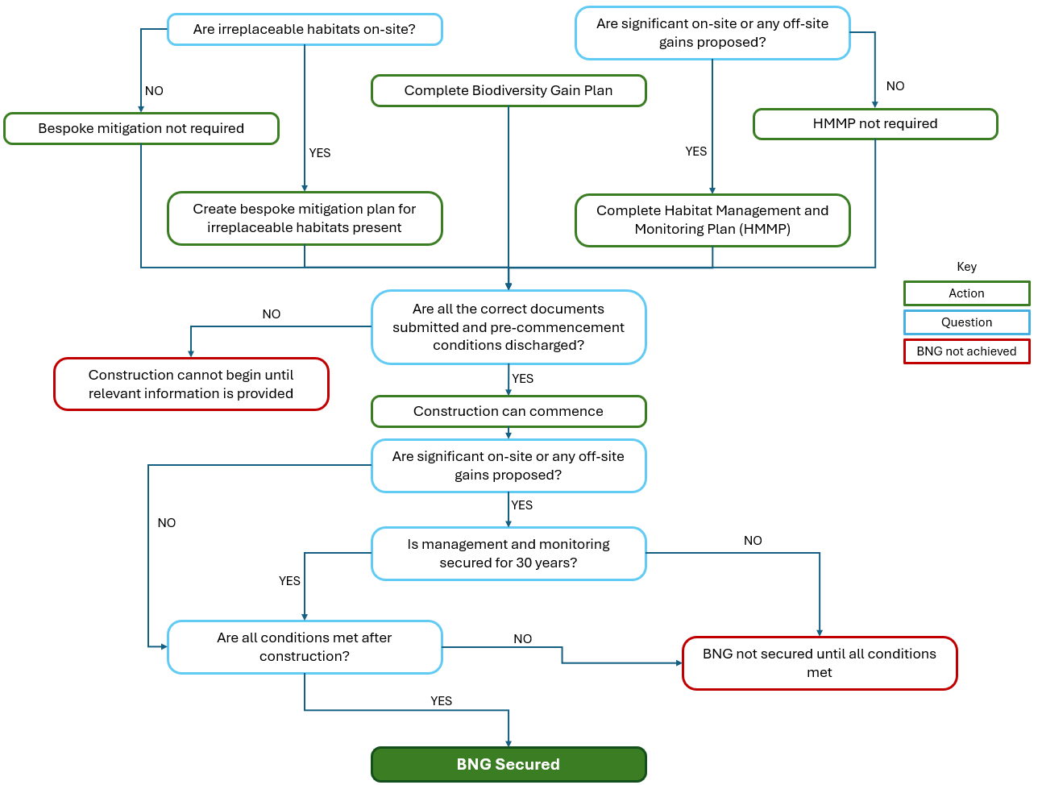

Understanding biodiversity net gain - GOV.UK (www.gov.uk)
Environment Act 2021 (legislation.gov.uk)
Biodiversity net gain - GOV.UK (www.gov.uk)
Statutory biodiversity credit prices - GOV.UK (www.gov.uk)
National Planning Policy Framework (publishing.service.gov.uk)
A priority habitat is a habitat listed by the Secretary of State for Environment, Food and Rural Affairs under section 41 of the Natural Environment and Rural Communities Act 2006.
The Town and Country Planning (Development Management Procedure) (England) Order 2015 (legislation.gov.uk)
Self-build and Custom Housebuilding Act 2015 (legislation.gov.uk)
Supplementary Planning Document 11: Natural Environment (rotherham.gov.uk)
Green Infrastructure Home (naturalengland.org.uk)
The Town and Country Planning (Development Management Procedure) (England) Order 2010 (legislation.gov.uk)
The_Statutory_Biodiversity_Metric_-_User_Guide_.pdf (publishing.service.gov.uk)
Statutory biodiversity metric tools and guides - GOV.UK (www.gov.uk)
European Protected Species are those listed on Schedules 2 and 5 of the Conservation of Habitats and Species Regulations 2017 (as amended)
Statutory Protected Sites are areas designated under law for environmental protection, such as Sites of Special Scientific Interest (SSSIs) (The Wildlife and Countryside Act 1981 (as amended)), Special Areas of Conservation (SACs) (Conservation of Habitats and Species Regulations 2017 (as amended)), and Special Protection Areas (SPAs) (Conservation of Habitats and Species Regulations 2017 (as amended))​
ukhab – UK Habitat Classification
Advice-Note.pdf (cieem.net)
RMBC Mapping (rotherham.gov.uk)
biodiversity-action-plan-bap-2012-introduction (rotherham.gov.uk)
Planning applications – Rotherham Metropolitan Borough Council
biodiversity-action-plan-bap-2012-introduction (rotherham.gov.uk)
The Town and Country Planning (Development Management Procedure) (England) Order 2015 (legislation.gov.uk)
Town and Country Planning Act 1990 (legislation.gov.uk)
The Biodiversity Gain Requirements (Irreplaceable Habitat) Regulations 2024 (legislation.gov.uk)
Biodiversity_gain_plan.pdf (publishing.service.gov.uk)
Building Regulation Charges – Rotherham Metropolitan Borough Council

