**Provider Portal Guidance September 2025**

Guidance will include different funding routes:

Under 2’s - Working Families………………………………………………………………………………………….….Page 2

2 Year - Additional Support (Previously Disadvantaged) …………………………………………………………Page 6

2 Year - Working Families…………………………………………………………………………………………………Page 10

2 Year - Additional Support & Working Family ………………………………………………………………….…Page 13

3 & 4 Year – Funded & Working Families………………………………………………………………………….…Page 17

Validating Codes…………………………………………………………………………………………….……………..Page 20

Summary………………………………………………………………………………………………………………………Page 21

**Under 2’s - Working Families (30 Hours)**

Funding > Select Year & Term > 9 month – 2 Year Old (New)

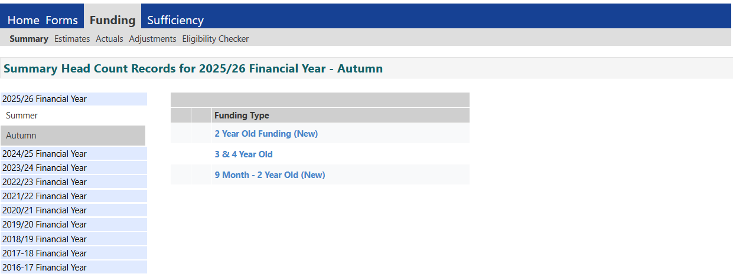

Actuals > Add child

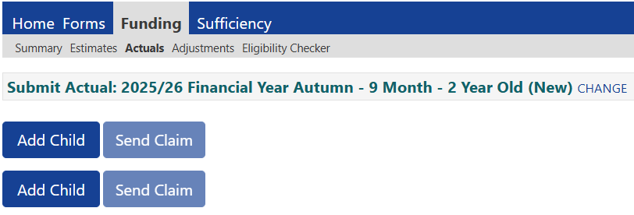

Child details tab > Enter Name > DOB > Tick Proof of DOB seen >Tick Gender > Select Ethnicity > Select SEN COP Stage > Enter house number & postcode > Search > Confirm

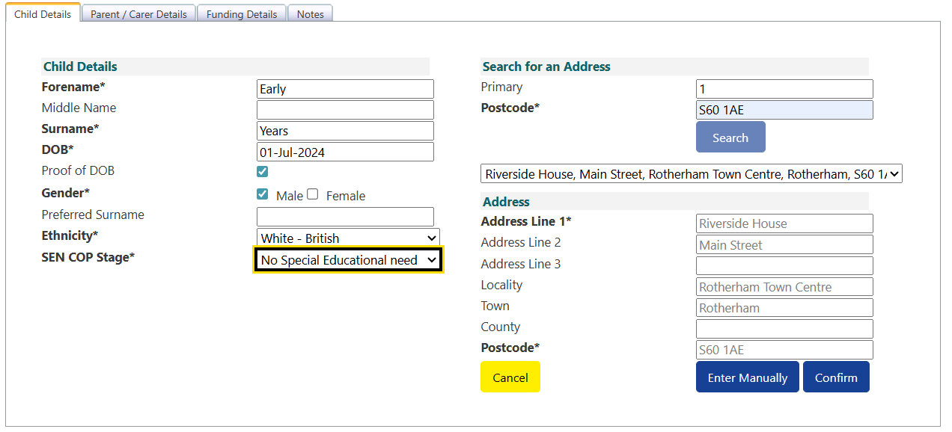

Parent/Carer Details Tab > Enter Name > DOB > National Insurance Number > Tick EYPP & Working Family Eligibility

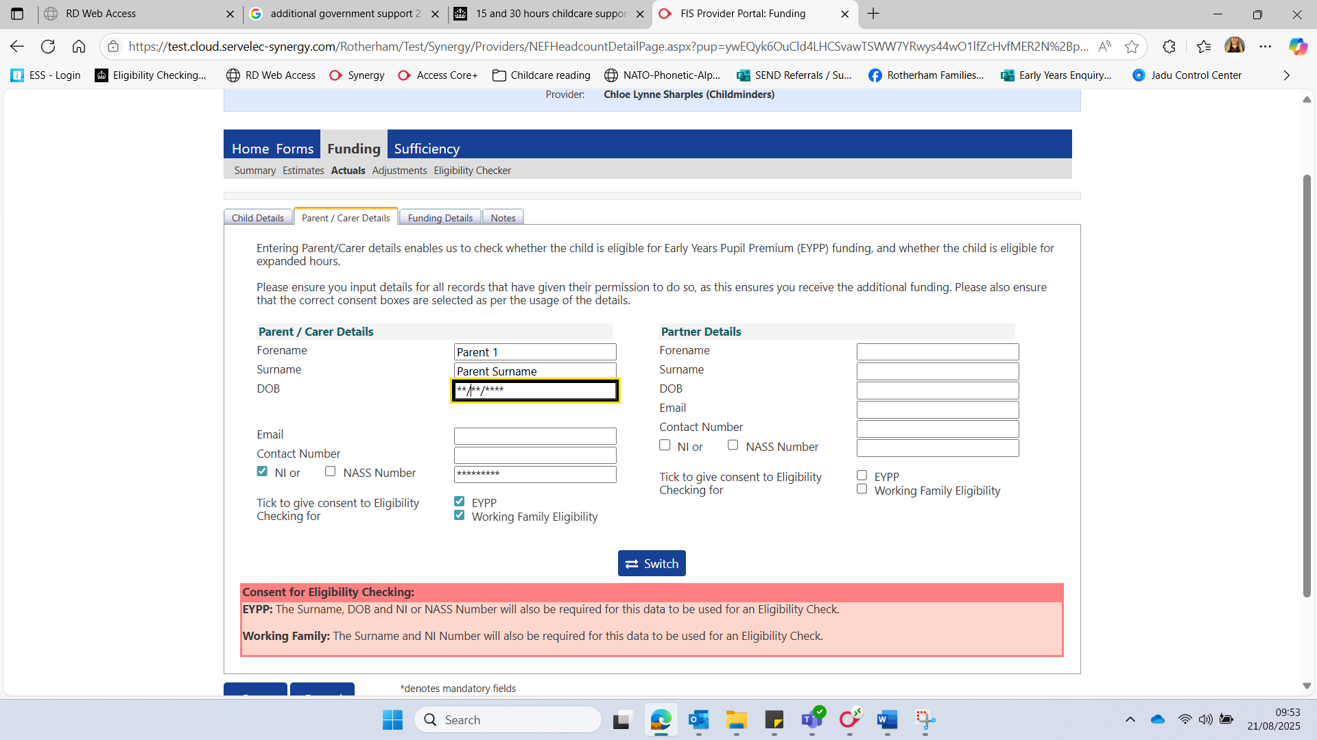

Funding Details Tab > Select Default Term Dates (or change if different to standard) > Weeks Attended e.g. 14 for Autumn Term (or stretched allowance) > If applicable, tick present at census > If applicable, tick attends 2 days or more > Choose if nominated for DAF > Tick stretched if stretching (if option not available please contact Early Years)

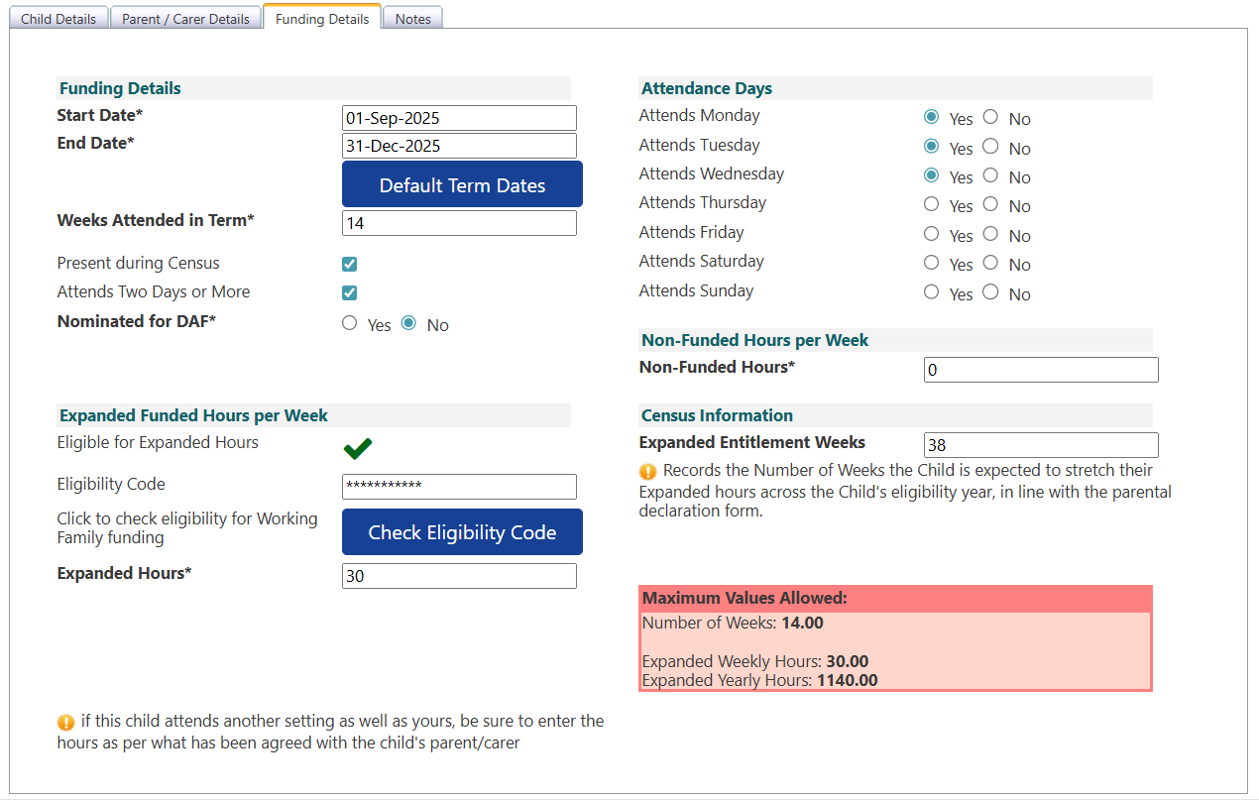

Expanded Funded Hours Per Week > Enter Code > Check Eligibility > Enter Expanded Hours > Max of 30 (22 if stretched)

Once eligibility has been checked you should receive the following message at the top of the screen:



Select 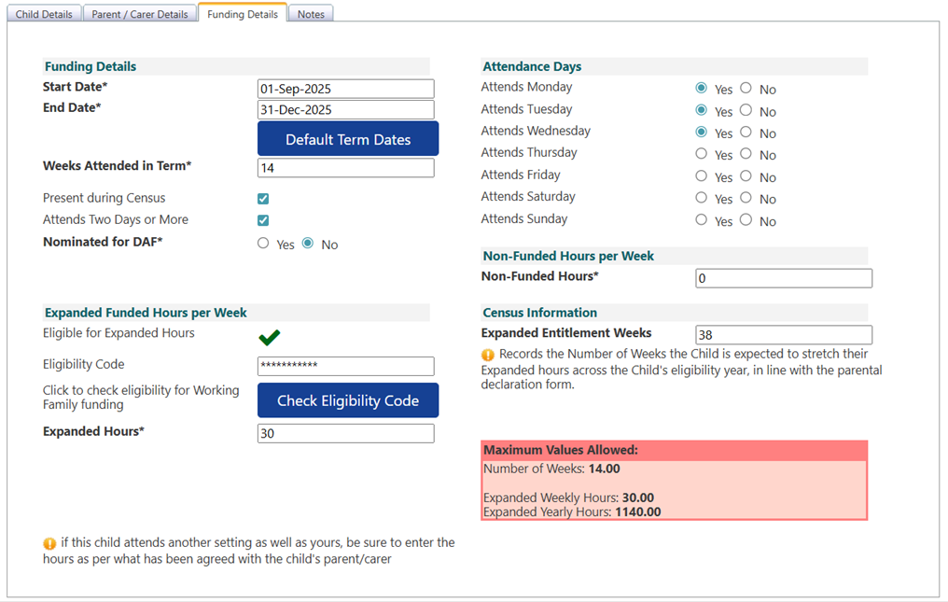Attendance days > Enter any non-funded hours (or 0) > Enter Expanded Entitled Weeks (38 term time or number of weeks you deliver funding over the year e.g. 50)

Enter any notes if necessary:

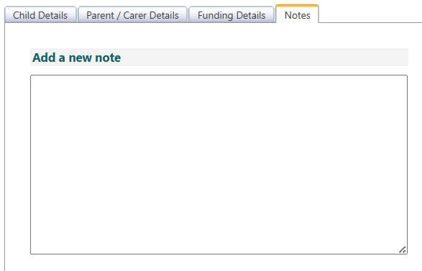

Save Child:

**2 Year - Additional Support (Previously Disadvantaged, 15 hours)**

Funding > Select Year & Term > 2 Year Old Funding (New)



Actuals > Enter EY Voucher **This allows the system to confirm a Local Authority eligibility check has taken place and ensures children have been checked by Rotherham FIS**

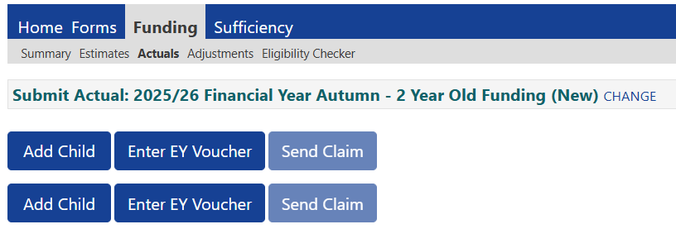

The following box will appear > Enter Code > Child’s DOB > Surname > Click Submit

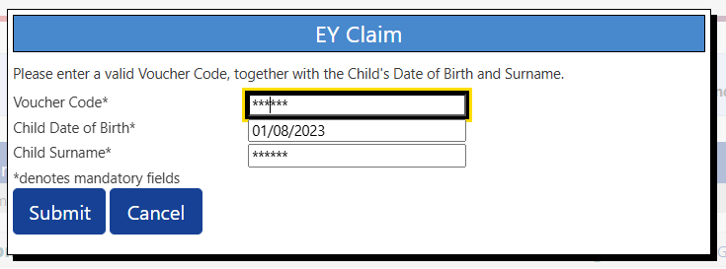

Once submitted it should take you to the following screen with information already inputted on the child details tab. Tick Proof of DOB seen >Tick Gender > Select Ethnicity > Select SEN COP Stage

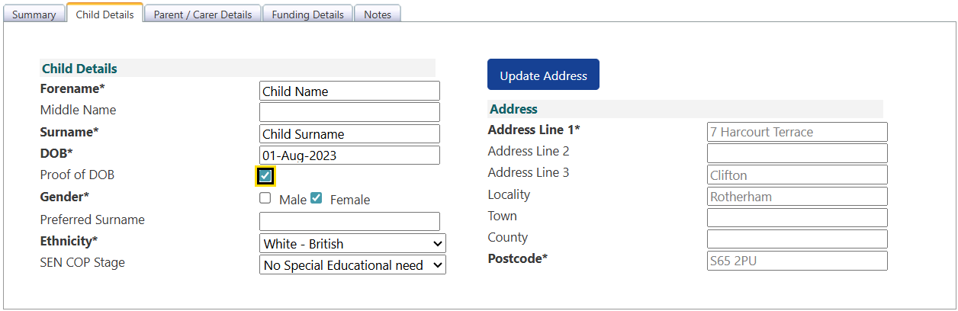

Parent/Carer Details Tab > Enter Name > DOB > National Insurance Number > Tick EYPP

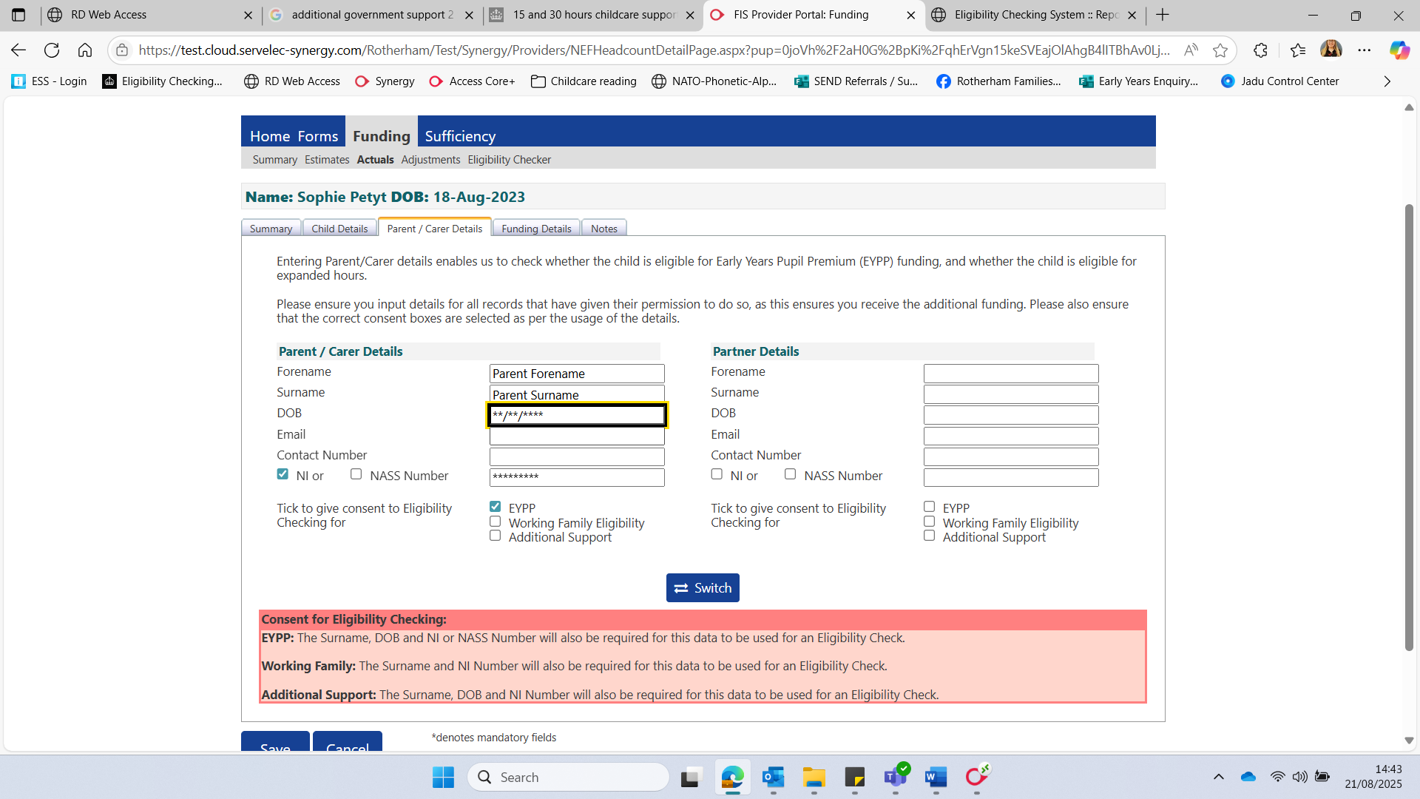

Funding Details Tab > Select Default Term Dates (or change if different to standard) > Weeks Attended e.g. 14 for Autumn Term (or stretched allowance) > If applicable, tick present at census > If applicable, tick attends 2 days or more > Choose if nominated for DAF > Tick stretched if stretching (if option not available please contact Early Years)

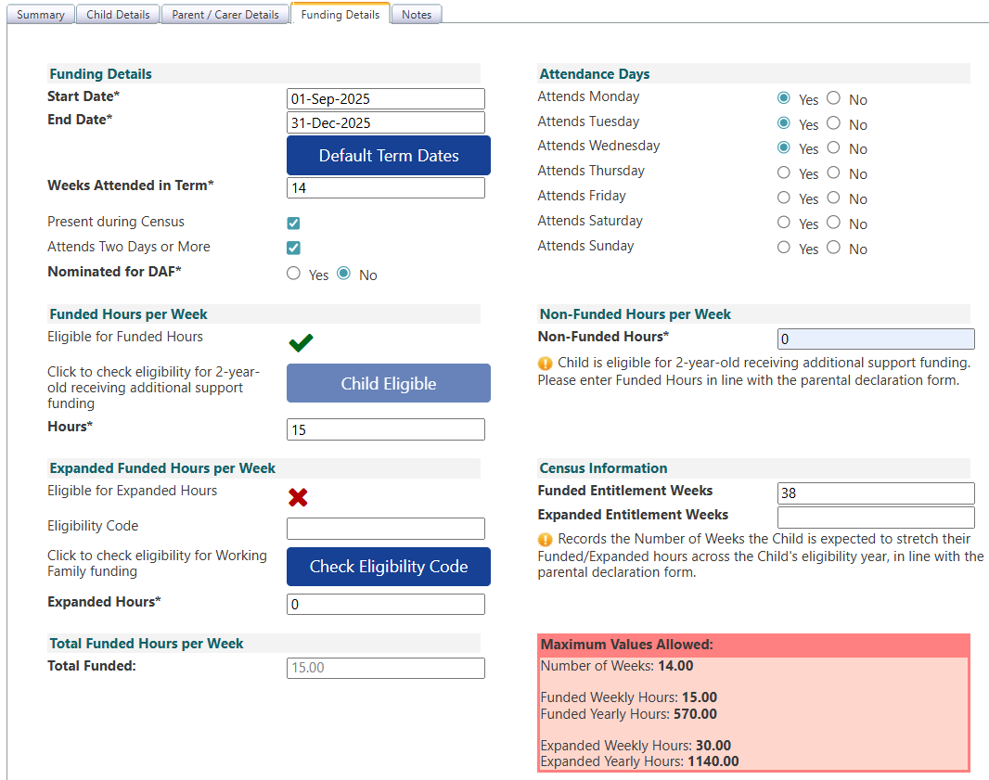

In Funded Hours per Week enter up to 15 Hours > Expanded Hours must be 0

Select Attendance days > Enter any non-funded hours (or 0) > Enter Funded Entitled Weeks (38 term time or number of weeks you deliver funding over the year e.g. 50)

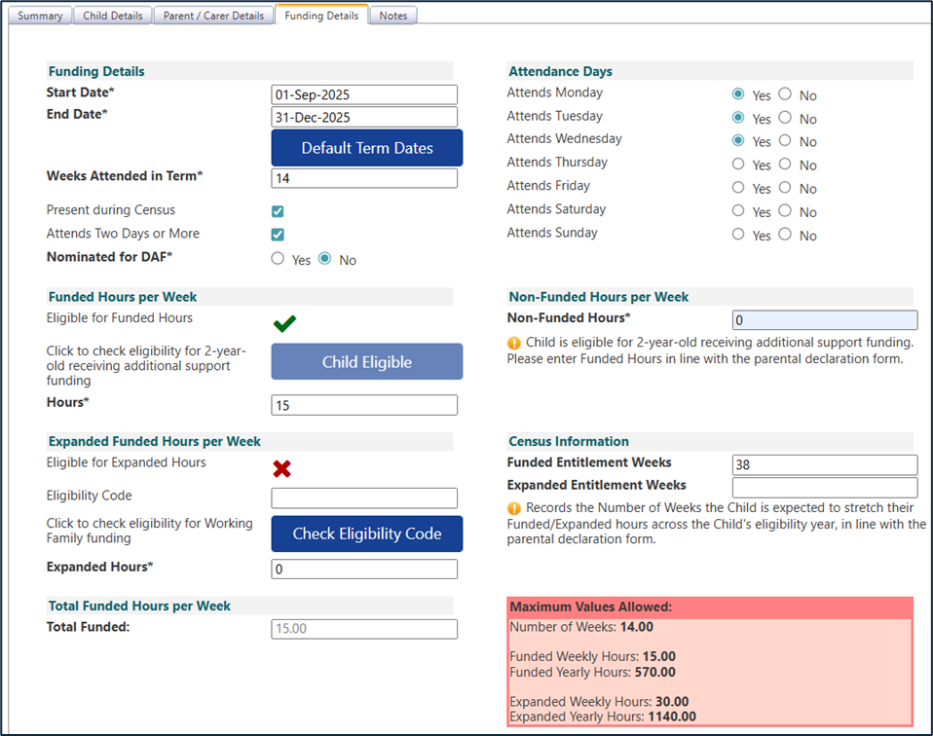

Enter any notes if necessary:



Save Child:

**IMPORTANT INFORMATION:**

It is important that you add children with additional support funding (previously disadvantaged) under the ‘ENTER EY VOUCHER’ button and not the ‘Add Child’. This allows the portal to confirm a Local Authority eligibility check has taken place and matches the child to our internal system. This ensures that you can offer the funded place with certainty that the child is eligible.

If you have entered a 2 year old with additional support funding under ‘add child’ and then click ‘check eligibility’ on the funding details tab you may receive the following message & eligibility cannot be confirmed.

**2 Year - Working Families (30 Hours)**

Funding > Select Year & Term > 2 Year Old Funding (New)



Actuals > Add child



Child details tab > Enter Name > DOB > Tick Proof of DOB seen > Tick Gender > Select Ethnicity > Select SEN COP Stage > Enter house number & postcode > Search > Confirm

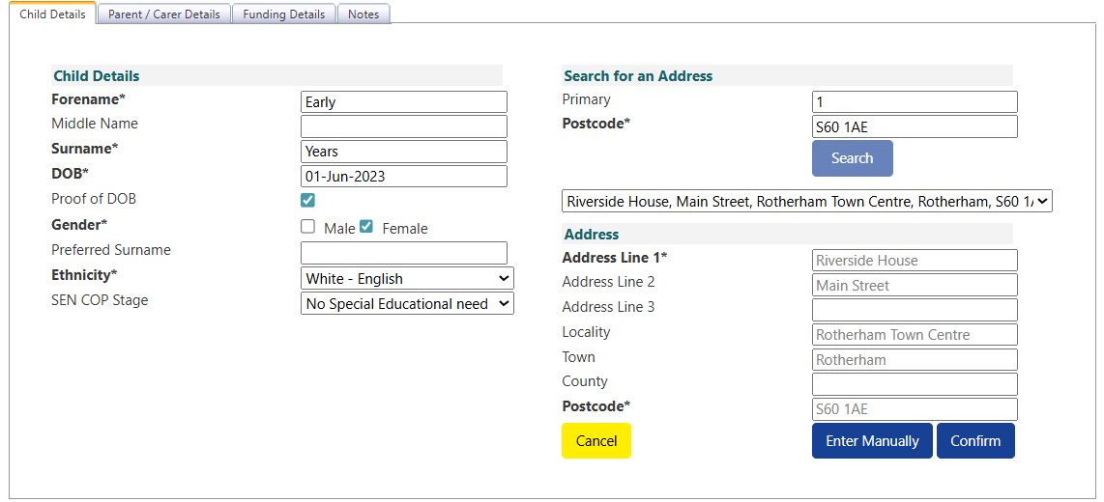

Parent/Carer Details Tab > Enter Name > DOB > National Insurance Number > Tick EYPP & Working Family Eligibility

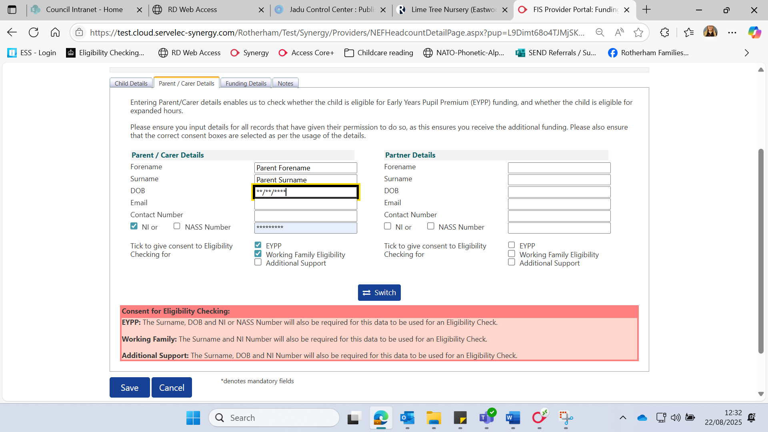

Funding Details Tab > Select Default Term Dates (or change if different to standard) > Weeks Attended e.g. 14 for Autumn Term (or stretched allowance) > If applicable, tick present at census > If applicable, tick attends 2 days or more > Choose if nominated for DAF > Tick stretched if stretching (if option not available please contact Early Years)

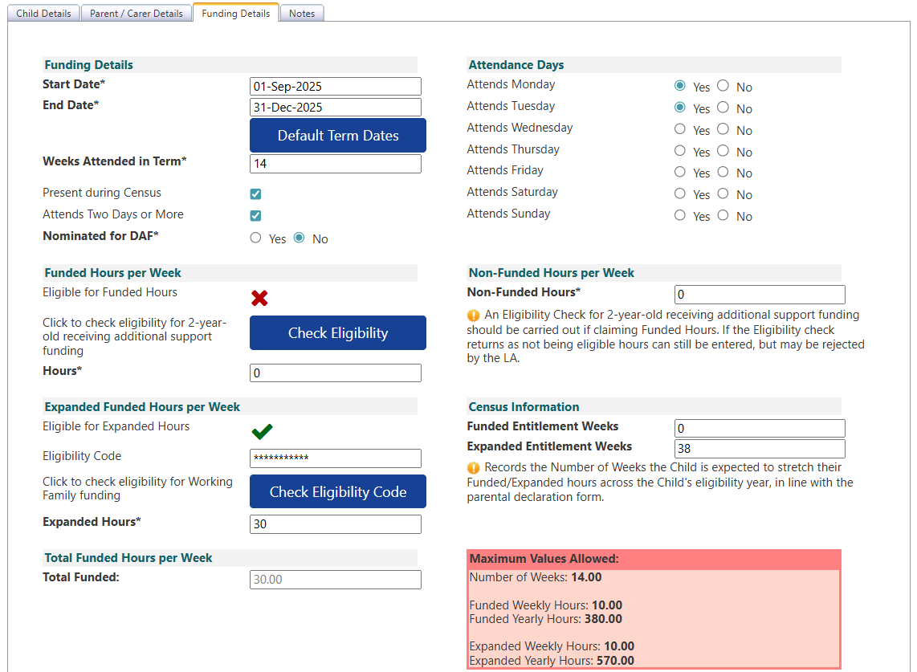

Funded Enter 0 Hours > Expanded Funded Hours Per Week > Enter Code > Check Eligibility Code > Enter Expanded Hours > Max of 30 (22 if stretched)

Once eligibility has been checked you should receive the following message at the top of the screen:

Select Attendance days > Enter any non-funded hours (or 0) > Enter 0 Funded Entitlement weeks > Enter Expanded Entitled Weeks (38 term time or number of weeks you deliver funding over the year e.g. 50)

Enter any notes if necessary:



Save Child:



**2 Year - Additional Support & Working Family (30 Hours)**

Some families who are eligible for the additional support 2 year funding may also be eligible for the working families funding. [Guidance form the DfE](https://assets.publishing.service.gov.uk/media/683981d4c99c4f37ab4e86e3/September_2025_early_education_and_childcare_entitlements_expansion_-_local_authority_system_guidance_May_2025.pdf) states where parents meet the eligibility criteria for both entitlements from September 2025, they should take up the entitlement for families receiving additional support **and** 15 hours of working parent entitlement. Parents may come to you with both codes; therefore, this is how they should be entered on the portal:

Funding > Select Year & Term > 2 Year Old Funding (New)



Actuals > Enter EY Voucher **This allows the system to confirm a Local Authority eligibility check has taken place and ensures children have been checked by Rotherham FIS**



The following box will appear > Enter Code > Child’s DOB > Surname > Click Submit



Once submitted it should take you to the following screen with information already inputted on the child details tab. Tick Proof of DOB seen >Tick Gender > Select Ethnicity > Select SEN COP Stage



Parent/Carer Details Tab > Enter Name > DOB > National Insurance Number > Tick EYPP & Working Family Eligibility



Funding Details Tab > Select Default Term Dates (or change if different to standard) > Weeks Attended e.g. 14 for Autumn Term (or stretched allowance) > If applicable, tick present at census > If applicable, tick attends 2 days or more > Choose if nominated for DAF > Tick stretched if stretching (if option not available please contact Early Years)

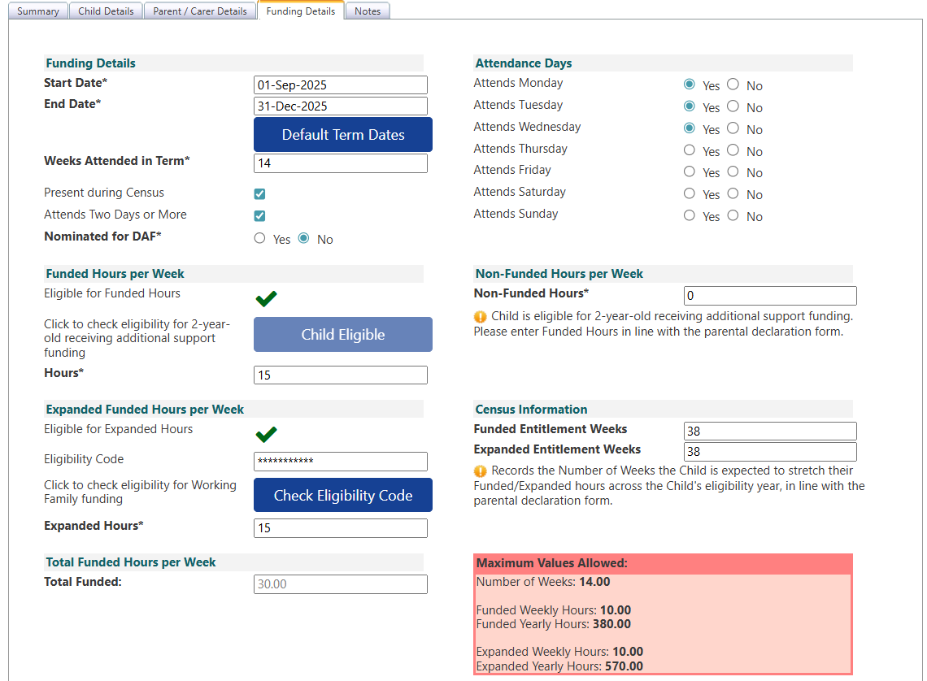

Funded hours per week should have a green tick – as you have put the EY Voucher in already > Enter Funded hours amount > In Expanded funded hours please enter the 11 digit working families code > Check eligibility code > Enter expanded hours amount.

Once eligibility has been checked you should receive the following message at the top of the screen:

Select Attendance days > Enter any non-funded hours (or 0) > Enter Funded Entitlement weeks > Enter Expanded Entitled Weeks (38 term time number of weeks you deliver funding over the year e.g. 50)

Enter any notes if necessary:



Save Child:



**3 & 4 Year – Funded & Working Families (15/30 hours)**

Funding > Select Year & Term > 3 & 4 Year Old



Actuals > Add child

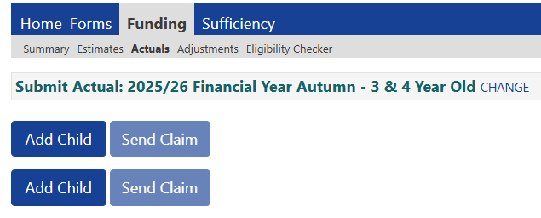

Child details tab > Enter Name > DOB > Tick Proof of DOB seen > Tick Gender > Select Ethnicity > Select SEN COP Stage > Enter house number & postcode > Search > Confirm

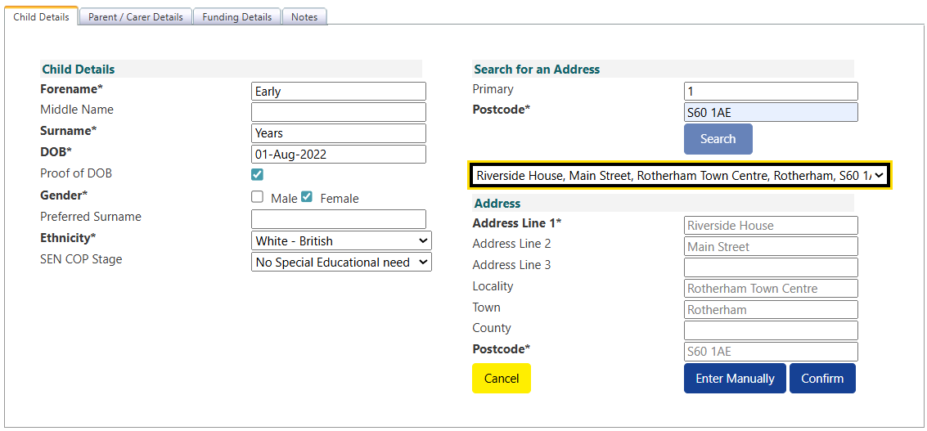

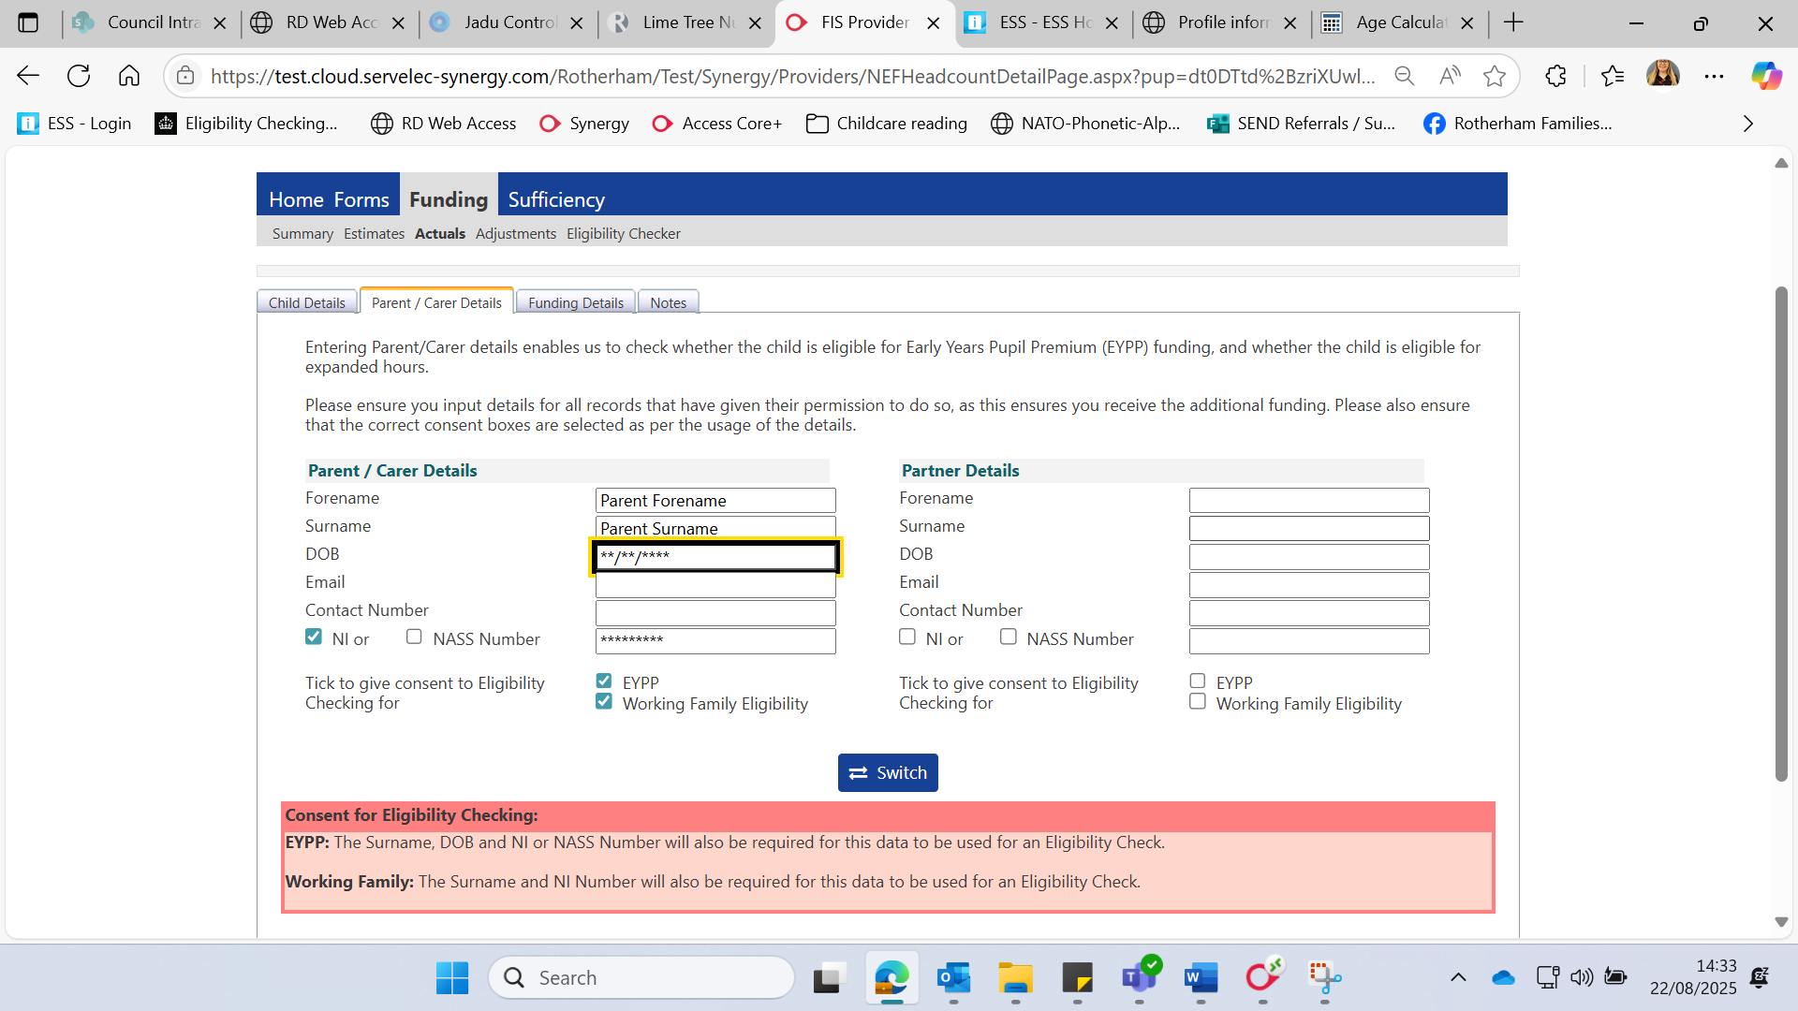Parent/Carer Details Tab > Enter Name > DOB > National Insurance Number > Tick EYPP > Tick Working Family Eligibility if using, or leave blank if just using 15 universal hours

Funding Details Tab > Select Default Term Dates (or change if different to standard) > Weeks Attended e.g. 14 for Autumn Term (or stretched allowance) > If applicable, tick present at census > If applicable, tick attends 2 days or more > Choose if nominated for DAF > Tick stretched if stretching (if option not available please contact Early Years)

Enter Funded hours per week > If using Extended funded hours > Enter Code > Check Eligibility > Enter Extended Hours > Max of 30 (22 if stretched)

Once eligibility has been checked you should receive the following message at the top of the screen:

Select Attendance days > Enter any non-funded hours (or 0) > Enter Funded Entitlement weeks > & Enter Extended Entitled Weeks if using (38 term time or number of weeks you deliver funding over the year e.g. 50)

Enter any notes if necessary:



Save Child:

**Validating Codes**

Please ensure you are validating the working families codes prior to the start of term to ensure the family is entitled to their funding before delivering the funded hours.

Enter mandatory fields: eligibility code, child DOB & Parent National Insurance Number and tick consent box ‘Eligibility Check’ > Submit

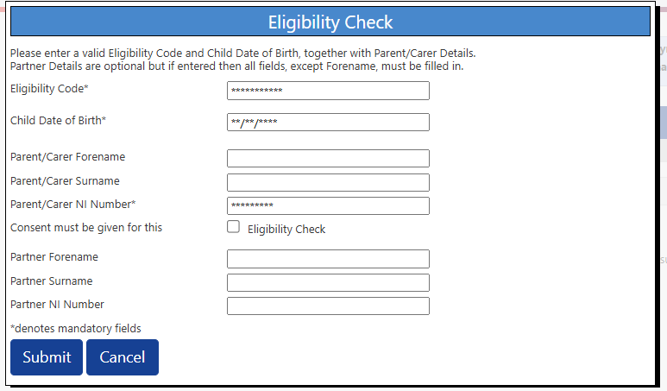

Once submitted the following yellow box will display the, start, end and grace period end date. Please ensure you check the dates associated with code are valid for the term the child is due to access their funding. For example, for Autumn 2025:

Start date is on or **before 31/08/2025**

End date is on or **after 01/09/2025**

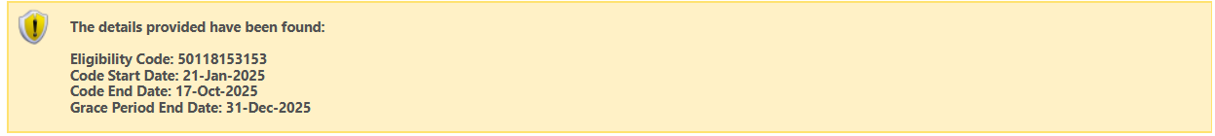

**Summary**

