Rotherham Secondary Fair Access Protocol

Effective: 1 September 2024
Agreed by: Local Admissions Forum 13 June 2024
Review date: January 2027

Secondary Fair Access Protocol (FAP)

Introduction
Each Local Authority is required to have in place a Fair Access Protocol to ensure that - outside the normal admissions round - unplaced children, especially the most vulnerable, are found and offered an education place quickly, so that the amount of time any child is out of school is kept to the minimum.
All admissions authorities must participate in the FAP once it is agreed by the majority of schools in the area. This includes, making available a representative who is authorised to participate in discussions, make decisions on placing children via the Protocol, and admitting pupils when asked to do so in accordance with the Protocol, even when the school is full.
The Rotherham Secondary FAP has been designed to best meet local need by:
- ensuring that children who require a school place through FAP are allocated one and admitted quickly and
- promoting a culture of openness and transparency between schools and the Local Authority to ensure that the needs of each school are considered through the FAP.
The Rotherham Fair Access Protocol should be read alongside key documents that underpin it:
• DfE School Admissions Code 2021
• Fair access protocols: advice for local authorities and school admission authorities

Aims
To ensure that unplaced and vulnerable children, and those who are having difficulty in securing a school place in-year, are allocated a school place as quickly as possible.
Provide a defined route for children who are permanently excluded or those who require reintegration from the PRU to be allocated and admitted to a school place.
Ensure that the needs of children for whom mainstream education is not yet possible are met.
Identify school places for children who require one to progress a School Attendance Order as they are not in receipt of a suitable education. This may include children who have been Electively Home Educated and the Local Authority cannot be satisfied that they are in receipt of suitable education.
That through data informed decision making, ensure that no school is asked to take a disproportionate number of children who have been permanently excluded from other schools, who display challenging behaviour, or who are placed via the Protocol.
To hold schools to account for decisions made through the FAP, admitting children who are allocated via this route without delay and escalating any situation where this doesn’t happen as described within the Protocol.
To ensure that the best interests of children and families are at the centre of all decisions made.

Operation
All schools are expected to participate in and admit children in accordance with the FAP, even when the school is full.
Participation means making available a representative with delegated decision making power to attend and participate in meetings called regarding the placement of students via the FAP.

For Secondary FAP referrals in Rotherham a tiered system will operate:
Locality Partnership Meeting- All schools within the defined locality and RMBC
Strategic FAP (SFAP)- A nominated representative from each locality and RMBC

Locality Partnerships
Locality partnerships will consist of a representative from each school within each defined area (North, Central and South East) and will meet with the aim of considering students at risk of permanent exclusion, those requiring a fresh start via an Off Site Direction or Managed Move and those students requiring placement via the FAP. Panels will meet with the intention of providing mutual support and guidance to support vulnerable children across the area. Meetings will be scheduled by RMBC on a 3 weekly basis throughout the school year and should be attended by a school representative who has the authority to discuss the students being presented and participate in decision making regarding students presented by other schools and RMBC. The new locality partnership meeting will cover current functions delegated to PMG and Secondary Inclusion panel and as such support agencies from RMBC will be invited to attend as appropriate- Early Help, SEND and Virtual School alongside the Strategic Lead for Inclusion and Alternative Provision.
With regard to FAP decisions, the aim of this meeting is to seek a local solution and agreement of the school that the child should attend. If a school doesn’t attend this doesn’t preclude consideration of this school; if the panel feel that this is the most appropriate school for the child a recommendation can be made that this placement is made. If the placement is not subsequently agreed by the recommended school following the Locality Partnership meeting then a referral may be made to SFAP for a binding decision. For any child remaining unplaced after panel then a referral to SFAP will be made. For all FAP referrals to Locality Panel from RMBC, papers will be circulated 5 working days in advance of the meeting.
Managed Moves and Off Site Directions fall outside of the statutory duty imposed on FAP but should be used by schools as a means to prevent exclusion and agreed on a local basis at the locality meeting.

Strategic Fair Access Panel
Strategic FAP panels will be scheduled on a 3 weekly basis, always in the week directly following locality partnership meeting. For any children requiring escalation to SFAP for placement, papers will be circulated 3 working days prior to SFAP to the representatives attending. The SFAP will be attended by RMBC representatives and one nominated representative from each locality. It is for head teachers in the locality to agree the representative, this can be a permanent nominated representative or rotating representation from all schools within the area. RMBC will request details at the start of each term of panel attendees from the partnership in order to ensure that invites are issued accordingly.

RMBC responsibilities
Issue at the start of each school year invites for Locality Partnership and Strategic FAP meetings.
Seek all relevant and available information about children referred for placement to ensure that decisions that support appropriate placement can be made.
Provide referral paperwork at least 5 days in advance of the Locality Partnership meeting and 3 working days in advance of SFAP.
Maintain and circulate with the agenda local data to support decision making. This will include information such as, number of children already admitted in the academic year through FAP, number on roll, original PAN for the year group at the point of entry, level of in year pupil movement, number of children with EHCP/ SEND on roll, number of children who are LAC, number of children permanently excluded, OFSTED category and any particular pressures/ support needs that the local authority is aware of.
Follow up the admission of children allocated through the FAP.

School responsibilities
To consider all parental applications and offer where possible places through the in year admissions process.
To make available for discussions a representative with delegated decision making power to agree placements via the FAP, even though the school may be full. This representative should be familiar with the Rotherham FAP and legislative context underpinning this.
To feed intelligence in to the FAP, as and when it is required, on individual children or families of children. There is a moral and social obligation to be open and honest about the records of individual pupils to allow any receiving school to establish an appropriate support package for any child who is offered a place via the FAP.
To engage in shared local discussions through agreed routes to support pupils who are at risk of exclusion and prevent a subsequent need for placement via the FAP following a permanent exclusion. Schools will endeavour to avoid a permanent exclusion and will utilise the full range of support available through the Rotherham Inclusion Pathway in doing so.
To agree within the Locality Partnership arrangements for the chairing and management of the meeting.

Referrals
Referrals will be made directly from the School Admission Team at RMBC when a child is without a school place following an unsuccessful application, including when a school has refused on the grounds of challenging behaviour as outlined in 3.10-3.13 of the School Admissions Code 2021.
Eligibility for the Fair Access Protocol does not limit a parent’s right to make an in year application and all applications must be processed in accordance with the admission authority’s determined admission arrangements. They must not refuse to admit children on the basis that they may be eligible to be placed via the Fair Access Protocol. The parent will continue to have the right of appeal for any place they have been refused, even if the child has been offered a school place via the Fair Access Protocol.
Fair Access should not be used as a means to circumvent the usual admission process; the School Admissions Code 2021 specifies that FAP may only be used as follows:
3:17 Fair Access Protocols may only be used to place the following groups of vulnerable and/or hard to place children, where they are having difficulty in securing a school place in-year, and it can be demonstrated that reasonable measures have been taken to secure a place through the usual in-year admission procedures:
a) children either subject to a Child in Need Plan or a Child Protection Plan or having had a Child in Need Plan or a Child Protection Plan within 12 months at the point of being referred to the Protocol.
b) children living in a refuge or in other Relevant Accommodation at the point of being referred to the Protocol.
c) children from the criminal justice system.
d) children in alternative provision who need to be reintegrated into mainstream education or who have been permanently excluded but are deemed suitable for mainstream education.
e) children with special educational needs (but without an Education, Health and Care plan), disabilities or medical conditions.
f) children who are carers.
g) children who are homeless.
h) children in formal kinship care arrangements.
i) children of, or who are, Gypsies, Roma, Travellers, refugees, and asylum seekers.
j) children who have been refused a school place on the grounds of their challenging behaviour and referred to the Protocol in accordance with paragraph 3.10 of this Code.
k) children for whom a place has not been sought due to exceptional circumstances.
l) children who have been out of education for four or more weeks where it can be demonstrated that there are no places available at any school within a reasonable distance of their home. This does not include circumstances where a suitable place has been offered to a child and this has not been accepted.
m) previously looked after children for whom the local authority has been unable to promptly secure a school place

In Rotherham, children meeting criterion d) will be referred through the Locality Partnership where it is agreed that reintegration to school directly following a permanent exclusion is the most appropriate route for the child, or from Rotherham Aspire (PRU) where children have spent a period of time attending the setting and are assessed by Aspire as requiring a return to mainstream. The process map for the reintegration of permanently excluded students can be viewed in Appendix 1.
The School Admission Code 2021 (footnote 76) provides a definition of challenging behaviour as being where it would be unlikely to be responsive to the usual range of interventions to help prevent and address pupil misbehaviour or it is of such severity, frequency, or duration that it is beyond the normal range that schools can tolerate. We would expect this behaviour to significantly interfere with the pupil’s/other pupils’ education or jeopardise the right of staff and pupils to a safe and orderly environment.
The following reasons on their own should not be grounds for considering that a child may display challenging behaviour:
• poor attendance elsewhere;
• a defined number of suspensions, without consideration of the grounds on which they were made;
• special educational needs; or
• having a disability.

Consideration of placements
Where it has been agreed that a child will be considered under the Fair Access Protocol, a school place must be allocated for that child within 20 school days. The appeals process is independent from the FAP and the fact that an appeal has been lodged for a child is not a reason to delay the FAP process, or for the school the appeal has been lodged against not to be considered. Parents retain the right of appeal against the refusal of any of their preferred school place(s) even where a child has been referred to the FAP and a place at an alternative school has been allocated through the FAP process. The FAP retain the authority to allocate a place at a school even if they have been refused a place at appeal, as the duty of the FAP is to balance the prejudice against all schools in an area as opposed to the remit of an appeal panel to consider the prejudice to one individual school.
There is an expectation that schools admit children via the FAP even when they are full and children referred for placement via the FAP can take priority over any child on a waiting list.
Although there is no duty to comply with parental preference when allocating places through the FAP, parents view should be taken into account and there should be consideration of whether the placement allocated through FAP is appropriate for a child and any needs they may have.
Where children are returning from Elective Home Education or have spent a period of time missing education, consideration will usually be given to placement at their most recent Rotherham school attended, unless compelling reasons against this are presented.
The FAP will make a decision about the most appropriate educational placement for each child referred in a fair, equitable and consistent manner, using the information made available by RMBC and taking into account the views of the school(s) concerned. Information that will be considered in coming to a decision is:
- The needs of the child and family in the context of an appropriate placement- travel time to school, relationships to be considered e.g. siblings, support needs of the child
- The objections raised by one or more schools against the best interests of the child
- Length of time the child has been out of school / education
- Any resource issues
- Advice on multi-agency support required

Communication of decisions and admission of children
Decisions made via the FAP will be communicated in the first instance to the school concerned if they are not yet aware and subsequently to the applicant.
Once they have been allocated a school place via the Fair Access Protocol, arrangements should be made for the child to start at the school as soon as possible. The process schools are expected to follow when a place is allocated and a child has not yet started is detailed at Appendix 2.
Where schools cannot make contact with parents or carers, or an admission does not proceed the agreed CME process should be followed by school staff as with any other allocation of a place. The only exception to this is where a child is already on roll at Aspire, and in this event the agreed process for reintegration of students who have been permanently excluded should be followed.

Children for whom mainstream education is not yet possible
Where children have been attending a PRU or alternative provision in another local authority area at the point of their move to Rotherham, a referral will usually be made directly to Rotherham Aspire for continuing assessment and placement. There is an expectation that children will be presented at a subsequent FAP by Rotherham Aspire at the point they are assessed as requiring a return to mainstream provision.
For children with complex SEND, including those who previously had an EHCP that has ceased due to a move out of the country, the Fair Access team at RMBC will arrange a ‘Complex SEND’ meeting with colleagues from RMBC’s SEND service. The aim of this meeting will be to determine appropriate next steps for placement based on current information available about the child and their needs. This may be a referral for placement through FAP if this is deemed an appropriate outcome from this meeting.

Escalation
In the unlikely event that a school or academy refuses to admit a child allocated a school place through the fair access protocol, then best endeavours will be made to resolve this locally between RMBC and the school will be made. If this local resolution is not successful then steps as detailed in the School Admission Code 2021 (3.23-3.29) to make or request direction to admit from the Secretary of State (in the case of an Academy) will be followed.

Review
The local authority must produce an annual report on admissions for all schools in their area and send this to the Schools Adjudicator. This details the numbers of children admitted via FAP and an assessment of the effectiveness of the FAP.
A report will be presented in the Autumn Term to secondary heads detailing a review of the FAP and its operation in Rotherham during the previous academic year. Termly data will be issued by Email to all heads to ensure that the process is open and transparent.
In the event that the majority of schools in Rotherham can no longer support the principles and approach of the local Fair Access Protocol, they should initiate a review with the local authority by contacting the Fair Access Principal Offier. The existing Fair Access Protocol will remain binding on all schools in the local area until the point at which a new one is adopted.

Membership and remit of the Secondary Locality Partnerships

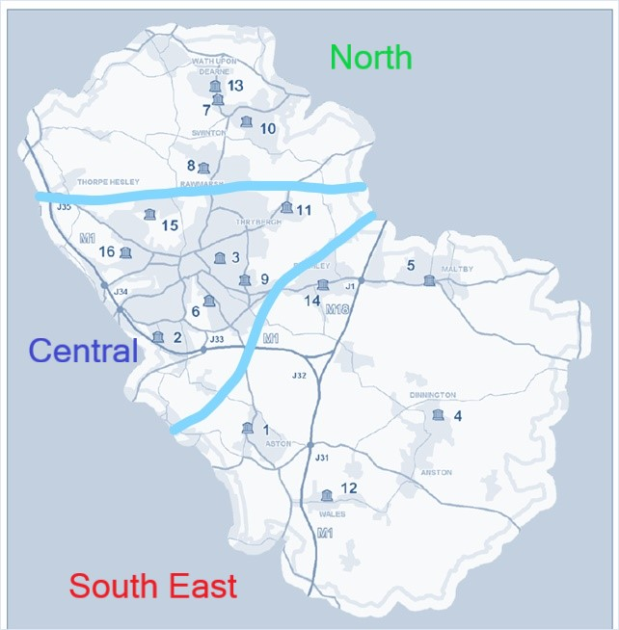

No | School Name | No | School Name
1 | Aston Academy | 9 | St. Bernard’s Catholic High School
2 | Brinsworth Academy | 10 | Swinton Academy
3 | Clifton Community School | 11 | Thrybergh Academy & Sports College
4 | Dinnington High School | 12 | Wales High School
5 | Maltby Academy | 13 | Wath Academy
6 | Oakwood High School | 14 | Wickersley School & Sports College
7 | Saint Pius X Catholic High School | 15 | Wingfield Academy
8 | Rawmarsh Community School | 16 | Winterhill School

The Partnership meeting consists of:
- Secondary Head Teachers / delegated representatives
- RMBC Fair Access representative
- Head of Aspire or deputy
- Permanent Officers linked to the Children and Young People’s Service eg. Early Help, Social Care, Inclusion service
- Invited other professionals depending on the agenda who may be able to offer professional advice and opinion

Membership of the Strategic FAP
- Members with a voting right:
- One executive level representative (e.g. Headteacher / Principal / CEO) nominated from each partnership on either a permanent or rotating basis (with 1 decision making vote each)
- Head of Service - Access to Education or deputy (with 1 vote) (Chair)
- Head of Aspire or deputy (with 1 vote)

- Members attending to facilitate the meeting and offer professional advice and opinion:
- Permanent LA Officers from the Access to Education Team
- Permanent Officers linked to the Children and Young People’s Service e.g. Early Help, Social Care, Inclusion Service
- Invited other professionals depending on the agenda who have no voting rights but may be able to offer professional advice and opinion
To be quorate, the Strategic Panel will be 2 representatives from schools / settings and 1 LA officer with voting rights.

Appendix 1- Reintegration of permanently excluded students
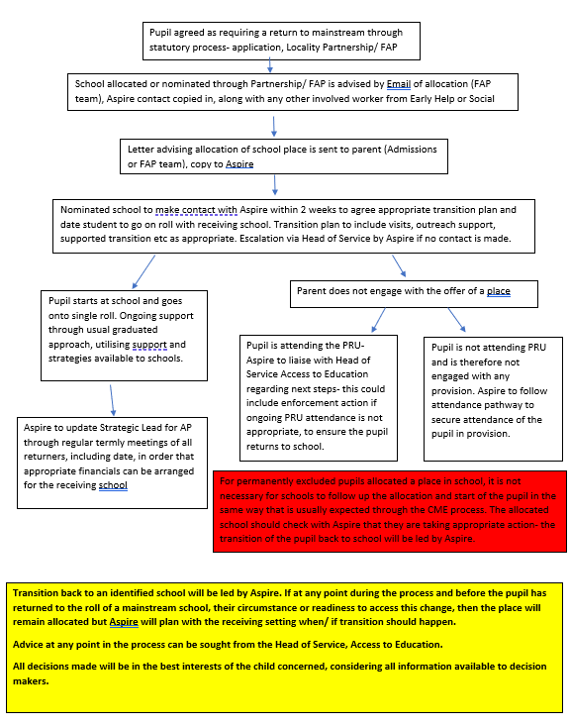

Appendix 2- Follow up of students allocated where contact cannot be made

