FAQs - Access Information
Every effort is made to ensure Rotherham Council’s town centre events are accessible, enjoyable and safe for all our visitors.

You can find the programme here which tells you more about what is happening where and when. We hope you find the programme and these FAQs helpful in planning your visit, but if you need any further information please get in touch with us at events@rotherham.gov.uk
If you have any questions during the event, please speak to a member of our friendly staff for more information. They’ll be wearing a hi-vis vest.

What is the Christmas Lights Switch On, when and where is it?

The Christmas Lights Switch On is a free event.
It takes place from 3pm to 6pm in a range of locations across Rotherham town centre.
The lights will be switched on at 6pm by the Mayor of Rotherham, Cllr Rukhsana Ismail in All Saints Square.

Can you tell me about the event site and what is happening where?

Due to the town centre location of the event, hard-standing routes and dropped kerbs are present throughout the footprint of the event. This includes in All Saints Square, Minster Gardens, Minster Yard and Effingham Street and Square.
The majority of the event will take place outside and the environment will reflect the weather.
All Saints Square
The main stage will be situated on All Saints Square. The stage will be BSL interpreted throughout the event.
There will be a range of local bands, choirs and professional musicians on this stage, and this is where the light switch on will happen.

This area will be quite noisy and busy throughout the event, but especially around the lights switch on at 6pm.

This is where the Christmas tree will be.
Market Square
Santa will be waiting to meet you in a step-free area. There may be a wait to meet Santa at busy times of the evening.
The Rotherham Libraries team will be aboard the The Big Yellow Bus Co.’s yellow bus, which is an American-style yellow school bus.
The bus has a relatively narrow door with 3-4 quite steep steps up from the ground. There is a handrail. The interior is also narrow and cosy, without much space to move around.

Rotherham Minster
There will be creative workshops taking place in Rotherham Minster throughout the afternoon. You may need to queue for workshops at busy times.
You can find out more about Rotherham Minster here - AccessAble - Your Accessibility Guide
There is access via steps to gendered toilets.

There is stepped access to a larger all gender toilet with baby-changing facilities.

Minster Yard
There is level access around Minster Yard.
Goodysphere will be joining us with their Sensory Bus, a relaxed, welcoming space for children, young people and adults who may need a break from the crowds. This will be located just outside of Rotherham Minster on Church Street.

They will be bringing their Christmas sensory trays and their small group entry rainforest themed bus. Inside you’ll find:

- A calming bubble tube
- A glowing fibre optic waterfall
- A gentle sensory swing
- A sequin board and mirror for visual and tactile play
- A basket of sensory fidget toys
- Goody the Gecko storybooks to explore
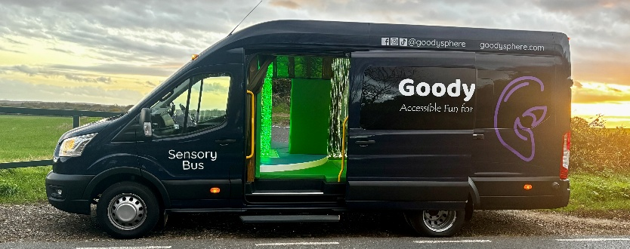
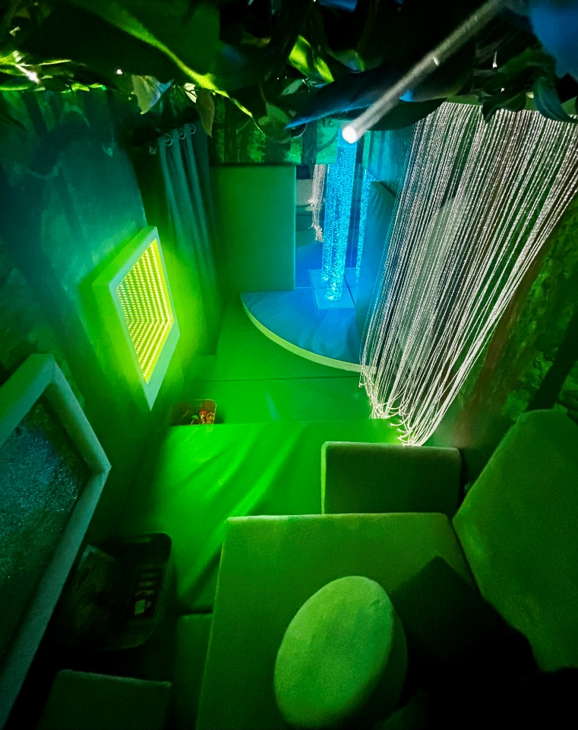
- Three Christmas themed sensory trays set up outside under their gazebo
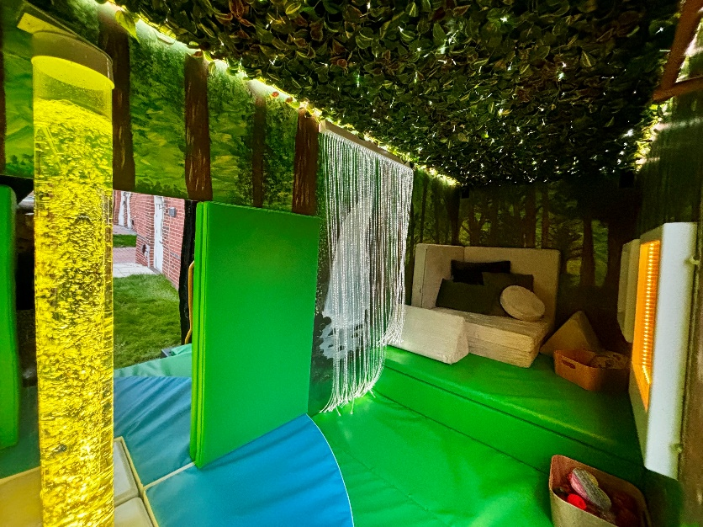

The free silent disco in Minster Yard will be run by the Children’s Capital of Culture team. If you’d like to join in, you’ll just need to pick up some headphones from the team in Minster Yard outside of Rotherham Minster and enjoy the music.
This is very informal, and you can move around the space however works for you. There are some benches and low walls in this area than can be used to sit down.
There will be uplighting to illuminate the area.

Our aim is for this space to be a little quieter and calmer, whether you want to wear headphones and experience the music, or spend some time in the space quietly and enjoy the lights.
Minster Gardens
There is level access around the perimeter of the gardens but there is a step up to the grassed area.

Yorkshire Circus will be running workshops and performing in this area throughout the event. They work with LEDs and will be performing a fire show (at 3:45pm and 5:45pm), so this area will often be bright.
There will also be a variety of walkabout performances throughout the event.

Effingham Street and Square
The gift market will be on Effingham Street. There will be lots of stalls selling a variety of items set up under gazebos. It is likely that there will be lots of people shopping and it will be crowded.

There will be a fairground in Effingham Square. It will be loud and bright in this area throughout the event.
Arc Cinema, Forge Island

Festive Films at Arc Cinema, 2pm to 3pm. More about the cinema here: Home | Arc Cinema Rotheram – Cinema listings, times and online tickets

THREE CRANES PUB

Flux Rotherham welcome you to a Lantern Making workshop, 1pm to 3pm, before the start of the main event at 3pm.
There are a set of steep stairs up to three gendered toilets in The Three Cranes.
Alcohol is served in this venue.

Do I need a ticket?
No. The Christmas Lights Switch On is a free annual town centre event with no ticket required. Workshops in Rotherham Minster are drop-in, so you won’t need a ticket for these either, but you might have to wait for your turn.

What should I wear?

This is an outdoor event taking place in November and will take place in all weathers. Warm outdoor clothing, appropriate footwear and umbrellas or waterproofs (to be on the safe side) are essential!

Is there first aid available?
There is First Aid available on site.

Will there be British Sign Language (BSL) interpretation?
The Main Stage will have BSL interpretation throughout the event.

Will I have to queue?

You may have to queue for workshops during periods of high demand, and it will be busy in the All Saints Square at, and in the lead up, to the Light switch on at 6pm.

Where are the creative workshops?

Free creative workshops for all ages and abilities will be running all afternoon. They will take place in Rotherham Minster.

Am I able to breastfeed at the event?

This is a breastfeeding-friendly event and you are welcome to breastfeed wherever you feel comfortable.

WILL IT BE NOISY? WILL THERE BE SOMEWHERE TO SIT DOWN? SOMEWHERE QUIET TO GET AWAY FROM THE HUSTLE AND BUSTLE?

Will it be noisy? Will there be somewhere to sit down/somewhere quiet to get away from the hustle and bustle?

Some areas of the event will have live music, and may be noisy, and generally the event gets quite busy, especially as the 6pm lights switch on time gets closer. It is usually a little quieter at the start of the event, and gets busier as the afternoon goes on.
If you feel overwhelmed, you can leave at any point. Everything is very informal, and you can come and go as you please.
There is seating available in areas throughout the town centre, and in Rotherham Minster.

Will there be food and drink available?
Find a full list of the businesses on Rotherham Council’s town centre website here – please note some may not be open into the evening: https://www.rotherhamtowncentre.co.uk/enjoying/eating-town-centre
You are welcome to bring your own food and eat it in the outdoor areas.

Is it suitable for dogs?
Assistance dogs are of course always welcome at Rotherham Council events.
You are also welcome to bring pet dogs, however, do be aware that some areas may be very noisy and busy!

Are there any public toilets?
Yes. All toilets listed below are free to use:
- All gendered Portaloo’s will be available at the event, this includes accessible Portaloos. They can be found at Market Square and on College Street (at the side of All Saints Square).
- There are toilets available at All Saints Centre. There is ramped access to All Saints Square toilets. There is an accessible all gender toilet, a baby change, and gendered toilets. You must have a radar key to use the accessible toilet.
- The Bus Interchange and Rotherham Markets also have gendered toilets.
- The nearest Changing Places toilet is at Rotherham United Community Sports Trust, New York Stadium, Don St, Rotherham S60 1FJ.
- There is an adult changing space at Riverside House, S60 1FJ
- There are free baby changing facilities at Riverside and All Saints Square. These all have ramped or level access from the venue entrance. There are free gendered toilets with level access at Riverside House.

Public transport

Train
Rotherham Central Station is located in Rotherham Town Centre and is 0.3 miles from the event.
Address: Rotherham Central station, Central Road, Rotherham, South Yorkshire, S60 1QH
For more information booking your journey via train, and access at Rotherham Central Station visit Northern.
Staff help is available and details of this can be found by calling 0808 156 1606 There is a lift for platform access and ramps for access to the ticket office. There is a taxi rank at the front of the station but there are no dedicated pick-up/set down points

Bus
Rotherham Bus Interchange is located in Rotherham Town Centre and is 0.2 miles from the event.
Address: Rotherham Interchange, Frederick St, Rotherham S60 1QB

The bus station has level access throughout. Staff are available to help and there is an assistance point.

The closest bus stops to the All Saints Square are:

Corporation Street 37035761 which is served by X1/X10 and 73
Corporation Street/Bridge Street 37036082 which is served by X1, X10, 19 and 19A

For more information on booking your journey via bus, and access at Rotherham Bus Interchange visit Travel South Yorkshire.

Bike
You can find cycle parking at:
- Rotherham Bus Interchange, near coach stand C3 & C4.
- Rotherham Central Train Station, in the car park.

Where can I park?

Closest car parks are:
- Forge Island, S60 1QE
- Drummond Street, S65 1EZ
- Westgate Car Park, S60 1BJ
- Clifton Hall Car Park, S60 1ED
- Rotherham Interchange Car Park, S60 1QB
Locations, charges and parking information (including electric vehicle charging points) can be found on Rotherham Metropolitan Borough Council’s website.

Rotherham Council offers free and time-unlimited parking for disabled drivers displaying a valid Blue Badge in all of its off-street pay and display car parks in Rotherham.

There are eight accessible spaces available for blue badge holders on College Street. This is the closest accessible parking to the festival and there is level access on tarmac or concrete pavement from the parking spaces to All Saints Square. It is 262ft (Approximately a minute walk) from the Festival Hub There are three accessible spaces for blue badge holders on Moorgate Street. This is 0.2 miles (Approximately four minutes work) from the Festival Hub. There are several paid car parks around Rotherham Town Centre. The closest ones are Westgate, Drummond Street and Greasborough Road.

Free parking is available on Saturdays in Council-owned off-street car parks in Rotherham town centre (not Forge Island), no ticket required. The normal maximum duration time allowed still applies. Find out more here.

You can find a digital map of all the car parking provided by Rotherham Council here.

You can download more parking information here.

Park and ride
You can travel to Rotherham town centre using the park and ride at the following locations:

Parkgate
Address: Stadium Way, S60 1TG
Opening times: 05:00-Midnight Monday to Saturday, 08:00-21:30 Sunday
Tickets from: Parking is free. Tickets for travel can be purchased onboard from the conductor
Please note: Parking facilities outside of the dedicated Tram Train parking spaces are subject to the parking terms and conditions of Parkgate Shopping. This includes terms of maximum stay.

Swinton Train Station
Address: Lime Grove, S64 8SP
Tickets from: Parking is free. Tickets for travel can be purchased from vending machines or via the Ticket Office. For ticket office hours please visit Northern Rail
Facilities: Toilets opening during staffed hours, cycle spaces available
Accessibility: Check information on the National Rail Enquiries website

Photography and filming

Please note that photography and filming will take place during the event. The material may be used in social media, in promotional videos and other publicity materials, both off and online. If you do not wish to appear in Rotherham Metropolitan Borough Council, Rotherham Music, Arts Council England and Children’s Capital of Culture or any other event partners promotional materials or have any other queries or concerns, please speak to a member of event staff.

Contact us

Drop us an email on: events@rotherham.gov.uk

