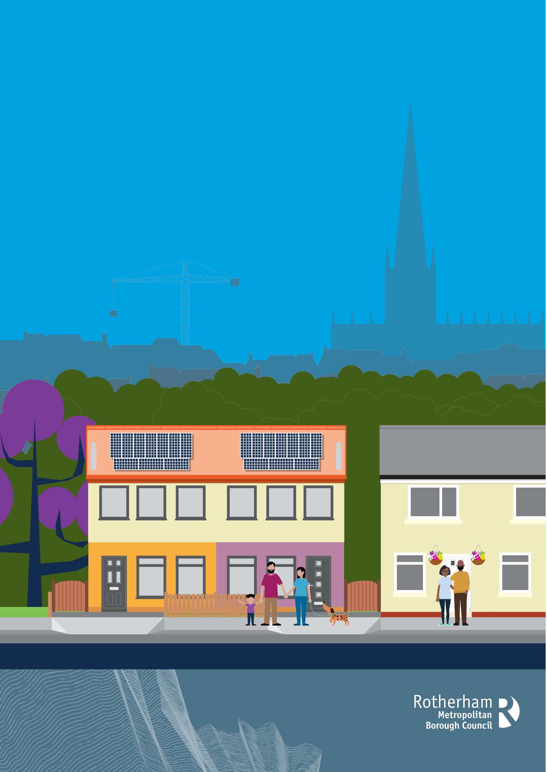
A GUIDE TO THE HOUSING ALLOCATION POLICY

www.rotherham.gov.uk

DEFINITIONS

Applicant | Somebody who wants a home from Rotherham Council or a housing association
Application form | An online form to fill out with your information
Bid | This is how you tell us you are interested in a home
Housing Online | A website where you can fill in an application form, update your application and place bids on properties you are interested in
Tenancy agreement | A legal document that says the terms and conditions between the landlord and person living in the home
Housing register | A list of everybody who has said they want a home from Rotherham Council or a Housing Association
Policy | A document that tells you what we will do and how we make decisions
Tenancy | When someone rents a property to live in, they sign an agreement saying that they as the tenant will pay money to their landlord in exchange for living at the property
Adaptation / adapted | When parts of a home have been modified to better suit those with disabilities or special requirements
Housing association | A non-profit organisation that provides affordable housing

INTRODUCTION
This is a guide to Rotherham Council’s Housing Allocation Policy. The policy says how the Council will help those who need housing the most find suitable homes, and how our properties are let in a fair way.
If you want to read the full Housing Allocation Policy, then you can find it online.
www.rotherham.gov.uk/downloads/download/453/housing-allocation-policy
If you need a new home quickly, then you need to consider all your housing options, such as private renting, as we have a lot of people on our housing register and only so many properties to re-let.
The Housing Allocation Policy considers various legislations and guidance to ensure that we allocate our properties fairly, as well as give reasonable preference to some groups.
During the allocation process, all customers will get helpful and quality information to help them make informed decisions about their future home.

HOW TO APPLY FOR THE HOUSING REGISTER IN ROTHERHAM

Residential Connection
Applicants over the age of 16 with a residential connection to Rotherham, may be eligible to join the housing register.
To join the housing register, applicants must live in Rotherham and have done for at least 3 out of the last 4 years. This rule must continue to be met after registration. If an applicant no longer meets it, they will be removed from the register
There are certain circumstances where applicants are exempt from the residential connection criteria, such as current/former members of the armed forces and care leavers. The full list is available in the policy.

How to Register
You can register for a Council home online: housingonline.rotherhamcouncil.org.uk
You will need to fully complete an application online and upload the following documents:
- Two forms of ID for all household members (passport or birth certificate).
- Proof of residential connection.
- Proof of address (such as a bank statement or recent utility bill).
- Proof of income (wage slip, proof of benefits or bank statement).
- Signed consent form.
Applications are verified in line with the Housing Allocation Policy. Applicants who are eligible will have a pre-tenancy interview to discuss their housing circumstances and placed in a band dependent upon their housing needs.

Applicants who will not qualify
All housing applications will be treated on an individual basis and therefore considered on their individual circumstances. The following applicants will not qualify to go on the housing register.
- Applicants who do not meet the residency test to Rotherham other than where they are exempt.
- Current or former social or private housing tenants with breaches in their tenancy conditions in the last five years, and that in the opinion of the Council affects the applicant’s suitability to be a tenant.
- Applicants who have previously been evicted from a council or housing association secure tenancy in the last 5 years due to breaches of their tenancy conditions. This includes tenancies where a court possession order has been attained in the last 5 years due to tenancy breaches, however prior to eviction, the applicant has voluntarily handed back their tenancy. This includes tenancies outside of Rotherham.
- Applications that have been cancelled will not qualify to re-join the housing register for 12 months.
- Applicants with rent arrears, or other housing related debt exceeding the equivalent to eight weeks rent.
Any applicant who is a current or former owner occupier, or who has savings worth more than £16,000, will be considered on a case-by-case basis. Cases where the applicant may be allowed to join the register could include:

- Living in conditions of disrepair or in unsuitable accommodation who are vulnerable due to age, long- term medical condition or disability and cannot resolve or adapt their property to make this suitable
- Experienced a change of circumstances that means their home is at risk or they are made homeless and where their potential homelessness cannot be prevented.
- Specific accommodation requirements that can only be met via a social housing allocation.
- A move is required to manage an urgent safeguarding risk.
An assessment will take into account all the resources available to the applicant. It will assume that applicants who have equity, savings, or assets worth over a quarter of the average property price for Rotherham will be expected to resolve their own housing circumstances, unless mitigation applies.
In determining whether in the Council’s opinion an applicant qualifies to join the register due to their behaviour, the Council will consider factors including:
- Has the applicant any mental health issues that need to be considered.
- In the Councils’ opinion would the unacceptable behaviour affect their suitability to be a tenant?
- At the time of the application, is the applicant still unsuitable to be a tenant by reason of that behaviour, or the behaviour of a member of his household?
Where an applicant does not qualify to join the housing register, they will be entitled to appeal
the decision if they consider that the Council should no longer treat them as ineligible as detailed in section 8.

BANDINGS
You will be placed into one of the following bands depending upon your individual circumstances. It is important that you notify us of any changes in your circumstances as it could affect your banding and effective date. Failing to do so could result in a property offer being withdrawn.

BAND ONE – HOUSING NEED CATEGORIES.
Applicants who are assessed as being statutory homeless under Part VII of the Housing Act 1996 and are owed the full housing duty.
Rotherham Care Leavers
Severe social and welfare circumstances
Housing management lettings
Severe medical need

BAND TWO - HOUSING NEED CATEGORIES
Relief Duty (assessed as priority need)
Prevention Duty (assessed as priority need)
Medical priority
Statutorily overcrowded
Households who are under occupying a council or housing association tenancy
Approved RMBC foster carers, adopters, guardians, and shared lives carers where they cannot resolve their own circumstances and require larger accommodation.
Households who live in a RMBC adapted property or disabled persons Unit (DPU) who wish to move once they no longer need the adaptation.
Applicants unable to succeed to a Rotherham council tenancy and have been granted use and occupation.
Households living in supported accommodation commissioned by the Council.
Armed Forces Covenant

BAND THREE – HOUSING NEED CATEGORIES
Relief Duty (not in priority need)
Prevention Duty (not in priority need)
Homeless households who have received an intentional decision.
Homeless cases in non-priority need when relief duty has ended.
Applicants living in non-commissioned supported housing.
Out of Borough Care Leavers who wish to move to Rotherham.
- Care Leavers under the age of 25 and in need of rehousing and are ready to live independently.
- Applicants are exempt from the residency test.
Out of Borough Care Leavers who are living in Rotherham.
- Reciprocal arrangements to be agreed with other placing Local Authorities
Applicants living with family & friends.
Households not statutory overcrowded, but where there are unsuitable sleeping arrangements.
Living in an upper floor Council, or Housing Association Flat in Rotherham with dependants under the age of 10 years.
Households who cannot afford to maintain the rent or mortgage or failure to move is causing hardship.

BAND FOUR – APPLICANTS NOT IN HOUSING NEED
Applicants who do not meet the housing need categories in Bands One, Two, or Three will be placed in Band Four if they meet the qualification criteria set out in this Policy.

Band Four will only be applied if the applicant:
- has a residential connection to Rotherham.
- does not have any tenancy related debt to the Council or other landlord.
- has not been evicted from a council tenancy during the last 5 years.
- has not got a history of anti-social behaviour in the last two years.
- has no intention to make the property overcrowded.
Examples include:

- Owner occupiers
Applicants who have been accepted onto the housing register following an assessment.
- Applicants in private rented accommodation not in housing need
- Applicants with savings over £16,000
Applicants will be considered on a case-by-case basis. Where there is a joint housing application both individual savings with be considered.
This does not apply to existing Rotherham Council tenants.
- Applicants owed a homeless duty and do not satisfy the local connection criteria in accordance with the Housing Act 1996 as amended by the Homelessness Reduction Act 2017.
- Applicants living in supported housing in Rotherham and do not satisfy the residency test.
This does not include applicants who have been referred to supported accommodation by the Council’s Homelessness Team to discharge a homeless duty.
- Existing Rotherham social housing tenants not in housing need.
Tenants will be required to have a clear rent account and no tenancy breaches within the last 12 months.

BEDROOM REQUIREMENTS

The table below shows you what type of property you are eligible for based on your household.

 | Bedsit | 1 Bed flat | 2 Bed flat | 3 Bed flat | 2 Bed maisonette | 3 Bed maisonette | 1 Bed house | 2 Bed house | 3 Bed house | 3 Bed Parlour** | 4 Bed house
Single person | YES | YES | YES | NO | YES | NO | YES | NO | NO | NO | NO
2 Individual adults | NO | NO | YES | NO | YES | NO | NO | NO | NO | NO | NO
3 Individual adults | NO | NO | NO | YES | NO | YES | NO | NO | NO | NO | NO
Single person with overnight access to children | NO | YES | YES | NO | YES | NO | YES | NO | NO | NO | NO
Couple | NO | YES | YES | NO | YES | NO | YES | NO | NO | NO | NO
Households with 1 child or applicants expecting  their first child (MATB1) | NO | NO | YES | YES | YES | YES | NO | YES | YES | NO | NO
Households with 2 children or dependents | NO | NO | YES | YES | YES | YES | NO | YES | YES | NO | NO
Households with 3 or more children or dependents | NO | NO | NO | YES | NO | YES | NO | NO | YES | YES | YES
**A three-bedroomed parlour house is a larger property and benefits from an additional reception room downstairs. Due to the demand on larger family accommodation, the criteria to allocate these properties is a minimum of three dependent children, however where a medical recommendation has been made for a parlour house, the Policy allows the Council to use its discretion if there are fewer than three children.

HOUSING OPTIONS

Staying with friends or family
It might be an option for you to live with friends or family, which can be useful for you to save up money for a deposit, be in education or find employment. The costs of renting or buying can be high, so living with friends or family means that you may be able to save money until you can live independently. You may also want to stay with family or friends to be supported, or to support them.

Private renting
One of the quickest ways to find accommodation may be to find a home you can rent privately.
You can find a private rented home by doing a quick internet search, or by visiting high street lettings agents in Rotherham. You can also try the following websites:
- Rightmove – www.rightmove.co.uk
- Zoopla – www.zoopla.co.uk
- Open Rent – www.openrent.co.uk
- On the Market – www.onthemarket.com/to-rent
- Spare Room – www.spareroom.co.uk (you could also look for a spare room in a shared house or flat)

Housing associations
We work alongside several housing associations who provide over 5,000 affordable homes within the borough. To be eligible for a housing association property, you will need to be registered on the Council’s housing register, as a lot of their properties are advertised through us. The housing association will
check that the applicant meets its own rehousing rules before any property is offered. A list of housing associations can be seen on the full policy or online:
www.rotherham.gov.uk/homelessness/housing-associations

Mutual exchanges
If you are a current Council or housing association tenant anywhere in England, then you may be able to complete a mutual exchange if you find somebody who wants to swap properties with you.
There are various websites you can use, such as Homeswapper www.homeswapper.co.uk, which is an independent website to assist you with finding a suitable property.

Extra care housing schemes
Extra care accommodation is longer term housing for those that want to live independently but might require a bit of support. It is usually reserved for those that are 55+ or for those with disabilities, such as dementia. The accommodation is usually small and easy to manage, but there is staff available where needed.
There are three extra care housing accommodation within Rotherham that are owned by Together Housing. To be eligible for these extra care properties, you would need to apply and be eligible to join the housing register, as well as applying to be rehoused on medical grounds. There is a high demand for these properties.

Shared ownership and other home ownership
If you are wanting to buy a home but can’t afford it or don’t have enough for a deposit, there are options available to you to help you.
You can use the tool on Own Your Home (www.ownyourhome.gov.uk) to identify if any government schemes are right for you. The website offers information on the Mortgage Guarantee Scheme, Shared Ownership, and First Homes.
If you are wanting to buy your own home without assistance from government schemes, then you will need to look on websites such as Zoopla (www.zoopla.co.uk) or Rightmove (www.rightmove.co.uk), as well as contacting local estate agents.

ADAPTED PROPERTIES
To be eligible for an adapted Council property, you will need to apply and be accepted onto the housing register, as well as apply and be accepted as having a medical need to move by completing a medical assessment form.
www.rotherham.gov.uk/council-social-housing/apply-rehousing-medical-grounds
If you have been assessed as needing a property which has been adapted to meet certain needs, you will be able to bid for these properties as they are advertised. Make sure you read the full details of the advert before you bid to make sure that the adaptations in the property are suitable for you.
You can also speak to Adult Social Care (01709 382121) to see if your current home can be adapted. Adaptations to private and Council properties are done in line with the Aids and Adaptation Assistance Policy 2023.

HOMELESSNESS
If you are homeless or worried about losing your home, the Housing Solutions Team are here to help you. They will assess your housing circumstances and suggest the most appropriate actions to be taken to assist you to either stay in your home or explore your other housing options with you.
You can find advice and contact information relating to homelessness on our website:
www.rotherham.gov.uk/housing

DIRECT LETS
There are certain circumstances when vacant properties may not be advertised on Housing Online, and on some occasions, properties may have been advertised but then the advert is removed. Direct lets are a proportion of total lets, and we will only do direct lets for the following reasons:
- Provision of temporary accommodation.
- Direct offer to homeless households.
- Direct offer to current Council tenants who are displaced from their Council tenancy and cannot return.
- Emergency re-housing, for example accommodation maybe required following fire, flood, or another major incident in Rotherham.
- Witness protection programme – this includes cross boundaries.
- Safeguarding Rotherham adults or children.
- Housing for Children & Young People’s Service including, provision of temporary and dispersed accommodation, care leavers, or ensuring foster placements are available for Rotherham residents.
- Individuals re-housed through multi-agency public protection arrangements (MAPPA)
- Customers who are in hospital and are well enough to return home, but their current home in Rotherham is not suitable for their needs; this is known as delayed discharge and has direct financial consequences to the Council.
- Customers who live in Rotherham are experiencing violence and need to move to ensure their safety.
- Other exceptional housing management reasons assessed by the Housing Assessment Panel.

ADVERTS AND SHORTLISTING
We operate a choice-based lettings scheme, and properties are advertised on the following advert cycles:
- Friday to Monday
- Tuesday to Thursday
You do not need to wait up to bid, we allocate properties based on the order of a shortlist. Shortlists are ordered automatically by the date of your application, and priority banding and not when you place your bid.
You can only place bids on properties you are eligible for. Some properties will be advertised with the following restrictions, if these apply to you, these will be discussed with you as part of your pre-tenancy interview:
- Rural connection.
- Adapted properties.
- Age restrictions will apply to certain properties.
- Preference for bungalows will be given to those applicants who are age eligible or have an assessed need.
Once the advert cycle has ended, a shortlist is generated. Successful applicants will be contacted to verify their housing circumstances and to check their eligibility.

VIRTUAL VIEWINGS
You will be sent a video link to a virtual viewing of the property. If you have any medical requirements and a physical viewing with an Occupational Therapist is required, you will be informed of this at the point we make an offer.

OFFERS
Applicants on the housing register will be subject to two offers of accommodation.
Applicants in Band 1 will be time limited to three months from the date of the award. If no bids are made within three months or one offer is refused, band one will be removed, and your application will be re-assessed.
Applicants who are owed a homeless duty, will receive one offer.

RIGHT NOT TO OFFER
The Council reserves the right not to offer a property, examples of these are:
- Requests an area where they may be unable to sustain a tenancy from lack of support. For example, in the case of an applicant with a medical priority on support grounds and the property requested is away from the support network.
- Requests a property that is too small for their family circumstances, and this would lead to an unacceptable overcrowding or cramped living conditions of the property including non-statutory overcrowding as per the Allocation Policy.
- Has specific needs for disability adaptations and the property does not meet these requirements.
- Where the applicant or members of the household have been involved in anti-social or criminal behaviour in the last 12 months.
- Where the applicant(s) has breached a condition of their current tenancy, e.g. rent arrears.
- Where the applicant cannot afford to take on the tenancy.
- Where the property or area has been deemed unsuitable to safeguard the applicant or neighbouring residents.

FURNISHED HOMES
If you are offered a Council tenancy, you will have the option to join Rotherham Councils Furnished Homes Scheme. The furnished scheme allows you to select furniture and appliances as well as floor coverings, to help make your home a home. There is a charge for this service, which would be added to your rent account and would be payable along with your rent. The charge varies depending on the furniture scheme you have requested. Further information on the Furnished Homes Scheme can be viewed online: www.rotherham.gov.uk/council-social-housing/furnish-council-home

TYPES OF TENANCIES
- Introductory tenancy – A tenancy under Part 5 of the Housing Act 1996, which usually covers a period of 12 months.
- Periodic tenancy – If no clauses of the tenancy agreement are breached, a periodic tenancy is usually a tenancy for life.
- Fixed term tenancy – A tenancy agreement which has a fixed term end date.

CANCELLING APPLICATIONS
Applications will be cancelled in the following circumstances:
- Failure to bid within the last 12 months.
- Does not reply to a housing register review letter within four weeks.
- People who complete a Right to Buy application.
- Is granted a tenancy by a council or housing association and has voluntarily terminated their secure tenancy.
- Has abandoned a council or housing association home.
- Has more than one application registered.
- Has been nominated to a Shared Ownership property.
- Has succeeded or been assigned a council tenancy.
- On accepting and signing a mutual exchange.
- Has applied and accepted major adaptation work that meets their long-term needs.
- Has refused two suitable offers of council or housing association accommodation.
- Has told us to do so.
- Has provided false information on their housing application.
Where no bids have been placed within 12 months, the application will be automatically cancelled. Applicants will be advised of this in writing. Where applicants re-approach within a six-month period, if there have been extenuating circumstances such as bereavement, or long-term illness, which has led to no bids being placed, their application will be reinstated to their original band and effective date.
Once an application is cancelled for any of the above reasons the applicant will not be allowed to re-join the Housing Register for 12 months.

RIGHT TO REQUEST A REVIEW
The applicant has a right to request a review if an applicant disagrees with the Council’s decision for the following:
- If an applicant believes that they are in the wrong band, or that their band has been changed unfairly.
- Cancellation following a Housing Register Review.
- Date of application.
- An offer has been withdrawn because the authority believes that the applicant has provided false information or has taken action which has made their circumstances worse.
- Where applicants have been suspended or excluded unfairly in the customer’s view.
- Offers of property made; if an applicant believes that a property has not been allocated according to the allocation policy. For instance, if they expressed an interest for a home, and were in the same priority band and had longer waiting time than the successful applicant.
Ref: 87996 / SEPTEMBER 2024
The applicant must submit a right to review request within 28 days of the applicant receiving the decision letter concerning their application.
The Right to Review will be reviewed by the Housing Assessment Panel and the applicant must be informed of any decision in writing and given the reasons for the action taken.

